**ARISS**

**Moderator Script for**

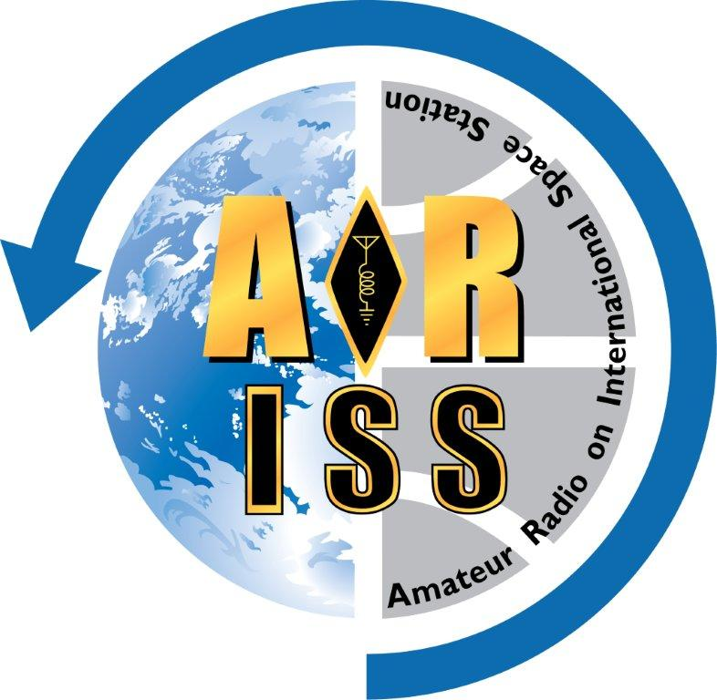**Tele-bridge ISS Contact**

**For: {{school_group_name}}**

**Contact Date: {{contact_date}}**

**Version: {{version}}**

Made Using Python ARISS Moderator Script Generator Version {{tool_version}}

Based on ARISS Moderator Script Master Short Template - Version N3FZX_20241130

**Event Schedule Outline**

All times are local school time (24hr), event durations & times to ISS rise are in minutes (m).

Conference start time........ {{contact_date}} {{T01}}

ISS Rise Time................... {{contact_date}} {{AOS_sch}}

Tele-bridge station............. {{telebridge_callsign}}, {{telebridge_location}}

Pre-contact preparation..... ~{{D14}}m

School/group program....... ~{{D15}}m

ARISS program/contact..... ~{{D16}}m

Total event duration........... ~{{D17}}m

| **Time** | **Dur.\*** | **Rise** |  | **Event Block Description** |
| --- | --- | --- | --- | --- |
| **{{T01}}** | **{{D01}}m** | **{{A01}}m** |  | **Start conference** |
| {{T02}} | {{D02}}m | {{A02}}m |  | Moderator ground station checklist |
| {{T03}} | {{D03}}m | {{A03}}m |  | Contact preparation checklist |
| {{T04}} | {{D04}}m | {{A04}}m |  | Practice run through with all students and ground station |
| **{{T05}}** | **{{D05}}m** | **{{A05}}m** |  | **S****chool/group program, or slack time** |
| **{{T06}}** | **{{D06}}m** | **{{A06}}m** |  | **Start ARISS program** |
| {{T07}} | {{D07}}m | {{A07}}m |  | ARISS introduction |
| {{T10}} | {{D10}}m | {{A10}}m |  | Introduce the ground station |
| {{T11}} | {{D11}}m | {{A11}}m |  | Handover to ground station |
| {{T12}} | {{D12}}m | {{A12}}m |  | ISS rise and Acquisition of Signal (AOS) |
| **{{AOS_sch}}** | **11m** | **0m** |  | **ISS Contact!** |
| {{T13}} | - | - |  | ISS set and Loss of Signal (LOS) |
| {{T13}} | {{D13}}m | - |  | Closing remarks & end of ARISS program |

*\* Events with 0 minute duration have been eliminated from the program, but not the report.*

Based on conference call start time at {{T01}}, ISS rise time at {{AOS}}, and ARISS portions (prep and program), the school/group program time, or slack time, is estimated to be no more than {{D05}} minutes starting at {{T05}}.

**Event Timeline**

School/group name: **{{school_group_name}}**

ISS contact date/time: **{{contact_date}} {{AOS}}**

**NOTE THAT ALL EVENT TIMES ARE IN SCHOOL/GROUP LOCAL TIME**

|  |
| --- |
| **{{T01}} {{D01}}m Duration {{A01}}m to ISS Rise**  **CALL IN CHECKLIST**  Everyone should be on-time at **{{conf_UTC}}** UTC & **{{conf_sch}}** local time for the school.  [ ] Moderator dialed in.  [ ] If using Verizon, moderator should greet the Verizon operator and ask  for their name. Verizon Operator Name: _________________  [ ] Ground station dialed in.  [ ] Mentor dialed in.  [ ] School/group dialed in.  [ ] Live stream operator dialed in.  → |
| **{{T02}}** **{{D02}}m Duration {{A02}}m to ISS Rise**  **MODERATOR GROUND STATION CHECKLIST**  Verify the ground station is ready to go with the checklist below.  Moderator to Ground Station:  [ ] Tracked ISS recently?  [ ] Antenna slews in azimuth and elevation?  [ ] Flip mode enabled if required?  [ ] Time check (synchronize).  [ ] Are your Keps up-to-date?  [ ] Check ISS AZ/EL and rise (AOS) time.  [ ] Check and confirm the uplink frequencies the ISS will be using.  [ ] Telebridge Station is ready to provide a brief overview just before the contact.  [ ] Telebridge Station to open squelch to check audio levels.  → |
| **{{T03}} Duration: {{D03}}m Duration {{A03}}m to ISS Rise**  **CONTACT PREPARATION CHECKLIST**  Verify the following with school/group, ground station and moderator.  Moderator:  [ ] Verify moderator script version. Make sure everyone is using same version.  [ ] Work out how the school will cue the moderator after the school program and the end of  the videos. Note that the moderator can not rely on a live stream feed for such cues.  [ ] Final checks for any video streaming from the ground station.  [ ] Final coordination discussion with mentor, moderator, ground station, and live stream  operator (if used).  [ ] If using Verizon, coordinate when the recording will start.  → |
| **{{T04}} {{D04}}m Duration {{A04}}m to ISS Rise**  **PRACTICE** **RUN THROUGH WITH ALL STUDENTS AND GROUND STATION**  All students should be present at this time. Note that this is where audio problems can surface. The sooner this can be completed the better.  [Make this duration longer if school/group program is shorter than the time made available.]  [Can increase the D04 duration in the ARISS moderator script form file to recalculate times.]  Moderator:  [ ] Verify the school can hear the moderator clearly.  [ ] Verify school can hear ground station audio clearly.  [ ] Verify ground stations can hear school/student audio clearly.  [ ] Verify no feedback issues.  [ ] Remind students to speak clearly and directly into the microphone, and to say “OVER”  at end of each question.  [ ] Have each student ask at least one question, in order, and have ground station  simulated astronaut report on audio quality. Adjust as needed.  **Do not change any audio settings once this has been completed.**  → |
| **{{T05}} ~{{D05}}m Duration {{A05}}m to ISS Rise**  **SCHOOL/GROUP PROGRAM, OR SLACK TIME**  School/group program is an optional event. If there is no program, then this is slack time.  The program should have a hard cutoff time to start the ARISS portion.  School/group:  [ ] School/group host hands off to ARISS moderator at the end of the their program.  → |
| **{{T06}} ~{{D06}}m Duration {{A06}}m to ISS Rise**  **START ARISS PROGRAM**  This needs to start on-time.  Moderator:  “Before we get started, I want to remind everyone, that this contact will be recorded.”  [Adjust the lines below depending on arrangements.]  [ ] If using Verizon, moderator requests Verizon Operator starts recording.  [ ] Live stream goes live: audio from conference call; video from Zoom.  Moderator:  “Hello everyone, this is **{{moderator_name}}**, callsign **{{moderator_callsign}}**, your ARISS moderator for today for our ISS contact with **{{school_group_name}}** in **{{school_group_city_state}}**.”  → |
| **{{T07}} ~{{D07}}m Duration {{A07}}m to ISS Rise**  **ARISS INTRODUCTION**  Moderator:  “Through the help of amateur radio volunteers and the crew on the ISS we soon hope to establish radio contact with the International Space Station as it flies more than 250 miles (400km) above the Earth over **{{telebridge_location}}**. This is all accomplished through ARISS, Amateur Radio on the International Space Station. The ISS is currently approaching today’s ARISS ground station traveling along at around 18,000 miles per hour (28,000km/h).”  “The contact for today will be performed using the ARISS telebridge network, a world-wide network of amateur radio ground stations that enable students to contact the ISS. ARISS is an International consortium of volunteers from several nations that assist to develop and operate the amateur radio equipment on board the International Space Station.”  “Some of those agencies that support ARISS are, The American Radio Relay League, The worldwide AMSAT Amateur Radio Satellite Corporations, The Canadian Space Agency, The European Space Agency, The Japanese Space Agency (JAXA), Roscosmos, the Russian Space Agency and NASA.”  Our linkup today will be with the student participants at **{{school_group_name}}** in **{{school_group_city_state}}**, now let’s check in with the group. We’ve asked teacher **{{teacher_name}}** to please tell us about the students that are taking part today.  School:  [ ] Usually ad-lib about student events, where are the students from, how many visitors  do you have at the venue, etc. for no more than 2 minutes.  Moderator:  Thank you **{{teacher_name}}**.  → |
| **{{T10}} ~{{D10}}m Duration {{A10}}m to ISS Rise**  **INTRODUCE THE GROUND STATION**  Moderator:  “Our contact for today is with astronaut **{{astronaut_name}}**, amateur radio callsign **{{astronaut_callsign}}**, who will be using the ISS amateur radio callsign **{{ISS_callsign}}**.”  “The amateur radio ground station that will establish radio contact with the ISS today is ARISS Ground Station **{{telebridge_callsign}}** located at **{{telebridge_location}}** and operated by **{{operator_name}}**, **{{operator_callsign}}.**  “**{{operator_name}}**, please tell us a little bit about the **{{telebridge_callsign}}** station and how you will handle today’s contact with the ISS.”  Ground Station:  [ ] Mention any additional people assisting at ground station.  [ ] Ground station describes station. Limit to ~2 minutes.  [ ] Ground station reports time to ISS rise and predicted AOS.  [ ] Ground station hands back to the ARISS moderator.  Moderator:  [ ] Moderator should be prepared with filler material if ahead of the timeline.  → |
| **{{T11}} ~{{D11}}m Duration {{A11}}m to ISS Rise**  **HANDOVER TO GROUND STATION**  Moderator:  “We are now about **{{A11}}** Minutes before the planned acquisition of signal from ISS. With the time for the ARISS contact quickly approaching, we want to remind all to please mute your cell phones and be as quiet as possible when not asking Astronaut **{{astronaut_name}}** a question.”  “Remember, what we are doing on ISS is an experiment, so we can never tell the results, positive or negative until the experiment is over. And students, please don’t forget to say OVER at the end of your question.”  “The International Space Station will soon come into radio range of the **{{telebridge_callsign}}** ARISS ground station in **{{telebridge_location}}** so, **{{operator_name}}**, it’s all yours. Good luck!, OVER!”  Moderator:  [ ] Handover to ground station at least one minute before ISS ride time.  → |
| **{{T12}} ~{{D12}}m Duration {{A12}}m to ISS Rise**  **ISS CONTACT!**  This is done by the ground station.  Ground Station:  [ ] Open squelch, rushing noise is heard.  [ ] Ground station calls ISS. This may take a few minutes.  [ ] Confirm that contact is solid and say “Over to the school for first question.”  → |

**School Questions**

[Copy the list of school/group questions from ARISS Ops Uplink file here.]

|  |
| --- |
| Ground Station:  [ ] IF TIME PERMITS, thank astronaut and invites all attendees to cheer in appreciation.  [ ] IF TIME PERMITS, asks astronaut for any additional comments.  [ ] Contact ends at LOS, ground station signs off.  → |

|  |
| --- |
| **{{T13}} ~{{D13}}m Duration Post LOS**  **CLOSING REMARKS AND** **END OF ARISS PORTION OF THE PROGRAM**  Moderator:  “Ladies and Gentlemen we have just shared a “wow” moment of history. Amateur radio ground station **{{telebridge_callsign}}** located at **{{telebridge_location}}** and operated by **{{operator_name}}**, **{{operator_callsign}}**, contacted astronaut **{{astronaut_name}}** (**{{astronaut_callsign}}**) aboard the International Space Station, and spoke with students at the **{{school_group_name}}** in **{{school_group_city_state}}**.”  “Now, for the international volunteer team of ARISS, including the Amateur Radio Satellite Corporations around the world, the American Radio Relay League, The Canadian Space Agency, The European Space Agency, the Japanese Space Agency, Roscosmos, and NASA, this is **{{moderator_name}}**, **{{moderator_callsign}}** your ARISS moderator, sending my salutation to all of you in amateur radio terms, 73’s, which means best wishes.”  Moderator:  [ ] If using Verizon, moderator requests Verizon Operator stop recording.  [ ] If using Verizon, moderator thanks Verizon Operator for the help.  [ ] Any live stream from the moderator and tele-bridge station is stopped.  [ ] Moderator releases ground station from conference or asks them to standby.  [ ] ARISS moderator hands off to school/group.  → |

**Logistics**

**Important Dates and Times**

Date of Contact (YYYY-MM-DD): **{{contact_date}}**

Start of Conference (HH:mm): **{{conf_UTC}}** UTC / **{{conf_sch}}** school local time

ISS Rise time (HH:mm): **{{AOS_UTC}}** UTC / **{{AOS_sch}}** school local time

**School/Group Information**

School/group name: **{{school_group_name}}**

School/group location: **{{school_group_city_state}}**

Coordinator/teacher at venue: **{{school_coordinator_name}}**

School principal name: **{{principal_name}}**

School teacher name: **{{teacher_name}}**

**ISS Information**

Astronaut name and callsign: **{{astronaut_name}}**, **{{astronaut_callsign}}**

ISS callsign to be used: **{{ISS_callsign}}**

**ARISS Mentor Information**

Mentor name, callsign: **{{mentor_name}}**, **{{mentor_callsign}}**

Mentor will be On-site or Remote for the contact: **{{mentor_location}}**

**ARISS Moderator Information**

Moderator name, callsign: **{{moderator_name}}**, **{{moderator_callsign}}**

Moderator will be On-site or Remote for the contact: **{{moderator_location}}**

**ARISS Tele-bridge Ground Station**

Station callsign & location: **{{telebridge_callsign}}**, **{{telebridge_location}}**

Operator name and callsign: **{{operator_name}}**, **{{operator_callsign}}**

Audio interface (Verizon/Zoom dial-in/Zoom client): **{{audio_interface}}**

Video interface: **{{telebridge_video}}**

**Live Streaming**

Live streaming planned (Yes/No): **{{livestream_plan}}**

Live stream operator name, callsign: **{{livestream_name}}**, **{{livestream_callsign}}**

**Miscellaneous**

None. [Manually edit any items here.]