ARISS
Telebridge ISS Contact
Event Timeline Summary

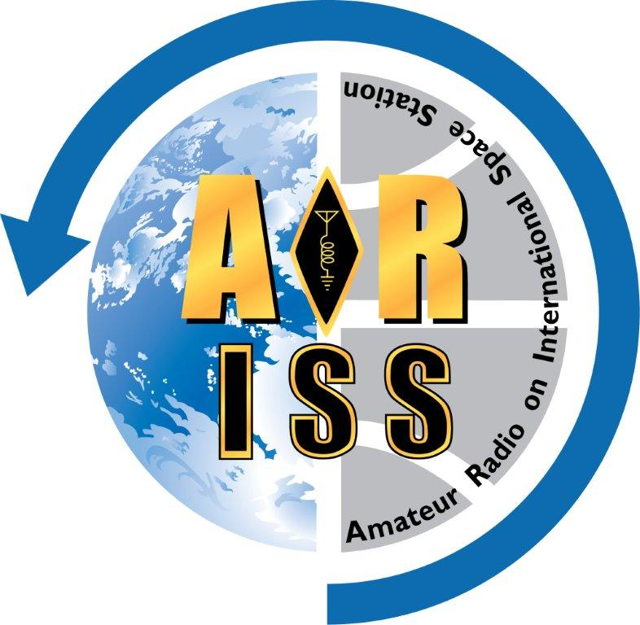
For: {{group_name}}
Contact Date: {{contact_date}}
Version: {{version}}

Event Schedule Outline for {{group_name}}
Moderator Script Version {{version}}
Event local time zone: {{etz}}, UTC {{TZ_shift}}
Conference start time: {{contact_date}} {{T01}} {{etz}} ({{conf_UTC}} UTC)
ISS rise time: {{contact_date}} {{AOS_sch}} {{etz}} ({{AOS_UTC}} UTC)
Tele-bridge station: {{gnd_sta_callsign}}, in {{gnd_sta_location}}

All times are local event time (24hr), event durations & times to ISS rise are in minutes (m).
ARISS preparation: ~{{D14}}m (Events #1-4)
School/group program: ~{{D15}}m (Event #5)
ARISS program/contact: ~{{D16}}m (Events #6-13)
Total event duration: ~{{D17}}m

Time | Dur.* | Rise |  | Event Block Description
{{T01}} | {{D01}}m | {{A01}}m |  | #1 - Start conference - via {{gnd_sta_audio}}
{{T02}} | {{D02}}m | {{A02}}m |  | #2 - Moderator ground station checklist
{{T03}} | {{D03}}m | {{A03}}m |  | #3 - Contact preparation checklist
{{T04}} | {{D04}}m | {{A04}}m |  | #4 - Practice run through with all questioners and ground station
{{T05}} | {{D05}}m | {{A05}}m |  | #5 - School/group program, or slack time
{{T06}} | {{D06}}m | {{A06}}m |  | #6 - Start ARISS program (must start on time)
{{T07}} | {{D07}}m | {{A07}}m |  | #7 - ARISS introduction
{{T08}} | {{D08}}m | {{A08}}m |  | #8 - Optional video from student perspective - {{ARRL_video}}
{{T09}} | {{D09}}m | {{A09}}m |  | #9 - Optional video from the ISS perspective - {{ISS_video}}
{{T10}} | {{D10}}m | {{A10}}m |  | #10 - Introduce the ground station
{{T11}} | {{D11}}m | {{A11}}m |  | #11 - Handover to ground station
{{T12}} | {{D12}}m | {{A12}}m |  | #12 - ISS rise and Acquisition of Signal (AOS)
{{AOS_etz}} | <11m | 0m |  | ISS Contact!
{{T13}} | --- | --- |  | ISS set and Loss of Signal (LOS)
{{T13}} | {{D13}}m | --- |  | #13 - Closing remarks & end of ARISS program
* Events with 0 minute duration have been eliminated from the program, but not this report.

Any needed event site customization or additions for the event should take place prior to Event #1, within the time constraints of Event #5, and/or after Event #13.
Logistics

Important Dates and Times
Contact date (YYYY-MM-DD): {{contact_date}}
Event local time zone abrv: {{etz}}, UTC {{TZ_shift}}
Conference start (HH:mm): {{conf_UTC}} UTC / {{conf_etz}} {{etz}}
ISS rise time (HH:mm): {{AOS_UTC}} UTC / {{AOS_etz}} {{etz}}
School/Group Information
School/group name: {{group_name}}
School/group location: {{group_city_state}}
Coordinator at event: {{coordinator_name}}
School/group presenter: {{presenter_name}}
ISS Information
Astronaut name, callsign: {{astronaut_name}}, {{astronaut_callsign}}
ISS callsign to be used: {{ISS_callsign}}
ARISS Mentor Information
Mentor name, callsign: {{mentor_name}}, {{mentor_callsign}}
For contact, mentor will be: {{mentor_location}}
ARISS Moderator Information
Moderator name, callsign: {{moderator_name}}, {{moderator_callsign}}
For contact, moderator will be: {{moderator_location}}
ARISS Ground Station/Telebridge
Station callsign & location: {{gnd_sta_callsign}}, {{gnd_sta_location}}
Operator name, callsign: {{gnd_sta_op_name}}, {{gnd_sta_op_callsign}}
Radio audio interface: {{gnd_sta_audio}}
Video feed interface: {{gnd_sta_video}}
Live Streaming
Live stream planned (Yes/No): {{livestream_plan}}
Live stream operator name: {{livestream_name}}
Miscellaneous
None. [Manually edit any additional items here.]

