**Challenge-2**

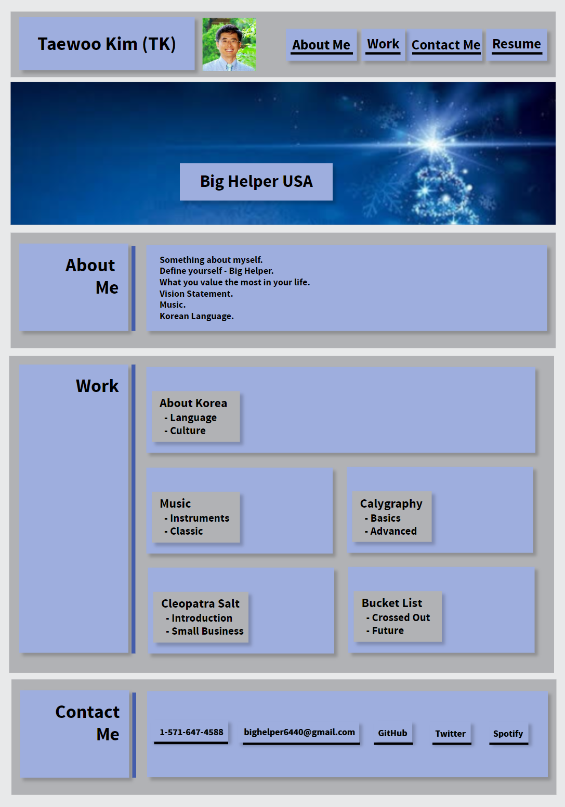**[Wire-Frame of TK’s portfolio page]**

1. **Acceptance Criteria**

**Q. where should it linked to?**



**When loaded,**

**Name, Photo, Links to Sections**

**When click one of the links,**

**UI scrolls to the corresponding section.**

**When click one of the section about the works,**

**UI scrolls to a section with titled images of developer’s applications.**

**When presented with the developer’s first application,**

**That application’s image should be larger in size that the others**

**When click on the image of applications,**

**I’m taken to that deployed application.**

**Resize the page or view the site on various screens and devices: present with a responsive layout that adapts to my viewport.**

GIVEN I need to sample a potential employee's previous work

WHEN I load their portfolio

THEN I am presented with the developer's name, a recent photo or avatar, and links to sections about them, their work, and how to contact them

WHEN I click one of the links in the navigation

THEN the UI scrolls to the corresponding section

WHEN I click on the link to the section about their work

THEN the UI scrolls to a section with titled images of the developer's applications

WHEN I am presented with the developer's first application

THEN that application's image should be larger in size than the others

WHEN I click on the images of the applications

THEN I am taken to that deployed application

WHEN I resize the page or view the site on various screens and devices

THEN I am presented with a responsive layout that adapts to my viewport

1. **Related HTML/CSS Topics to solve**

**Q. where should it linked to?**



**Flex box;**

**Pseudo elements**

**Pseudo classes**

**Positions: absolute/relative**

**Media Queries**

**Padding, margin,**

**Display, display flex, media queries**

1. **index.html – Structure of my webpage**

**wrapper**



**header**

**main**

**logo**

**aboutMe**

**work**

**contactMe**

1. **style.css – Visualization of my webpage**

