Workday Redesign

P7 Final Report

IE 5720 Team 03
Stephen Fieffer, Evelyn Khew, Thomas Lenz, Ryan McCurnin

5/9/25

Introduction
There has been broad pushback against the new Enterprise Resource Planning software, Workday, that Iowa State University implemented this year to replace the old system, AccessPlus. It is seen as less usable and an unwelcome change, but little dialogue about the new system dives deeper than the shallow sentiment that “Workday sucks.” This project has identified that most problems users encounter in the current Workday system stem from infrequent use on a system not designed for learnability, difficulty navigating the site due to inconsistent and non-hierarchical organization, and vague or arcane menu and function names. It suggests a restructuring of the interface that includes a shallower menu, consistent and hierarchical page organization, and simple and descriptive function names. Based on user testing, a redesigned prototype shows significant improvement in navigability and usability and greatly reduces both frustration and time spent on tasks.

Background
The current Workday interface contains all the information that is needed to accomplish one’s task, but the structure and labels for such information are problematic. Different buttons can have similar label text that is different only in slight nuance and may contain jargon that is not understood by the entire user population. A quote from a participant during initial user interviews stated “I don’t like financial hub, what does it mean? Benefits and pay should be under that hub.” This comment illustrates the confusing structure of the current interface, where clicking a button does not navigate the user to the information expected. A different participant from initial user interviews commented that they “get UI blinded in Workday” due to the number of buttons to select from.
Currently there does not exist a solution to avoid these interface issues apart from familiarization with the interface layout and navigation. This results in tasks taking a longer amount of time to complete than necessary and greater user frustration.

System description
For this project, we decided to use Unity to help bring our prototype design to life. In this section, we discuss the rationale and thought processes for design choices, as well as the insights that we have gained throughout this journey. Figure 1 below depicts a first look at our final design.
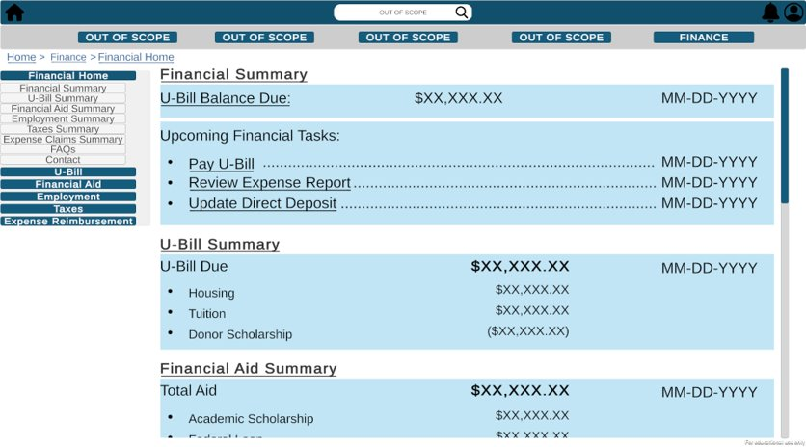
Figure 1: First look at Workday Redesigned
Our redesign provides our userbase with a more organized structure. As seen with our paper prototype (see Appendix A: Experimental Materials section 10.3.1), the final design features a systematic arrangement of headers and sub-headers for our redesigned menu. For these header options in order to promote Norman’s heuristic of making things visible (Miller, 2003). We also made sure to avoid jargon words as much as was possible, adhering to Jakob Nielsen's 10 Usability Heuristics (Nielsen & Molich, 1990), specifically “speak the user’s language”. One example of the implementation within our redesign for this is with changing “claims and reports” from our paper prototype to “Expense reimbursement” for our final design. Because submitting receipts to be paid back for purchases is inherently bureaucratic and does not have a great plain-language label, the best alternative we had to clear up confusion for this was “expense reimbursement.”
Next, in order to determine which menu options to allocate and include, we performed a card sort to create an affinity diagram. To revisit, Figure 1 depicts the referenced affinity diagram, which we worked on for P2.
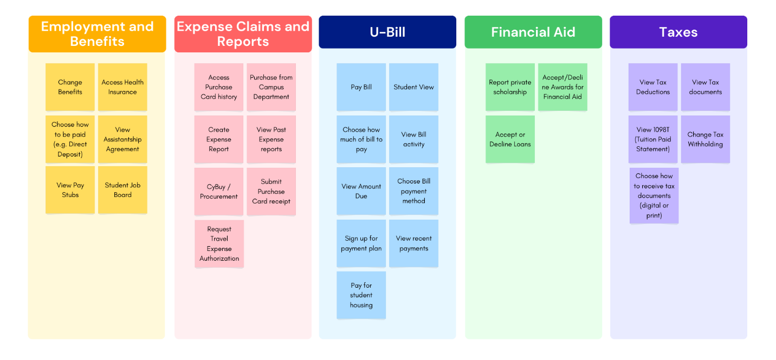
Figure 2: Affinity diagram of financial function in Workday
Through this initial affinity diagram, we were then able to incorporate the following menu seen in Figure 1 for our final design.
We also designed the menu to be both shallow and persistent across all financial-related pages that we created, as one of the key heuristics that we wanted to focus on was to minimize the user’s memory load, as per Nielson’s guidelines (Miller, 2003). This ties into having consistency and discoverability as a part of our redesign as well, both of which are derived from Tog’s heuristics (Nielsen & Molich, 1990). Having the menu be persistent across pages helps with the heuristic of consistency since the menu itself doesn’t change with both content and location on the page. Not only that, having a shallower menu and logical grouping and mapping of features helps with promoting the discoverability of our redesign as well, which is a key heuristic that can help alleviate lostness within our design, and this is important as we expect many of the target users of Workday’s financial features to be infrequent users. Although a shallower menu with many features could lead to the user needing a longer time to review all the possible options, we still believed that this would be a good tradeoff.
An extra bolster we implemented into our final design to further promote navigability within our redesign was to include breadcrumbs for each unique page visited. Through breadcrumbs, we would be able to promote the visibility of our system’s status. For consistency, we also made sure to anchor the breadcrumbs at the top left corner of our screen, using the same visual style throughout. Another positive of implementing this feature into our redesign is that it can help improve its navigability as well. Through the addition of breadcrumbs, users can have a deeper understanding of where they currently are in the system, and navigation can be promoted because of this. Figure 3 demonstrates our implementation of the breadcrumbs.
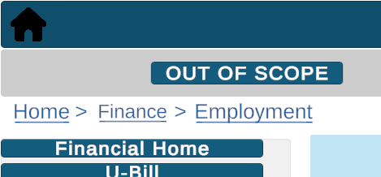
Figure 3: Example of the implemented breadcrumbs for Workday Redesigned
Discoverability was also a key factor when deciding where to place the mailing address for users who prefer to pay their U-Bill through mailing in a check to the university instead. With the current Workday design, the mailing address is located one page level above where one would opt to pay their U-Bill, and it is also tucked off to the bottom left of the screen, making it harder for users to notice. Another possible way for users to be able to find the mailing address on the current Workday is by rotating through the carousel at the top of the U-Bill page. However, that feature is very unintuitive, as it is very unclear for users to understand that it is a carousel design and an arrow exists for them to explore the other options. Since the mailing address section of this carousel is tucked off screen, most users would miss out noticing it altogether. With our redesign, we wanted our users to be able to find the option of mailing in checks better, so we decided to relocate the mailing address to right below the “pay U-Bill" button, thus ensuring that the user can be made aware of this alternative they could utilize more easily.
Figure 4 shows where we have relocated the information for the mailing alternative for students to pay their U-Bill.
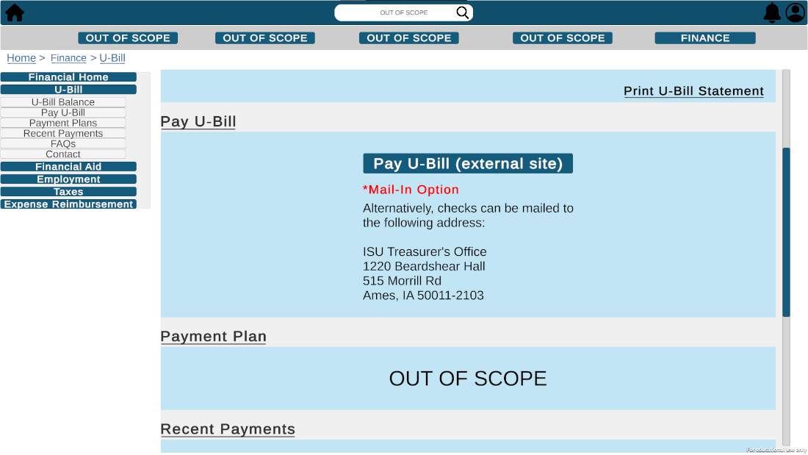
Figure 4: View of the U-Bill main page

Another aspect of our redesign to highlight is the feedback provided after the user clicks on the “Pay U-Bill button, as it was a part of the feedback Figure 4we received from our cognitive walkthrough evaluation. By adding a pop-up menu as feedback with information on both how much they just paid and how much money they still owe, users can have a clearer understanding of the payment process and not be left confused or frustrated. shows the pop-up that appears once the “Pay U-Bill (external site)” button is clicked. In a real-world implementation of this feature, this pop-up would only appear once the redesigned Workday site receives feedback from the external site Iowa State University uses to complete payments.
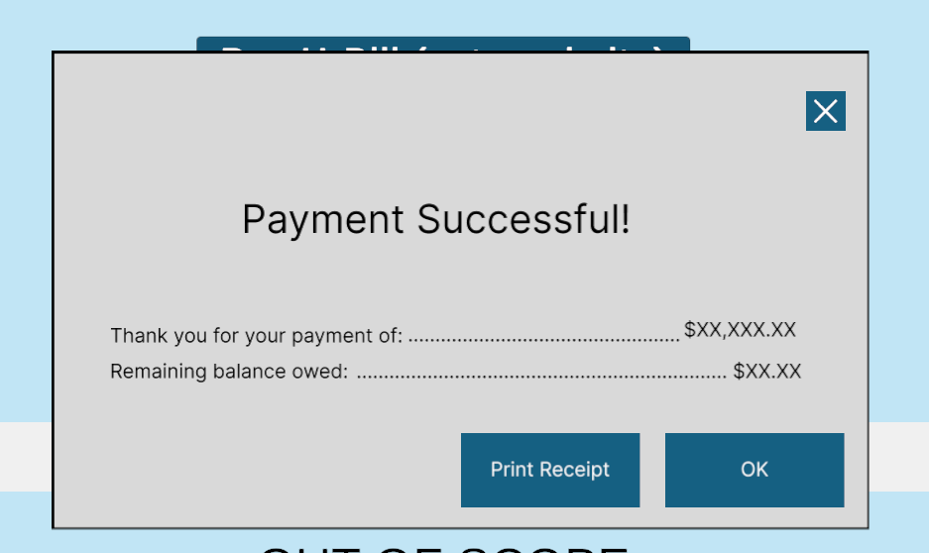
Figure 5: Pop -up feedback once “Pay U-Bill (external site)” button is clicked.
Lastly, we also wanted to highlight the inclusion of FAQs and Contact information sections throughout our site. One issue we found from Workday’s current design was with the low discoverability of help or FAQ options within the pages. With some other pages, these options do not exist for the users. This lack of information paired with the convoluted navigation system that current Workday presents could further instigate feelings of confusion and frustration with the site. As such, we thought that it would be important to include these options at the bottom of every page. Each page’s FAQ and Contact information sections are also tailored to their specific needs as well. For example, financial aid FAQs and the contacts for financial aid and loan issues would be available on the Financial Aid page, whereas employment FAQs and contacts for human resources would be available on the Employment page. Figure 6 below shows the FAQ and contact sections from the Employment page as an example.
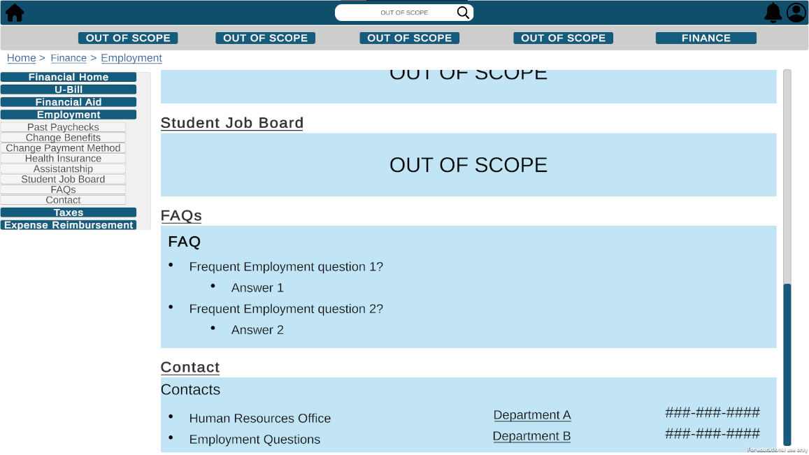
Figure 6: The FAQs and Contact sections from the Employment page

User Evaluation Methodology

Research Objectives and Hypothesis
The research objectives while redesigning the Workday financial sections were to provide users with less hassle, improved navigability, and less time needed to complete their goals.
These objectives were investigated by examining three hypotheses:
H1 – Users will experience lower levels of workload on the prototype design than the current design.
H2 – Users will experience lower levels of lostness on the prototype design than the current design.
H3 – Users will complete their task faster on the prototype design than the current design.

Participants
We ran a total of six participants. The following four tables summarize their demographics.
Table 1: Participants’ Gender Demographics
Gender | Number of Participants
Male | 5
Female | 1

Table 2: Participants’ Major Demographics
Major | Number of Participants
Industrial Engineering | 3
Computer Science | 2
Management Information System | 1

Table 3: Participants' Undergraduate Year
Undergrad Year | Number of Participants
1 | 1
2 | 1
3 | 3
4 | 1

Table 4: Participants’ Experience with Workday (“How often do you use Workday for financial tasks?”)
Experience | Number of Participants
Once per Semester | 4
Weekly | 2

Tasks / Scenarios
During the evaluation, the participants performed four tasks in each of the two designs.
- Pay their U-Bill
- Check their financial aid statement
- Determine the total of their past three paychecks
- Find where to mail U-Bill check and how much to pay

Independent Variables (IV)
The single independent variable controlled in the experiment was the change between the existing Workday and our redesign.

Dependent Variables (DV) / Metrics
To examine our hypotheses (H1, H2, H3), we collected data that could be compared with respect to the Independent Variable (Existing Workday vs. Redesign). The dependent variables are given in Table 5.
Table 5: Dependent variables used in this study
Dependent Variables | Metric | Data Type (unit) | Method | Frequency
Workload | NASA-TLX score | Survey response (0-10, ordinal) | Survey | After each task
Lostness | Lostness score | Lostness score (0-1, ratio) | Behavioral observation | After each task
Task Time | Task completion time | Time (sec, ratio) | Screen recording | During each task
Usability | SUS survey | Survey response (0-100, ordinal) | Survey | After each design
Insight about differences | Open-ended feedback, what was liked or disliked between designs | Qualitative | Open-ended feedback | After experiment
Preference of design | Point distribution between favorite design | Points assigned (0-100, ordinal) | Point distribution | After experiment

Workload
To explore our objective of lowering workload (H1), we surveyed participants through the NASA Task Load Index (TLX) after each task. The NASA–TLX score provides a measurement of users’ subjective mental workload (Hart & Staveland, 1988).
NASA Task Load Index (TLX) Survey
Respond with a rating from 0 to 10.
- How mentally demanding was the task?
- How physically demanding was the task?
- How hurried or rushed was the pace of the task?
- How successful were you in accomplishing what you were asked to do?
- How hard did you have to work to accomplish your level of performance?
- How insecure, discouraged, irritated, stressed, and annoyed were you?

Lostness
The Lostness score quantifies how lost users are while navigating an interface (H2). The metric uses the minimum number of pages required to complete a task, then compares it to the number of pages visited by the participant. This was calculated post-hoc through screen recordings (original Workday) and Unity keystroke logging (redesign).

Task Time
We measured task completion time to examine H3. Similar to the Lostness score, this was calculated post-hoc.

Usability
After completing all four tasks on one design, participants took the System Usability Scale (SUS) survey. The SUS is a widely used questionnaire for the assessment of perceived usability (Lewis, 2018).

System Usability Scale Survey
Please indicate how much you agree or disagree with the statements below related to the design you just experienced:
- I think that I would like to use this system frequently.
- I found the system unnecessarily complex.
- I thought the system was easy to use.
- I think that I would need the support of a technical person to be able to use this system.
- I found the various functions in this system were well integrated.
- I thought there was too much inconsistency in this system.
- I would imagine that most people would learn to use this system very quickly.
- I found the system very cumbersome to use.
- I felt very confident using the system.
- I needed to learn a lot of things before I could get going with this system.

Insights of differences
Following the experiment, participants were asked to provide open-ended feedback to determine what was liked or disliked between the two designs.
Open-ended Questions
- What aspects of the Design A (current Workday) did you like better than Design B (prototype)?
- What aspects of Design B (prototype) did you like better than Design A (current Workday)?
- What aspects of Design A (current Workday) could be improved?
- What aspects of Design B (prototype) could be improved?

Preference of design
Finally, the participants were asked to distribute points between the two designs to provide further insights into their preferences.
Point Distribution Feedback Question
You have 100 points to distribute between the two designs you experienced. Please distribute them as you see fit based on your preference for each design. (A score of 60 means 60 points for Design A and 40 for Design B)

Experiment Design
The experiment systematically compared the existing Workday to our final Workday prototype. We used a within-subjects design – each participant used both interfaces. To mitigate carryover effect, participants were split into two groups. The first group trialed the redesign first, followed by the original Workday. The second group reversed this order – first the original Workday, then the redesign. The group division is shown below (Figure 2).
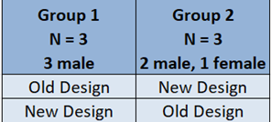
Figure 7: Within-subjects counterbalance makeup

Procedure
Overview of the Experiment 5 minutes
- Introduction
- Consent Form
- Demographics Form

Task Performance 10 minutes
- Overview of Tasks
- Perform all 4 tasks on Design A (Existing Workday)
- Post-design survey
- Perform all 4 tasks on Design B (Redesigned Workday)
- Post-design survey

Debrief 5 minutes
- Comparative Survey
- Q&A
- Thank You

*Participants with odd ID # will perform tasks on Design B first.

Data Analysis Plan
To identify statistical differences between the two designs, we ran t-tests on quantitative metrics. Further qualitative analysis on the open-ended responses allowed us to further explore unknowns that may lead to new important variables to control or measure.
We performed one-tailed paired t-tests on NASA-TLX scores, Lostness scores, task completion times, and SUS scores. To analyze the point distributions, we used a one-sample one-tailed t-test.
Open-ended responses allowed participants to discuss their preferences between the current Workday and the redesign. This data could provide valuable insights into unforeseen issues that we failed to notice, control, or measure.

Limitations and Assumptions
All participants are friends or colleagues of the experimenters. It is possible that results seen are because participants wanted to please the experimenters, although trends in performance on the two systems held true even for a participant who professed to prefer existing Workday.
We limited our focus to the financial aspects of Workday, ignoring the rest of Workday’s features. By redesigning and testing only the financial aspects, we are unable to understand how our redesign could interact with the rest of Workday’s abilities. It is possible that by only implementing a subset of features, a prototype was designed that performs better only on the tasks for which it was designed. However, the design is modular enough to suggest that it would continue to perform well even with more features implemented.
Our experiment was also limited to only undergraduate students and had an uneven (and unplanned) gender distribution (5 males, 1 female). It also lacked other groups of users, such as graduate students, professors, and administrative staff. It is possible that other, more frequent user groups might see differences in performance gains, but since the total number of steps have been reduced in addition to navigability gains, it seems likely that general trends would extend to frequent users.
Further insights may be gained by examining additional features within Workday and recruiting a more representative participant pool to be included in future experiments.

Testing environment
Experiments were carried out on Evelyn’s laptop in a reserved study room at Parks Library. The room remained free of auditory and visual distractions throughout the trials.
The existing Workday interface was accessed through a desktop browser logged into Evely’s Workday account. This provided consistency throughout the trials and respected the participants' privacy.
The Workday redesign was accessed through a published Unity application to simulate a desktop browser.

Team Members Roles
Evelyn and Ryan were responsible for implementing the final Workday redesign into Unity.
At least two group members were present for each trial – at least one interviewer with the other(s) taking notes.
After the experiment concluded, Stephen and Tommy accumulated results and conducted data analysis.

Results

Workload
Workload was calculated for each individual task and averaged across all four tasks to achieve a “Total Average” score for each design. The resulting means and standard deviations can be seen in Table 6.
Table 6: NASA-TLX workload descriptive statistics
 | Current Workday |  | Prototype Design
 | Mean | Std Dev | Mean | Std Dev
Task 1 | 3.86 | 4.43 | 1.08 | 0.20
Task 2 | 1.86 | 1.34 | 1.06 | 0.14
Task 3 | 2.69 | 1.44 | 1.08 | 0.20
Task 4 | 4.69 | 1.96 | 1.36 | 0.88
Total Avg | 3.28 | 1.96 | 1.15 | 0.24

A one tailed paired t-test was performed on each of the five value pairs. These t-tests resulted in p < .05 for task 3 (t(5) = 2.73) and the Total Average rating (t(5) = 2.53), both indicating that the current Workday interface had higher workload levels for these two tests compared to the prototype design. Tasks 1 (p = .08), 2 (p = .10), and 4 (p = .11) did not show significance, but were nearing significance. Figure 3 highlights the box plot for each task group.
*
*
Figure 8: NASA-TLX Box Plots

Lostness
(1) $L=\sqrt{{\left(1-\frac{N}{S}\right)}^{2}{\left(1-\frac{R}{N}\right)}^{2}}$
Lostness (Equation 1) is a function of the number of unique pages visited, N, the total number of pages visited, S, and the minimum number of pages to complete a goal, R. In plain terms, it combines the backtracking and circuitousness of navigation to estimate the navigability of an interface. Lostness scores from user evaluation are show in Table 7.
Table 7: Lostness descriptive statistics
 | Current Workday |  | Prototype Design
 | Mean | Std Dev | Mean | Std Dev
Task 1 | 0.12 | 0.29 | 0 | 0
Task 2 | 0.15 | 0.27 | 0 | 0
Task 3 | 0.20 | 0.24 | 0.06 | 0.14
Task 4 | 0.49 | 0.30 | 0.11 | 0.17
Total Avg | 0.24 | 0.28 | 0.04 | 0.08

One-tailed paired t-tests of the lostness between interfaces for each task only showed significantly lower lostness on the prototype for task 4, with a p-value of .036. Other p-values were .18, .12, and .16 for tasks 1, 2, and 3, respectively. However, a one-tailed paired t-test of the average lostness across all four tasks for each participant between the two interfaces showed significance with p = .029, suggesting that on average participants found the prototype interface more navigable. On average this is an 83% reduction in lostness. Figure 4 illustrates the average lostness between the two designs.

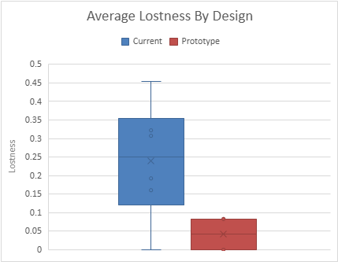
*
Figure 9: Lostness box plot

Task Time
Time spent on each task was recorded to identify whether the new design is faster to use. Results are shown in Table 8.
Table 8: Task time descriptive statistics
 | Current Workday |  | Prototype Design
 | Mean | Std Dev | Mean | Std Dev
Task 1 | 34.3 | 46.0 | 15.2 | 17.4
Task 2 | 20.8 | 6.6 | 12.0 | 5.5
Task 3 | 49.7 | 52.3 | 15.8 | 13.6
Task 4 | 69.8 | 47.8 | 18.0 | 7.7
Total Avg | 43.7 | 38.2 | 15.3 | 11.1

A one-tailed paired t-test for the difference of task time for each task showed significantly faster task time on the prototype for task 2 (p=.033) and task 4 (p=.028). The p-values for task 1 and task 3 were p=.083 and p=.102, respectively. Figure 5 illustrates the total average task completion time for both designs.
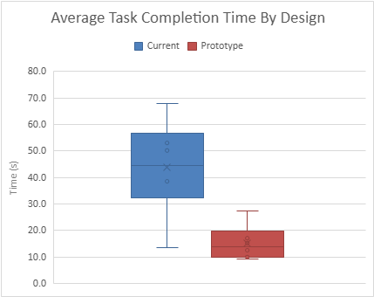
*
Figure 10: Average task completion time box plot

Usability
System usability was calculated for each design after the completion of all four tasks on that design interface. Current Workday responses resulted in a mean of 34.58 and standard deviation of 21.99, while the prototype resulted in a mean of 95.83 and standard deviation of 7.85. The one-tailed paired t-test result was significant with p = .001, t(5) = -5.69. This result indicates that the current Workday interface scores significantly lower on system usability than the prototype interface. Figure 5 displays the box plot for the system usability data.
*
Figure 11: System usability box plots

Insights of Differences
Participants were asked open-ended questions about what they preferred about the current Workday system, what they preferred about the prototype, and what could be improved for each.
Preferred About Current Workday. The broad consensus, from five out of the six participants, was that they preferred the visuals of the current workday. They liked it because it appeared polished and aesthetically pleasing.
Preferred About Prototype. Participants noted that the prototype interface was simpler (mentioned by 3 out of 6 participants), easier to navigate (mentioned by 4 out of 6), and did a better job conveying information to users through effective organization and labelling (mentioned by 3 out of 6).
Could Be Improved in Current Workday. Four participants noted that it was hard to find information in the current Workday because of too many menu options, poor labelling, or confusing organization. Participants wished it were simpler (mentioned by 4 out of 6 participants), had a better menu (mentioned by 3 out of 6), and took less steps to achieve goals (mentioned by 2 out of 6).
Could Be Improved in Prototype. All users who listed anything they thought could be improved, or 5 out of the 6 participants, listed that the aesthetics of the design could be improved. One thought that more features should be added.

Preference of Design
Participants were asked to split 100 preference points between the two designs as they saw fit. Figure 6 shows the ratings by each of the participants for both designs. Only one of the five participants rated the current Workday interface higher than the prototype interface. The smallest difference in points between the designs was 20 points, while the largest difference was 58. A one-sample one-tailed t-test comparing the number of points awarded to the prototype with 50 (an indifferent distribution) yielded a p-value of .028, so there is sufficient evidence to suggest that users assigned more preference points to the prototype than the current Workday system.

Figure 12: Point distribution between designs

Discussion
The results from the user study partially supported hypothesis one of reducing the user’s workload. Workload ratings were significantly lower for task three and the total average of all four tasks, but not significantly different for tasks one, two, or four individually. This only partially supports hypothesis one because not every task experienced a reduction in workload, and it is not understood if task three is the driver of the total average significant difference.
Hypothesis two, that the prototype would lead to lower lostness, was fully supported by the user evaluation results. By reducing the number of steps to achieve goals, categorizing the menu items based on logical groupings, flattening the menu, and using simple and clear labels, users became 83% less lost on average. This suggests that the prototype was much more navigable to the users studied.
Hypothesis three, that tasks would take less time to complete on the prototype than the existing Workday, was fully supported by the user evaluation. On average, the tasks measured took 65% less time to complete on the prototype. This is for similar reasons as the improved navigability; using logical groupings and clear labels leads to faster identification of the correct action to take, and lower likelihood of wasting time searching for a function in the wrong menu.
Given these results and the full or partial support of each hypothesis, the prototype design shows great promise as an upgrade to the current interface’s design. Some limitations should be considered, such as the small sample size of six participants, which would not be sufficient if this were a full product study. Most notably, bias towards Workday, both positive and negative, could have influenced the results. For instance, one participant said that they like Workday and do not have a problem using it and rated the current interface higher than the prototype. However, their quantitative results indicated that they performed better on and found the prototype version more usable, so the results are likely still valid. Other participants made hints that anything would be better than the current Workday, which could have influenced their results, but again the more objective measures of performance back up their claims. Bias towards the prototype design could have also influenced the results, as the participants each knew at least one member of the research team. This could have influenced a more positive rating of the prototype design than if they were random participants. Regardless of these potential biases, the quantitative results are of great promise, especially since the current Workday design had the advantage of familiarity from previous experiences and still did not perform as well as the prototype.

Recommendations and Conclusions
A major finding of this report is that there is more behind frustration over the adoption of Workday than “Workday sucks.” A large part of the issue is that many users who use the system infrequently are being exposed to a system that was never intended for this sort of use. Their ability to learn the system is inhibited by inconsistent menu and page design that provides more information than they need and doesn’t match their expectations. Page organization is not consistent and does not match the menu, which is exacerbated by unclear labels and financial jargon.
Luckily, the results of the design and testing of this prototype indicate that many of these issues can be solved. Creating a shallower menu based on logical groupings that provides the most important information to users first leads to better ease of use for novice users. Further, consistent page design and simple, descriptive labels make it easier for users to extend their knowledge from the world and from past experience with the site to new pages in the site. Results show that many of the issues Workday faces can be solved by following these principles, leading to better navigability and usability, and lower frustration and time required to perform tasks.
Future work could implement the changes described for the Iowa State system and extend the principles of this prototype to the full suite of Workday functions. This study focused mainly on the most common tasks undergraduate users might perform, but the modularity of the design implies that it may benefit frequent users, such as administrators, as well. More testing is needed to confirm this promising indication.

Author Contribution Statement
TL was the lead author for sections 1, 7, 5.2, 5.3, and 5.5. EK was the lead author for section 3. RM was the lead author for section 4. SF was the lead author for sections 2, 5.1, 5.4, 5.6 and the appendix. TL and SF split as lead author for section 6. All authors contributed to the review, revision, and approval of the final version of this document.

References
Hart, S. G., & Staveland, L. E. (1988). Development of NASA-TLX (Task Load Index): Results of empirical and theoretical research. Advances in Psychology, 52, 139–183. https://doi.org/10.1016/S0166-4115(08)62386-9
Lewis, J. R. (2018). The System Usability Scale: Past, present, and future. International Journal of Human–Computer Interaction, 34(7), 577–590. https://doi.org/10.1080/10447318.2018.1455307
Miller, R. (2003). “6.893 UI Design and Implementation”. MIT EECS
Nielsen, J., & Molich, R. (1990). Heuristic evaluation of user interfaces. Proceedings of the ACM Conference on Human Factors in Computing Systems, pp. 249‐256.

Appendix A: Experimental Materials

Consent form
Title of Study
Workday Reimagined

Investigators
Stephen Fieffer, Evelyn Khew, Thomas Lenz, Ryan McCurnin

Introduction
Recently, Iowa State University transitioned to Workday. Thousands of students and faculty have been transformed into new users. In this fresh environment, some thrive while others continue to struggle. Frequent and sporadic users alike are expected to navigate this campus-wide required software. The blend of enthusiasm and outrage risks quieting important questions: Is the Workday UI optimal? What changes should be considered? In the search for answers, we turn to the users. This study is for a class project for IE 5720 and conducted completly by students of the class.

Description Of Procedures
The investigators will host a structured procedure with the participants. We will record the screen while they perform their tasks in order to retain a concrete record of the sequence in which they perform them. All tasks will be performed in an experimenter's Workday account, so all participants will have access to all of the tasks and not disclose their own personal Workday information.
First, participants will be requested to complete a pre-survey about demographics and Workday experience. Participants will be prompted to then complete the task twice, once on each design.
The sequence of functions is as follows: pay U-Bill, check for financial aid, find out how much the last three paychecks amounted to, submit reimbursement request, and find the U-Bill mailing address. In between the tasks the participant will complete a brief survey about their experience.
To end the procedure, we will prompt the participants for any further questions. After the procedure is completed, the participants’ data will be uploaded to a CyBox folder that only team members have access to and destroy any other copies of the recording immediately. After completion of this project, the recordings in the CyBox folder will be permanently deleted. No videos of participants’ face will be recorded; video recordings will only include the screen and the participants’ voice.

Risks
There are no foreseeable risks associated with the activities of the study. Participation in this study will not affect the educational or employment status of any students or employees of the researchers if they are.

Benefits
While there are no direct benefits to you, the information gained through this study will benefit the investigative team on designing a better UI for Workday.

Costs and Compensation
There are no costs or compensation for your participation in this study.

Participant Rights
Your participation in this study is completely voluntary. You may refuse to participate or withdraw with no costs or penalty at any point during the study.

Confidentiality
Records identifying participants will be kept confidential to the extent permitted by applicable laws and regulations and will not be made publicly available. This study is not approved by the ISU Institutional Review Board (IRB). However, auditing departments at Iowa State University and the IRB may inspect or copy your records for quality assurance and data analysis. These records may contain private information. You will be assigned a participant ID, and all data reported from you (surveys, testing results, behaviours from recordings) will be reported with that ID (e.g., P0000). A key linking the participant ID and your contact information (email, cellphone number and name) will be kept in a CyBox folder only accessed by the investigators, for rescheduling purposes.

De-identified data collected about you, which includes quotes from the recorded audio and behavioural data from navigating the game during the study, may be shared with other researchers or used for future experiments and research studies. Before recording starts, you will be reminded to take caution in mentioning any direct or indirect identifiers (such as your age, gender, etc.) during the recording.

The results from this study will not be published publicly and will only be presented to the IE5720 class.

Questions and Problems
You are encouraged to ask questions anytime during or after the study. The investigators can be reached at the following emails:
Stephen Fieffer : sfieffer@iastate.edu
Evelyn Khew : evelyn@iastate.edu
Thomas Lenz : tlenz@iastate.edu
Ryan McCurnin : rpm3o@iastate.edu
Supervising Faculty
Michael Dorneich : dorneich@iastate.edu

Participant Agreement
By entering your full name below, you are indicating that:

- You voluntarily agree to participate in this study,
- You are at least 18 years of age,
- You are fluent in English, and
- You are comfortable using a computer for completing online surveys.

Participant Script – Pre-Design Interview
Interview Script for Student Participants
Note to researcher:
- If you have any follow-up questions at any point, feel free to ask them! Just remember to get back on track with the structured portion of the interview.
- Have a secondary recording option (such as a paper and pen) ready in case there is a failure with the recording itself. Important things to record include participants’ answers and the steps they take while working within the app.

BEFORE PARTICIPANT ARRIVES
Preparation checklist:
- Printed out copy of consent form
- Pen
- If recording on local computer, open OBS
- If through Zoom, open Zoom
- Secondary recording material

ONCE PARTICIPANT ARRIVES
READ:
Hello [Name], thank you for agreeing to allow us to interview you regarding Workday’s financial features. Our names are [PRIMARY INTERVIEWER INTRODUCE FROM LEFT TO RIGHT]. As mentioned in the email, this project is for our IE572 Class. Since we will be recording identifying and sensitive data such as your voice and your device screen, we need your assistance in reviewing and signing this consent form before we begin.
ACTION:
Provide physical copy of consent form and pen.
Note: if participant refuses to sign, release participant and end interview. Thank them for their attendance.

[After Consent form signed]
READ:
Thank you for signing the consent form, we will now start recording and move ahead with the interview.

ACTION:
If on desktop locally, start recording using OBS. If on Zoom, use Zoom’s recording feature.

READ:
First, we have some questions for you as a Workday user.
[Questions SBW1-SBW8 for Students]
- What platform do you typically use Workday on to perform financial tasks? (Webpage/Mobile App)
- Do you have to pay for student housing through Workday?
- How often do you use workday for financial tasks?
- What financial tasks do you use workday for?
- What financial information do you look for on Workday and how easy is it to find?
- How easy is it to understand the financial information?
- How long does it take you to complete the financial task [replace with the tasks they described] typically?
- What do you think could be improved with the current bill paying process?
[Questions ABW1-ABW8 for Advisors]
- Is Workday’s view on the admin side different from students’? How?
- Do parents of students get to see students’ financial information on Workday?
- How often do you help students with Workday information?
- What Workday financial tasks are unique to graduate students?
- What’s the weirdest Workday interaction you’ve encountered?
- How much can you change in Workday?
- How much do you have to forward to someone else in terms of Workday financials and how much is just guiding students on how to complete tasks?
- How are scholarship awards handled?
ACTION:
Record participant’s answers on secondary recording material. If have follow-up questions, ask and record them as well.

[Start of Walkthrough process]
READ:
Thank you very much for your insight. We will now move on to the next step in this process. Now, we would like to observe your navigation process through a few tasks on Workday. Note that some of these tasks may not be available to you. If they are not available, just let us know and we can proceed to the next task.

The first task is to check how much financial aid you’ve received this semester. [pause for participant to navigate.]
Thank you, please return to the homepage. [pause for participant to navigate.]

The next task is to pay your bill. We understand that it is the middle of the semester and you most likely will have your bill settled by now. If that is the case, then just navigating up to the “pay your bill” button will suffice. [pause for participant to navigate.]
Thank you, please return to the homepage. [pause for participant to navigate.]

The next task is to check your balance statement. [pause for participant to navigate.]
Thank you, please return to the homepage. [pause for participant to navigate.]

The last task is to check your income statement. [pause for participant to navigate.]
Thank you, please return to the homepage. [pause for participant to navigate.]

ACTION:
Allow time for user to navigate through the tasks. Record steps taken on secondary recording material.

[Card Sorting Process]
READ:
Thank you for completing the tasks. Now, we have some strips of paper for you with words on them. On your own, please sort them in categories that makes sense to you.

ACTION:
Present participant with card sorting pieces. Allow time for them to sort.

READ:
Okay, thank you. I see that you have X, X, and X in one group, X, X and X in another group, etc. Could you let us know what your categories are and why you chose to sort them in this manner?

ACTION:
Record categories and reasoning.

[Last section of questions]
READ:
Now, we will move on to our last set of questions.
[Questions AW1-AW9 for all participants]
- How easy was it to find the information you were looking for?
- What do you think could be improved with the current bill paying process?
- Was there anything that you couldn’t do that you wanted to do?
- What was most frustrating about the Workday experience you just had?
- How satisfied are you with the current bill paying process? (1-7)
- How easy is the current process to use? (1-7)
- Please rank the following from least important to most important: Aesthetics, functionality, ease of use, presentation of information.
- Do you have any final comments?

[Wrap Up]
READ:
Once again, thank you for participating in our interview, and for your insightful data. If we do need to meet again for another round of interviews later in the semester, would that be a possibility?

ACTION:
Note down response.

In-Class Evaluation Materials

Paper Prototype Pages
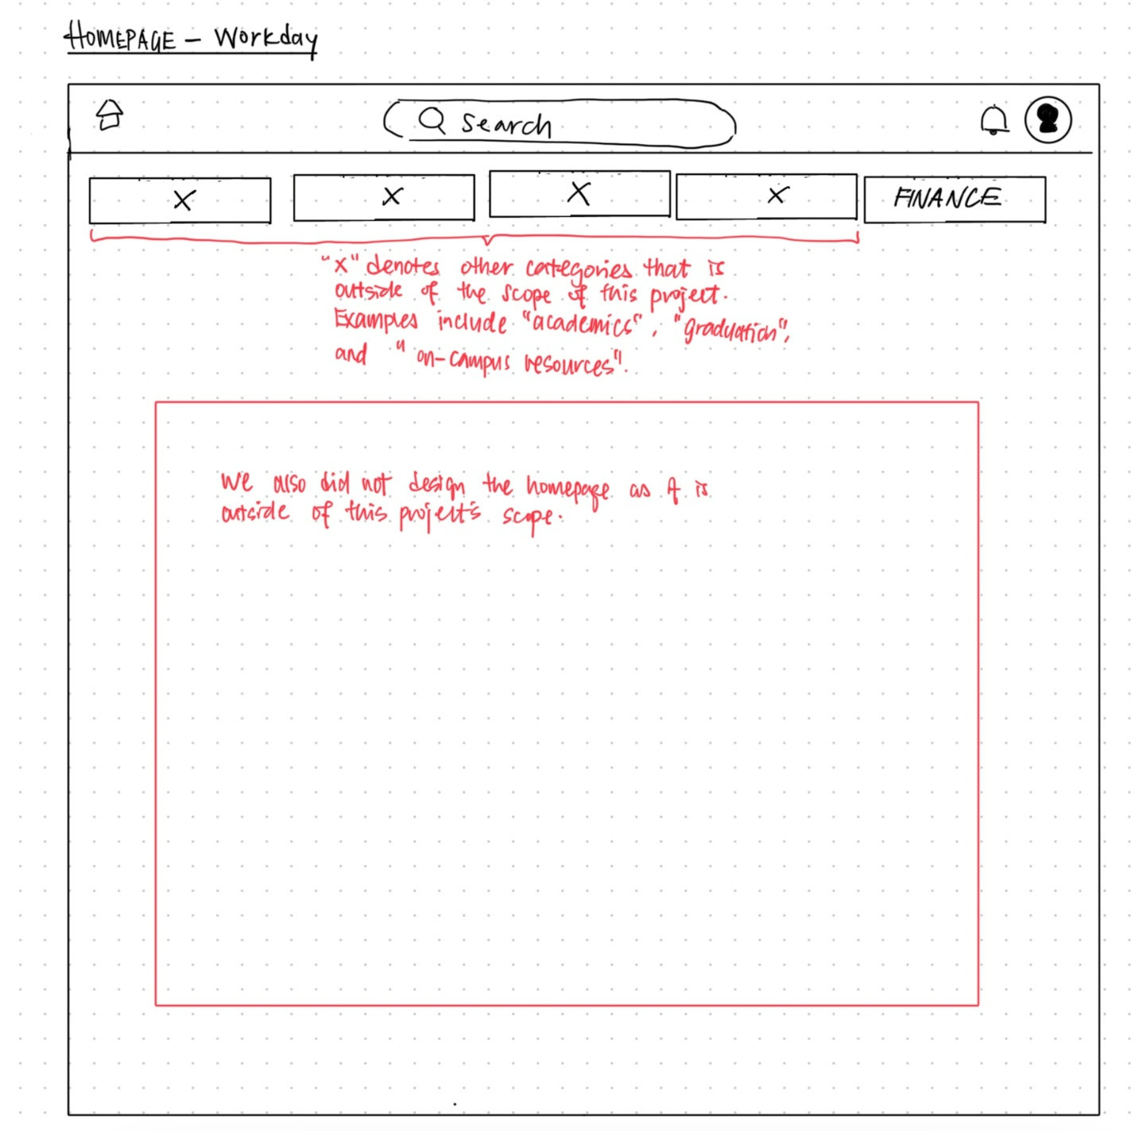
Workday homepage
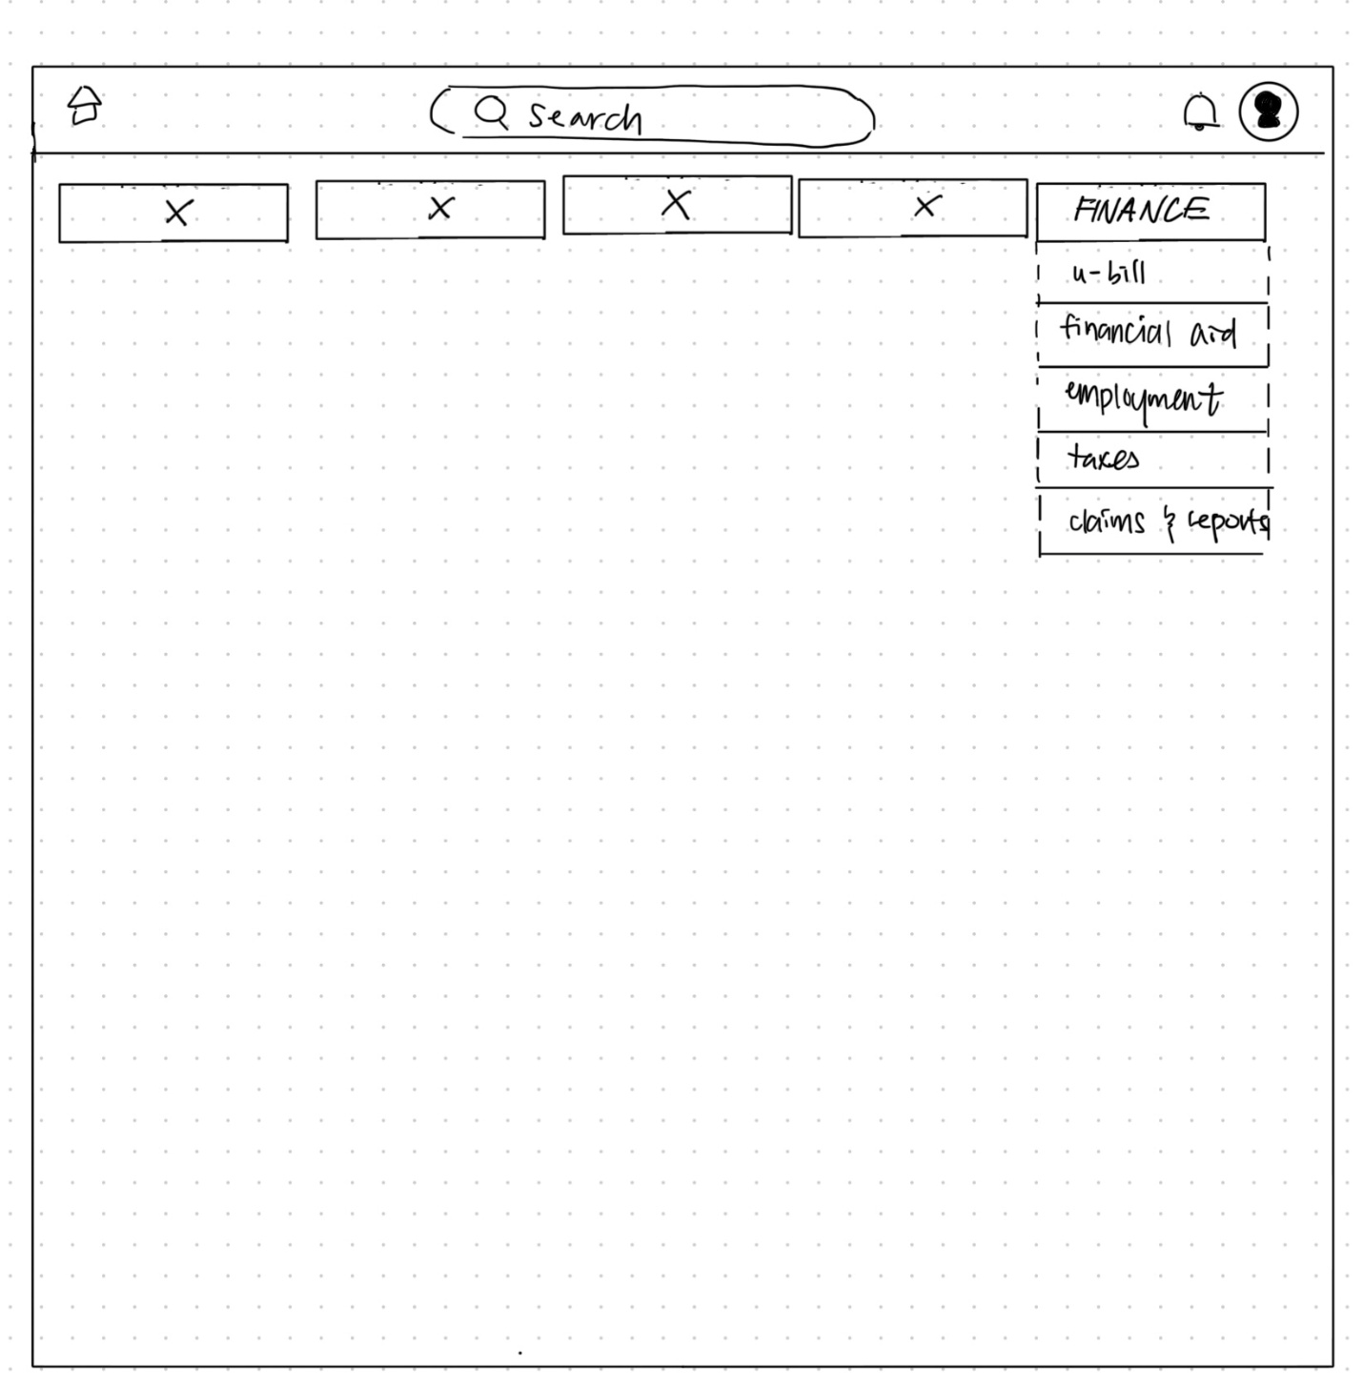
Finance tab dropdown display
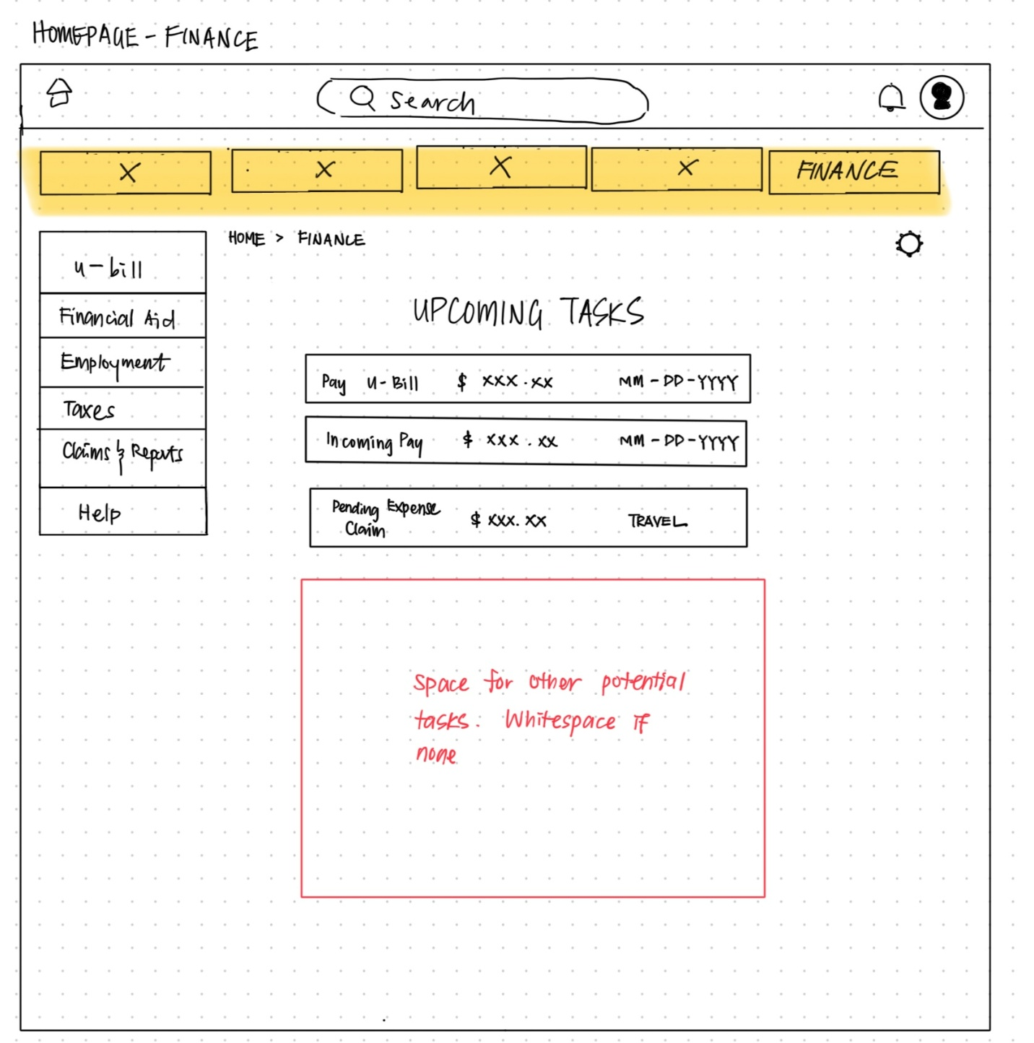
Financial homepage
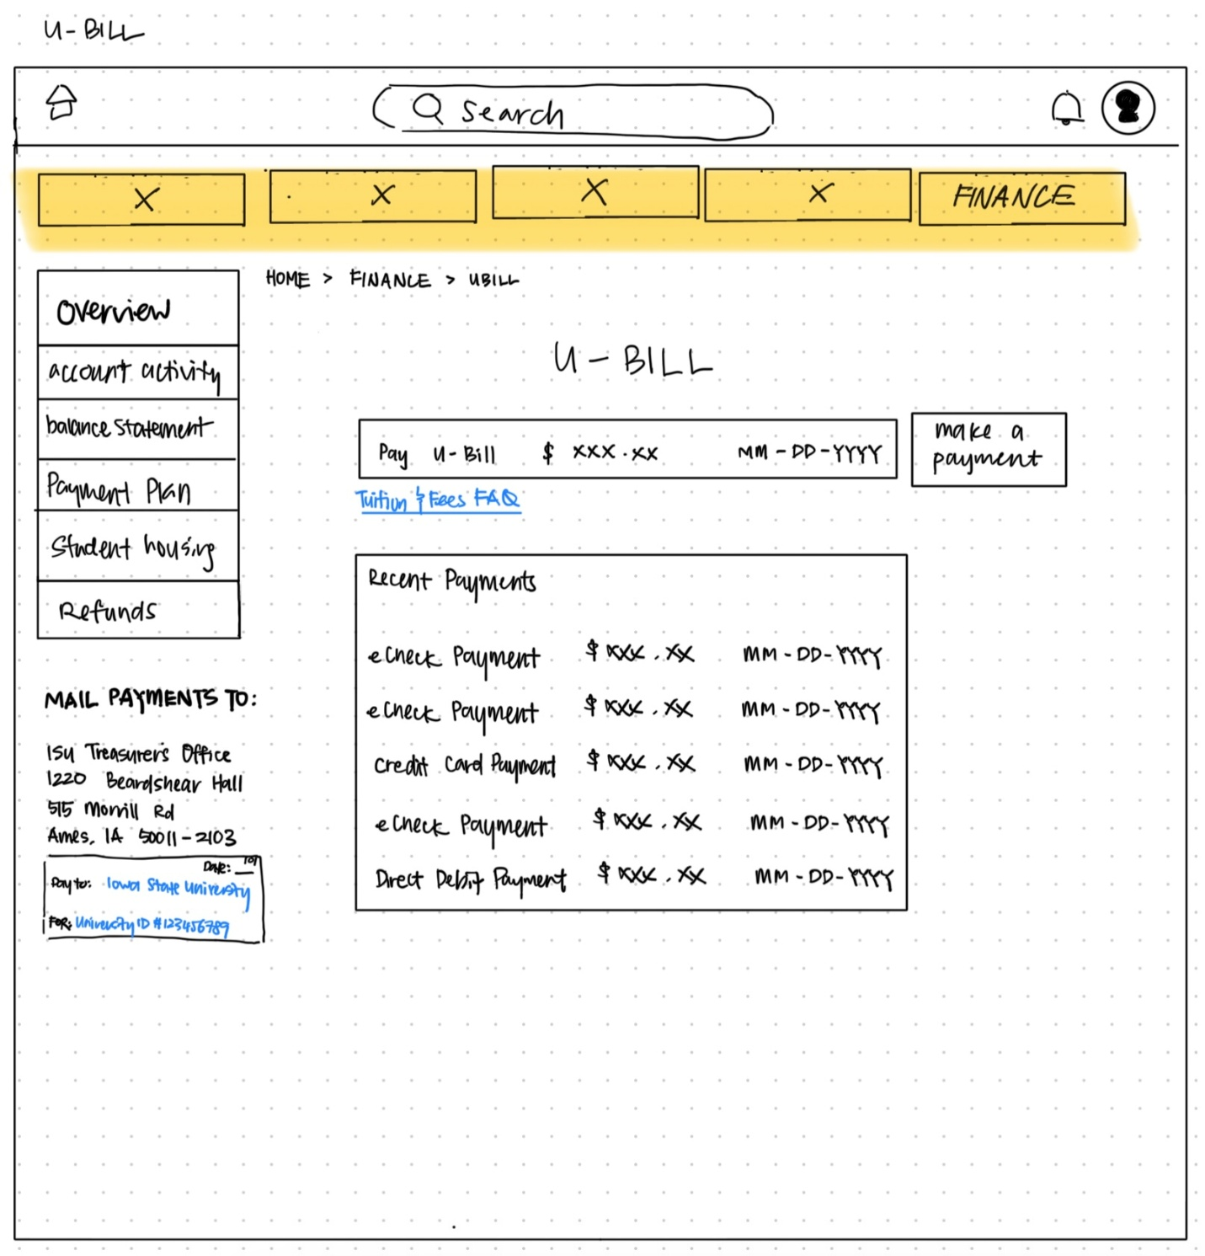
U-Bill homepage
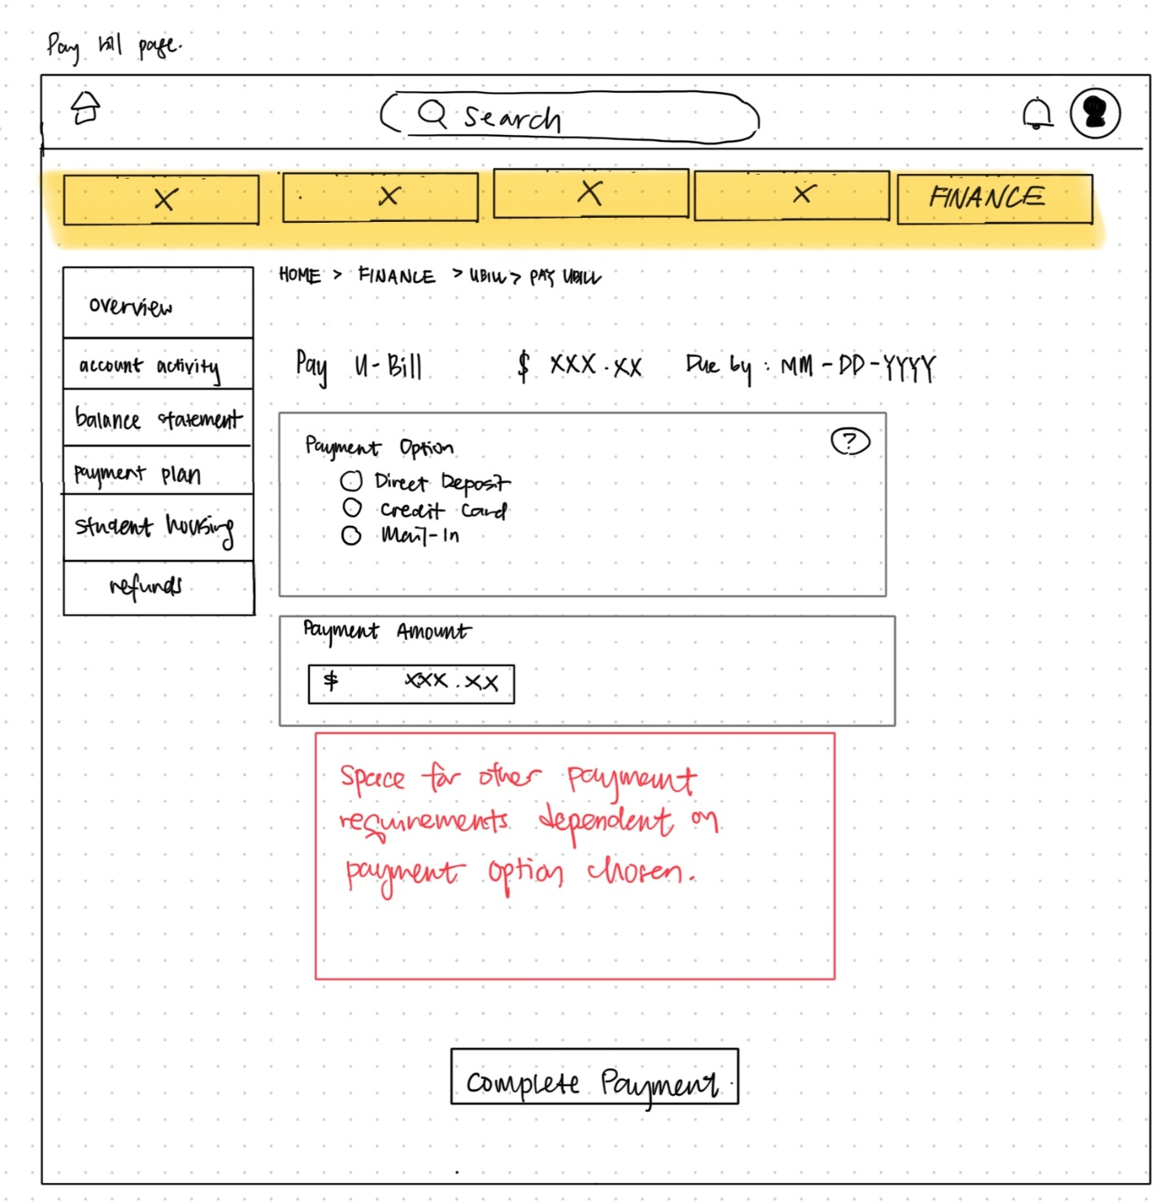
Pay U-Bill page
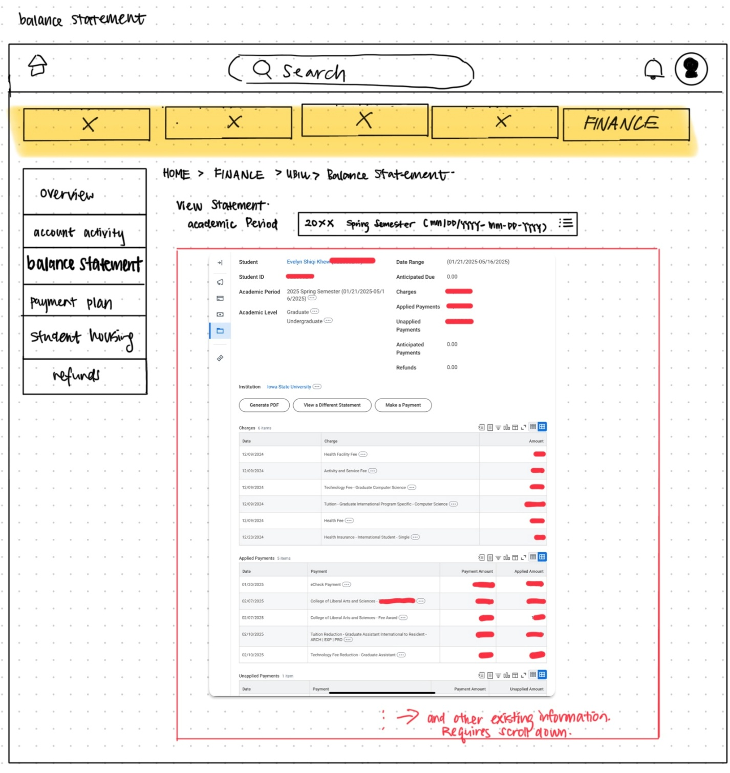
U-Bill balance statement page
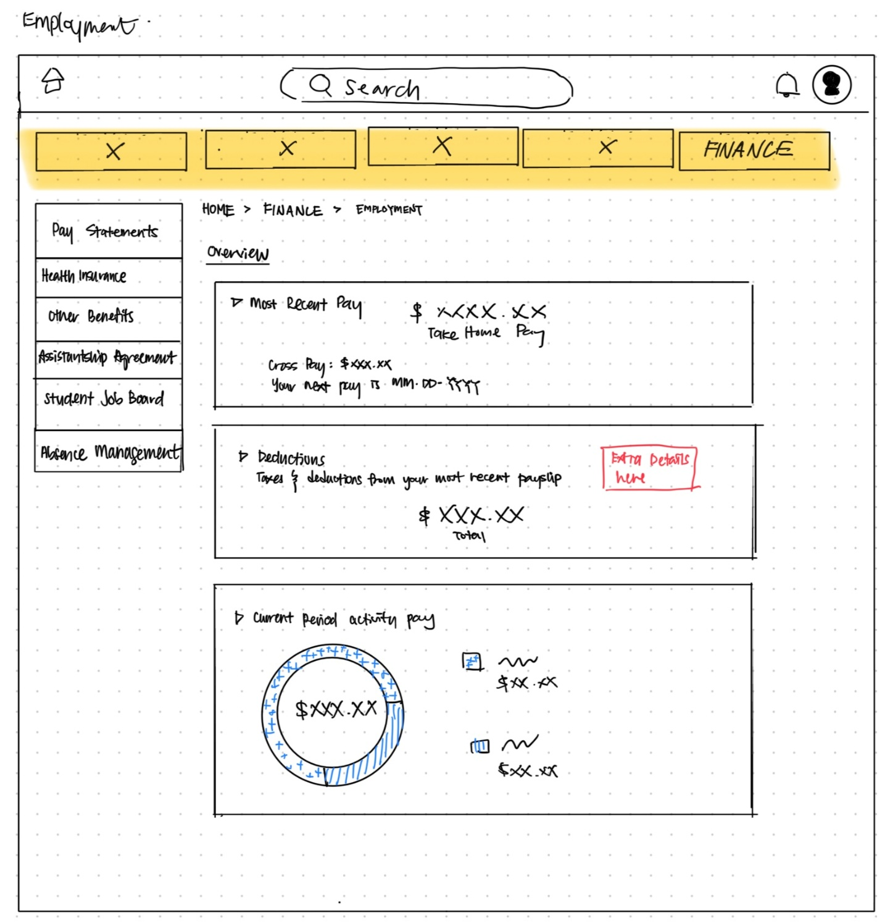
Employment homepage
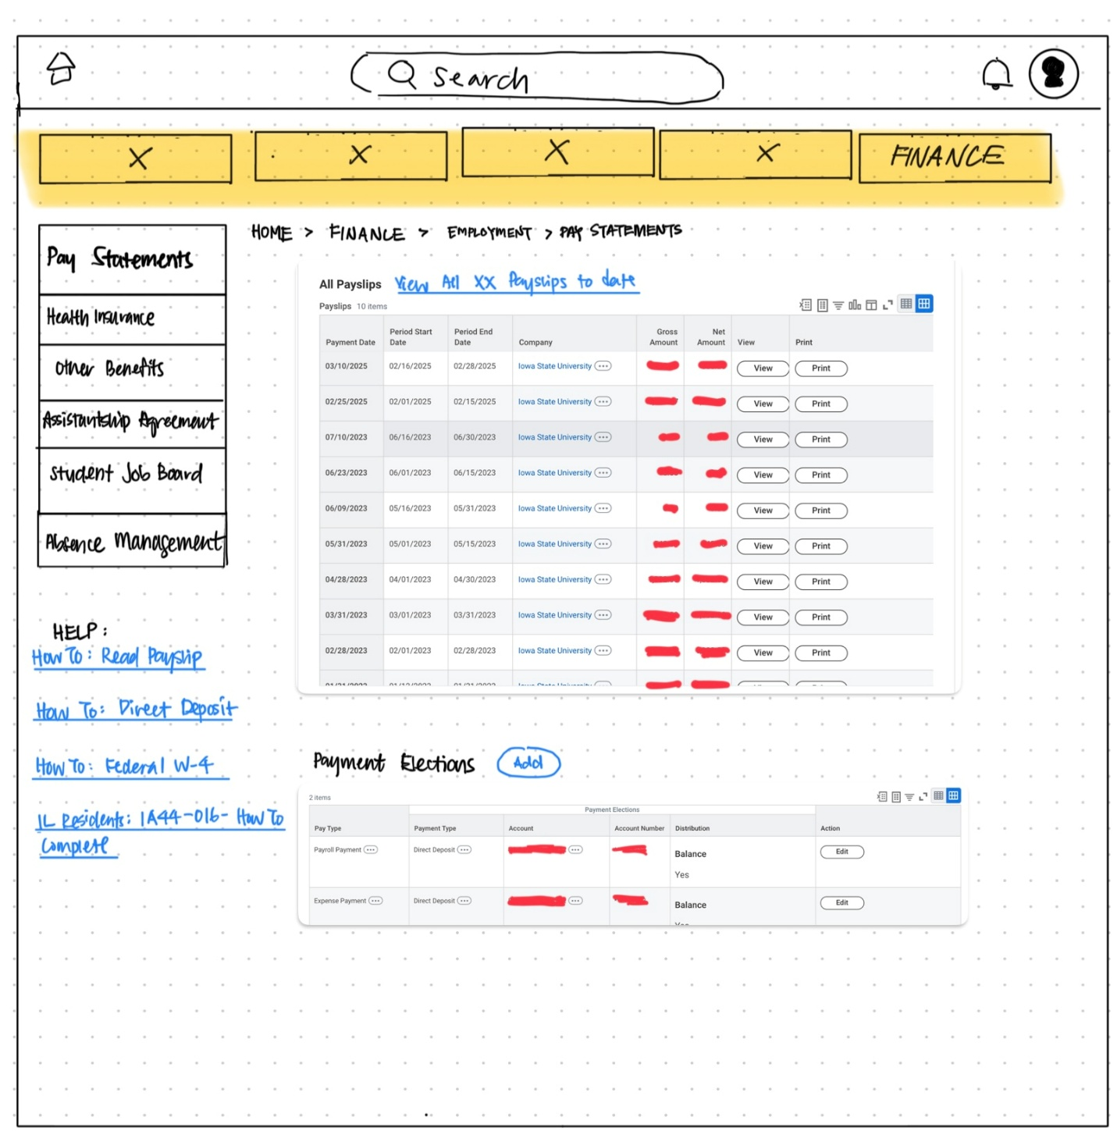
Employment pay statements page
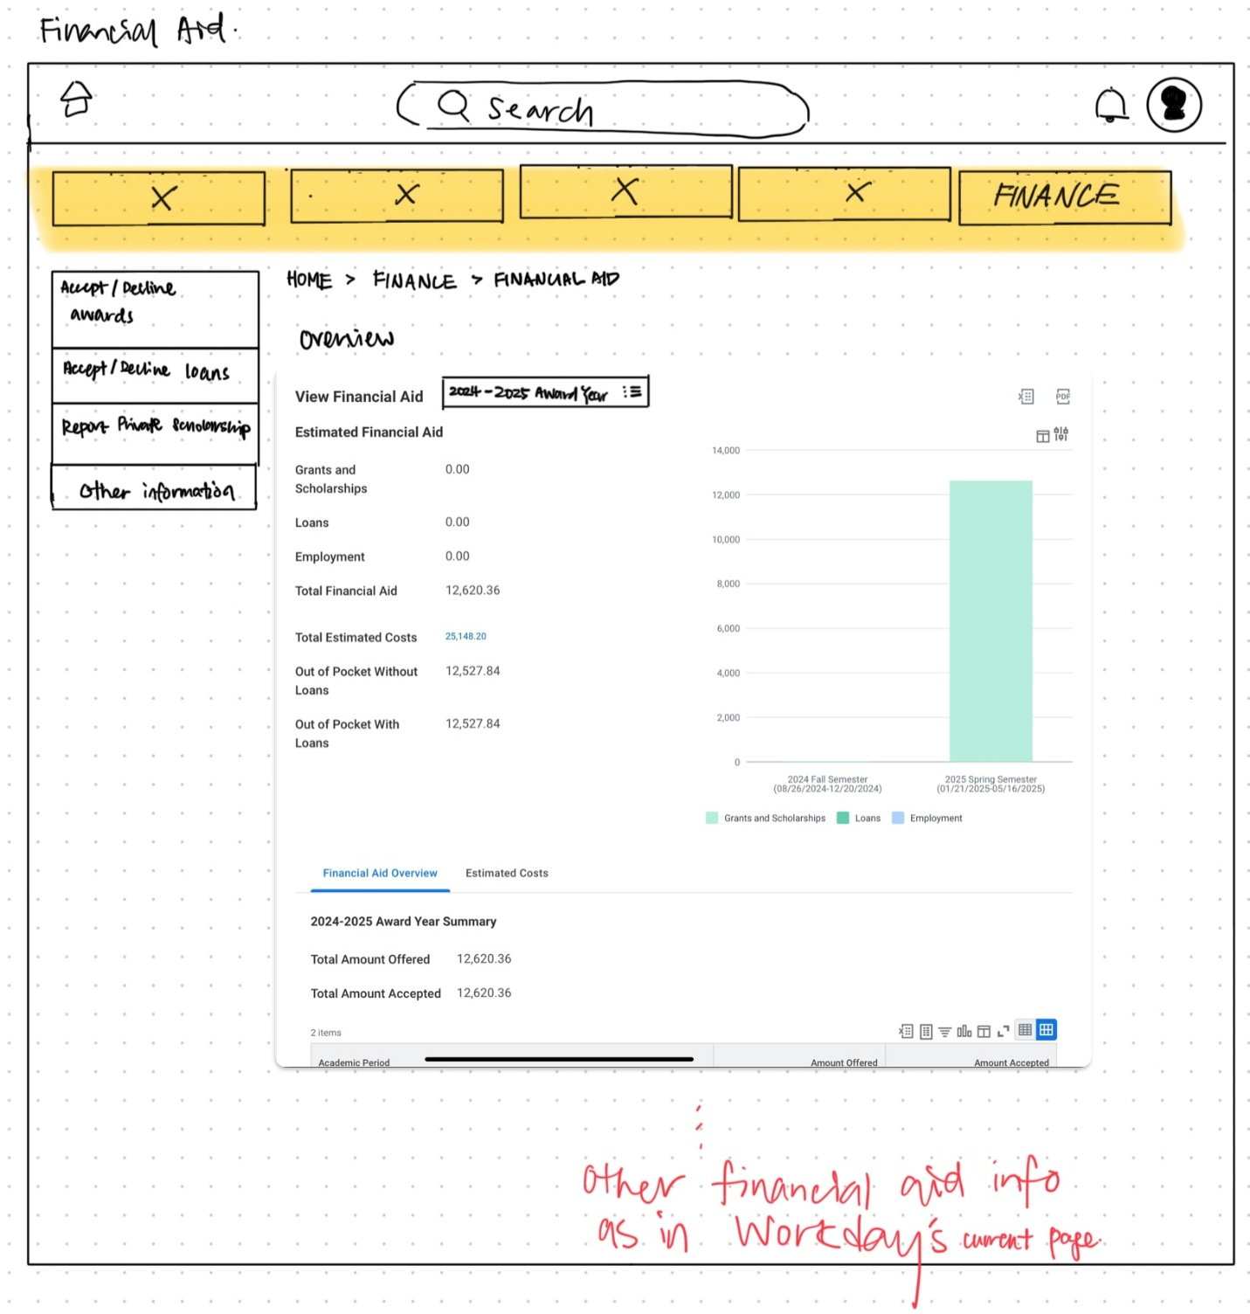
Financial aid homepage

Cognitive Walkthrough Sheet
Below is the evaluation sheet presented to the group that performed the cognitive walkthrough. The sheet was adapted from Michael Dorneich’s IE 5720 class activity.

Cognitive Walkthrough
Task Name: Check Financial Aid
Step # | Q1. Is the effect of the action the same as the user’s goal at that point? | Q2. Will users see that the action is available? | Q3. Once users have found the correct action, will they know it is the one they need? | Q4. After the action is taken, will users understand the feedback they get?
Step # | (does the interface support what the user is trying to do?) | (is the needed control visible?) | (once the user sees the button, will they recognize its effect?) | (will feedback tell users they made right or wrong choice?)
 | Yes/ No (why?) | Yes/ No (why?) | Yes/ No (why?) | Yes/ No (why?)
1
2
3
4
5
Task Name: Pay U-Bill
Step # | Q1. Is the effect of the action the same as the user’s goal at that point? | Q2. Will users see that the action is available? | Q3. Once users have found the correct action, will they know it is the one they need? | Q4. After the action is taken, will users understand the feedback they get?
Step # | (does the interface support what the user is trying to do?) | (is the needed control visible?) | (once the user sees the button, will they recognize its effect?) | (will feedback tell users they made right or wrong choice?)
 | Yes/ No (why?) | Yes/ No (why?) | Yes/ No (why?) | Yes/ No (why?)
1
2
3
4
5

Task Name: Check Balance Statement
Step # | Q1. Is the effect of the action the same as the user’s goal at that point? | Q2. Will users see that the action is available? | Q3. Once users have found the correct action, will they know it is the one they need? | Q4. After the action is taken, will users understand the feedback they get?
Step # | (does the interface support what the user is trying to do?) | (is the needed control visible?) | (once the user sees the button, will they recognize its effect?) | (will feedback tell users they made right or wrong choice?)
 | Yes/ No (why?) | Yes/ No (why?) | Yes/ No (why?) | Yes/ No (why?)
1
2
3
4
5

Task Name: Check Income Statement
Step # | Q1. Is the effect of the action the same as the user’s goal at that point? | Q2. Will users see that the action is available? | Q3. Once users have found the correct action, will they know it is the one they need? | Q4. After the action is taken, will users understand the feedback they get?
Step # | (does the interface support what the user is trying to do?) | (is the needed control visible?) | (once the user sees the button, will they recognize its effect?) | (will feedback tell users they made right or wrong choice?)
 | Yes/ No (why?) | Yes/ No (why?) | Yes/ No (why?) | Yes/ No (why?)
1
2
3
4
5

Provided task descriptions and actions
Task 1: Check Financial Aid
Option 1: Home > Hover Finance > Click Financial Aid
Option 2: Home > Click Finance > Click Financial Aid

Task 2: Pay U-Bill
Option 1: Home > Hover Finance > Click U-Bill > Click Make Payment
Option 2: Home > Click Finance > Click U-Bill > Click Make Payment

Task 3: Check Balance Statement
Option 1: Home > Hover Finance > Click U-Bill > Click Balance Statement
Option 2: Home > Click Finance > Click U-Bill > Click Balance Statement

Task 4: Check Income Statement
Option 1: Home > Hover Finance > Click Employment > Click Pay Statements
Option 2: Home > Click Finance > Click Employment > Click Pay Statements

Profile of Users
Jonathon Webber, 21, 2nd year International Graduate Student


Jonathon Webber is a 21-year-old second-year international graduate student studying statistics. He is paid on a biweekly basis without the need to clock in. He typically logs into Workday once a semester to check on his financial aid and U-Bill, plus once a year for tax purposes. Before ISU transitioned to Workday, he used AccessPlus and clearly preferred it.
Functionality Preferences (most important to least):
1 and 2) Ease of Use and Functionality (tied)
3) Presentation of Information
4) Aesthetics

He faces a few pain points and constraints while using Workday. For instance, he struggles to locate his W-2 tax forms, which can be frustrating. He has expressed dissatisfaction with Workday's user interface, finding it aesthetically pleasing but more challenging to navigate. Furthermore, he finds the Financial Hub confusing due to unclear category names.

"W-2 stuff is very hard to find."
"I love AccessPlus because it’s not pretty, but it gets the job done.”
“Workday is prettier, but in the prettiness, you lose simpleness."
"I don’t like Financial Hub. What does Financial Hub even mean?"

Grace Gibson, 19, Freshman Psychology Undergraduate Student


Grace Gibson is a 19-year-old freshman undergraduate student majoring in psychology. She uses Workday almost daily to clock in for her job, where she assists psychology PhD students in running research with participants. Beyond her work, she checks her financial aid and U-Bill once or twice a semester. Grace has never used EAS software prior to Workday, so she has no comparisons to draw upon.
Functionality Preferences (most important to least):
1 and 2) Presentation of Information and Functionality (tied)
3) Ease of Use
4) Aesthetics

Grace faces several challenges that hinder her experience. She often struggles to navigate the user interface, feeling overwhelmed by the sheer number of options available. The financial jargon used on the platform confuses her, making it difficult to understand the information. Additionally, she finds Workday to be somewhat vague and cluttered, which can make important functions hard to notice.

"I get UI blinded in Workday."
"It could be a little more clear."
“There is some financial jargon I don’t understand, and that may add to my confusion."
"It's a little vague sometimes."

Heuristic Evaluation Sheet
Below is the evaluation sheet presented to the group that performed the heuristic evaluation. The sheet was adapted from Michael Dorneich’s IE 5720 class activity.

Heuristic Evaluation
Team Number: ____ Name(s): _______________________________________________________________________
Date: _________________
Evaluating Design Against Heuristics
Thank you for evaluating our design. For each heuristic below, please evaluate the entire interface and identify any issues you might encounter. For each issue found, please include:
- Issue location
- Brief description of issue
The domain for this interface is university administrative tasks. Specifically, we are focusing on the part of Workday related to financial information and actions. Typical users are students, who are likely occasional users. No specific domain knowledge is needed beyond your current knowledge.
We appreciate your diligence!
Evaluation Heuristics:
Number | Heuristic Name | Evaluation
1 | Make things visible
2 | Speak the user’s language
3 | Minimize user memory load
4 | Provide clearly marked exits
5 | Consistency (with past user experience and within the interface)
6 | Discoverability

Raw data from evaluation

Session 1 (Cognitive Walkthrough)
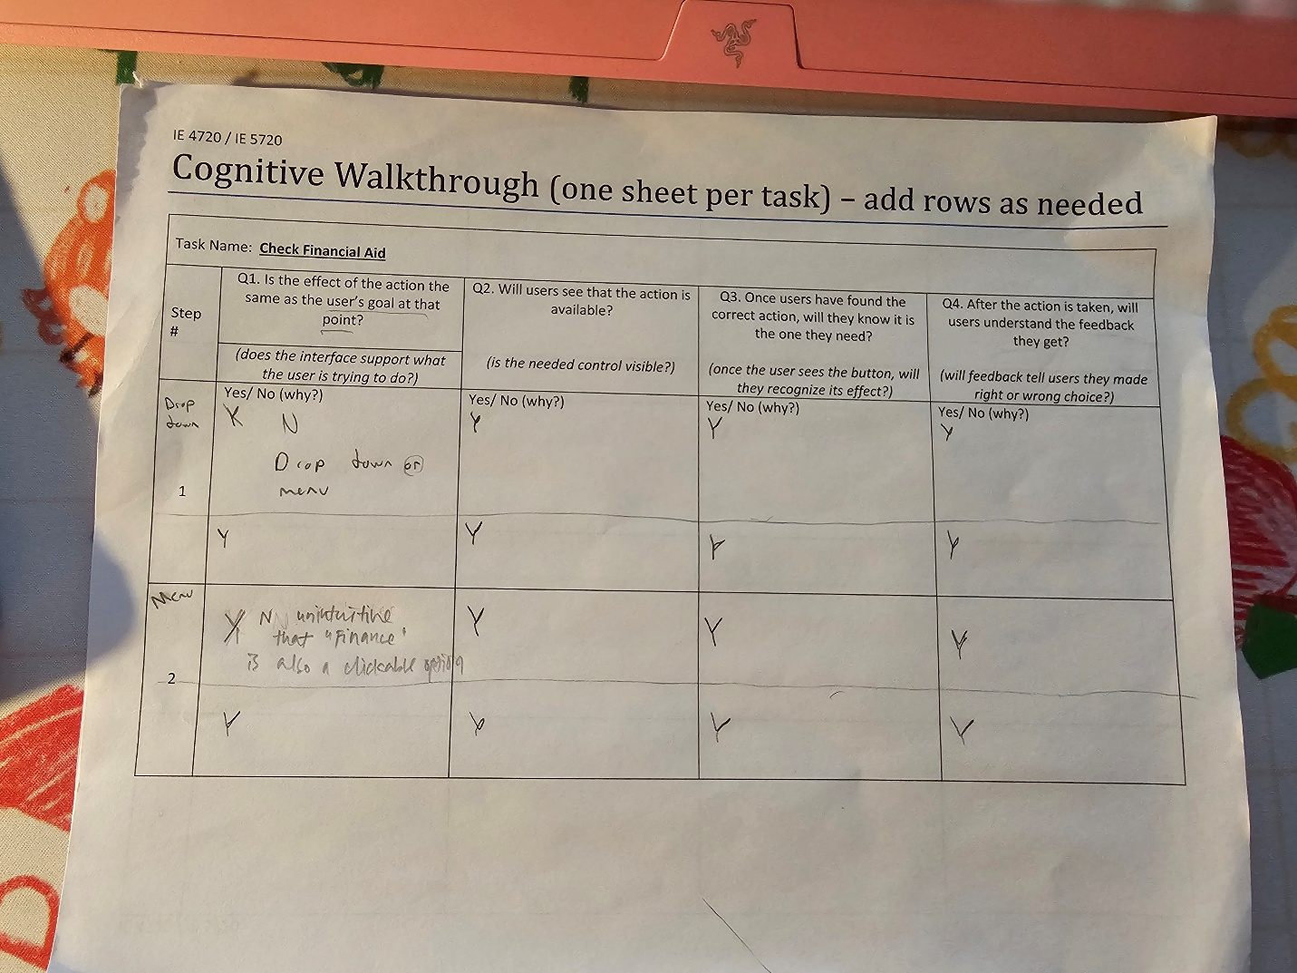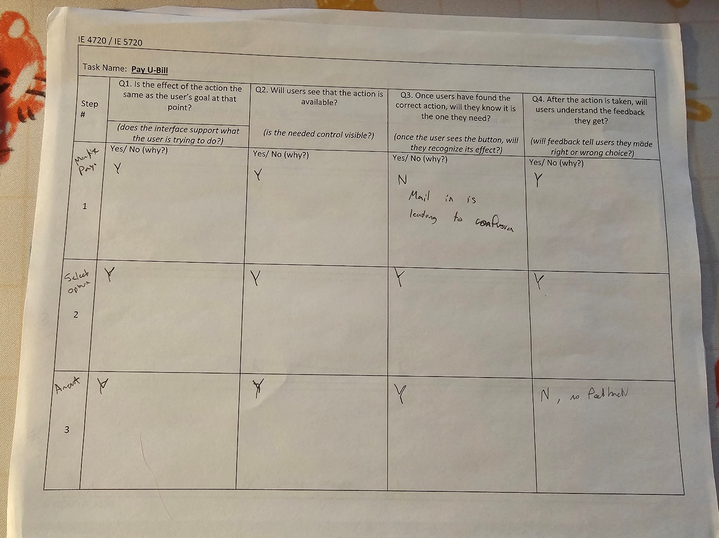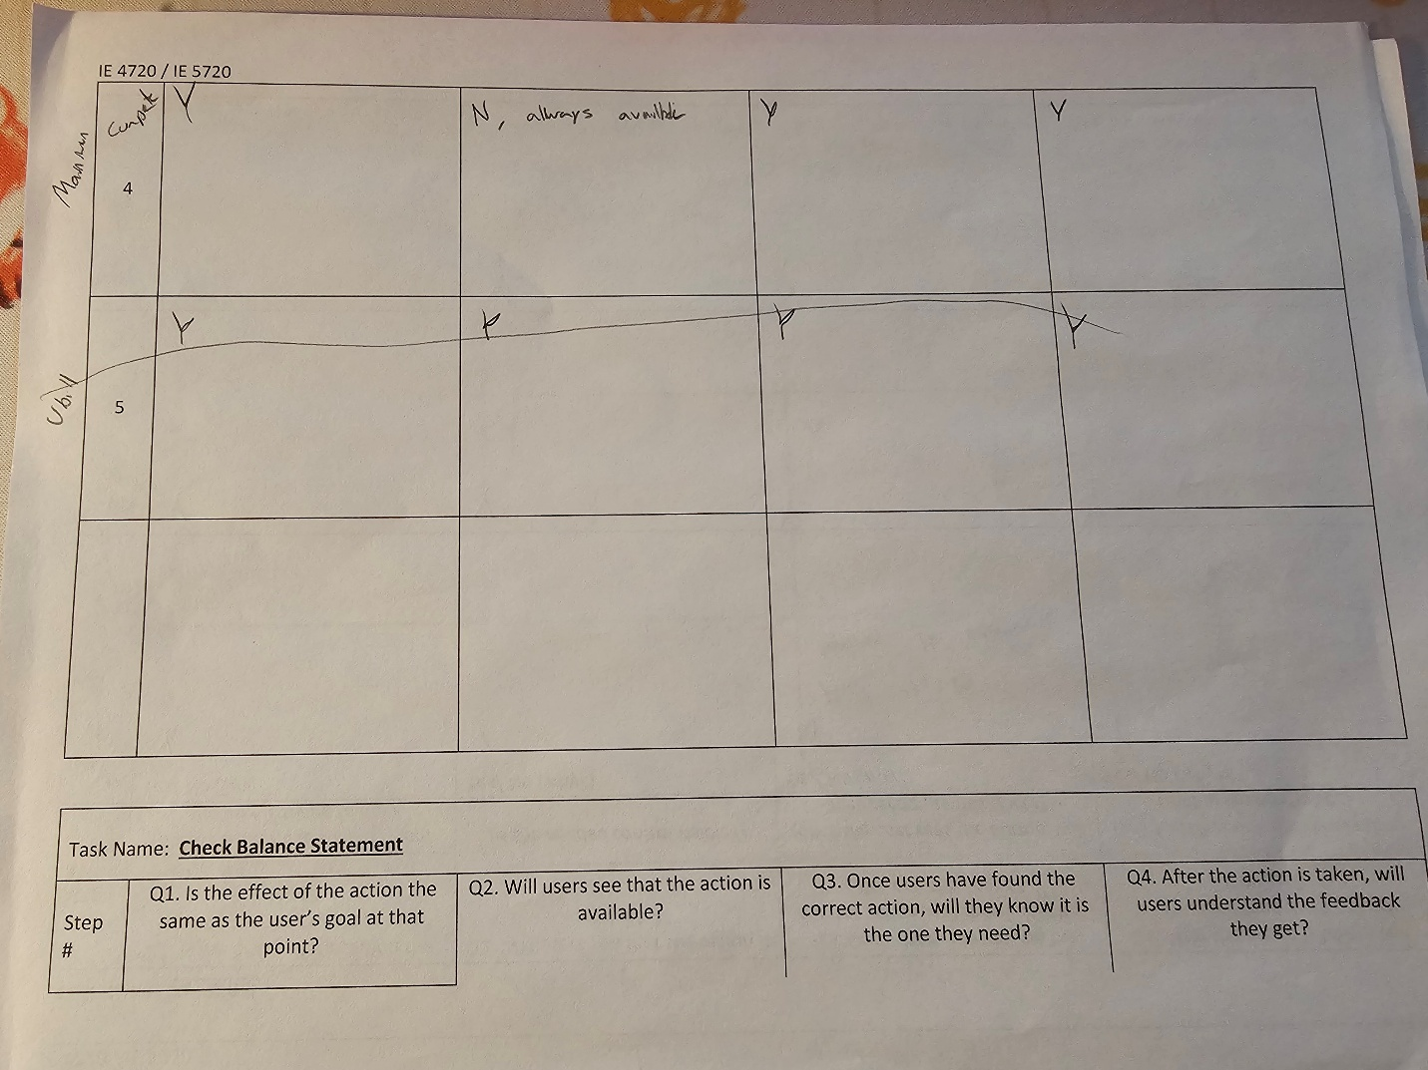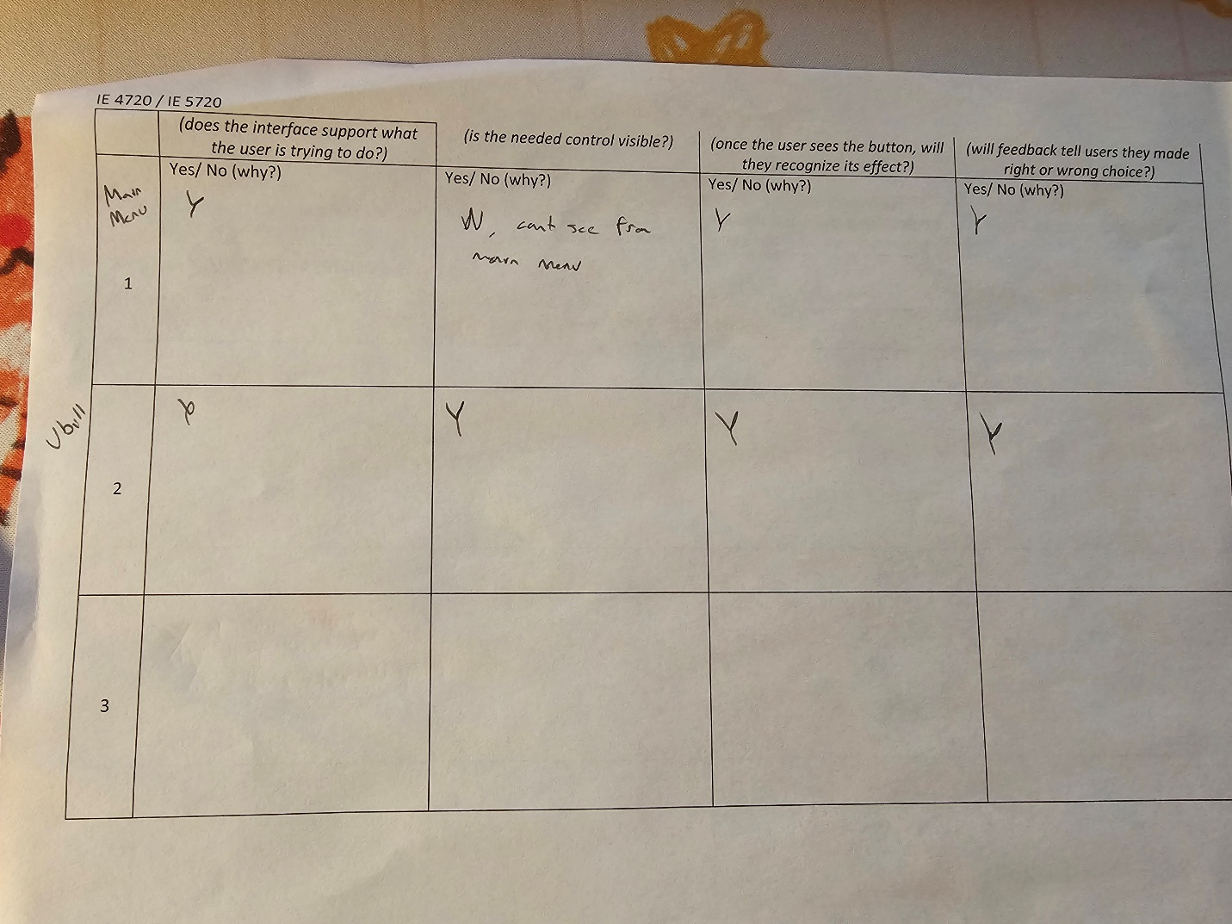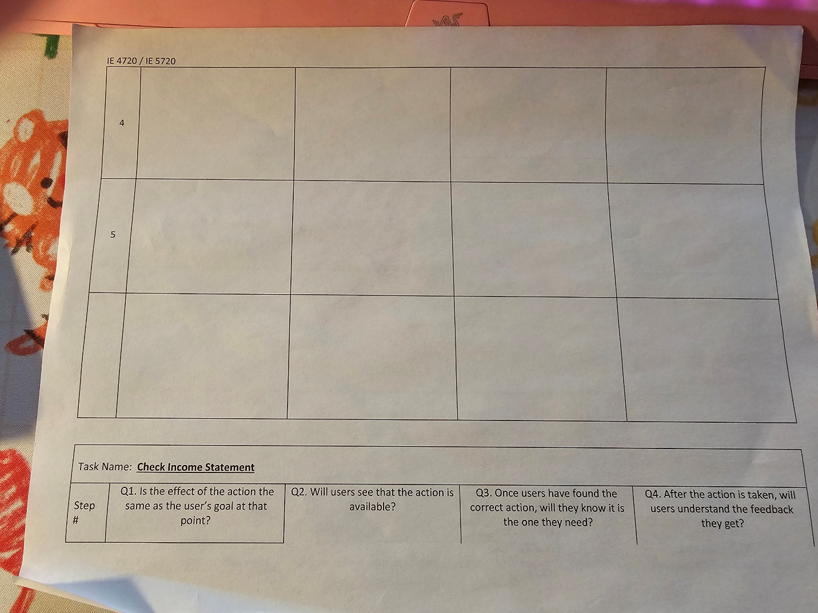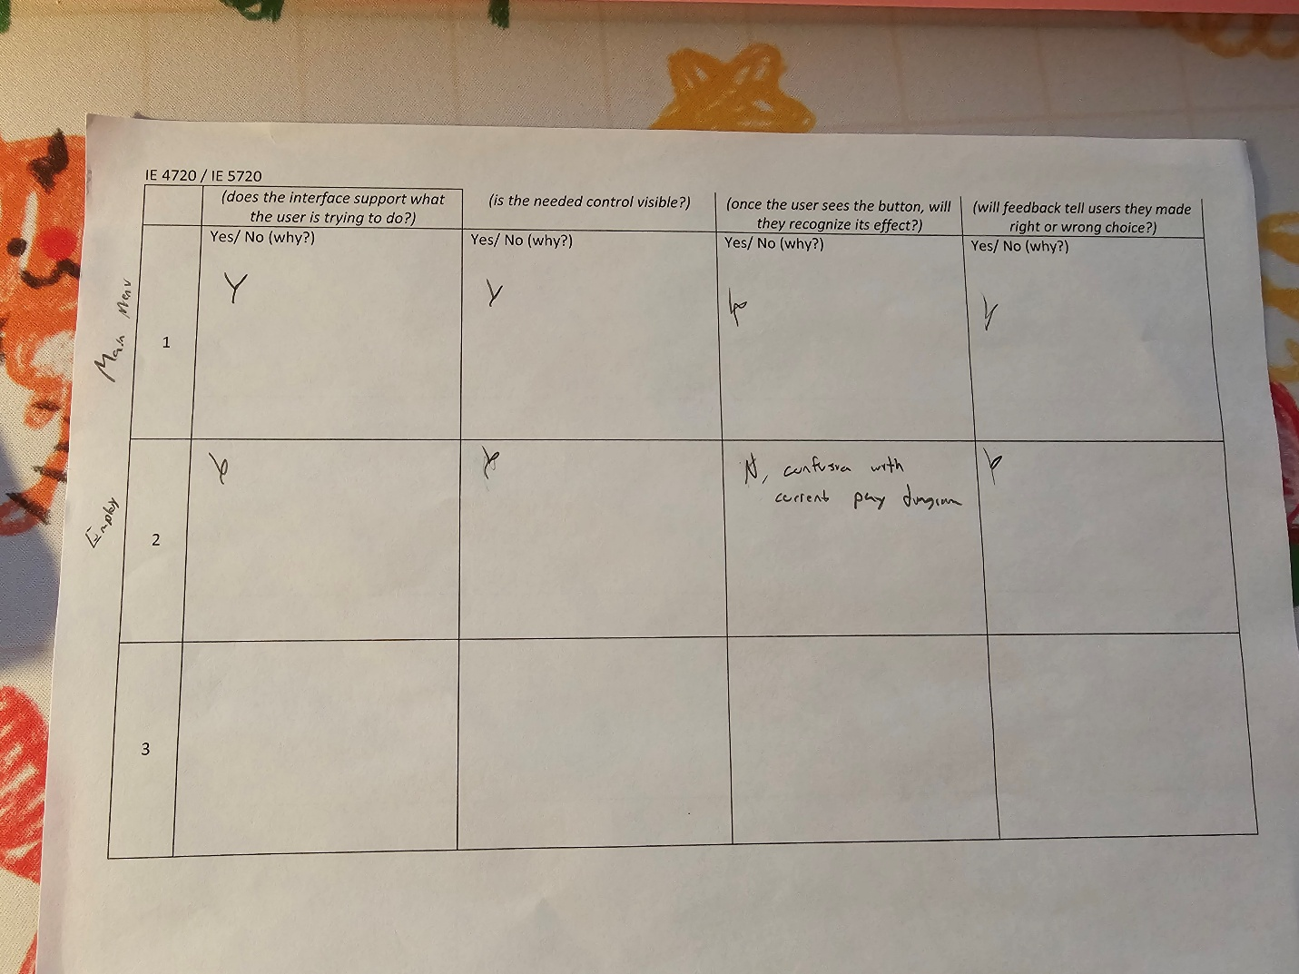

Session 2 (Heuristic Evaluation)
