- 查詢電表契約集合: /electricity-contract-setting (get)
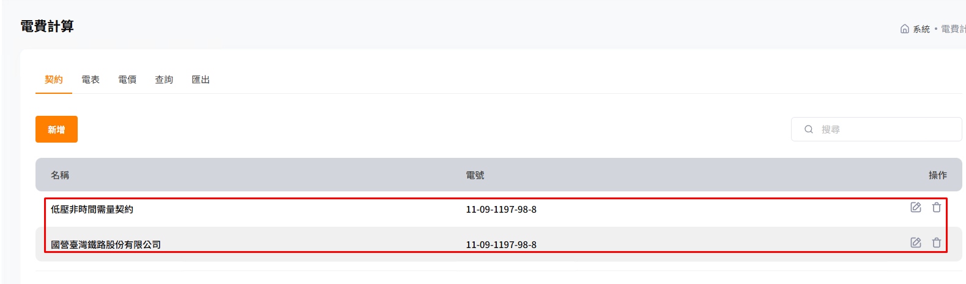
Api: /electricity-contract-setting
method: Get
Request: 没有
Response:
{
"Message": "",
"ReturnCode": 1,
"Detail": {
"ElectricityContractSettings": [
{ // 低壓非時間需量契約電價
"Id": "0a6df179-436b-488d-b0a7-a1093e1568e4",
"ElectricityNumber": "33_00-2197-98-8”,
"Name": "低壓非時間需量契約",
"PowerSupplyType": "LowVoltage",
"LowVoltageContractType": "Power",
"TimeOfUseSegment": 0,
"ContractType": "Demand",
"IsBusiness": false,
"ContractCapacity": 80,
"BackupCapacity": 0,
"HalfPeekContractCapacity": 0,
"SaturdayHalfPeakContractCapacity": 0,
"OffPeakContractCapacity": 0,
"NonSummerMonthContractCapacity": 0
},
{ //高壓時間需量契約電價
"Id": "68d99f3b-9f7d-4c23-89d8-057ee96277bf",
"ElectricityNumber": "11-09-1197-98-8",
"Name": "國營臺灣鐵路股份有限公司",
"PowerSupplyType": "HighVoltage",
"LowVoltageContractType": null,
"TimeOfUseSegment": 2,
"ContractType": "Demand",
"IsBusiness": false,
"ContractCapacity": 1500,
"BackupCapacity": 0,
"HalfPeekContractCapacity": 0,
"SaturdayHalfPeakContractCapacity": 0,
"OffPeakContractCapacity": 0,
"NonSummerMonthContractCapacity": 0
}
]
}
}

欄位名稱 |  | 用途 | 說明
Id |  | 契約識別碼
ElectricityNumber |  | 電號
Name |  | 契約名稱
PowerSupplyType |  | 用電種類 | LowVoltage: 低壓  HighVoltage: 高壓
LowVoltageContractType |  | 低壓用電契約項目 | Power: 低電壓非時間  null : 高壓
ContracType |  | 契約 | Demand: 需量契約  Device: 裝置契約
TimeOfUseSegment |  | 時段 | 時間段數, 非時間電價為0
IsBusiness |  | 是否商業用途 | 目前為 false
ContractCapacity |  | 經常契約容量 | 低壓非時間電價為0
BackupCapacity |  | 備容量 | 低壓非時間電價為0
HalfPeekContractCapacity |  | 非夏月/半尖峰契約容量 | 低壓非時間電價為0
SaturdayHalfPeakContractCapacity |  | 週六半尖峰容量 | 低壓非時間電價為0
OffPeakContractCapacity |  | 離峰契約容量 | 低壓非時間電價為0
NonSummerMonthContractCapacity |  | 非夏月契約容量 | 高壓時間電壓為0
附記 | [低壓非時間電價]  PowerSupplyType= LowVoltage, LowVoltageContractType=Power, TimeOfUseSegment=0  [高壓二段式時間電價]  PowerSupplyType= HighVoltage, TimeOfUseSegment=2  [高壓三段式時間電價]  PowerSupplyType= HighVoltage, TimeOfUseSegment=3

- 新增高壓二段時間電價契約(需量契約): /electricity-contract-setting (post)
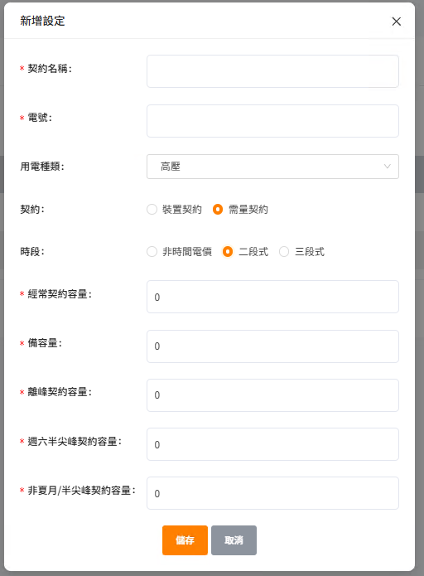
Api: /electricity-contract-setting
method: Post
Request:
{
"ElectricityNumber": "123-123-123",
"Name": "高壓~二段契約",
"PowerSupplyType": 2,
"LowVoltageContractType": null,
"TimeOfUseSegment": 2,
"ContractType": 2,
"IsBusiness": false,
"ContractCapacity": 1000,
"BackupCapacity": 10,
"HalfPeekContractCapacity": 20,
"SaturdayHalfPeakContractCapacity": 30,
"OffPeakContractCapacity": 40
}
Response:
{
"Message": "",
"ReturnCode": 1,
"Detail": {}
}

欄位名稱 |  | 用途 | 說明
ElectricityNumber |  | 電號 | 填入實際文字
Name |  | 契約名稱 | 填入實際文字
PowerSupplyType |  | 用電種類(高壓) | 2
LowVoltageContractType |  | 低壓用電契約項目 | null
ContracType |  | 契約(demand) | 2
TimeOfUseSegment |  | 時段 | 2 or 3
IsBusiness |  | 是否商業用途 | 目前為 false
ContractCapacity |  | 經常契約容量 | 填入實際整數
BackupCapacity |  | 備容量 | 填入實際整數
HalfPeekContractCapacity |  | 非夏月/半尖峰契約容量 | 填入實際整數
SaturdayHalfPeakContractCapacity |  | 週六半尖峰容量 | 填入實際整數
OffPeakContractCapacity |  | 離峰契約容量 | 填入實際整數
附記

- 新增低壓非時間電價電表契約(需量契約) /electricity-contract-setting (post)
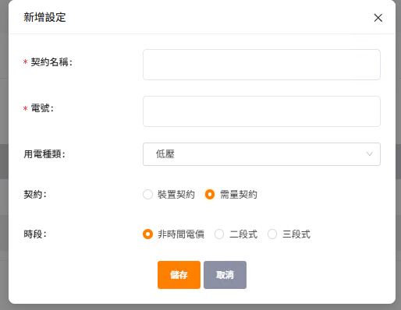
Api: /electricity-contract-setting
method: Post
Request:
{
"ElectricityNumber": " 223-123-123",
"Name": "低壓~非時間契約",
"PowerSupplyType": 1,
"LowVoltageContractType": null,
"TimeOfUseSegment": 0,
"ContractType": 2,
"IsBusiness": false,
"ContractCapacity": 40,
"BackupCapacity": 0,
"HalfPeekContractCapacity": 0,
"SaturdayHalfPeakContractCapacity": 0,
"OffPeakContractCapacity": 0,
"NonSummerMonthContractCapacity": 20
}
Response:
{
"Message": "",
"ReturnCode": 1,
"Detail": {}
}

新增欄位:
「非夏月契約容量」
NonSummerMonthContractCapacity
要顯示:
「經常契約容量」
ContractCapacity
欄位名稱 |  | 用途 | 說明
ElectricityNumber |  | 電號 | 填入實際文字
Name |  | 契約名稱 | 填入實際文字
PowerSupplyType |  | 用電種類(低壓) | 1
LowVoltageContractType |  | 低壓用電契約項目(Power) | 2
ContracType |  | 契約(demand) | 2
TimeOfUseSegment |  | 時段 | 0
IsBusiness |  | 是否商業用途 | 目前為 false
ContractCapacity |  | 經常契約容量 | 填入實際整數
BackupCapacity |  | 備容量 | 0
HalfPeekContractCapacity |  | 非夏月/半尖峰契約容量 | 0
SaturdayHalfPeakContractCapacity |  | 週六半尖峰容量 | 0
OffPeakContractCapacity |  | 離峰契約容量 | 0
NonSummerMonthContractCapacity |  | 非夏月契約容量 | 填入實際整數
附記

- 編輯高壓時間電價電表契約(需量契約): /electricity-contract-setting/[contractSettingId] (put)
[contractSettingId]: 呼叫 /electricity-contract-setting (get) 所得的 ID(契約 識別碼)
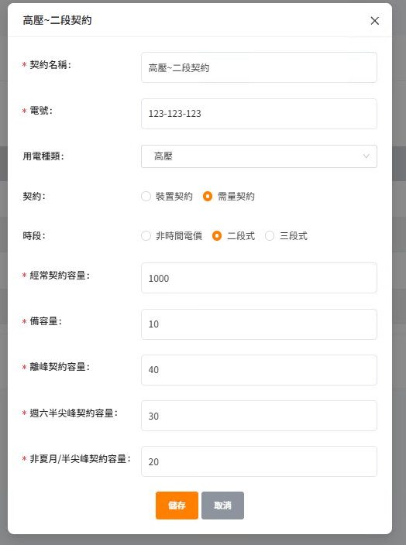
Api: /electricity-contract-setting/eb4a1ea9-64a1-438b-a1d9-c0398e9b2210
method: Put
Request:
{
"Name": "高壓~二段契約",
"ElectricityNumber":"123-123-123",
"PowerSupplyType":2,
"LowVoltageContractType": null,
"TimeOfUseSegment": 2,
"ContractType": 2,
"IsBusiness": false,
"ContractCapacity": 1000,
"BackupCapacity": 10,
"HalfPeekContractCapacity": 20,
"SaturdayHalfPeakContractCapacity": 30,
"OffPeakContractCapacity": 40
}
Response:
{
"Message": "",
"ReturnCode": 1,
"Detail": {}
}

欄位名稱 |  | 用途 | 說明
Name |  | 契約名稱 | 填入實際名稱
ElectricityNumber |  | 電號 | 填入實際電號
PowerSupplyType |  | 用電種類(高壓) | 2
LowVoltageContractType |  | 低壓用電契約項目 | null
ContracType |  | 契約(demand) | 2
TimeOfUseSegment |  | 時段 | 2 or 3
IsBusiness |  | 是否商業用途 | false
ContractCapacity |  | 經常契約容量 | 填入實際整數
BackupCapacity |  | 備容量 | 填入實際整數
HalfPeekContractCapacity |  | 非夏月/半尖峰契約容量 | 填入實際整數
SaturdayHalfPeakContractCapacity |  | 週六半尖峰容量 | 填入實際整數
OffPeakContractCapacity |  | 離峰契約容量 | 填入實際整數
附記

- 編輯低壓非時間電價電表契約(需量契約): /electricity-contract-setting/[contractSettingId] (put)
[contractSettingId]: 呼叫 /electricity-contract-setting (get) 所得的 ID(契約 識別碼)
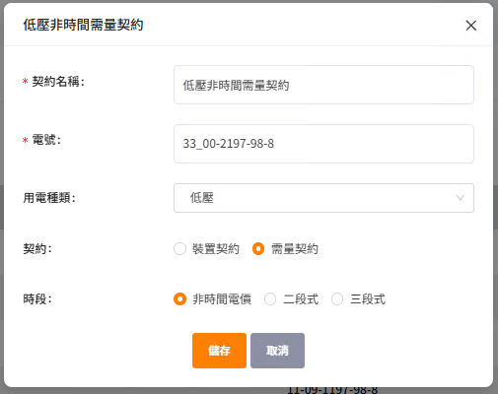
Api: /electricity-contract-setting/0a6df179-436b-488d-b0a7-a1093e1568e4
method: put
Request:
{
"ElectricityNumber": "33_00-2197-98-8",
"Name": "低壓非時間需量契約",
"PowerSupplyType": 1,
"LowVoltageContractType": 2,
"TimeOfUseSegment": 0,
"ContractType": 2,
"IsBusiness": false,
"ContractCapacity": 80,
"BackupCapacity": 0,
"HalfPeekContractCapacity": 0,
"SaturdayHalfPeakContractCapacity": 0,
"OffPeakContractCapacity": 0,
"NonSummerMonthContractCapacity":20
},
Response:
{
"Message": "",
"ReturnCode": 1,
"Detail": {}
}

新增欄位:
「非夏月契約容量」
NonSummerMonthContractCapacity
要顯示:
「經常契約容量」
ContractCapacity

欄位名稱 |  | 用途 | 說明
ElectricityNumber |  | 電號 | 填入實際文字
Name |  | 契約名稱 | 填入實際文字
PowerSupplyType |  | 用電種類(低壓) | 1
LowVoltageContractType |  | 低壓用電契約項目(Power) | 2
ContracType |  | 契約(demand) | 2
TimeOfUseSegment |  | 時段 | 0
IsBusiness |  | 是否商業用途 | 目前為 false
ContractCapacity |  | 經常契約容量 | 填入實際整數
BackupCapacity |  | 備容量 | 0
HalfPeekContractCapacity |  | 非夏月/半尖峰契約容量 | 0
SaturdayHalfPeakContractCapacity |  | 週六半尖峰容量 | 0
OffPeakContractCapacity |  | 離峰契約容量 | 0
NonSummerMonthContractCapacity |  | 非夏月契約容量 | 填入實際整數
附記

- 新增一筆低壓非時間電價(需量契約) /electricity-rate/power-supply/0/segment/0/details (post)
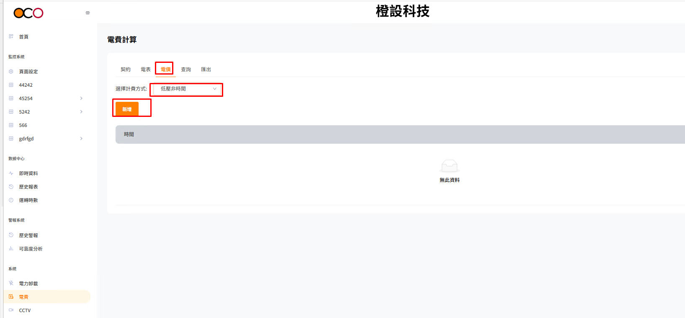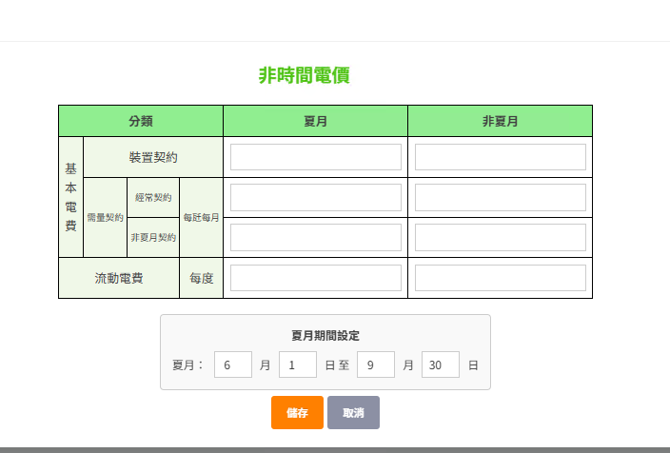
非時間電價需加三個欄位:
電價實施「年」
電價實施「月」
臨時用電倍數(非臨時用電為1, 臨時電依規定為大於1的小數)

Api: /electricity-rate/power-supply/0/segment/0/details
method: post
Request:
{
"TemporaryUsageMultiplier":1.6, // 臨時用電倍數(非臨時用電為1, 臨時電依規定, 小數)
"Year": 2025, // 電價實施年
"Month":1, // 電價實施月
"SummerMonth": {
"StartDate": "06-01", // 每年夏月開始月日(MM-dd)
"EndDate": "09-30" // 每年夏月截止月日(MM-dd)
},
"PeakTimeRanges": { // PeakTimeRanges 故定這個內容
"WeekDays": [
{
"PeakType": 0,
"StartTime": "00:00:00",
"EndTime": "00:00:00",
"UseType": 1
}
]
},
"DetailItems": [
{ // 夏月電價
"DataYear": 2025, // 電價實施年
"DataMonth": 1, // 電價實施月
"BasicRateSinglePhase": 0, // 固定這個值
"BasicRateThreePhase": 0, // 固定這個值
"BasicRateDeviceContractByDevice": 137.5, // 基本電費/裝置契約/夏月電價
"BasicRateDeviceContractByHouse": 0, // 固定這個值
"DemandContractByHouse": 0, // 固定這個值
"DemandContractRegular": 236.2, //基本電費/需量契約/經常契約/夏月電價
"DemandContractNonSummer": 0, //基本電費/需量契約/非夏月契約/夏月電價
"DemandContractSaturdayHalfPeak": 0, // 固定這個值
"DemandContractOffPeak": 0, // 固定這個值
"MobileRateWeekdaysPeak": 4.08, // 流動電費/夏月電價
"MobileRateWeekdaysHalfPeak": 0, // 固定這個值
"MobileRateWeekdaysOffPeak": 0, // 固定這個值
"MobileRateSaturdayHalfPeak": 0, // 固定這個值
"MobileRateSaturdayOffPeak": 0, // 固定這個值
"MobileRateSundayAndOffDayPeak": 0, // 固定這個值
"MobileRateExceedKwh": 0, // 固定這個值
"MobileRateExceedPrice": 0, // 固定這個值
"IsSummer": true // 固定這個值
},
{ // 非夏月電價
"DataYear": 2025, // 電價實施年
"DataMonth": 1, // 電價實施月
"BasicRateSinglePhase": 0, // 固定這個值
"BasicRateThreePhase": 0, // 固定這個值
"BasicRateDeviceContractByDevice": 137.5, // 基本電費/裝置契約/非夏月電價
"BasicRateDeviceContractByHouse": 0, // 固定這個值
"DemandContractByHouse": 0, // 固定這個值
"DemandContractRegular": 173.2, //基本電費/需量契約/經常契約/非夏月電價
"DemandContractNonSummer": 173.2, //基本電費/需量契約/非夏月契約/非夏月電價
"DemandContractSaturdayHalfPeak": 0, //固定這個值
"DemandContractOffPeak": 0, //固定這個值
"MobileRateWeekdaysPeak": 3.87, // 流動電費/非夏月電價
"MobileRateWeekdaysHalfPeak": 0, //固定這個值
"MobileRateWeekdaysOffPeak": 0, //固定這個值
"MobileRateSaturdayHalfPeak": 0, //固定這個值
"MobileRateSaturdayOffPeak": 0, //固定這個值
"MobileRateSundayAndOffDayPeak": 0, //固定這個值
"MobileRateExceedKwh": 0, //固定這個值
"MobileRateExceedPrice": 0, //固定這個值
"IsSummer": false//固定這個值
}
]
}
Response:
{ "Message": "", "ReturnCode": 1, "Detail": {}}

- 查詢低壓非時間電費費率基本設定集合
/electricity-rate/power-supply/0/segment/0/time-settings (get)
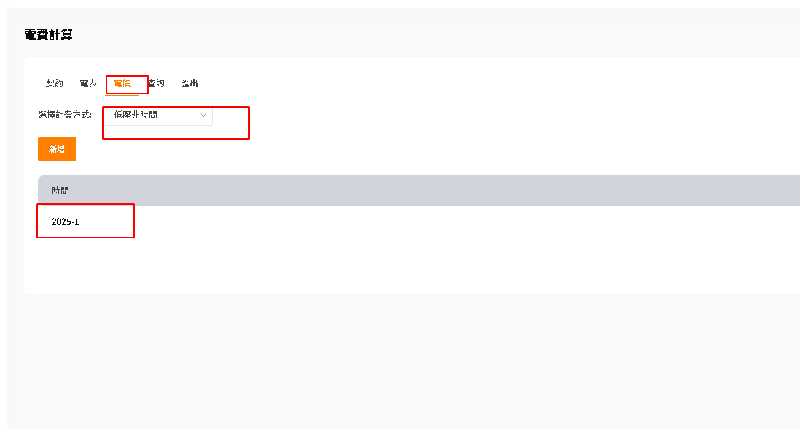
Api: /electricity-rate/power-supply/0/segment/0/time-settings
method: Get
Request: 沒有
Response:
{
"Message": "",
"ReturnCode": 1,
"Detail": { // 低壓非時間電價
"DetailTimes": [
{
"Year": 2025, // 實施 年
"Month": 1 // 實施月
}
]
}
}

- 查詢低壓非時間電價明細
/electricity-rate/power-supply/0/segment/0/details?Year=2025&Month=1 (get)
紅字部分為查詢所得的低電壓非時間電價的實施年，月 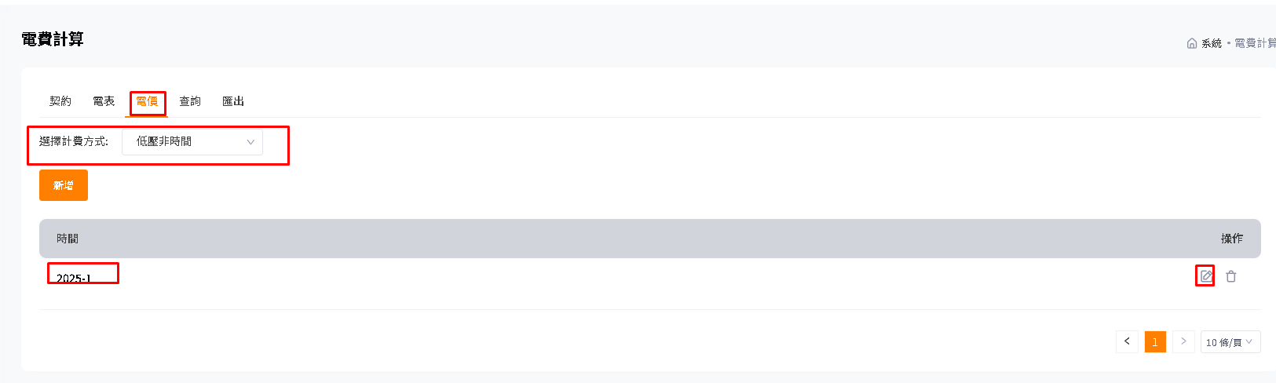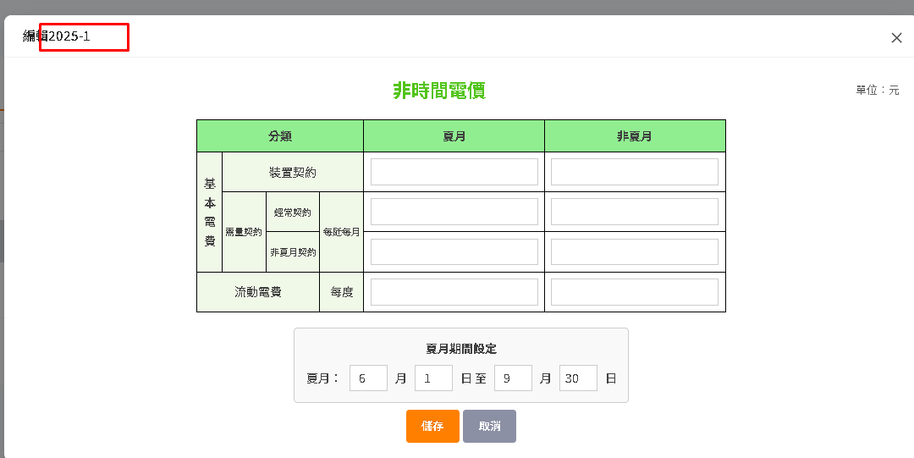
非時間電價需加一個欄位:
臨時用電倍數(非臨時用電為1, 臨時電依規定為大於1的小數)

false
API: /electricity-rate/power-supply/0/segment/0/details?Year=2025&Month=1
method: get
Request: 没有
Response:
{
"Message": "",
"ReturnCode": 1,
"Detail": {
"SummerMonth": {
"StartDate": "06-01", // 夏月起始日(MM-dd)
"EndDate": "09-30" // 夏月截止日(MM-dd)
},
"PeakTimeRanges": {
"WeekDays": [ // 低電壓非時間電價固定丟這組資料回來
{ "PeakType": "Peak", "StartTime": "00:00:00", "EndTime": "00:00:00", "UseType": "Default" }
]
},
"DetailItems": [
{ // 夏月
"DataYear": 2025, //低電壓非時間電價開始施年
"DataMonth": 1, //低電壓非時間電價開始施月
"BasicRateSinglePhase": 0, // 低電壓非時間電價固定回傳0
"BasicRateThreePhase": 0, // 低電壓非時間電價固定回傳0
"BasicRateDeviceContractByDevice": 137.5, // 基本電費/裝置契約/夏月電價
"BasicRateDeviceContractByHouse": 0, // 低電壓非時間電價固定回傳0
"DemandContractByHouse": 0, // 低電壓非時間電價固定回傳0
"DemandContractRegular": 236.2, // 基本電費/需量契約/經常契約/夏月電價
"DemandContractNonSummer": 0, // 基本電費/需量契約/非夏月契約/夏月電價
"DemandContractSaturdayHalfPeak": 0, // 低電壓非時間電價固定回傳0
"DemandContractOffPeak": 0, // 低電壓非時間電價固定回傳0
"MobileRateWeekdaysPeak": 4.08, // 流動電費/夏月電價
"MobileRateWeekdaysHalfPeak": 0, // 低電壓非時間電價固定回傳0
"MobileRateWeekdaysOffPeak": 0, // 低電壓非時間電價固定回傳0
"MobileRateSaturdayHalfPeak": 0, // 低電壓非時間電價固定回傳0
"MobileRateSaturdayOffPeak": 0, // 低電壓非時間電價固定回傳0
"MobileRateSundayAndOffDayPeak": 0, // 低電壓非時間電價固定回傳0
"MobileRateExceedKwh": 0, // 低電壓非時間電價固定回傳0
"MobileRateExceedPrice": 0, // 低電壓非時間電價固定回傳0
"IsSummer": true // 回傳 true, 表示夏月
},
{ // 非夏月
"DataYear": 2025, //低電壓非時間電價開始施年
"DataMonth": 1, //低電壓非時間電價開始施月
"BasicRateSinglePhase": 0, // 低電壓非時間電價固定回傳0
"BasicRateThreePhase": 0, // 低電壓非時間電價固定回傳0
"BasicRateDeviceContractByDevice": 137.5, // 基本電費/裝置契約/非夏月電價
"BasicRateDeviceContractByHouse": 0, // 低電壓非時間電價固定回傳0
"DemandContractByHouse": 0, // 低電壓非時間電價固定回傳0
"DemandContractRegular": 173.2, // 基本電費/需量契約/經常契約/非夏月電價
"DemandContractNonSummer": 173.2, //// 基本電費/需量契約/非夏月契約/非夏月電價
"DemandContractSaturdayHalfPeak": 0, // 低電壓非時間電價固定回傳0
"DemandContractOffPeak": 0, // 低電壓非時間電價固定回傳0
"MobileRateWeekdaysPeak": 3.87, // 流動電費/非夏月電價
"MobileRateWeekdaysHalfPeak": 0, // 低電壓非時間電價固定回傳0
"MobileRateWeekdaysOffPeak": 0, // 低電壓非時間電價固定回傳0
"MobileRateSaturdayHalfPeak": 0, // 低電壓非時間電價固定回傳0
"MobileRateSaturdayOffPeak": 0, // 低電壓非時間電價固定回傳0
"MobileRateSundayAndOffDayPeak": 0, // 低電壓非時間電價固定回傳0
"MobileRateExceedKwh": 0, // 低電壓非時間電價固定回傳0
"MobileRateExceedPrice": 0, // 低電壓非時間電價固定回傳0
"IsSummer": false // 回傳 false, 表示非夏月
}
],
"TemporaryUsageMultiplier": 1.6 // 臨時用電倍數
}
}

- 編輯低壓非時間電價 /electricity-rate/power-supply/0/segment/0/details (put)
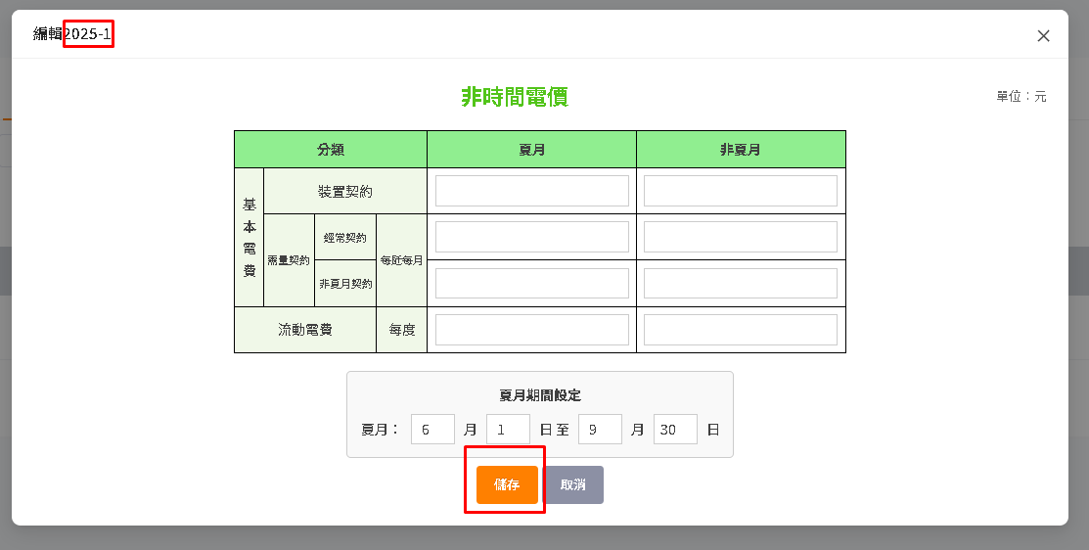
非時間電價需加一個欄位:
臨時用電倍數(非臨時用電為1, 臨時電依規定為大於1的小數)

Api: /electricity-rate/power-supply/0/segment/0/details
Method: put
Request:
{
"TemporaryUsageMultiplier":1.62, // 臨時用電倍數
"Year": 2025, // 電價實施年
"Month": 1, // 電價實施月
"SummerMonth": {
"StartDate": "06-01", // 夏月起始月日(MM-dd)
"EndDate": "10-01" // 夏月截止月日(MM-dd)
},
"PeakTimeRanges": { // 低壓非時間電價固定填這個
"WeekDays": [
{
"PeakType": 0,
"StartTime": "00:00:00",
"EndTime": "00:00:00",
"UseType": 1
}
]
},
"DetailItems": [
{ // 夏月
"DataYear": 2025, // 電價實施年
"DataMonth":1, // 電價實施月
"BasicRateSinglePhase": 0, // 低電壓非時間電價固填0
"BasicRateThreePhase": 0, // 低電壓非時間電價固填0
"BasicRateDeviceContractByDevice": 137.51, // 基本電費/裝置契約/夏月電價
"BasicRateDeviceContractByHouse": 0, // 低電壓非時間電價固填0
"DemandContractByHouse": 0, // 低電壓非時間電價固填0
"DemandContractRegular": 236.21, // 基本電費/需量契約/經常契約/夏月電價
"DemandContractNonSummer": 0, // 基本電費/需量契約/非夏月契約/夏月電價
"DemandContractSaturdayHalfPeak": 0, // 低電壓非時間電價固填0
"DemandContractOffPeak": 0, // 低電壓非時間電價固填0
"MobileRateWeekdaysPeak": 4.081, // 流動電費/夏月電價
"MobileRateWeekdaysHalfPeak": 0, // 低電壓非時間電價固填0
"MobileRateWeekdaysOffPeak": 0, // 低電壓非時間電價固填0
"MobileRateSaturdayHalfPeak": 0, // 低電壓非時間電價固填0
"MobileRateSaturdayOffPeak": 0, // 低電壓非時間電價固填0
"MobileRateSundayAndOffDayPeak": 0, // 低電壓非時間電價固填0
"MobileRateExceedKwh": 0, // 低電壓非時間電價固填0
"MobileRateExceedPrice": 0, // 低電壓非時間電價固填0
"IsSummer": true // 夏月
},
{ // 非夏月
"DataYear": 2025, // 電價實施年
"DataMonth": 1, // 電價實施月
"BasicRateSinglePhase": 0, // 低電壓非時間電價固填0
"BasicRateThreePhase": 0, // 低電壓非時間電價固填0
"BasicRateDeviceContractByDevice": 137.51, // 基本電費/裝置契約/非夏月電價
"BasicRateDeviceContractByHouse": 0, // 低電壓非時間電價固填0
"DemandContractByHouse": 0, // 低電壓非時間電價固填0
"DemandContractRegular": 173.21, // 基本電費/需量契約/經常契約/非夏月電價
"DemandContractNonSummer": 173.21, /// 基本電費/需量契約/非夏月契約/非夏月電價
"DemandContractSaturdayHalfPeak": 0, // 低電壓非時間電價固填0
"DemandContractOffPeak": 0, // 低電壓非時間電價固填0
"MobileRateWeekdaysPeak": 3.871, // 低電壓非時間電價固填0
"MobileRateWeekdaysHalfPeak": 0, // 低電壓非時間電價固填0
"MobileRateWeekdaysOffPeak": 0, // 低電壓非時間電價固填0
"MobileRateSaturdayHalfPeak": 0, // 低電壓非時間電價固填0
"MobileRateSaturdayOffPeak": 0, // 低電壓非時間電價固填0
"MobileRateSundayAndOffDayPeak": 0, // 低電壓非時間電價固填0
"MobileRateExceedKwh": 0, // 低電壓非時間電價固填0
"MobileRateExceedPrice": 0, // 低電壓非時間電價固填0
"IsSummer": false // 非夏月
}
]
}
Response:
{
"Message": "", "ReturnCode": 1,
"Detail": {}
}

- 刪除低壓非時間電價資料 /electricity-rate/power-supply/0/segment/0/details (DELETE)
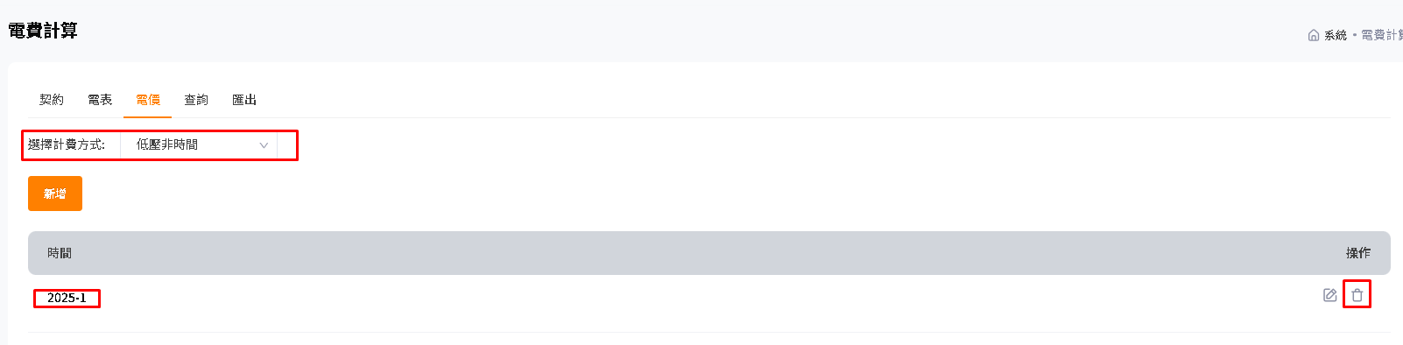
Api: /electricity-rate/power-supply/0/segment/0/details
Method: delete
Request:
{
"Year": 2025, // 電價實施年
"Month": 1 // 電價實施月
}
Response:
{
"Message": "", "ReturnCode": 1,
"Detail": {}
}

- 查詢假日集合列表 /holidays (Get)
2024
下拉式選單,
選定年後,下面的「假日日期」會更新內容
西元年：
假日日期：
2024-01-01
2024-02-09
2024-02-11
2024-02-12
2024-02-13
2024-02-14
2024-02-28
2024-04-04
2024-05-01
2024-06-10
2024-09-17
2024-10-10

唯讀
Api: /holidays
Method: get
Request: 沒有
Response:
{
"Message": "",
"ReturnCode": 1,
"Detail": {
"Holidays": [
{
"Year": 2024,
"Dates": [
"2024-01-01",
"2024-02-09",
"2024-02-10",
"2024-02-11",
"2024-02-12",
"2024-02-13",
"2024-02-14",
"2024-02-28",
"2024-04-04",
"2024-05-01",
"2024-06-10",
"2024-09-17",
"2024-10-10"
]
},
{
"Year": 2025,
"Dates": [
"2025-01-01",
"2025-01-28",
"2025-01-29",
"2025-01-30",
"2025-01-31",
"2025-02-01",
"2025-02-28",
"2025-04-04",
"2025-05-01",
"2025-05-31",
"2025-10-06",
"2025-10-10"
]
}
]
}
}

匯出
「匯出」鈕
請詳匯出假日列表

- 匯出假日列表 /holiday/[西元年]/export (post)
Api: /holiday/[西元年]/export
Method: post
Request: 沒有
Response: 從網頁下載檔案

- 匯入假日列表檔案 /holiday/[西元年]/import
2024
西元年：
匯入
選定檔案
xlsx
Api: /holiday/[西元年]/import
Method: post
Request(Content-Type: multipart/form-data):
File:選定的 .xlsx檔
Response:
{
"Message": "",
"ReturnCode": 1,
"Detail": {}
}

