Romanized | Deva-nagari | Stroke of Deva-nagari | Exp.on the net
 |  | 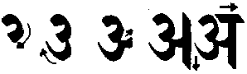 | a
 |  |  | aa
 |  | 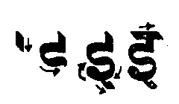 | i
 |  | 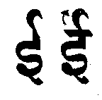 | ii
 |  | 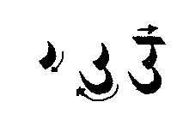 | u
 |  | 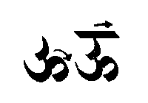 | uu
 |  | 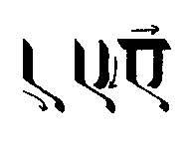 | e
 |  | 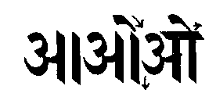 | o
 |  | 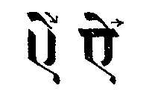 | ai
 |  | 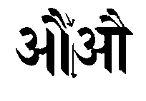 | au
 |  |  | .m  or ”n
 |  |  | a.h
 |  | 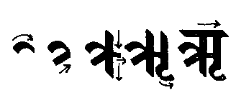 | .r
Romanized | Deva-nagari | Stroke of Deva-nagari | Exp.on the net
 |  | 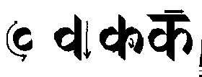 | ka
 |  | 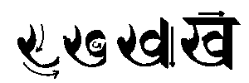 | kha
 |  | 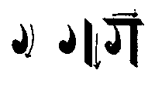 | ga
 |  | 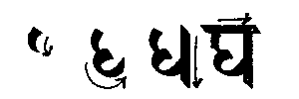 | gha
 |  | 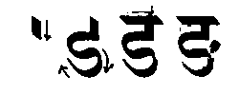 | ’na
 |  | 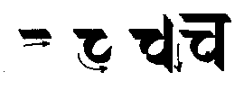 | ca
 |  | 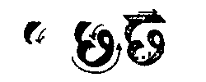 | cha
 |  | 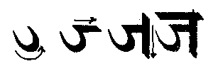 | ja
 |  | 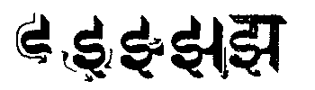 | jha
 |  | 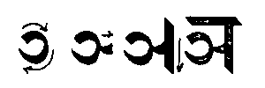 | ~na
 |  | 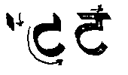 | .ta
 |  | 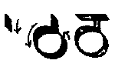 | .tha
 |  | 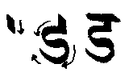 | .da
 |  | 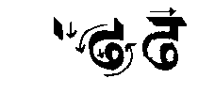 | .dha
 |  | 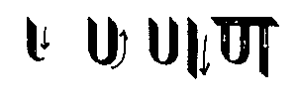 | .na

Romanized | Deva-nagari | Stroke of Deva-nagari | Exp.on the net
 |  | 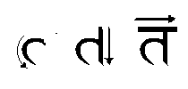 | ta
 |  | 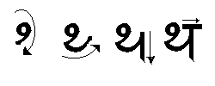 | tha
 |  | 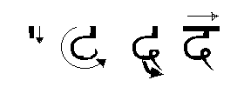 | da
 |  | 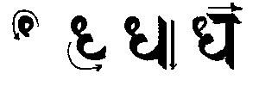 | dha
 |  | 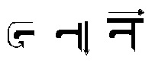 | na
 |  | 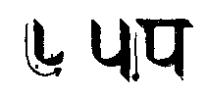 | pa
 |  | 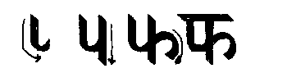 | pha
 |  | 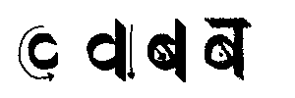 | ba
 |  | 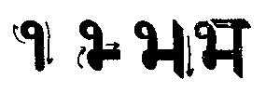 | bha
 |  | 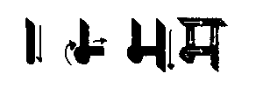 | ma
 |  | 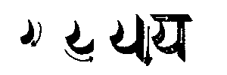 | ya
 |  | 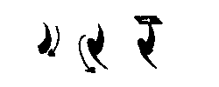 | ra
 |  | 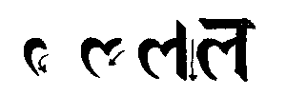 | la
   |  |  | va  wa
Romanized | Deva-nagari | Stroke of Deva-nagari | Exp.on the net
 |  | 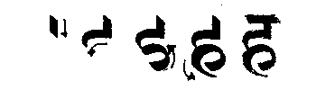 | ha
 |  | 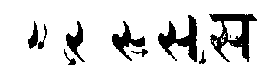 | sa
 | ■  | shift-a | aa
 | ■ | I | i
 | ■ | shift-i | ii
 | ■ | u | u
 | ■ | shift-u | uu
 | ■ | e | e
 | ■ | o | o
 | ■ | e space e | ai
 | ■ | eo | au

Romanized | Deva-nagari | Exp.on the net
 |  | kaa
 |  | khaa
 |  | gaa
 |  | ghaa
 |  | ’naa
 |  | ci
 |  | chi
 |  | ji
 |  | jhi
 |  | ~ni
 |  | .ta
 |  | .tha
 |  | .da
 |  | .dha
 |  | .na
Romanized | Deva-nagari | Exp.on the net
 |  | tu
 |  | thu
 |  | du
 |  | dhu
 |  | nu
 |  | puu
 |  | phuu
 |  | buu
 |  | bhuu
 |  | muu
 |  | ke
 |  | khe
 |  | ge
 |  | Ghe
 |  | ’ne
Romanized | Deva-nagari | Exp.on the net
 |  | co
 |  | cho
 |  | jo
 |  | jho
 |  | ~no
 |  | ki.m
 |  | khi.m
 |  | gi.m
 |  | ghi.m
 |  | ’ni.m

