第一次实验

实验1

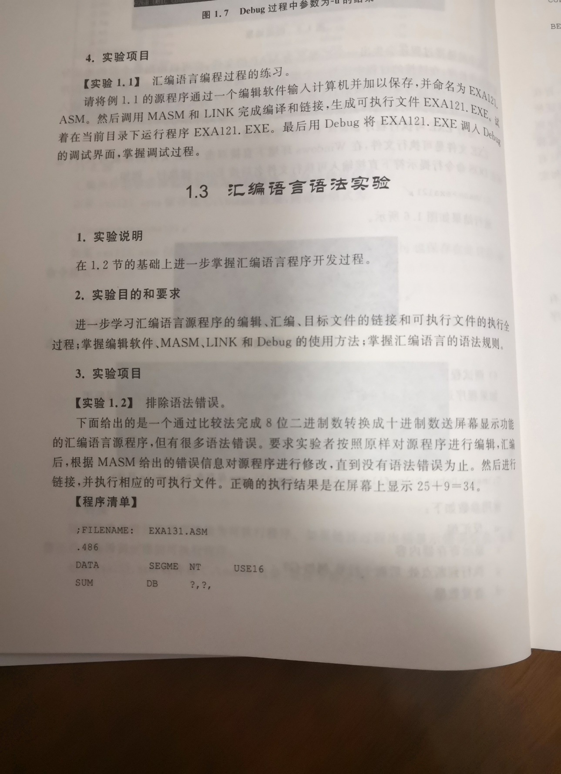

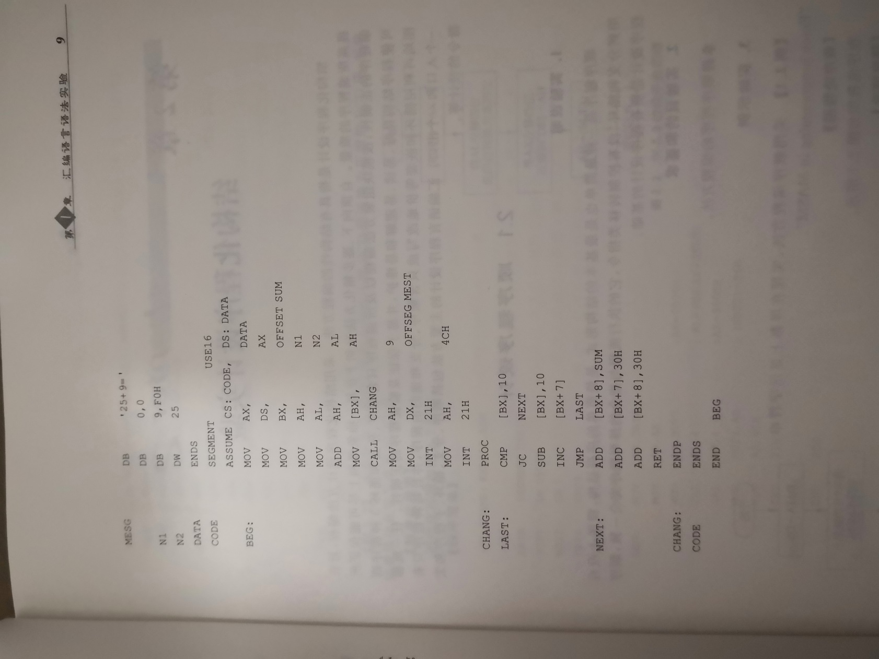

实验2

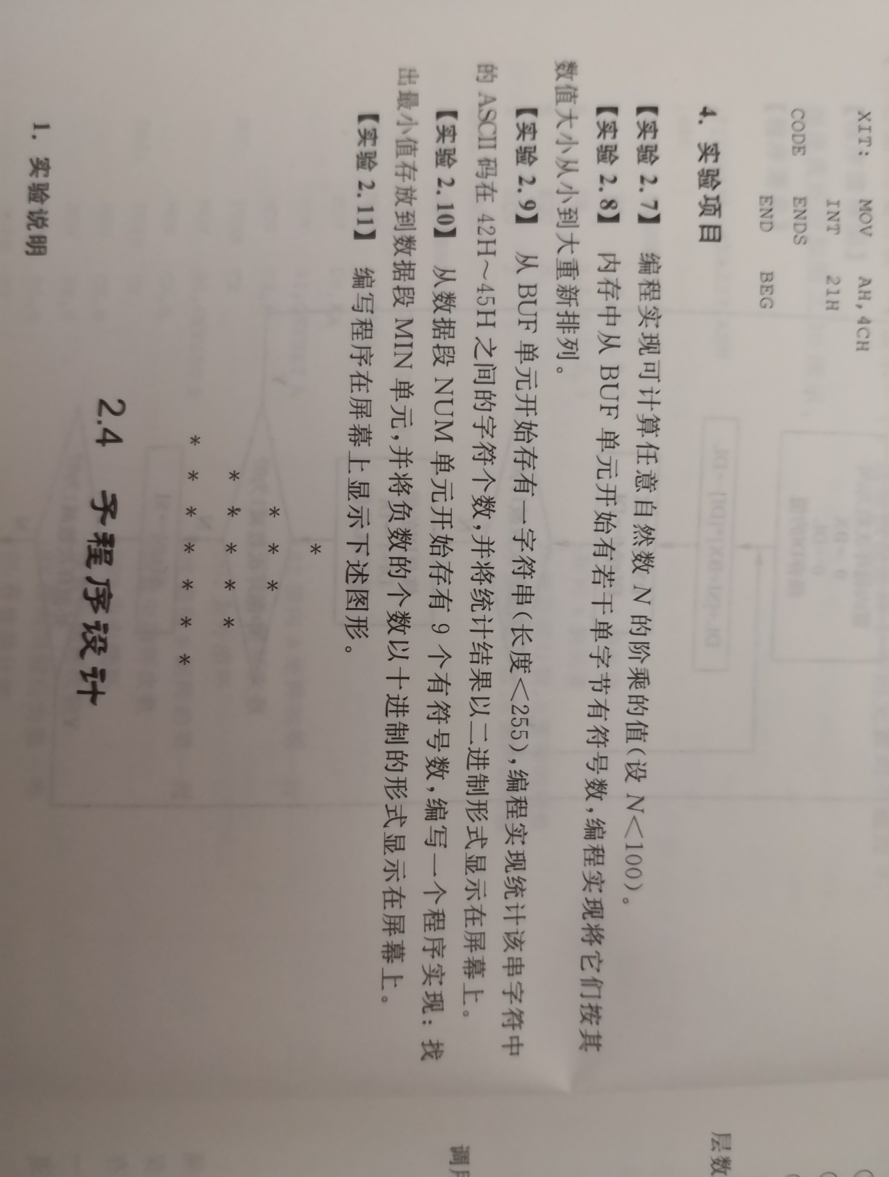

第二次实验

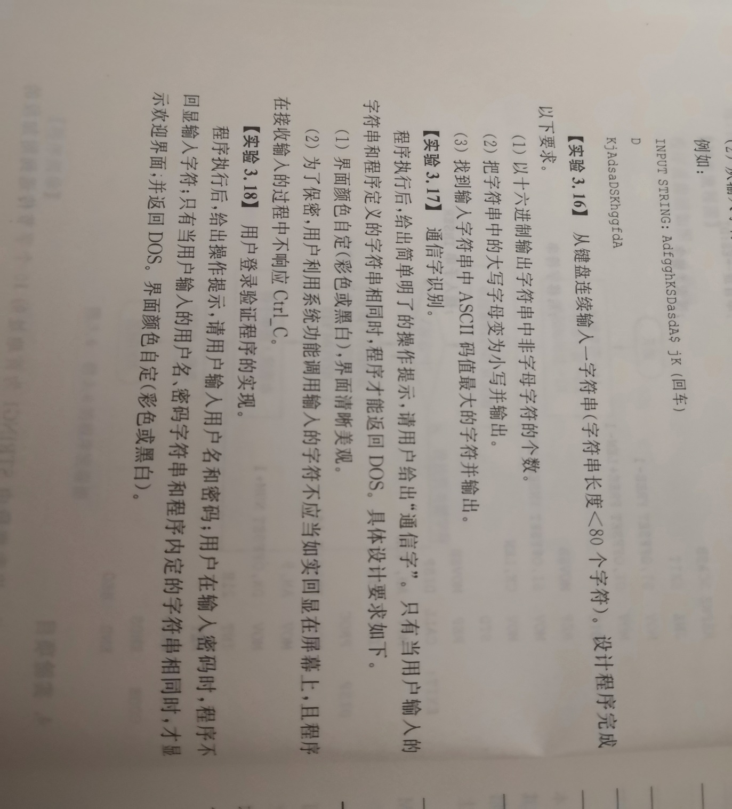

;FILENAME: EXA2_1.ASM

DATAS SEGMENT

MESG DB 'Please input your passward:'

LEN1 EQU $-MESG

BUF DB '123' ;通信量

LEN2 EQU $-BUF

PWD DB 100 DUP(?)

DATAS ENDS

CODES SEGMENT

ASSUME CS:CODES,DS:DATAS,ES:DATAS

START:

MOV AX,DATAS

MOV DS,AX

MOV ES,AX

;显示提示语句模块

FIRST: MOV AH,0003H;彩色文本80*25

INT 10H

MOV AX,1301H;显示属性相同的字符串

MOV BH,0;页号

MOV BL,01001111B;红底白字

MOV CX,LEN1;串长度

MOV DH,12;起始行

MOV DL,20;起始列

MOV BP,OFFSET MESG

INT 10H

;键入字串模块

MOV CX,0

LAST: MOV AH,01H

INT 21H

LEA BX,PWD

MOV PWD,AL

INC BX

INC CX

CMP AL,'#'

JNZ LAST

DEC CX

;对两字符串进行比较模块

CMP CX,3

JNZ FIRST

LEA SI,PWD

LEA BX,BUF

NEXT: MOV AL,[BX]

CMP AL,[SI]

JNZ FIRST

INC SI

INC BX

LOOP NEXT

MOV AH,4CH

INT 21H

CODES ENDS

END START