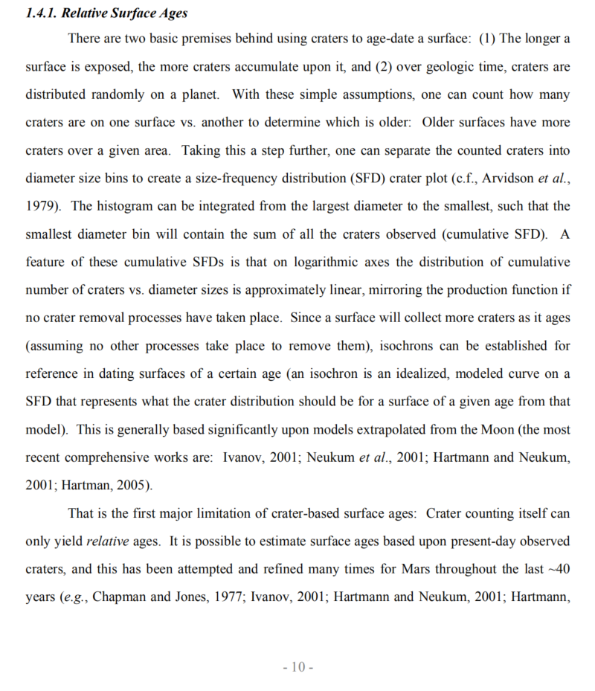

Figure1: page10 from the larger code book (mars)

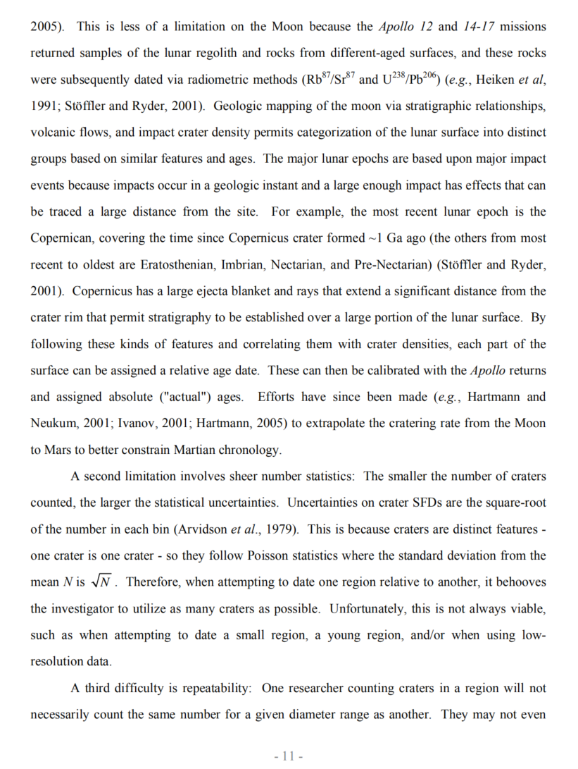

Figure2: page11 from the larger code book (mars)

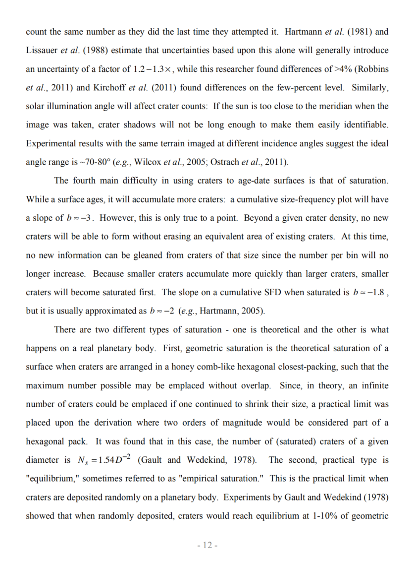

Figure3: page12 from the larger code book (mars)

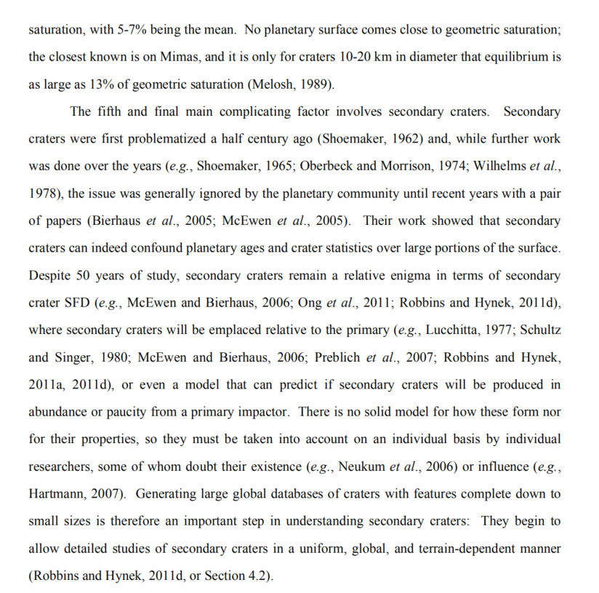

Figure4: page13 from the larger code book (mars)

**Variables will be used:**

DIAM_CIRCLE_IMAGE,

DEPTH_RIMFLOOR_TOPOG,

LONGITUDE_CIRCLE_IMAGE,

LATITUDE_CIRCLE_IMAGE