 Rainfall Logger App
USER DOCUMENTATION
(For end-users, non-technical, clear and practical)
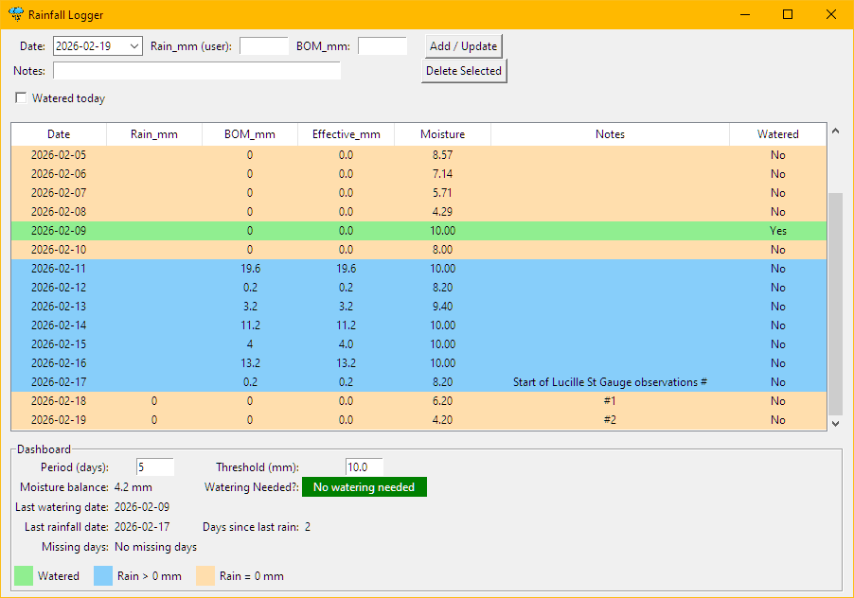
App designed by Wayne Freestun and implemented with Microsoft’s Copilot assistance on Thursday, 19 February 2026

What RainApp Does
RainApp helps you track:
- Daily rainfall
- Watering events
- Notes
- Soil moisture balance
The app uses a simple, explainable moisture model based on your chosen Threshold (mm) and Period (days). It stores a Moisture value for every day, allowing you to verify calculations and maintain a complete moisture history.

How Moisture Is Calculated
Moisture is a stored value, not recalculated every time.
Each day’s moisture is computed using:
- Yesterday’s stored moisture
- Today’s rainfall
- Today’s watering flag
- Your current Threshold and Period settings
The formula:
- Daily decay = Threshold ÷ Period
- Moisture = max(0, yesterday’s moisture − decay)
- Rainfall adds to moisture
- Moisture is capped at Threshold
- Watering resets moisture to Threshold
This creates a realistic, stable moisture curve.

Viewing Moisture in the Table
The table now includes a Moisture column.
It is read-only
It shows the moisture value stored for that day
It allows you to verify the model’s behaviour

Editing Past Records
When you edit a past record:
- The selected day’s moisture is recalculated
- All future days are recalculated forward
- Past days remain unchanged
This preserves historical accuracy while allowing corrections.

Changing Threshold or Period
Changing settings does not rewrite history.
Instead:
- The new settings apply only to the selected row
- When you click Add/Update, moisture is recalculated from that day forward
- All earlier days remain unchanged
This allows you to fix incorrect settings used in the past.

Deleting Records
When you delete a record:
- The record is removed
- Moisture is not automatically recalculated
- If needed, edit the previous day and click Add/Update to recompute forward

Missing Days
The app detects gaps in the date sequence and allows you to view missing dates.

Migration Requirement
If you are upgrading from an older version of RainApp:
- Run the included migration script once
- It adds the Moisture column and computes historical moisture values
- No manual editing of the CSV is required

End

