Requirements for programming report:
- Write an E-report for your programming assignments (no hand-writing);
- Show your numerical results (e.g., errors, etc.), state/report the key formula and other key parameters you used; e.g. 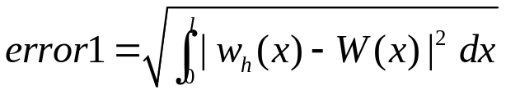,
Let 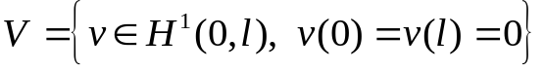; Variational/weak form (V)?
Partition: ,
Let 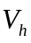 be a finite-dim subspace of with piece-wise quadratic polynomial.
, then specify the nodal basis for ? What’s the finite dimensional problem 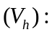 etc.
- Graph/plot your solutions, use tables as possible (多用图和表)，e.g.
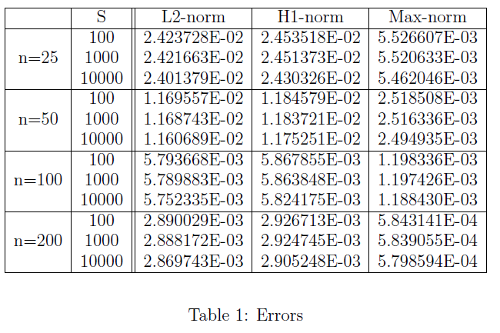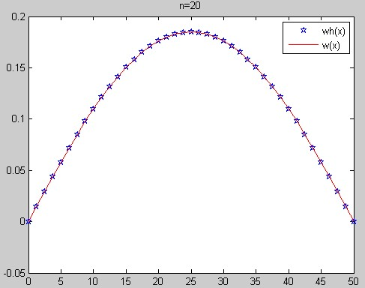
- Give your conclusion or explanation or discussion on your results;
- Print it out! (Email submission is not acceptable.)

