Numerical Analysis

Programming Assignment #1

Name:
Student ID:

Problem 3.1(Bisection Method)
1. Write and test a subprogram or procedure to implement the bisection algorithm. Test the program on these functions and intervals:
- 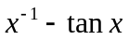 on 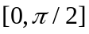
For this problem, we use bisection method. We let 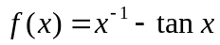 and choose the initial interval 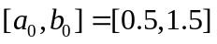, since 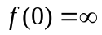 and 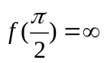. Due to the figure 1, we know the initial interval is reasonable. The results are listed in Table 1. We use M=1000 or 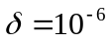 or 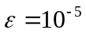 as stopping condition.
The approximate solution of the equation 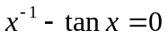 on is 0.860332 and the function value is 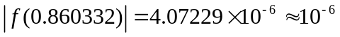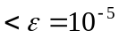.
Table 1
Iterations n | 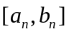 | 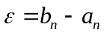 | 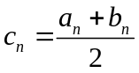 | 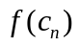
1 | [0.5,1.5] | 1 | 1 | -0.557408
2 | [0.5,1] | 0.5 | 0.75 | 0.401737
3 | [0.75,1] | 0.25 | 0.875 | -0.00545645
4 | [0.75,0.875] | 0.125 | 0.8125 | 0.175042
5 | [0.8125,0.875] | 0.0625 | 0.84375 | 0.0611001
6 | [0.84375,0.875] | 0.03125 | 0.859375 | 0.0035477
7 | [0.859375,0.875] | 0.015625 | 0.857188 | -0.0254301
8 | [0.859375,0.867188] | 0.0078125 | 0.863281 | -0.0109227
9 | [0.859375,0.863281] | 0.00390625 | 0.861328 | -0.00368299
10 | [0.859375,0.861328] | 0.00195313 | 0.861328 | -6.65394e-005
11 | [0.859375,0.860352] | 0.000976563 | 0.859863 | 0.00174085
12 | [0.859863,0.860352] | 0.000488281 | 0.860107 | 0.00174085
13 | [0.860107,0.860352] | 0.000244141 | 0.860229 | 0.000385361
14 | [0.860229,0.860352] | 0.00012207 | 0.860291 | 0.000159415
15 | [0.860291,0.860352] | 6.10352e-005 | 0.860321 | 4.64389e-005
16 | [0.860321,0.860352] | 3.05176e-005 | 0.860336 | -1.005e-005
17 | [0.860321,0.860336] | 1.52588e-005 | 0.860329 | 1.81945e-005
18 | [0.860329,0.860336] | 7.62939e-006 | 0.860332 | 4.07229e-006
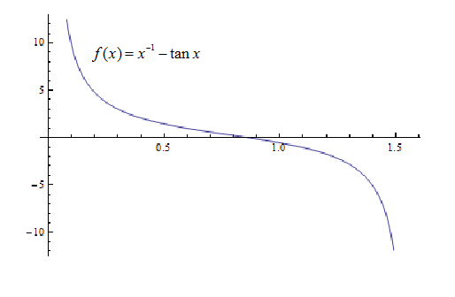
Figure 1

c. 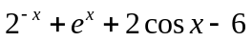 on 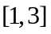
In this problem on the interval , we use bisection algorithm. We let 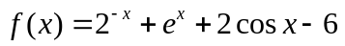 and the initial interval 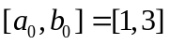, since 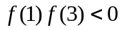. We guess the root approximate 1.81 from figure 2. The results are listed in Table 2. We use M>1000 or 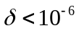 or 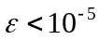 as stopping condition.
The approximate root of 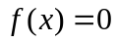 on is 1.82938. 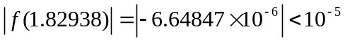 nearly satifies the precision. So the approximate solution of the equation is 1.82938. It is close to our initial guess 1.81.

Iterations n
1 | [1,3] | 2 | 2 | 0.806753
2 | [1,2] | 1 | 1.5 | -1.02329
3 | [1.5,2] | 0.5 | 1.75 | -0.304594
4 | [1.75,2] | 0.25 | 1.875 | 0.194371
5 | [1.75,1.875] | 0.125 | 1.8125 | -0.0682819
6 | [1.8125,1.875] | 0.0625 | 1.84375 | 0.0596296
7 | [1.8125,1.84375] | 0.03125 | 1.82813 | -0.00516436
8 | [1.82813,1.84375] | 0.015625 | 1.83584 | 0.0270211
9 | [1.82813,1.83594] | 0.0078125 | 1.83203 | 0.0108758
10 | [1.82813,1.83203] | 0.00380625 | 1.83008 | 0.00284257
Table 2

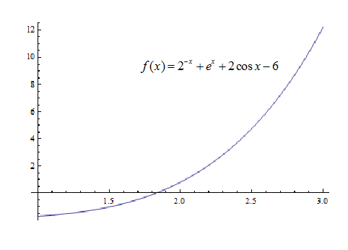
Figure 2

4. Find a root of

Problem 3.2(Newton’s Method)
5. The equation 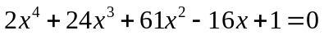 two roots near 0.1. Determine them by means of Newton’s method.
In this problem, we must choose two different initial points. Let 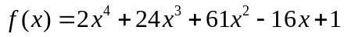, we can get 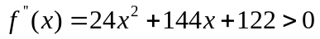 on 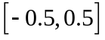. From figure 5, we can find  is convex and increasing on 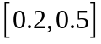, so we can get an initial point on this interval. Meanwhile, we also find is convex and decreasing on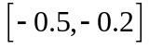, then we let the other initial point on this interval. So we get two initial points -0.2 and 0.2.
First, we choose 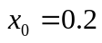 and use the Newton’s iteration: 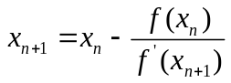 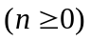. We use M>1000 or or as stopping condition.M is interations, 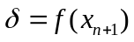 and 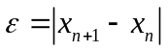. The results are listed in Table 4.
Iterations n | 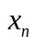 | 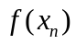
0 | 0.2 | 0.4352
1 | 0.161636 | 0.0277356
2 | 0.142071 | 0.0277356
3 | 0.132197 | 0.00694433

Table 4

Next, choose 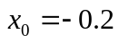and apply the Newton’s iteration: 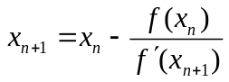 . We use M>1000 or or as stopping condition.M is interations, and . The results are listed in Table 5.
Iterations n
0 | -0.2 | 6.4512
1 | -0.0283525 | 1.50213
2 | 0.0490717 | 0.364591
3 | 0.0861276 | 0.0898978
Table 5
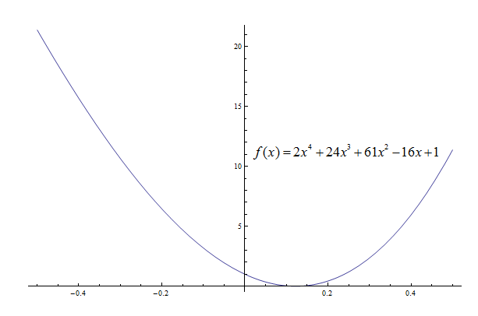
Figure 5
The two approximate/numerical roots found are

Summary:
Through the above problems and analysis, we find that bisection method’s rate of convergence is obviously slower than Newton’s method. But ….

