HW1

111078513

2023-02-15

## Load customers data

data <- read.table("customers.txt", header = T)  
age <- data$age  
head(age)

## [1] 49 69 41 73 45 71

### 1. What is the 5th element in the original list of ages?

q1 <- age[5]  
q1

## [1] 45

### 2. What is the fifth lowest age?

remove the duplicated data from ‘age’ and get the fifth lowest

sort_age <- sort(age)  
uni_sort_age <- unique(sort_age)  
uni_sort_age[5]

## [1] 22

### 3. Extract the five lowest ages together

head(uni_sort_age, 5)

## [1] 18 19 20 21 22

### 4. Get the five highest ages by first sorting them in decreasing order first.

tail(uni_sort_age, 5)

## [1] 80 81 82 83 85

### 5. What is the average (mean) age?

mean(age)

## [1] 46.80702

### 6. What is the standard deviation of ages?

sd(age)

## [1] 16.3698

### 7. Make a new variable called age_diff, with the difference between each age and the mean age.

age_diff <- age - mean(age)  
head(age_diff)

## [1] 2.192982 22.192982 -5.807018 26.192982 -1.807018 24.192982

### 8. What is the average age_diff?

mean(age_diff)

## [1] -1.623275e-15

### 9. Visualize the raw data as we did in class: (a) histogram, (b) density plot, (c) boxplot+stripchart

# (a) histogram  
hist(age)

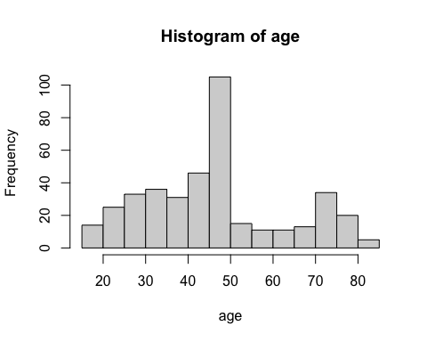

# (b) density plot  
plot(density(age))

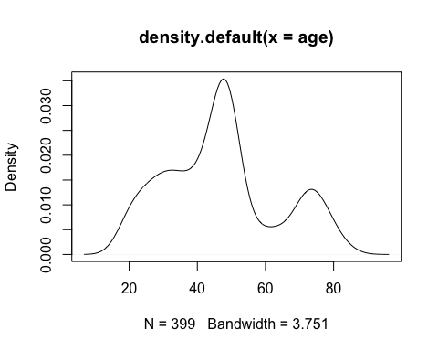

# (c) boxplot+stripchart  
boxplot(age, horizontal = TRUE)  
stripchart(age, method = "stack", add = TRUE)

