* 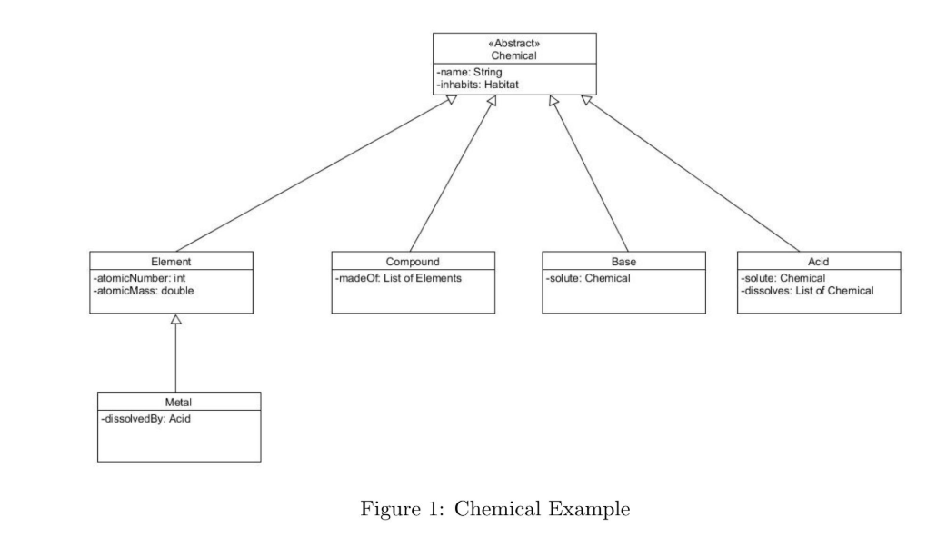
* Create a JUnit class for each Gateway, have tests inside for each method
* Surround the actual database query with a try catch
* Create class to manage the database connection
* **Single Table Inheritance**
  + Create / drop Table function
    - This will have all the columns in one table
  + CreateRowDataGateway
    - Getter/setter ID
      * Prefixes:
        + 00 Chemical
        + 01 Element
        + 02 Metal
        + 03 Compound
        + 04 Base
        + 05 Acid
      * Made like “Prefix” len 2 + “Extension” some long. IE. {00}{123456} for some Chemical.
    - Getter/setter name VARCHAR
    - getter/setter inhabits VARCHAR
    - getter/setter atomicNumber INT
    - getter/setter atomicMass DOUBLE
    - getter/setter dissolvedBy LONG //foreign key to id
    - getter/setter solute LONG
    - find(): RowDataGateway
    - findSet(): List<RowDataGateway>
    - update(): void
    - insert(): void
  + Create / drop Table Function CompoundsMadeOfElement
    - This will have 2 foreign keys to ID
  + Create TableDataGateway
    - getter/setter compoundID //Both are foreign keys to ID
    - getter/setter elementID
  + Create / drop Table Function AcidDissolvesChemical
    - This will have 2 foreign keys to ID
  + Create TableDataGateway
    - getter/setter acidID //Both are foreign keys to ID
    - getter/setter chemicalID
* **Class Table Inheritance**
  + Create / drop Table for Chemical
    - Getter/setter ID
      * Prefixes:
        + 00 Chemical
        + 01 Element
        + 02 Metal
        + 03 Compound
        + 04 Base
        + 05 Acid
      * Made like “Prefix” len 2 + “Extension” some long. IE. {00}{123456} for some Chemical.
    - Create RowDataGateway
      * getter/setter name
      * getter/setter inhabits
    - Create TableDataGateway
      * getter/setter name
      * getter/setter inhabits
  + Create / drop Table for Element
    - Getter/setter ID
      * Prefixes:
        + 00 Chemical
        + 01 Element
        + 02 Metal
        + 03 Compound
        + 04 Base
        + 05 Acid
      * Made like “Prefix” len 2 + “Extension” some long. IE. {00}{123456} for some Chemical.
    - Create RowDataGateway
      * getter/setter atomicNumber
      * getter/setter atomicMass
    - Create TableDataGateway
      * getter/setter atomicNumber
      * getter/setter atomicMass
  + Create / drop Table for Compound
    - Getter/setter ID
      * Prefixes:
        + 00 Chemical
        + 01 Element
        + 02 Metal
        + 03 Compound
        + 04 Base
        + 05 Acid
      * Made like “Prefix” len 2 + “Extension” some long. IE. {00}{123456} for some Chemical.
    - Create RowDataGateway
      * getter/setter madeOf
    - Create TableDataGateway
      * getter/setter madeOf
  + Create / drop Table for Base
    - Getter/setter ID
      * Prefixes:
        + 00 Chemical
        + 01 Element
        + 02 Metal
        + 03 Compound
        + 04 Base
        + 05 Acid
      * Made like “Prefix” len 2 + “Extension” some long. IE. {00}{123456} for some Chemical.
    - Create RowDataGateway
      * getter/setter solute
    - Create TableDataGateway
      * getter/setter solute
  + Create / drop Table for Acid
    - Getter/setter ID
      * Prefixes:
        + 00 Chemical
        + 01 Element
        + 02 Metal
        + 03 Compound
        + 04 Base
        + 05 Acid
      * Made like “Prefix” len 2 + “Extension” some long. IE. {00}{123456} for some Chemical.
    - Create RowDataGateway
      * getter/setter solute
      * getter/setter dissolves
    - Create TableDataGateway
      * getter/setter solute
      * getter/setter dissolves
  + Create / drop Table for Metal
    - Getter/setter ID
      * Prefixes:
        + 00 Chemical
        + 01 Element
        + 02 Metal
        + 03 Compound
        + 04 Base
        + 05 Acid
      * Made like “Prefix” len 2 + “Extension” some long. IE. {00}{123456} for some Chemical.
    - Create RowDataGateway
      * getter/setter dissolvedBy
    - Create TableDataGateway
      * getter/setter dissolvedBy
* **Concrete Table Inheritance**
  + Create / drop Table for Element
    - Create RowDataGateway
      * getter/setter name
      * getter/setter inhabits
      * getter/setter atomicNumber
      * getter/setter AtomicMass
    - Create TableDataGateway
      * getter/setter name
      * getter/setter inhabits
      * getter/setter atomicNumber
      * getter/setter AtomicMass
  + Create / drop Table for Compound
    - Create RowDataGateway
      * getter/setter name
      * getter/setter inhabits
      * getter/setter madeOf
    - Create TableDataGateway
      * getter/setter name
      * getter/setter inhabits
      * getter/setter madeOf
  + Create / drop Table for Base
    - Create RowDataGateway
      * getter/setter name
      * getter/setter inhabits
      * getter/setter solute
    - Create TableDataGateway
      * getter/setter name
      * getter/setter inhabits
      * getter/setter solute
  + Create / drop Table for Acid
    - Create RowDataGateway
      * getter/setter name
      * getter/setter inhabits
      * getter/setter solute
      * getter/setter dissolves
    - Create TableDataGateway
      * getter/setter name
      * getter/setter inhabits
      * getter/setter solute
      * getter/setter dissolves
  + Create / drop Table for Metal
    - Create RowDataGateway
      * getter/setter name
      * getter/setter inhabits
      * getter/setter dissolvedBy
    - Create TableDataGateway
      * getter/setter name
      * getter/setter inhabits
      * getter/setter dissolvedBy