A suggestion to CW’s structure. This report can be updated during the course.

1. Initial researches about smart home devices and ECG

build your assumption

build about 300 words:, smart home devices, ECG

and device’s concept

build the requirements: functionalities, audience

use case/

-deadline- Wednesday next week

1. Literature review
   * + 1. **Design frameworks(W5 material)**
   1. Interaction design frameworks: user-centered, goal -directed..
   2. Explain which framework to use in this coursework?
   3. **Cognition**
      * 1. 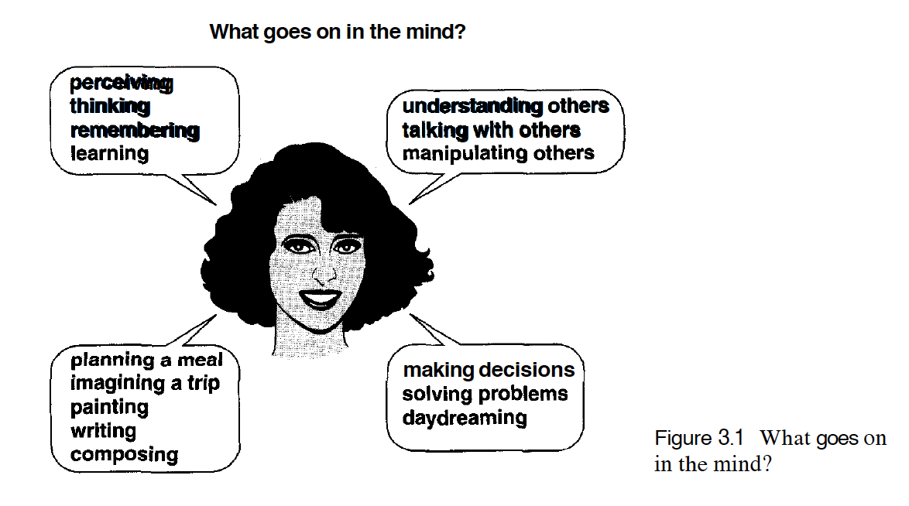

* attention
* perception and recognition
* memory
* learning
* reading, speaking, and listening
* problem solving, planning, reasoning, decision making

Conceptual models:

* Conceptual models based on activities
* Conceptual models based on objects
* A case of mix and match?
* Interface metaphors
* …

Build a conceptual model for the CW by combining with these

diagram

story board

interaction styles

1. designing a low fidelity prototype

Issues of multiple screen sizes

metaphors can be used

provide wireframes

1. High fidelity prototype

Justify design(user manual)

1. Usability testing and Evaluation

-testing : test all links work as expected by you self

Evaluation: heuristic evaluation

usability testing: ask your classmates to test the application and response to the survery

1. Conclusion