**SETUP**

Create API key in Eventbrite, then enter the “Private token” in civi Administer > CiviEvent > EventBrite Integration > Settings

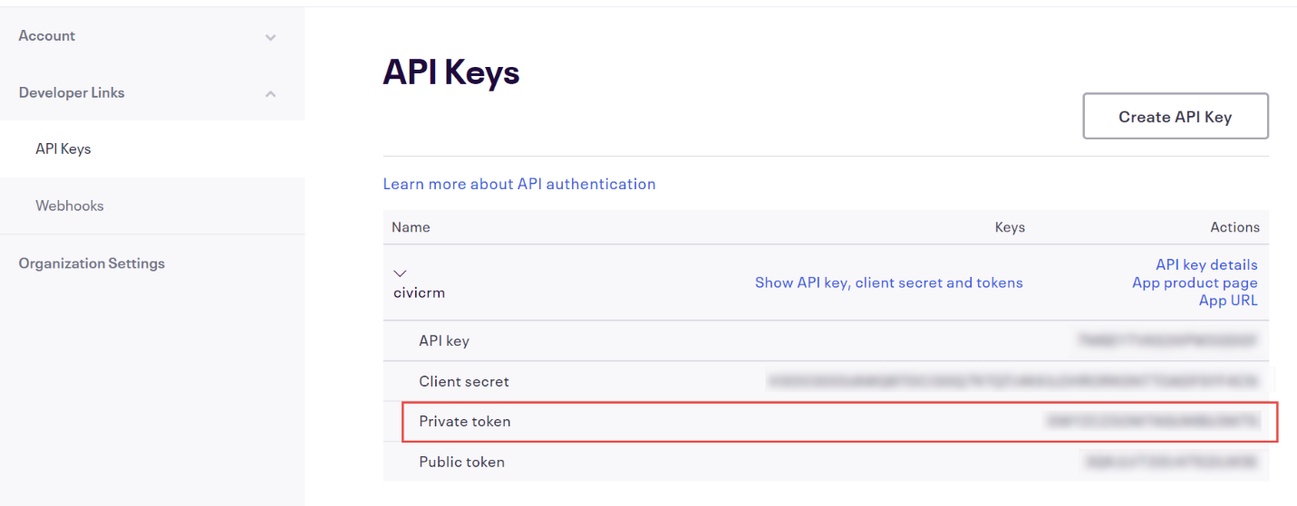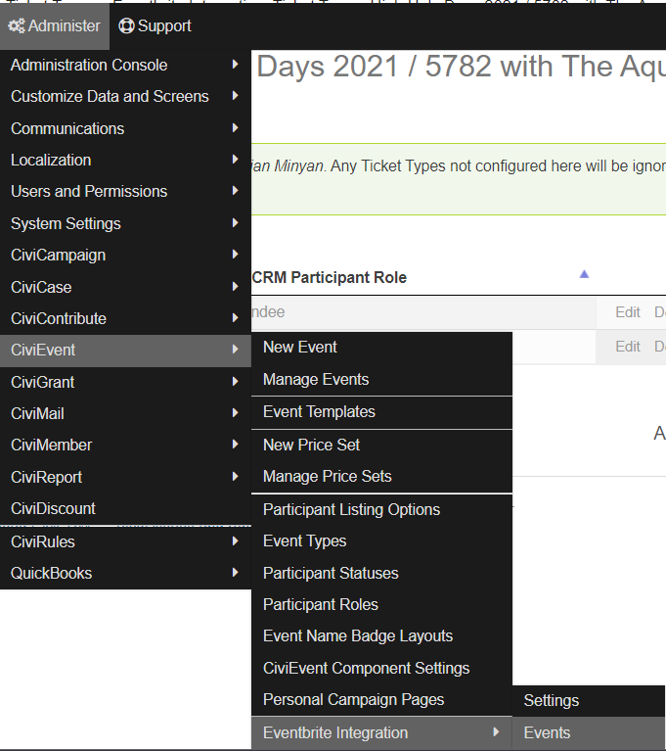

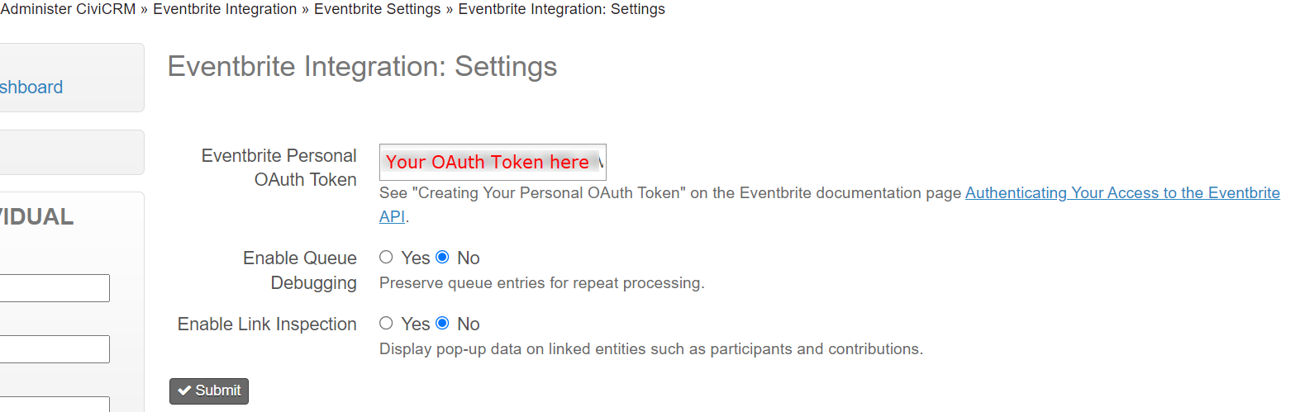

Webhooks should be created on submit.

**THE EVENT**

In Civi, I created a single event for registration. (ID 15679 in the screenshots)

In Eventbrite, the event was set up as a “recurring event” by someone else in my organization. An attendee could register for “all” sessions or select specific dates (total of 5, Schedule > Add Dates).

There were 6 different “tickets” in Eventbrite (1 “all” and 5 individual dates). All tickets were configured as “donation”, meaning people could pay what they wanted. Some people simply chose the “all” ticket and put in a total amount, but others purchased multiple “tickets” for only the days they were going to attend.

To match EventBrite event with CiviEvent, go to civi Administer > CiviEvent > EventBrite Integration > Events and “Add Event”

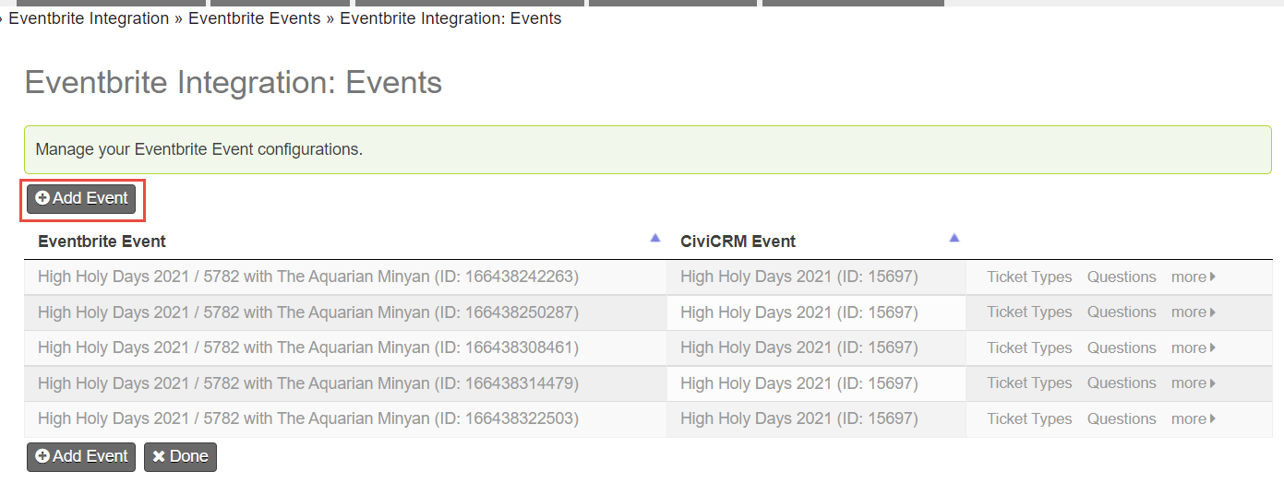

It automatically populates all your Eventbrite events and all your civi events into the dropdown. Note that each event “Date” had its own EventBrite ID and I matched all of these to the single civi event. The “master” event ID did not appear in the drop-down, only the 5 specific dates. 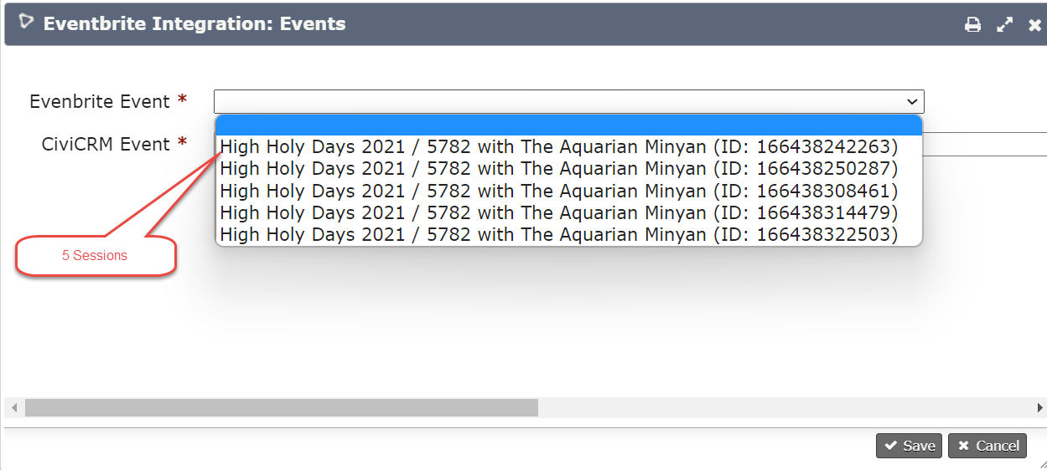

Associate a civi participant role with at least one ticket. Click on “Ticket Types” in the right column and “Add Ticket Type”. This will automatically populate ticket types from EventBrite for that event. Choose the role it is to be associated with. In my case, each “event” aka “session” aka “date” had two ticket types associated: the “All days” and the particular date. 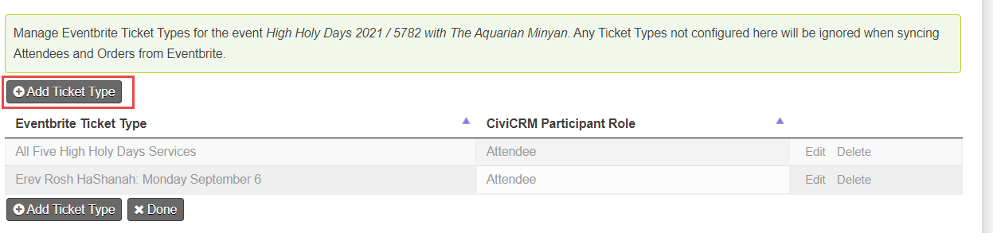

We did not have any questions configured in EventBrite, so didn’t use. Looking at field.php it looks like you can ask a question such as (e.g. “How did you hear about us?”, “Do you need ASL?” and then have that populate to a custom or existing field in civi (e.g. “Referred by”, “Yes”)

Minor UI issue which could be theme-related

