# Employee-Time-Management-System

This is a school team final project

## Table of Contents

* Employee-Time-Management-System
  + Table of Contents
  + Objectives
  + Software Requirements Specification
    - Users
    - Functional Requirements
      * 1. Authentication Module
  + Software Design Description (SDD)
    - User Interface Design
      * Home page
    - Sign Up page
    - Database Design
      * Users Table
      * Attendance Table

## Objectives

## Software Requirements Specification

### Users

1. Employee - This is users is able to login in the system when he/she arrives at the work station and is able to clock when leaving the work station.
2. HRM - View reports of employee attendance and reccommends the necessary plans of action.

### Functional Requirements

#### 1. Authentication Module

1. Creating users accounts
2. Login
3. Profile
4. Logout
5. Reset password
6. Edit profile

## Software Design Description (SDD)

### User Interface Design

This contain sketches of the interfaces. The sketches could draw by hand on a paper or use a prototyping tool like Figma.

#### Home page

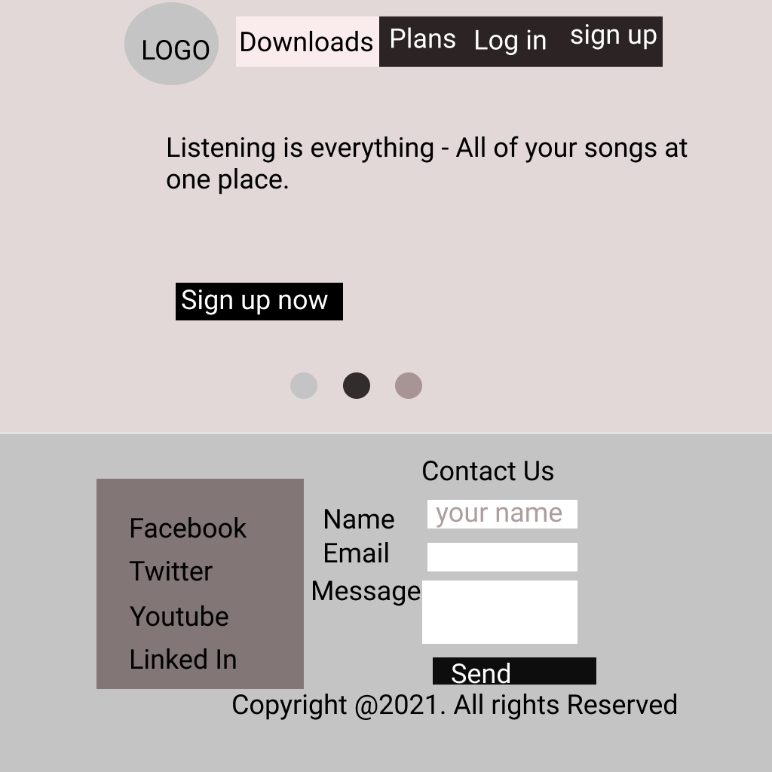

homepage

* navigation bar
* jumbotron / call to action
* Testimonials
* Footer

### Sign Up page

### Database Design

Contains tables of the database.

#### Users Table

|  |  |  |
| --- | --- | --- |
| Column | Type | Lenght |
| id | int (PK) |  |
| first_name | tinytext |  |
| last_name | tinytext |  |
| email | tinytext |  |
| password | text |  |
| user_type | text |  |
| last_updated | date |  |

#### Attendance Table

|  |  |  |
| --- | --- | --- |
| Column | Type | Lenght |
| id | int (PK) |  |
| emp_no | int(FK) |  |
| time_in | datetime |  |
| time_out | datetime |  |