JUSTIN **LE**

ME**@**JUSTINLE**.**PAGE



206.947.6138  SEATTLE, WA

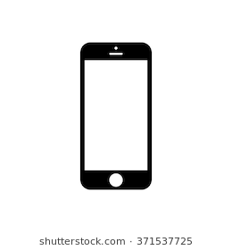

 www.linkedin.com/itsjustinle

**SUMMARY**

Aspiring Developer that is friendly and personable with a long history of customer service experience. I am currently in the process of obtaining my Bachelor of Science from the University of Washington and am strongly interested in a position at a technology driven company.

**PROFESSIONAL EXPERIENCE**

Garage Booth Attendant | WASHINGTON ATHLETIC CLUB

JUNE 2010 – PRESENT

* Serve as an initial point of contact/service for members & guests of the WAC
* Collaborate with the bellman, guests, & valet to queue up cars in an efficient manner
* Communicate (e-mail & phone) with other departments to confirm account charges, daily events, reservations, parking validations, etc.
* Continually update a database of overnight parking charges for guests of the Inn
* Maintain a secure & welcome environment by consistently viewing security cameras

Team Supervisor | MIKE’S SHAVE ICE

JUNE 2018 – PRESENT

* Designed & created company’s logo, t-shirts, etc.
* Educate unfamiliar customers with the product while establishing customer relations
* Work in a small team while facilitating minimal wait times for a high volume of customers
* Setup & breakdown a mobile setup, serving at both public & private events/caterings

Team Supervisor | 20 OZ TEA

JANUARY 2018 – JANUARY 2019

* Assisted with recipe creation & testing
* Sourced ingredients & store supplies from various local/international distributors
* Developed & designed store website per owner’s specifications
* Bar Back responsibilities, e.g. restock ingredients & supplies, brew tea, cook tapioca, etc.

**SKILLS**

Adobe Creative Suite Microsoft Office Suite Point of Sale Operation Fluent Vietnamese  
Customer Service Flexibility Independent & Collaborative Work Multi-Tasking Problem-Solving

**EDUCATION**

Bachelor of Science – University of Washington, Seattle

In Progress, expected completion June 2021

Full-Stack Web Development Certificate – University of Washington, Seattle

In Progress, expected completion May 2020