Sample Client System Certificate Generation _ With KeyStoreExplorer 5.4.1

-------------------------------------------------------------------------------------------------------------------
Start with cloud certificate:

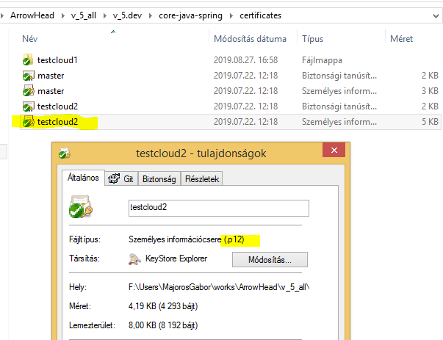
-------------------------------------------------------------------------------------------------------------------
Open it with KeyStoreExplorer:
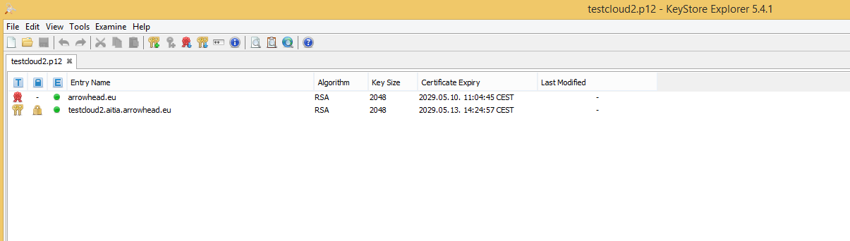

-------------------------------------------------------------------------------------------------------------------
Right-click on keyPair and select SignNewKeyPair:

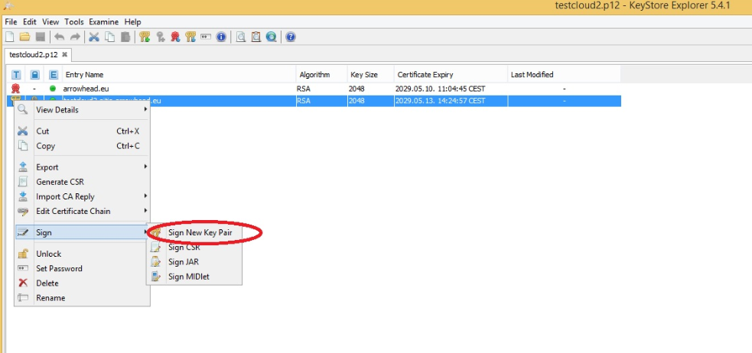
-------------------------------------------------------------------------------------------------------------------
Select RSA.
Set Key Size to 2048.
Then click Ok on Generate Key Pair popup window.

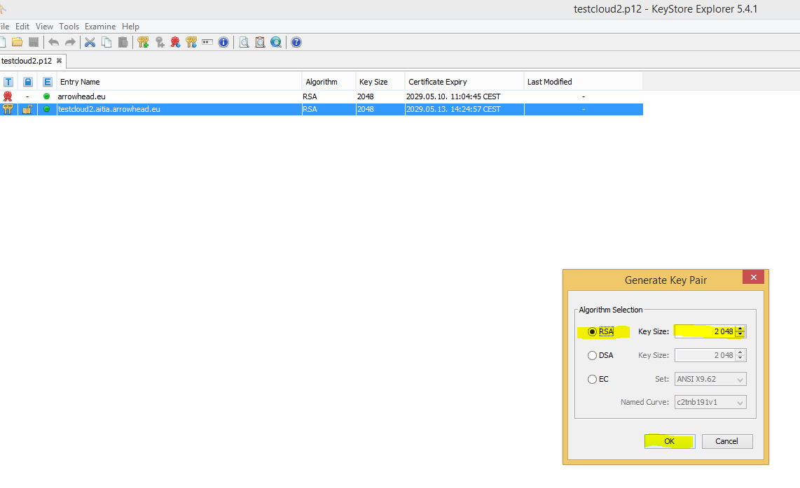

-------------------------------------------------------------------------------------------------------------------
Set validity Period to 10 year.
Click Apply !

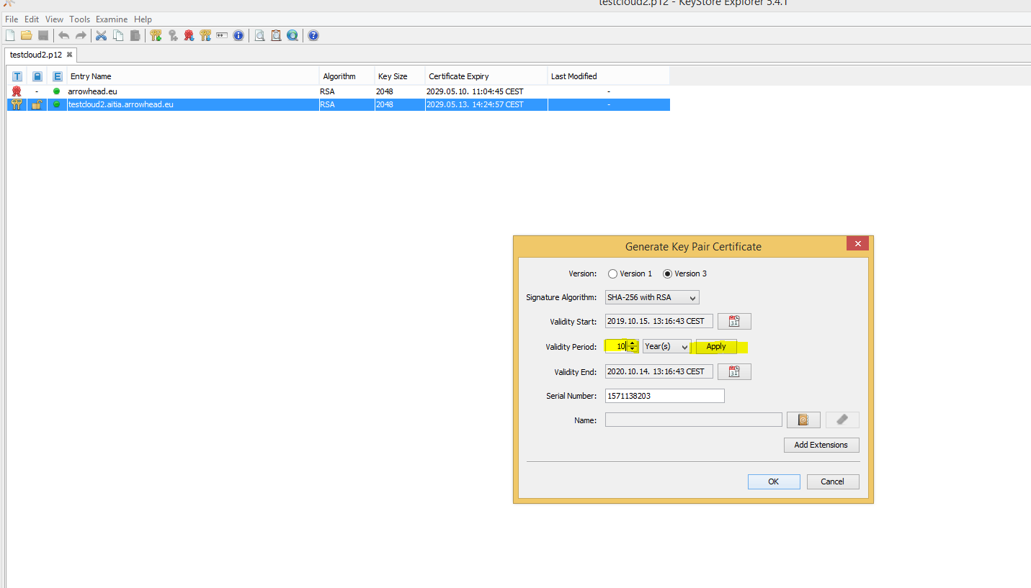

-------------------------------------------------------------------------------------------------------------------
Click on Edit name ( Symbol of a book with @ sign ).

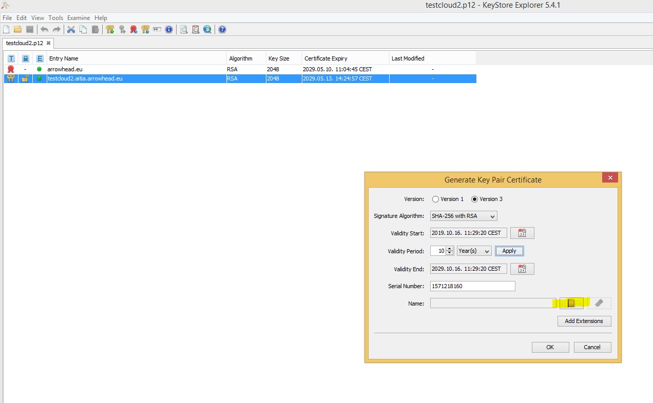

-------------------------------------------------------------------------------------------------------------------
Set Common Name (CN).
Example: your_system.testcloud2.aitia.arrowhead.eu
Then click Ok on Name popup window.

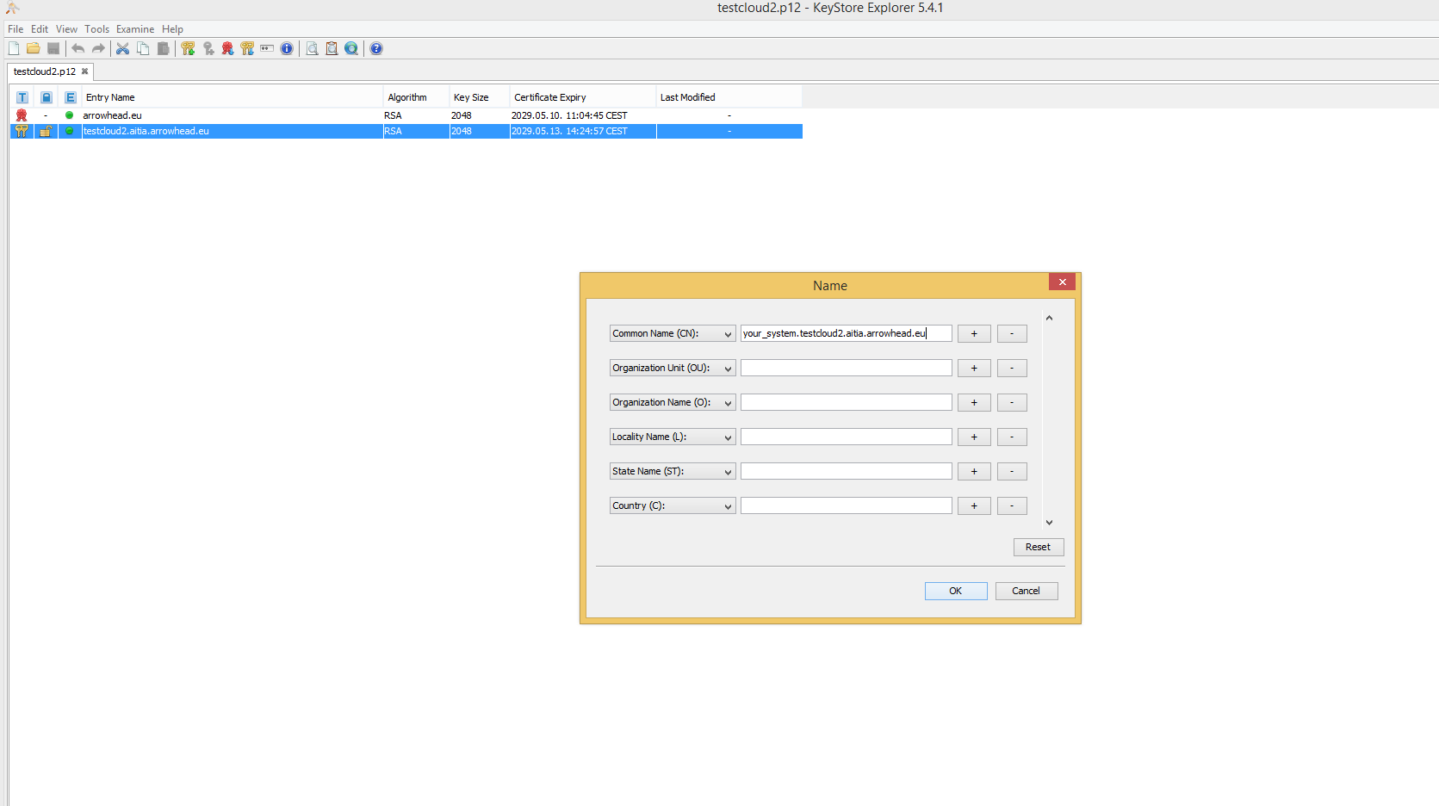

Click Add Extensions

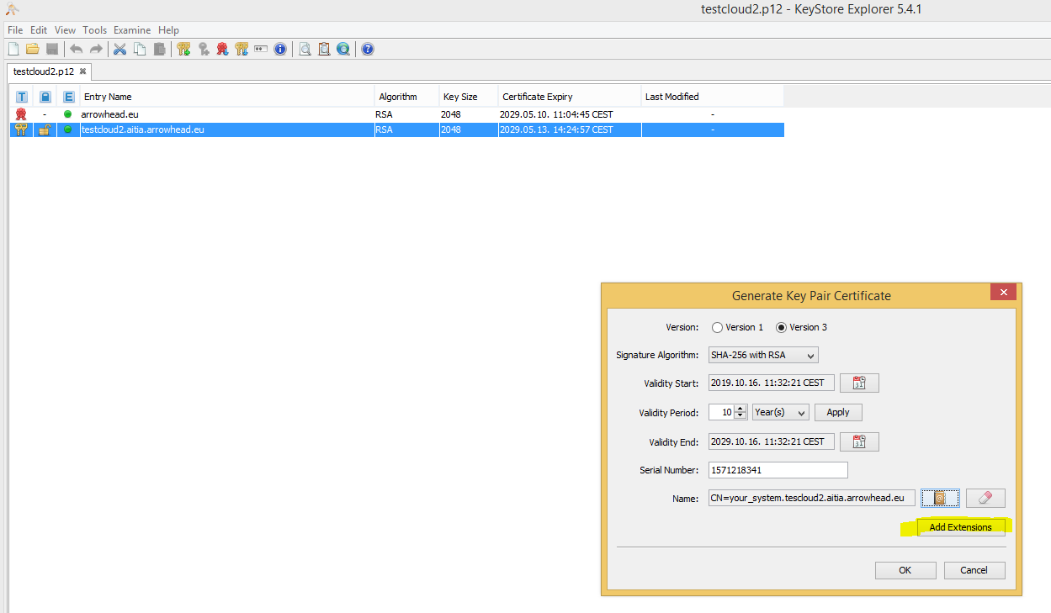

Click green +.
Select Add Authority Key Identifier.
Click key symbol.
Select the 160-bit Hash.
Click Ok on Key Identifier popup window.
Then click Ok on Authority Key Identifier Extension popup window.

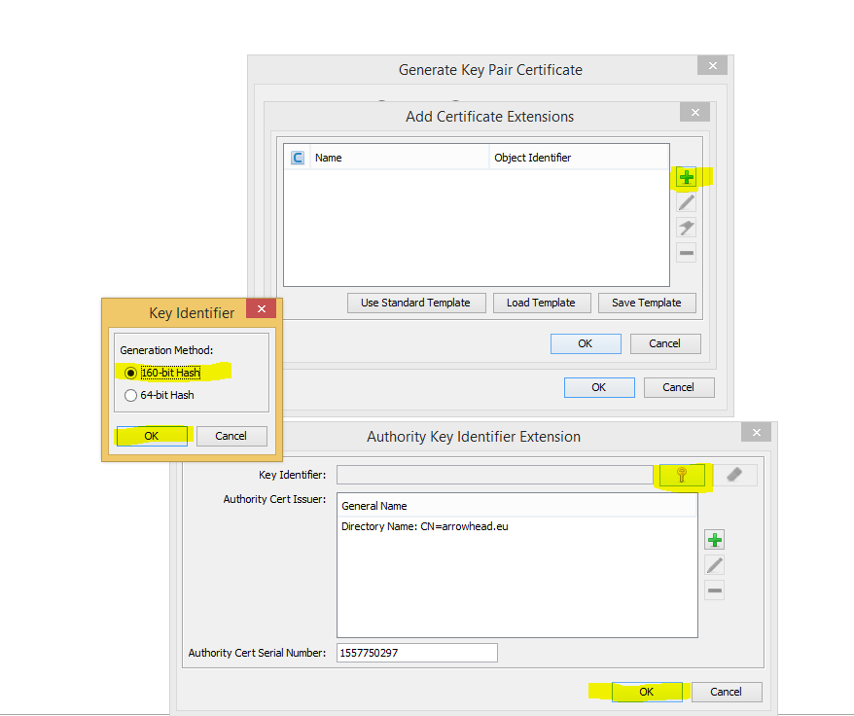

Click green +.
Select Add Subject Alternative Name.
Select DNS Name
Set General Name Value: localhost
Then click ok on the Alternative Name popup window.
Repeat if you want to add your other DNS Names ( for accessing remote services ).

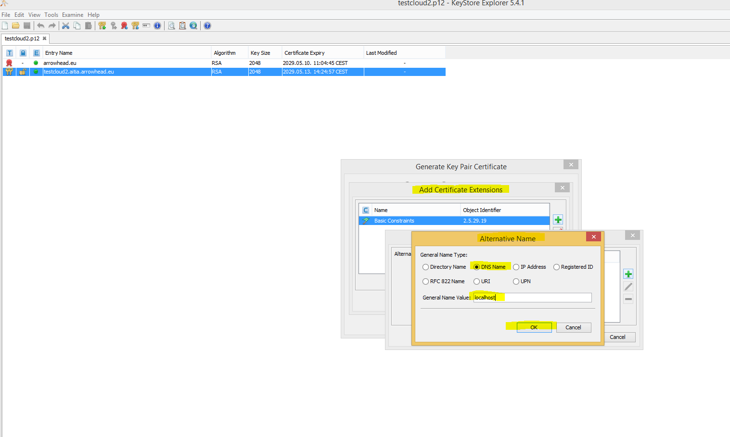

Click green +.
Select IP Address
Set General Name Value: 127.0.0.1
Then click ok on the Alternative Name popup window.
Repeat if you want to add your other IP Address ( for accessing remote services ).
Then click ok on Subject Alternative Name Extention popup window.

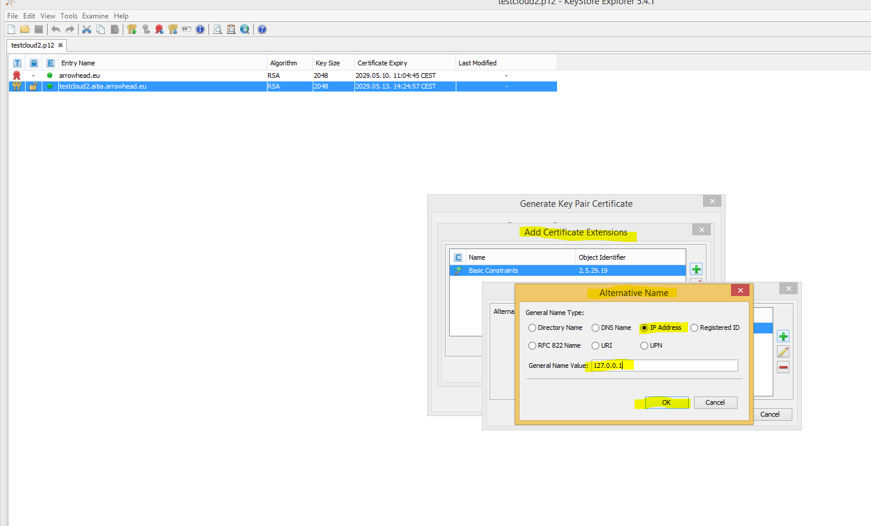

Click green +.
Select Subject Key Identifier
Click Ok on Add Extention Type popup window.
Click on the key symbol.
Select a 160-bit Hash.
Click Ok on Key Identifier popup window.
Click Ok on Subject Key Identifier popup window.
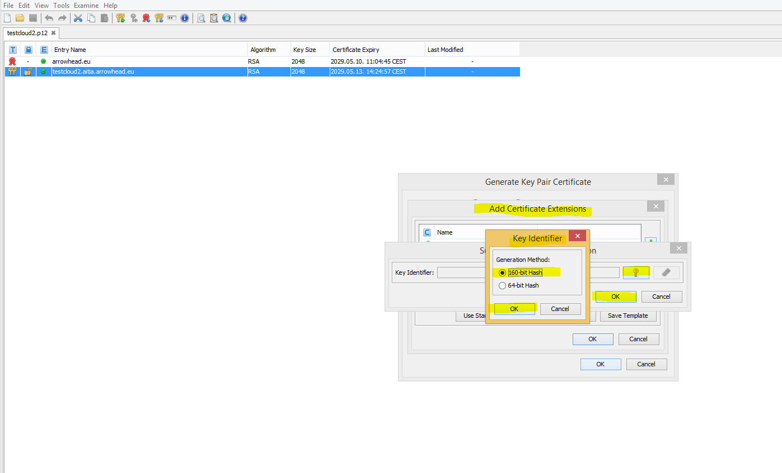
-------------------------------------------------------------------------------------------------------------------
Finished adding extensions - Click Ok on Add Certificate Extensions popup window.

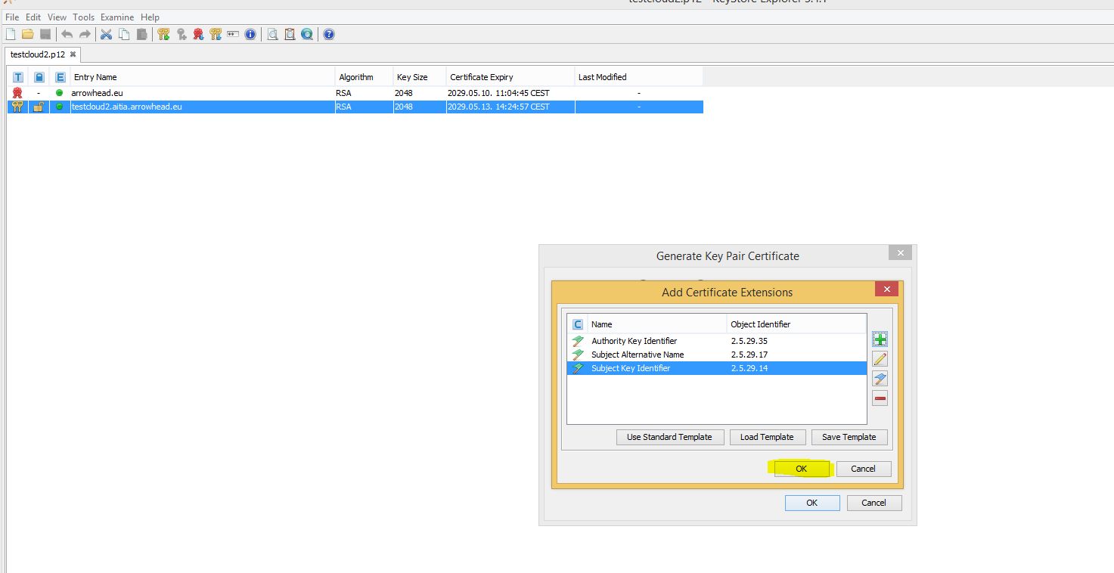
-------------------------------------------------------------------------------------------------------------------
Click Ok on Generate Key Pair Certificate popup window.

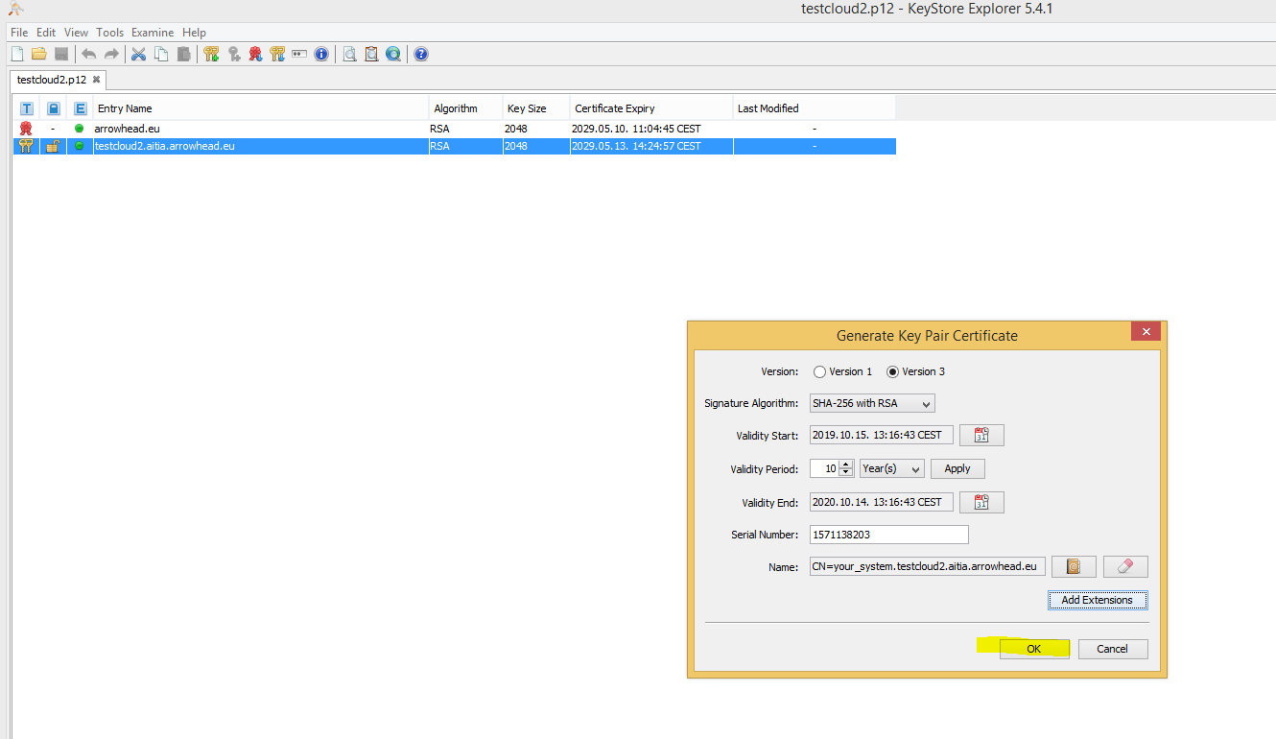
-------------------------------------------------------------------------------------------------------------------
Edit alias of your new keypair – for example : your_system.
Click Ok.

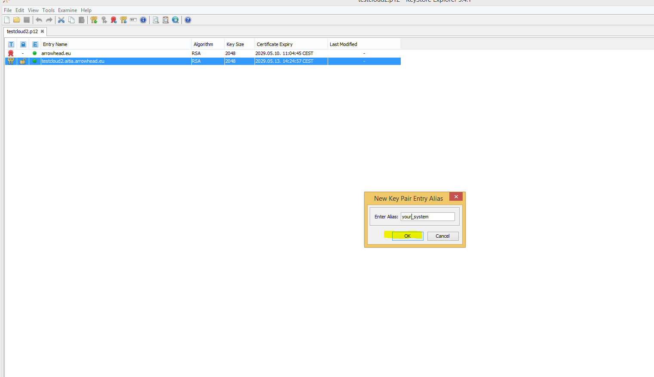

-------------------------------------------------------------------------------------------------------------------
Enter Password for your new keyPair

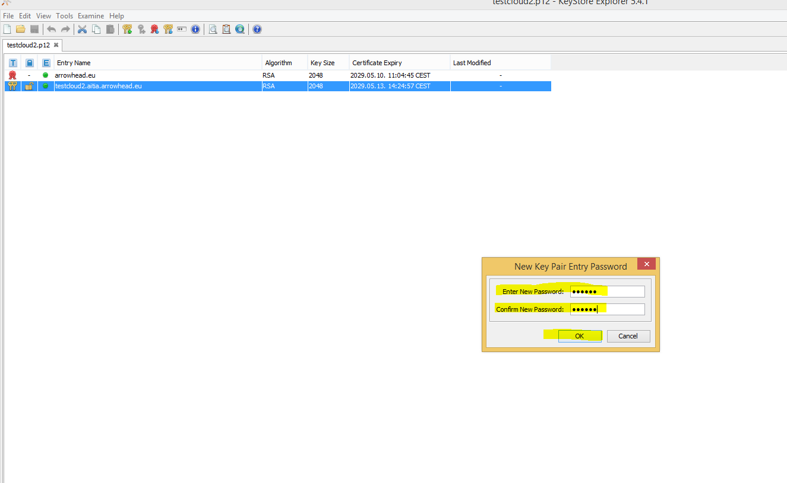
-------------------------------------------------------------------------------------------------------------------
You should see a similar popup window:

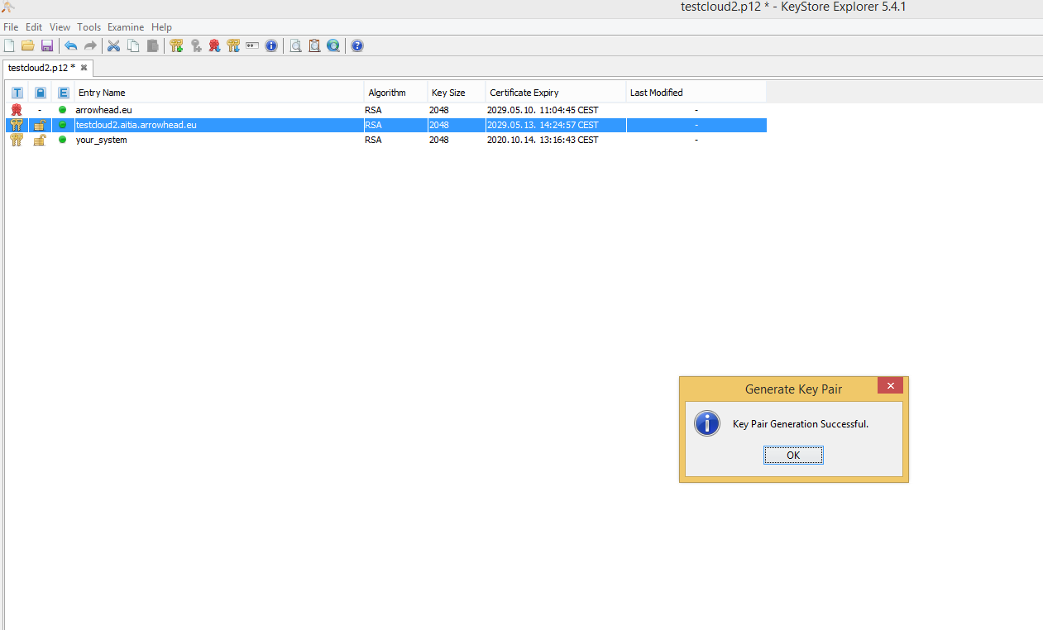

-------------------------------------------------------------------------------------------------------------------
Click and dropp the newly generated keypair to a new tab.
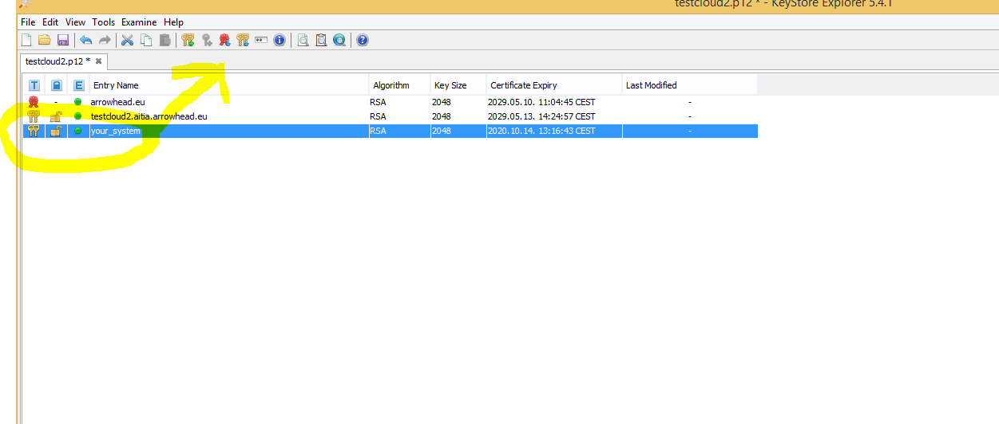

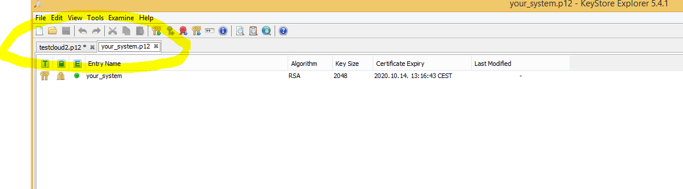
-------------------------------------------------------------------------------------------------------------------
Import trusted master certificate ( the one with crt extension ):
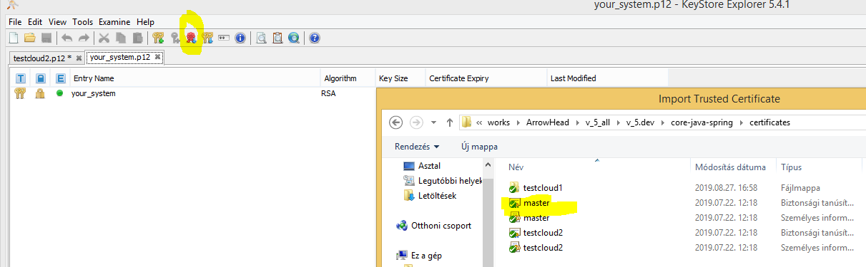

-------------------------------------------------------------------------------------------------------------------
Edit imported master certificate alias – for example: arrowhead.eu
Click ok.

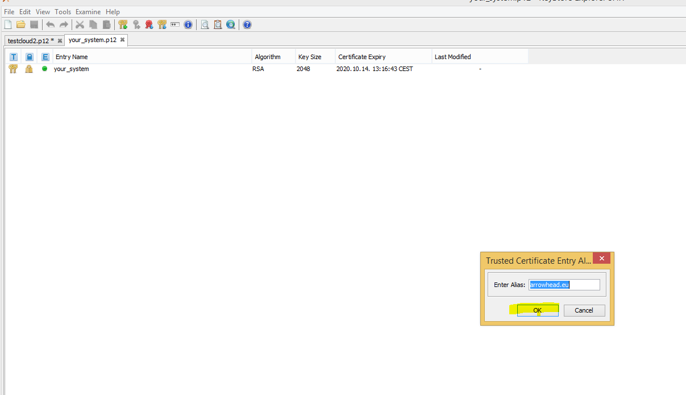

-------------------------------------------------------------------------------------------------------------------
Import trusted cloud certificate ( the one with crt extension ):

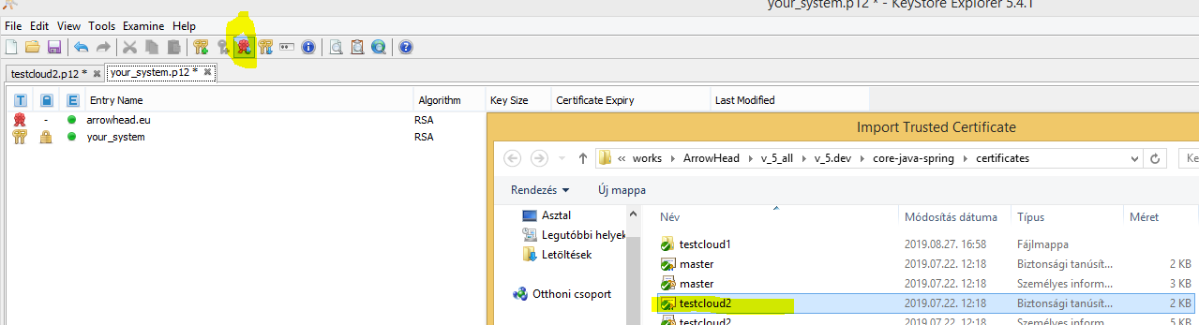

-------------------------------------------------------------------------------------------------------------------
Edit trusted cloud certificate alias – for example : testcloud2.aitia.arrowhead.eu
Click Ok.

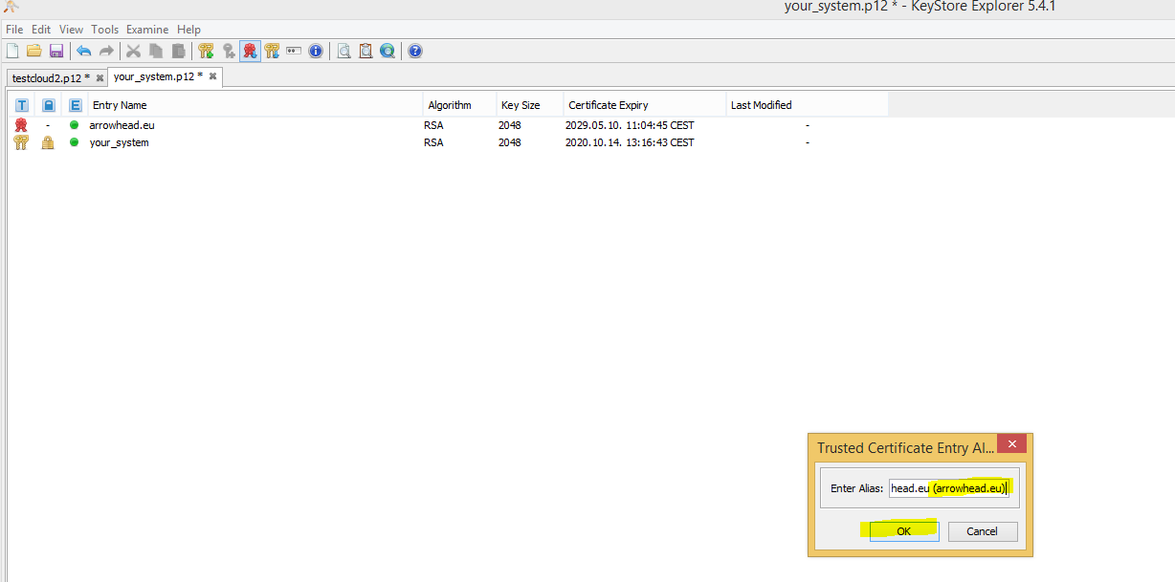

-------------------------------------------------------------------------------------------------------------------
Set Keystore Password:

Click Tools.
Click Set Key Store Password.
Enter Password for KeyStore.
Click Ok.

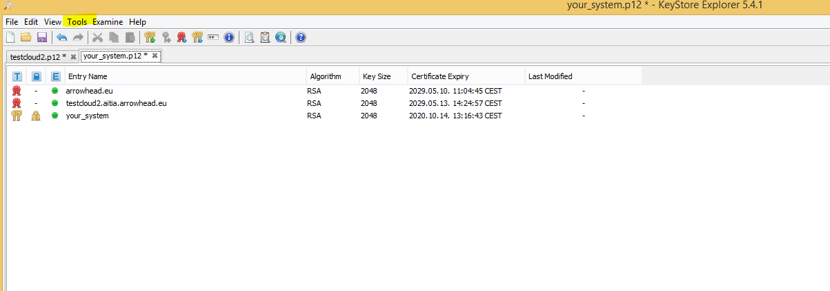

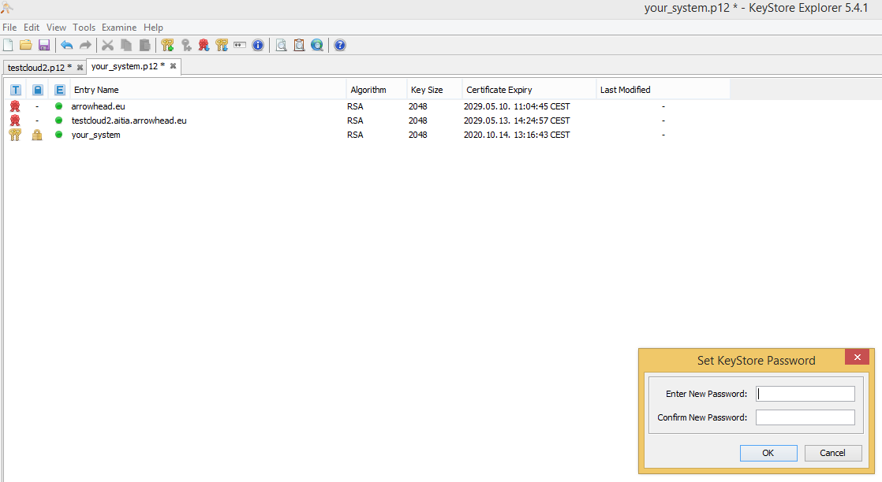
-------------------------------------------------------------------------------------------------------------------
Save As new keyPair as a p12 file – for example: you_system.p12

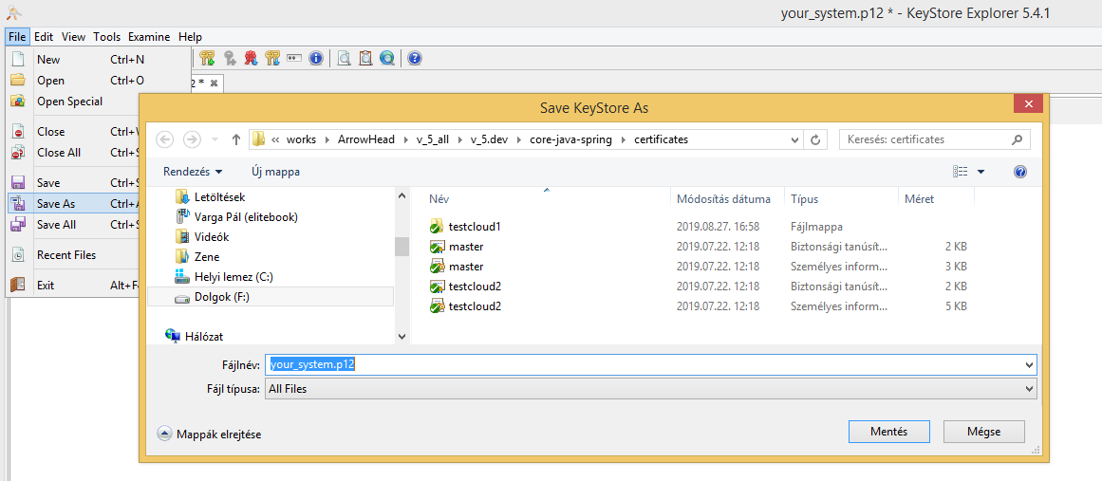

-------------------------------------------------------------------------------------------------------------------
DO NOT SAVE THE CHANGES TO THE ORIGINAL CERTIFICATE!!!

