**ReadMe:**

**1. How to start and dependencies.**

>Install dependencies: npm install

>Code style lint check: ng lint

>Start the server: ng serve

>To run the test: ng test

**I done all bonus points per the requirement.**

For test framework I use karma and jasmine to do the test. I write 12 test sections to cover the common cases. Pls see spec.ts file to view code and comments for details.

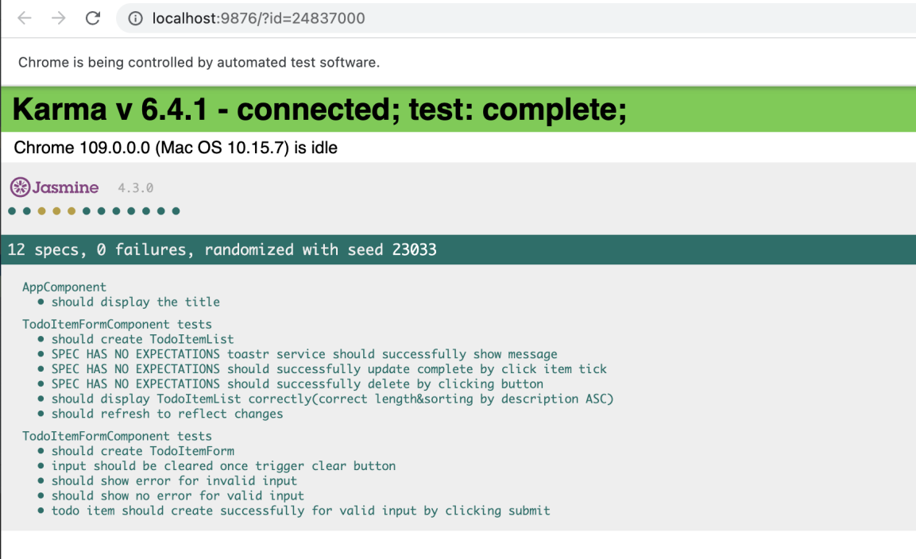

1. Design concept and user guide.

Overall view:

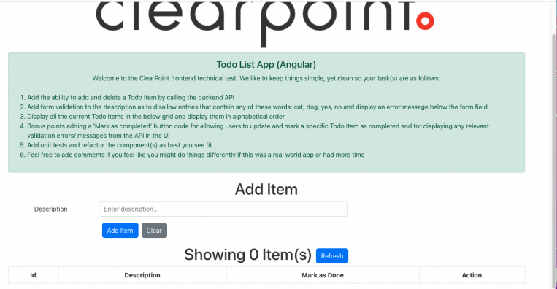

I divide the app into 2 functional components.

Component 1 is form-component to handle input check, add item, clear and subsequent functions.

Case 1: add new item

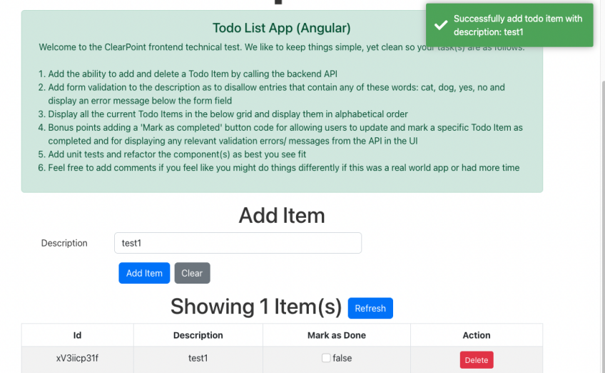

For valid user input, notification will **pop up on right corner screen**. The new item will appear in item-list-component. It use event subscribe mechanism by using a sharedStatusService, **no need to manually click refresh button to reflect the changes.**

Case 2: error input or empty input

For invalid input:

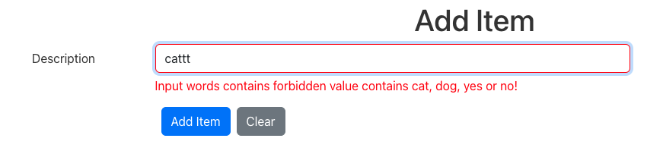

For empty input:

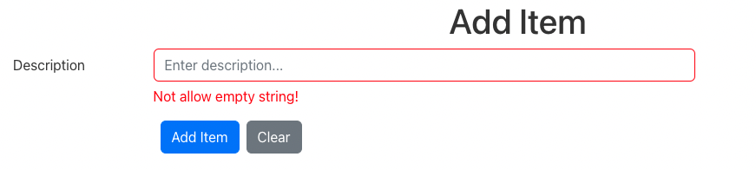

Case 3: clear button

Click clear button will make input field empty.

Component 2 is items-list-component to handle list, refresh, update mark as done status, delete and subsequent functions.

Case 1: List items using ASC order by description.

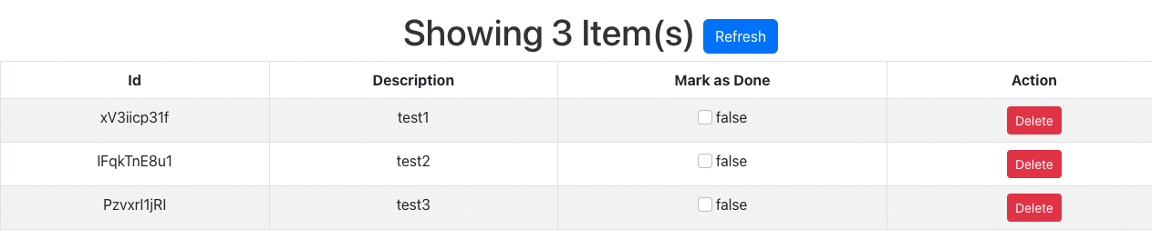

Case 2: Able to update Mark As Done status:

Once click the tickbox, the status will update and reflect on backend. The notification will **pop up on right corner screen**. Meanwhile. The tickbox reflect the changes.

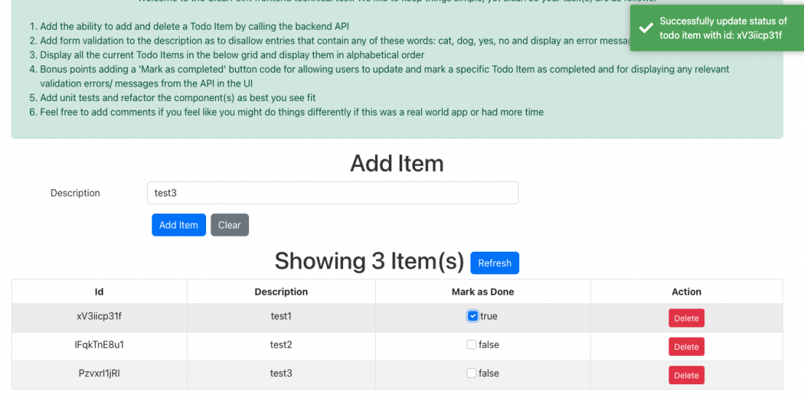

Case 3: Click delete button

A notification will also pop up and delete the select item, the list will immediately reflect the change.

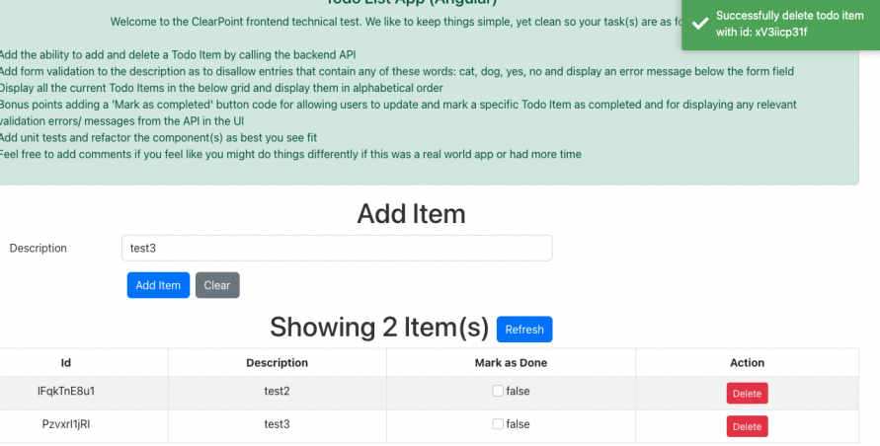

Case for API error return, it will give hint like this. For example, delete an item directly using postman. When trying to update the mark as done status on UI, because the item no longer there, it will show the error message from backend I wrapped.

