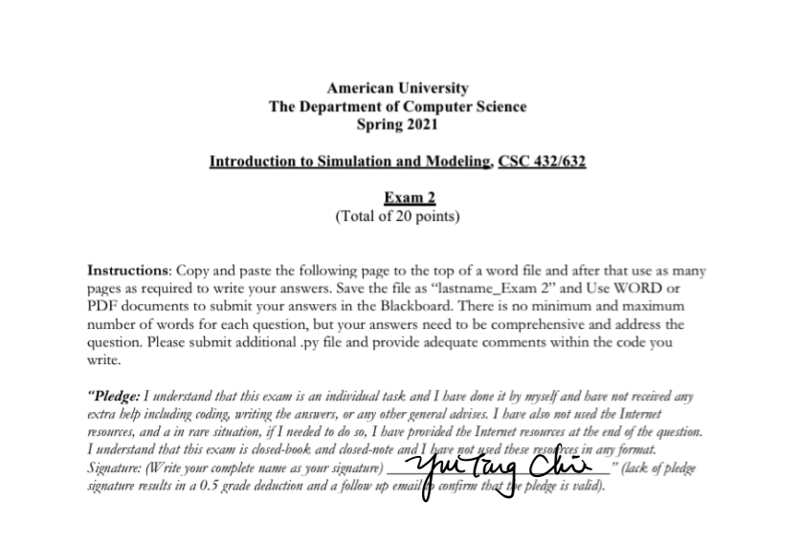

**Question 1 (3 points)**

RUBRIC: (-Write down all steps of the answer. Write down your final answers and explain as needed. Lack of each item results in 0.5-to-1-point deduction)

Delta Airlines quotes a flight time of 2 hours, 5 minutes for its flights from Cincinnati to Tampa. Suppose we believe that actual flight times are uniformly distributed between 2 hours and 2 hours, 20 minutes.

a) Show the graph of the probability density function for flight time.

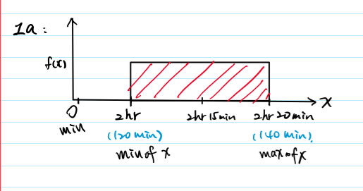

b) What is the probability that the flight will be no more than 5 minutes late?

P(X <= x) = x-a/ b-a

P(X < 2hr 5mins + 5 mins) = P(X < 130) = 130 - 120 / 140 - 120 = 10 / 20 = .5

Ans: The probability that the flight will be no more than 5 minutes late is .5

c) What is the probability that the flight will be more than 10 minutes late?

P(X > x) = 1 - (x-a/ b-a)

P(X > 2hr 5mins + 10 mins) = P(X > 135) = 1-(135 - 120) / (140 -120)

= 1 - 15/20 = .25

Ans: the probability that the flight will be more than 10 minutes late is .25

d) What is the expected flight time?

expected fight time = the mean of flight time

mu = (120+140) / 2 = 130

Ans: the expected flight time is 130 mins.

**Question 2 (4 points)**

RUBRIC: (-Write down all steps and formula. -Write down (or copy) the normal distribution formula in Excel or Python. Write down your final answers. For each item Sketch or draw the normal distribution and highlight the desired area. Lack of providing the graph for each question results in 0.5-1-points grade deduction).

Automobile repair costs continue to rise with an average 2015 cost of $367 per repair (U.S. News & World Report website). Assume that the cost for an automobile repair is normally distributed with a standard deviation of $88. Answer the following questions about the cost of automobile repairs.

We know that the **mu = 367, sd = 88**, and the automobile repair costs follow a normal distribution.

a) What is the probability that the cost will be more than $450?

P(x > 450) = 1- P(x<=450) = 1 - NORMDIST(450, 367, 88, 1) = 0.1727939558

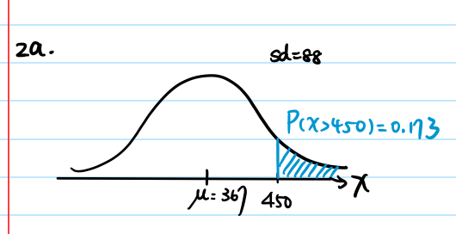

b) What is the probability that the cost will be less than $250?

P(x < 250) = NORMDIST(250, 367, 88, 1) = 0.09183403998

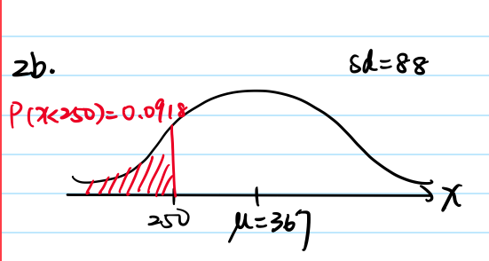

c) What is the probability that the cost will be between $250 and $450?

P (250 < x < 450) = P(x < 450) - P(x < 250)

= NORMDIST(450, 367, 88, 1) - NORMDIST(250, 367, 88, 1)

= 0.7353720042

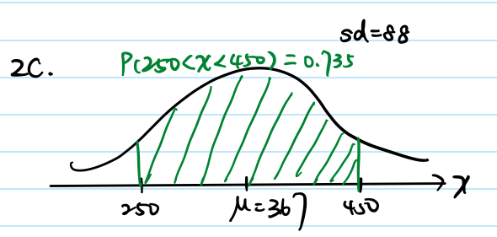

d) If the cost for your car repair is in the lower 5% of automobile repair charges, what is

your cost?

P(x < cost) = 0.05, cost = ?

cost =NORMINV(0.05, 367, 88) = 222.252881

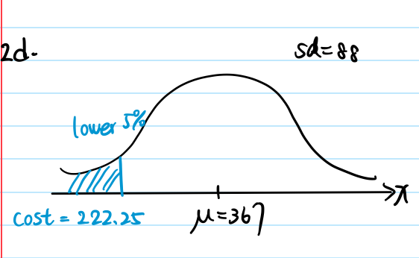

e) If the cost for your car repair is in the upper 3% of automobile repair charges, what is

your cost?

1 - upper 3% = lower 97 % (probability)

P(x < cost) = 0.97, cost = ?

cost =NORMINV(0.97, 367, 88) = 532.5098373

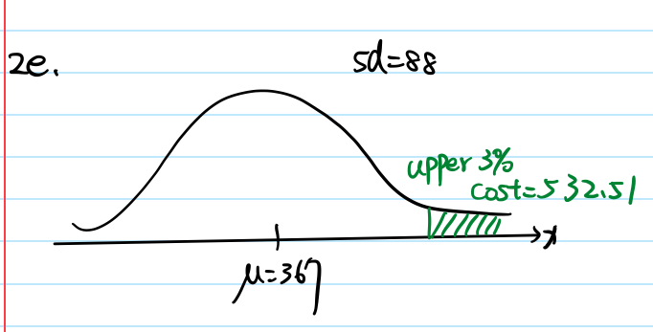

**Question 3 (3 points)**

RUBRIC: (-Write down all steps and formula. -Write down (or copy) the normal distribution

formula in Excel or Python. -Write down your final answers. -For each item Sketch or draw the

normal distribution and highlight the desired area. Lack of providing the graph for each question

results in 0.5-1-points grade deduction).

Sales personnel for Skillings Distributors submit weekly reports listing the customer contacts

made during the week. A sample of 65 weekly reports showed a sample mean of 19.5 customer

contacts per week. The standard deviation was 5.2.

n = 65, x̄ = 19.5, sd = 5.2

According to the t-table, we know that if the degrees of freedom is 64, the t-score is 1.671 when alpha = .1, and the t-score is 2 when alpha = .05. Also, confidence intervals are always two tailed. I use t-table to calculate part a.

T-table: <https://www.statisticshowto.com/tables/t-distribution-table/>

a) Provide 90% and 95% confidence intervals for the population mean number of weekly

customer contacts for the sales personnel.

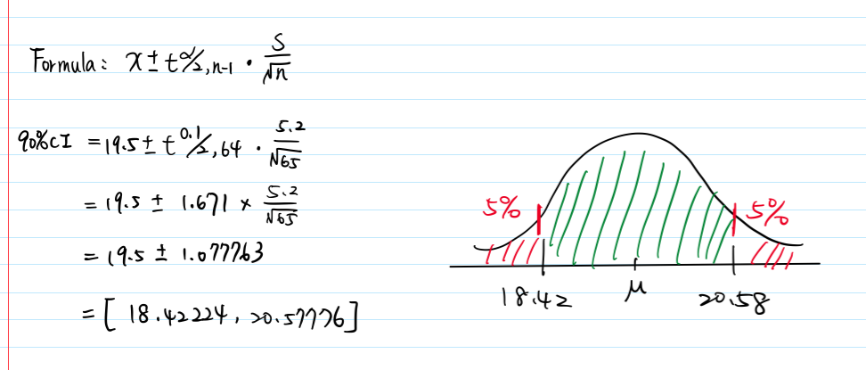

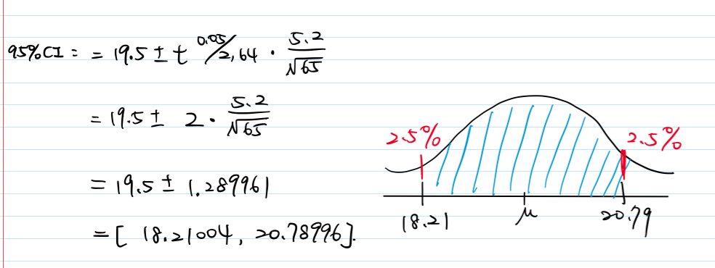

b) Provide the conclusion that you can make based on this interval estimation.

Based on the result, we have 90 % confidence to say that the population mean of weekly customer contacts is between 18.42 to 20.58. Also, we have 95 % confidence to say that the population mean of weekly customer contacts is between 18.21 to 20.79.

c) Repeat Part a) using a Python code. Provide the code file in a .py file and provide

comments within the code. For this problem in python use a t-test (as described in the

class).

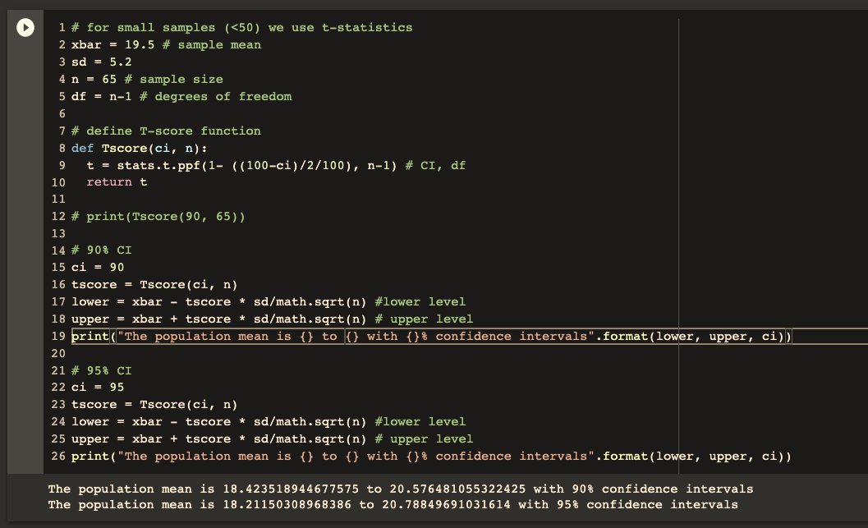

**Question 4 (4 points)**

RUBRIC: (-Write down all steps and formula. -Write down (or copy) the normal distribution

formula in Excel or Python. -Write down your final answers).

Many medical professionals believe that eating too much red meat increases the risk of heart

disease and cancer. Suppose you would like to conduct a survey to determine the yearly

consumption of beef by a typical American and want to use **3 pounds** as the desired margin of

error for a confidence interval estimate of the **population mean** amount of beef consumed

annually. Use **25 pounds** as a planning value for the population standard deviation and

**recommend a sample size** for each of the following situations.

Note: margin of error = 3, sd = 25

Z-score: <https://www.medcalc.org/manual/values_of_the_normal_distribution.php>

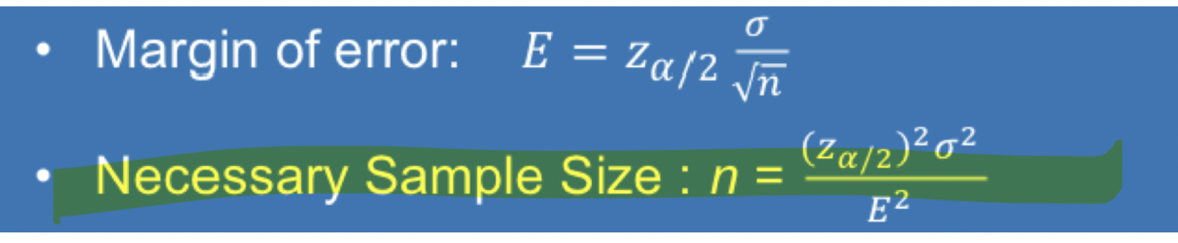

a) A 90% confidence interval is desired for the mean amount of beef consumed.

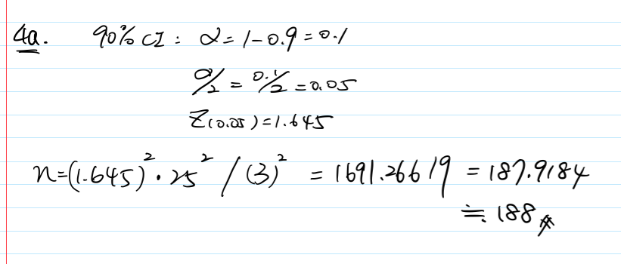

b) A 95% confidence interval is desired for the mean amount of beef consumed.

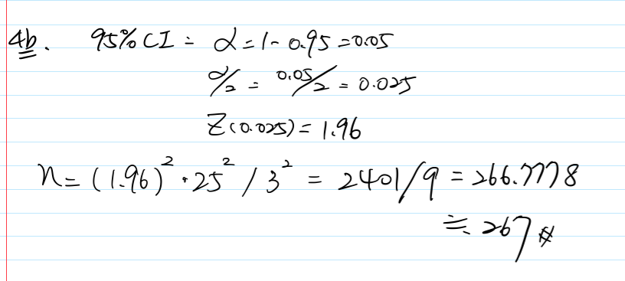

c) A 99% confidence interval is desired for the mean amount of beef consumed.

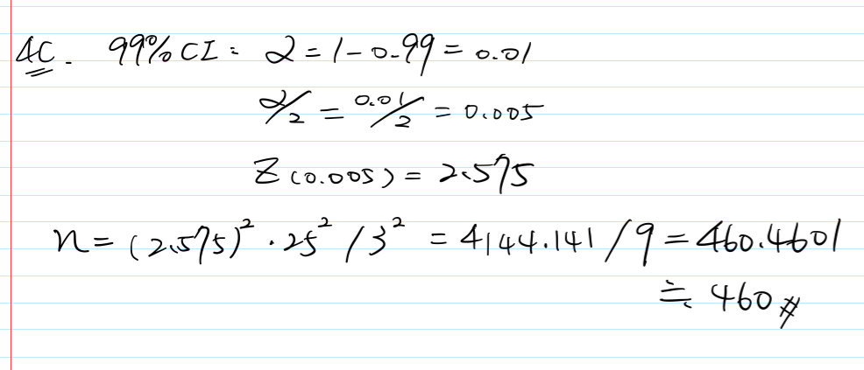

d) For the above three parts Part a-c, write a Python code to calculate the sample size.

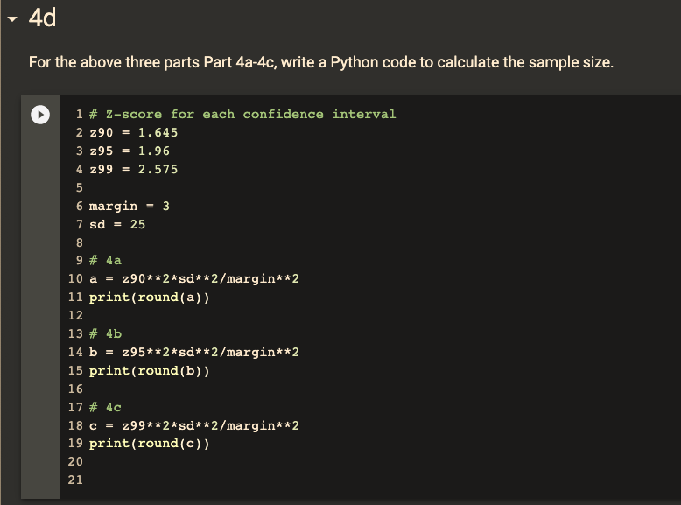

e) When the desired margin of error is set, what happens to the sample size as the

confidence level is increased? Would you recommend using a 99% confidence interval in

this case? Discuss.

compared to 90 %, 95%, and 99 % confidence intervals, the 99 % confidence interval is the most precise. Also, it also recommend 460 sample sizes, which is not a big number, meaning that we can refer to