**AU Air Reservation System**

Introduction

Founded in 2010, AU Air is the largest airline company of AU with greater than 100,000 hours

of flights, 3 million satisfied passengers from 9 different domestic destinations. It has the highest

capacity aircraft, all equipped with modern technology stuffs ensuring quality & safe flying.

AU Air has several branches in different countries. Most branches are in AU on many

states. Its dedicated employees are keen to prove the quality service often recommended by its

customers. AU Air is well known for low airfare for both way routes services across

domestic customers.

Highly dedicated in customer services, AU Air offers several discount schemes for children

and people with disabilities. AU Air has won multiple awards for its safety & reliability

records of flying from national and international organizations.

Due to its high reliability, safety records and highly gained trusts from customers, AU Air is

having more transactions, causing day to day expanding business activities hard to manage its

operations. To ensure more flexible service for customers, it’s highly recommended to

implement an **Airlines Reservation System**, a computerized system that will help manage all

information related to the operation of the system.

**You have been asked to build the AU Air Reservation System.**

**To start, do a more detailed analysis of the above system and provide the following:**

1. In detail, Identify all the appropriate entities (with keys), attributes, relationships, and

constraints

Entities

Airport, Flight_Schedules, Employees, Reservations, Passengers, AU_members

Attributes

* Airport: airport_ID (primary key), airport_name, country, state, city
* Flight_Schedules: flight_ID (primary key), flight_name, arrival_date, arrival_time, departure_date, departure_time, departure, destination
* Employees: employee_ID (primary key), employee_name, country_code, service
* Reservations: passenger_ID (primary key), passenger_name, seat, check-in_status, discount
* Passengers: passenger_ID (primary key), passenger_name, phone, address, sex, email
* AU_members: passenger_ID (primary key), passenger_name, login_ID, passward

Relationships

“passenger ID” is the primary key attribute in Passengers entity. “passenger ID” also has a foreign key in the Reservations and AU_members entities .

Constraints

Airport entity: In the Airport entity, the **airport_ID** is a primary key, meaning that each row is unique and it does not contain a null value. The other columns airport_name, country_code, state, city indicate the detailed information about the airport.

Flight_Schedules entity: The attribute **flight_ID** is a primary key in this entity, meaning that each flight schedule is distinct. On this table, the user can see the arrival and departure times for each flight.

Employees entity: The **employee_ID** is a primary key that represents the details of employees who work for which airline and country and who provide that service.

Reservations entity: The **passenger ID** is used as a foreign key to obtain information about the reservation status, such as seat number, check-in status and the conditions of discount (children or disable people).

Passengers entity: **passenger_ID** is a primary key. the user can know more details about passenger’s information, such as their mobile phone number, address, and sex.

AU_members entity: The **passenger ID** is used as a foreign key. This table contains information about the passenger who is only a member of an AU airline. The user can also find the name of the passenger, as well as their login account and password.

2. Provide a complete ER diagram for the database (Use Visual Paradigm, or similar tool)

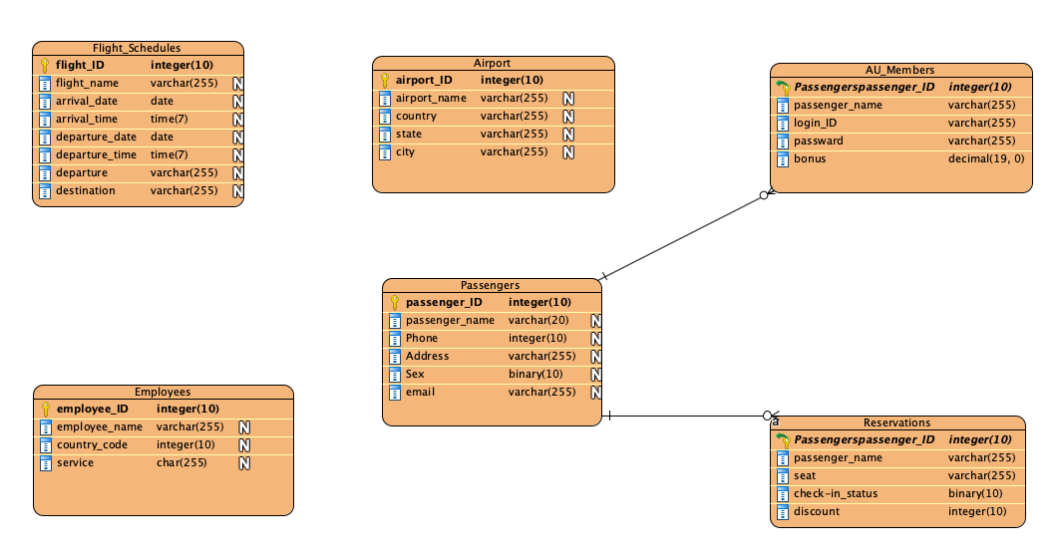

3. Make any assumptions that are relevant to the system. Clearly define your assumption.

Airport

It is basic information to keep track of airport locations. If the users need more detail about the airport, please join from another airport table using airport_ID as a key.

Flight_Schedules

We assume that all arrivals and departures are on time, and that the time zone is set to the headquarters of AU airline.

Employees

The service attribute records the main job description of the employee. It is a character type and the max length of each string is 255.

Reservations

In the Reservations entity, we ignore the reservation process. Only the third-party association will be held accountable for the payment method record. AU Air Reservation System focuses on

the reservation status with passerange’s name. The cost and price of flight tickets is calculated using a different system. The discount attribute is only for children and disable people from the description mentioned.

Passengers

We assume that the gender of Passengers entity only has male and female.

AU_members

AU_members is an internal AU Airline Reservation system system. It keeps track of passengers' membership, and the system assists members in remembering their login ID and password. When AU members book a flight, the system also adds to their bonus.

**Submit your document to AU Blackboard as FirstLastName.pdf.**