**Author: Yunting Chiu**

**Email:** [**yc6705a@american.edu**](mailto:yc6705a@american.edu)

**Design Purpose**

As consumer behavior shifts during the covid pandemic, new roles in e-commerce emerge. Many businesses began to market their products online in order to meet the needs of their customers. Because Amazon has the world's largest ecommerce platform, many retailers want to sell their products through the Amazon online store. But how do they manage their product and keep their budget under control? The goal of an ecommerce company database management system is to assist every retailer in selling their products through Amazon platform.

1) - Define the information content of your database.

Entities: Transaction_Income, Customer, Amazon_Order, Employee, Store, Order_Detail, Category, Product, Transaction_Expenditure, Manufacturer, Stock

Attributes: Please see the following ER diagram for more information. That is, the columns in each entity.

b)-Define a set of relationships that might exist between/among entities and attributes. Such

relationships may include one-to-one, one-to-many and many-to-many associations.

* Customer and Amazon_Order have a 1-M relationship as one customer can place multiple orders on Amazon.
* Amazon_Order and Store have a M-1 relationship as multiple orders can be shipped by one store.
* Amazon_Order and Order_Detail have a 1-M relationship as one ASIN (the primary key in Amazon_Order) can be included multiple order_id.
* Amazon_Order and Employee have an M-1 relationship because one employee can manage multiple ASINs.

c)-Define a set of constraints that may be imposed on data.

* Not null and primary key constraints: The primary key of each entity cannot have a null value. It prevents null values from being entered into one or more columns within a table. On the following SQL sessions, I will show how to create tables with constraints that the primary key has no null value.
* Foreign key: Ir constraint states that the key can only contain values from the referenced main key, ensuring the referential integrity of data linked by the two keys. For instance, set “foreign key (store_id) references Store (store_id)” as a foreign key constraint when you create a table.

2) - Define an E-R Diagram for your database design.

**#**

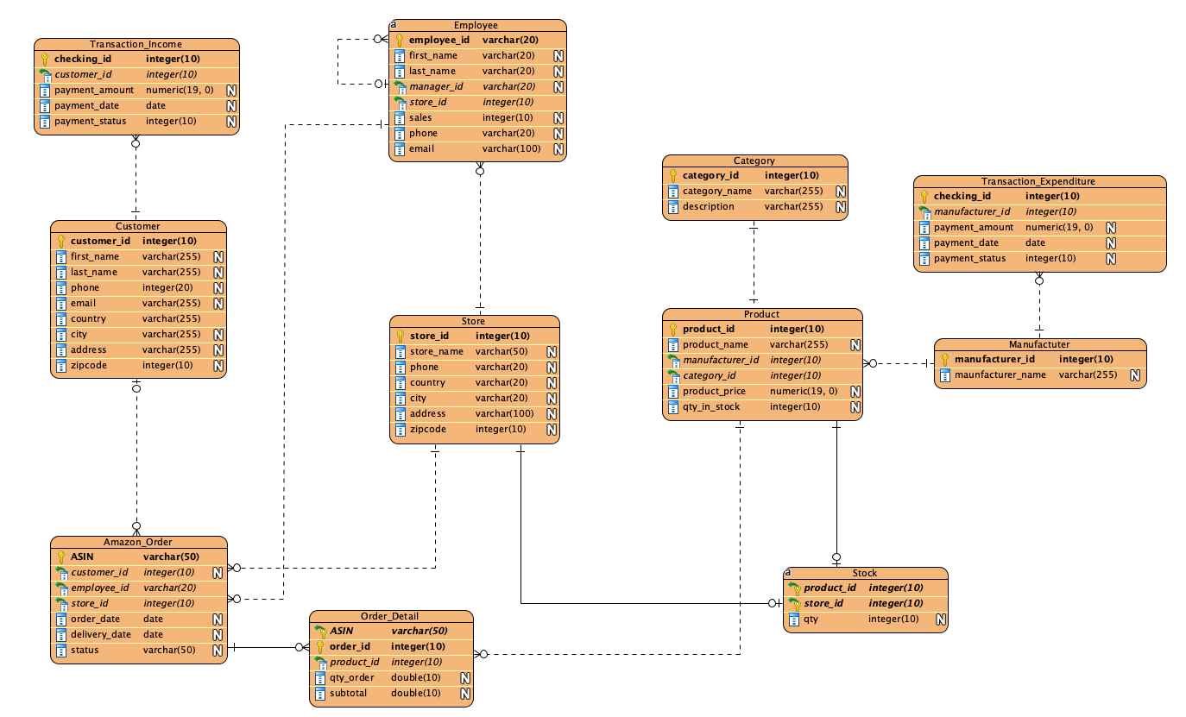

3) - Define a relational schema for your database design. Make sure that you have both one-to-many and many-to-many associations.

4) Implementation: Create your database using MySQL, or… to Perform the following operations. Create 4 tables from your database project that are connected/linked together and insert a few dummy records into these tables. Then use these tables to answer the following queries.

I'm going to create four tables: Employee, Store, Order_Detail, and Amazon_Order with 6 tuples in each entity.

**Create a Database**

create database if not exists ecomDB;

use ecomDB;

**Create Tables**

# create a Store entity

create table if not exists Store (

store_id int not null primary key,

store_name varchar(50) not null,

phone varchar(20),

country varchar(20),

city varchar(20),

address varchar(100),

zipcode int

);

# create a Employee entity

create table if not exists Employee (

employee_id varchar(20) not null primary key,

first_name varchar(20) not null,

last_name varchar(20) not null,

manager_id varchar(20),

store_id int,

sales int,

phone varchar(20),

email varchar(100) not null unique,

foreign key (manager_id) references Employee (employee_id),

foreign key (store_id) references Store (store_id)

);

# create a Amazon_Order entity

create table if not exists Amazon_Order (

ASIN varchar(50) not null primary key,

customer_id int,

employee_id varchar(20),

store_id int,

order_date date,

delivery_date date,

status varchar(50),

foreign key (employee_id) references Employee (employee_id),

foreign key (store_id) references Store (store_id)

);

# create a Order_Detail entity

create table if not exists Order_Detail (

ASIN varchar(50) not null,

order_id int not null,

product_id int,

qty_order double,

subtotal double,

PRIMARY KEY (ASIN, order_id)

);

**POPULATING THE TABLES**