# CSC 476/676 Computer vision

# Homework 1: simple vision system. (55+5pts)

Due: 11:59pm, Feb 5, 2021

Late policy applies (each late hour 5% reduction after mid-night round up to next hour).

No homework is accepted after 5 days of the due date.

Knowledge required: Python, Numpy, Scipy, Image Convolution, Image gradients, Edge detection.

Required reading: SimpleVision.pdf, Szeliski Chapter 3

Be sure to finish the tutorial and the exercise PythonTutorial.ipynb before you try this homework. It is important you understand how to code in Numpy.

## Instructions:

1. Finish the python tutorial (***PythonTutorial.ipynb***) I uploaded on blackboard last week. Make sure to run all of the code and finish the exercises. These are crucial for future homework. You can use [google colab](https://colab.research.google.com/notebooks/intro.ipynb#recent=true) to finish your homework but make sure to send the correct link and also a notebook file (.ipynb) together with your media files . If you use your own laptop and please send both .py and the notebook.
2. Read ***chapter_01_simplesystem.pdf***, **Lecture 2&3 slides.**
3. Please type your equation solutions in a document ( Recommend [Latex](https://www.latex-project.org/get/) but you can also use word). Please save your report as as ***ps1_yourfirstname_yourlastname***.
4. Please read course syllabus for collaborative policy.
5. Please submit all of your work (.ipynb, .py and your report) in a zipped folder to blackboard. No email. Please do not share your code on Github at least 24 hours after due date.

### Problem 1. A simple image formation model (10pts)

The goal of this first exercise is to take images with different settings of a camera to create

pictures with perspective projection and with orthographic projection. Both pictures should

cover the same piece of the scene. You can take pictures of real places (e.g., the street, a living

room, ...) or you can also create your own simple world (e.g., you can print simpleWorld.pdf

and create your own scenes. I recommend printing on mate paper).

To create pictures with orthographic projection you can do two things: 1) use the zoom of the

Digital camera, 2) crop the central part of a picture. You will have to play with the distance between the camera and the scene, and with the zoom (or amount of cropping) so that both images look as similar as possible only differing in the type of projection (similar to figure 1.4, in the lecture 1 notes). Submit the two pictures and label out clearly which parts of the images reveal their projection types.

### Problem 2. Orthographic projection (10pts)

Prove the projection equations (eq. 1.2 and 1.3 in chapter_01_simplesystem.pdf) that relate the coordinates of one point in 3D world and the image coordinates of the projection of the point in the camera plane. You can use drawings or sketches if necessary.

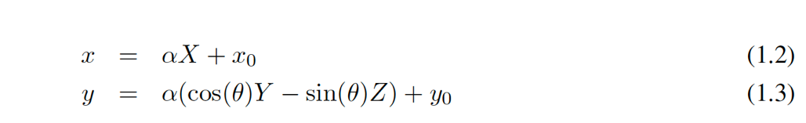

### Problem 3. Constraints (10pts)

In the Lecture slide, we have written all the derivative constraints for Y(x,y). Write the constraints for Z(x,y).

## Problem 4. Approximation of derivatives. (10pts)

Fill the missing kernels (lines 51 and 65 in Build Constraints) in the script *SimpleWorld.ipynb.*

Please include your answers also in the report.

## Problem 5. Run the code. (10pts)

Select some of the images included with the code and show some new view points on them.

You can also try with new images taken by you if you decide to create your own

simple world.

## Problem 6. Violating simple world assumptions. (5pts)

Find one example from the four images provided with the problem set (img1.jpg, ..., img4.jpg)

when the recovery of 3D information fails. Include the image and the reconstruction in your

writeup, and explain why it fails.

## Problem 7. The real world. (Extra 5pts)

A research problem is a question for which we do not know the answer. In fact, there might

not even be an answer. This question is optional and could be extended into a larger course

project.

The goal of this problem is to test the 3D reconstruction code with real images. A number

of the assumptions we have made will not work when the input are real images of more

complex scene. For instance, the simple strategy of differentiating between foreground and

background segmentation will not work with other scenes.

Try taking pictures of real-world scenes (not the cubes) and propose modifications to the

scheme proposed in this lecture so that you can get some better 3D reconstructions. The goal

is not to build a general system, but to be able to handle a few more situations.