# Progress report

## What has been done

### Research topic

Forecasting the Ammonia Concentration in the Reclaimed Water using Machine Learning.

### 2021 Sep & Oct

* 9/21 – Progress report
  + Using manually collected data to forecast NH $​_{3}$ N.
  + Train model with DO, colour, etc.
* 9/30 – Finish setting up colour spectrophotometer.
* 10/5 – Install colour photospectrometer on-site.
* 10/12 – Complete photospectrometer introduction video.
* 10/22 – Work with Zhao Jing (ML models training).

### 2021 Nov & Dec

* 11/29 – Group presentation
  + Use RF, DNN, and LSTM models to forecast ammonia.
  + Models were trained with different input size and with or without data smoothing filter.
  + Ammonia data was collected in May and June.
* 12/15 – Confirm thesis outline structure with Dr. Yin.

### 2022 Jan & Feb & March

* 1/21 – Group presentation
  + Use 5 more models to forecast ammonia.
  + Introduce a new data smoothing filter and outlier removal method to perform data cleaning.
  + Ammonia data was collected in Nov and Dec.
* 2/21 – Progress report to Dr. Yin (to confrim the ACS abstract content)
* 2/25 – Last day of calibrating colour spectrophotometer in SHW.
* 3/10 – Submission of ACS abstract.
* 3/18 – Finalize the coverage of my reserach works.

## Future plan

### April & May

* 4/22 – Finish MPhil thesis 1 $​_{st}$ draft.
* 4/22 – Group presentation.
* 5/11 – EVNG 6050X presentation.
* 5/27 – Finish MPhil thesis 1st revision.  
  (Start to shcedule time for oral defense)

### June & July

* June – Preparing for oral defense
* Jul – Oral defense

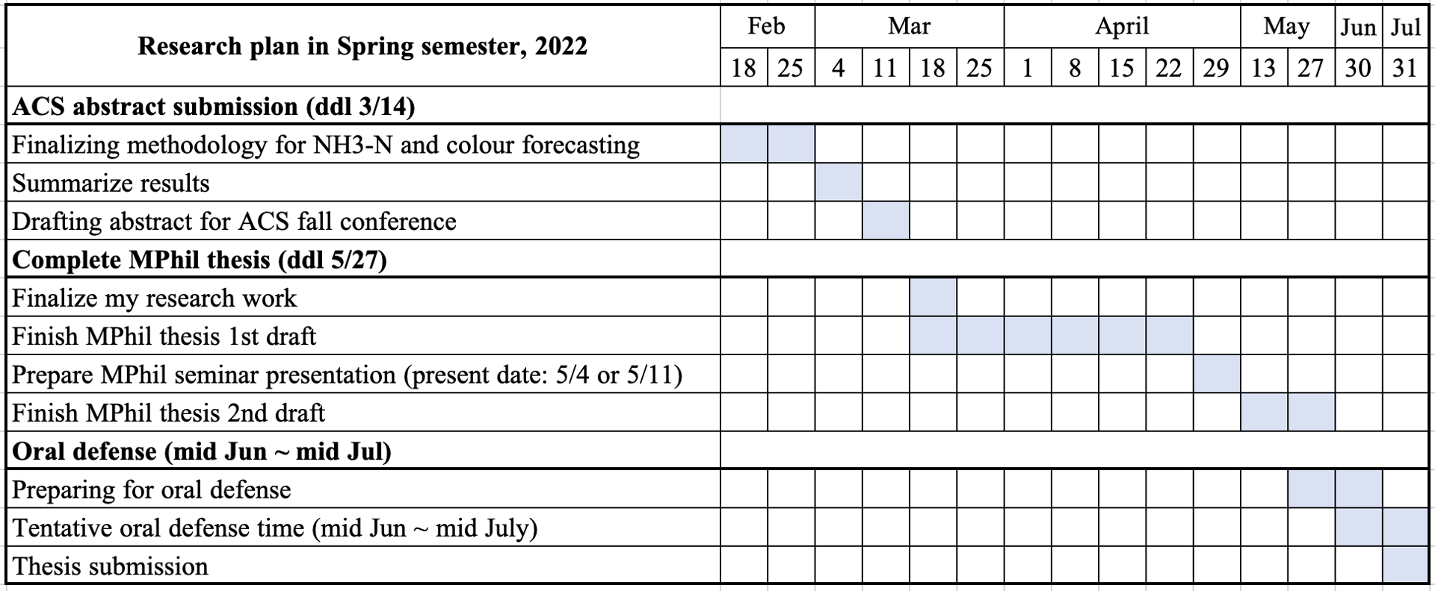

## Progress report

### Key findings in Feb and March

* Train ammonia forecasting model with colour decreased the model performance.
* New method was used to increase the model training data quality (i.e., feature engineering).
* New state-of-the-art model (Transformer) is used and a better model performance is achieved compared to LSTM and DNN.