## What has been done

### Research topic

Forecasting the Ammonia Concentration in the Reclaimed Water using Machine Learning.

### 2021 Sep & Oct

* 9/21 – Progress report
  + Use manually collected data to forecast NH $​_{3}$ N.
  + Train model with DO, colour, etc.
* 9/30 – Finish setting up colour spectrophotometer in lab.
* 10/5 – Install colour photospectrometer on-site at SHW.
* 10/12 – Finish editing photospectrometer introduction video.
* 10/22 – Work with Zhao Jing (ML models training).

### 2021 Nov & Dec

* 11/29 – Group presentation
  + Use sensor collected data in May and June to forecast NH $​_{3}$ N.
  + RF, DNN, and LSTM models were used.
  + Models were trained with different input size and with/without data smoothing filter (i.e., data cleaning).
* 12/15 – Confirm thesis outline structure with Dr. Yin.

### 2022 Jan & Feb & March

* 1/21 – Group presentation
  + Use sensor collected data in Nov and Dec to forecast NH $​_{3}$ N.
  + 5 more models were used.
  + Models were trained with two data smoothing filters and outlier removal method.
* 2/21 – Progress report to Dr. Yin to confrim the ACS abstract content.
* 2/25 – Last day of calibrating colour spectrophotometer at SHW.
* 3/10 – Submission of ACS abstract.
* 3/18 – Finalize the coverage of my research works.

## Future plan

### April & May

* 4/22 – Finish MPhil thesis draft.
* 4/22 – Group presentation.
* 5/11 – EVNG 6050X presentation.
* 5/27 – Finish MPhil thesis 1 $​^{st}$ revision.  
  (Start to shcedule time for oral defense)

### June & July

* June – Preparing for oral defense
* Jul – Oral defense

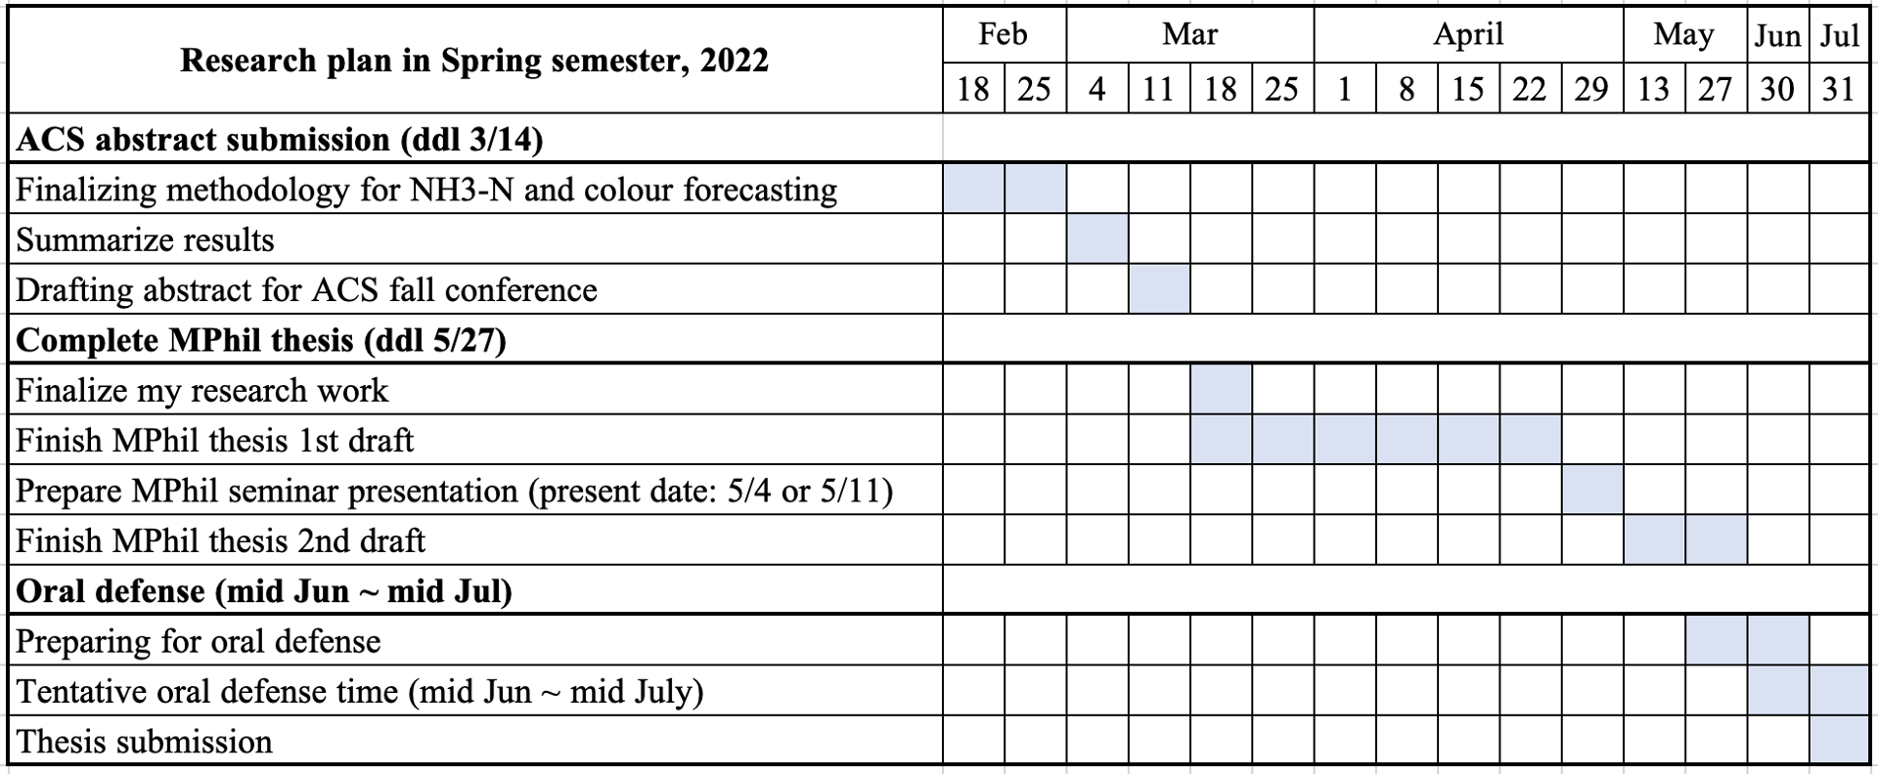

## Progress report

### Key findings in Feb and March

* 2/13 – Train ammonia forecasting model with colour data decreased the model performance.
* 3/2 – New state-of-the-art model (Transformer) was used and a better model performance was achieved compared to LSTM and DNN.
* 3/5 – Feature enginnering was applied to increase the model performance, and the improvement of the model can be explained in environmental engineering perspective.
* 3/10 – Submit ACS abstract.
* 3/18 – Finalize the coverage of my research works.
* 3/29 - Second draft of my thesis outline.