Forecasting Ammonia Concentrations and Color Levels using Machine Learning for Reclaimed Water Treatment Operation and Management

Ting Hsi LEE

Water scarcity is a global challenge, and one of the promising ways to mitigate the water resource crisis is via wastewater reclamation. Chlorine is commonly used for reclaimed water disinfection and requires precise dosing to satisfy endorsed quality standards. Ammoniacal nitrogen (NH-N) and colour substances exist in the reclaimed water, which consumes chlorine and affects the chlorine dosing. Therefore, the on-line monitoring of NH-N and colour are usually practiced in reclaimed water facilities. However, the conventional on-line analyzers are wet-chemistry-based, and the measurement takes time. The limitation creates a potential issue: there may not be sufficient time for the downstream chlorine dosing system to respond to sudden surges in color and ammonia levels. To tackle this challenge, this thesis work developed time-variant models based on machine learning to predict the NH-N concentrations and colour levels in the reclaimed water three hours into the future. For the training dataset, the NH-N and colour data were collected by an on-line analyzer and a customized auto-sampling spectrophotometer, respectively. Both are installed in a reclaimed water treatment facility in Hong Kong. Baseline models for forecasting ammonia concentrations and colour levels were first developed with five machine learning algorithms. Long Short-Term Memory (LSTM) was found to be the most effective algorithm, with the lowest MSE values of 0.0405 and 0.0148 for ammonia and colour forecasting models, respectively. In the training processes, novel data pre-processing methods and feature engineering techniques were implemented to enhance predictive model performance. The data pre-processing methods were proved to enhance the quality of training datasets and improved the performance of ammonia and colour forecasting models by reducing the MSE values by 4.2% and 8.1%. The feature engineering results supported that the daily fluctuations in NH-N and colour have correlations with the urban water consumption patterns. This finding further enhanced the NH-N and colour forecasting model performance by reducing MSE by 8.9% and 28.6% compared to baseline models. The established models can be used to assist the disinfection control strategies based on the model predictions with the use of traditional process control systems. This research offers novel methods and feature engineering processes for NH-N concentrations and colour levels forecasting in reclaimed water for treatment optimization.

# 1 Results and Discussion

## 1.1 Baseline performance of the forecasting models

In this study, five machine leanring algorithms were trained with univariate datasets to predict the ammonia concentrations and colour levels in reclaimed water system. The forecasting model performance is presented in Fig. [fig:baseline-performance]. The performance of RF models in Fig. 1.1 and Fig. 1.2 showed much higher test loss values compared to DNN, RNN, GRU and LSTM models. During the processes of hyperparameter turning, we discovered that the RF model performance didn’t improve much when the models were trained with a varied number of estimators, while test loss values of all the other deep learning models decreased quite much toward the optimum settings of the hyperparameters.

The significant higher test loss of RF models compared to other models can be visualized by plotting the forecasted values with the ground truths (i.e., observed values). In Fig. [fig:baseline-plot], one-step-ahead forecast horizon of ammonia concentration and colour level is plotted by RF as in Fig. 1.3 and Fig. 1.5 and LSTM models as in Fig. 1.4 and Fig. 1.6. It’s easier to observe that the RF models are less capable of predicting the water quality paratmers.

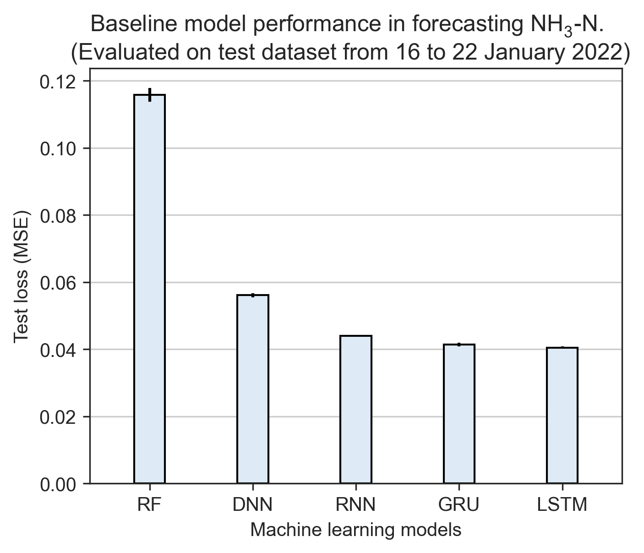

Test loss values from five ammonia forecasting models.

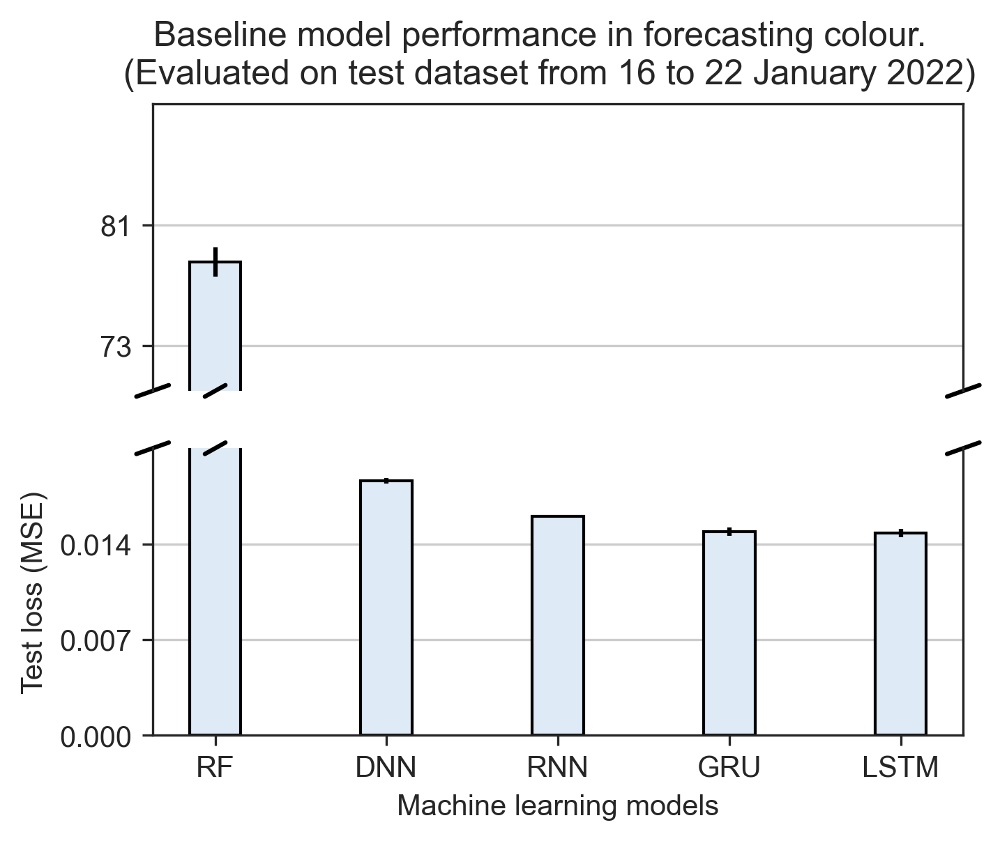

Test loss values from five colour forecasting models.

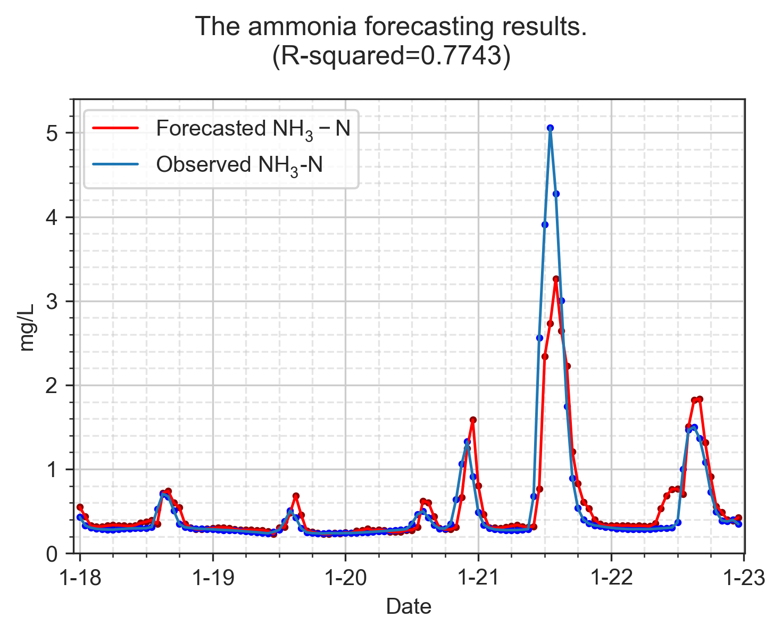

Baseline RF model forecasting ammonia concentration.

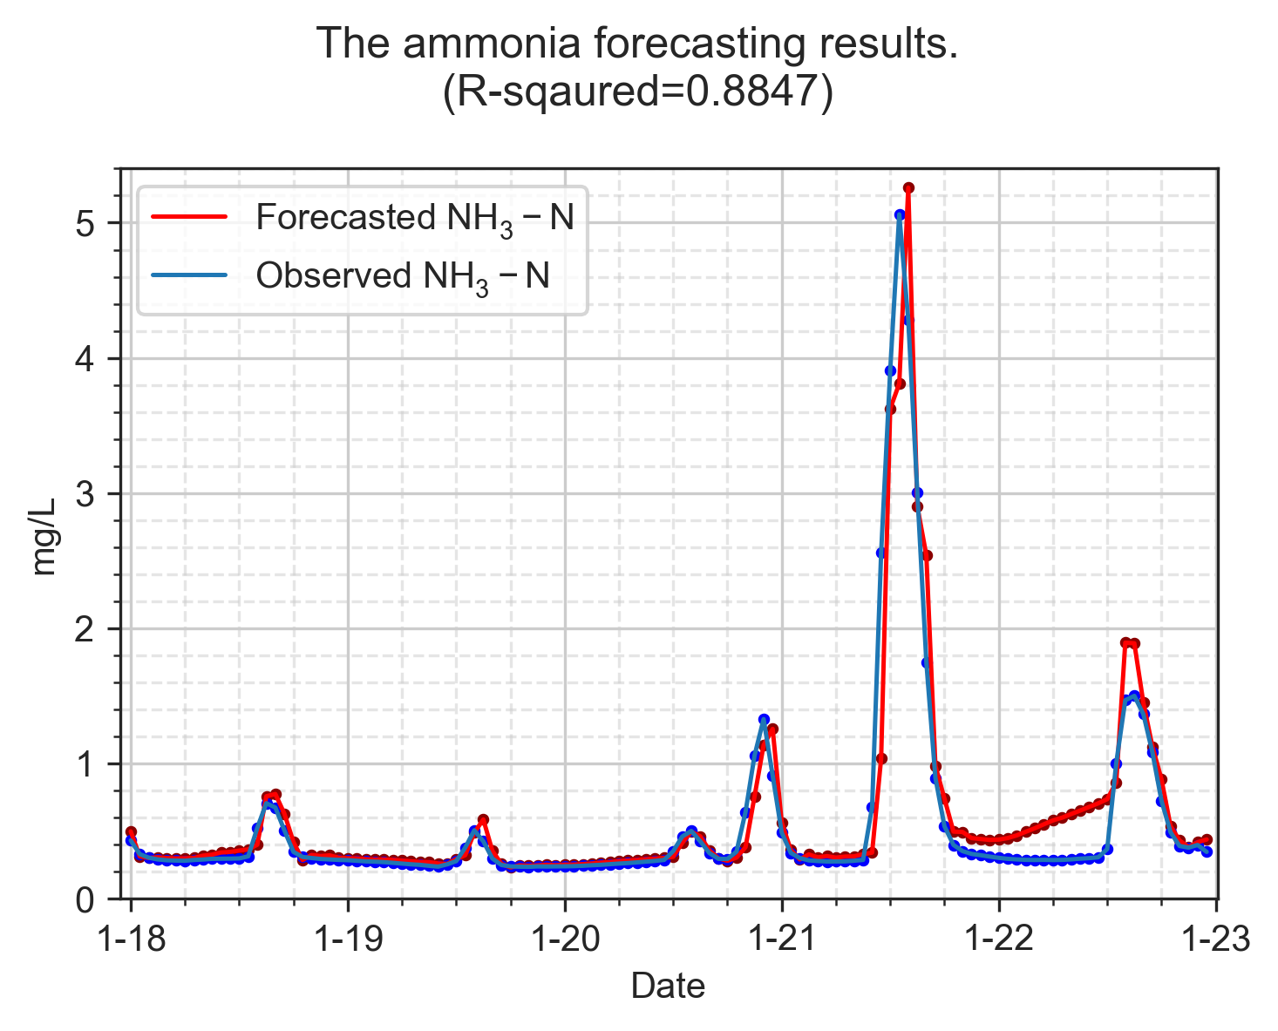

Baseline LSTM model forecasting ammonia concentration.

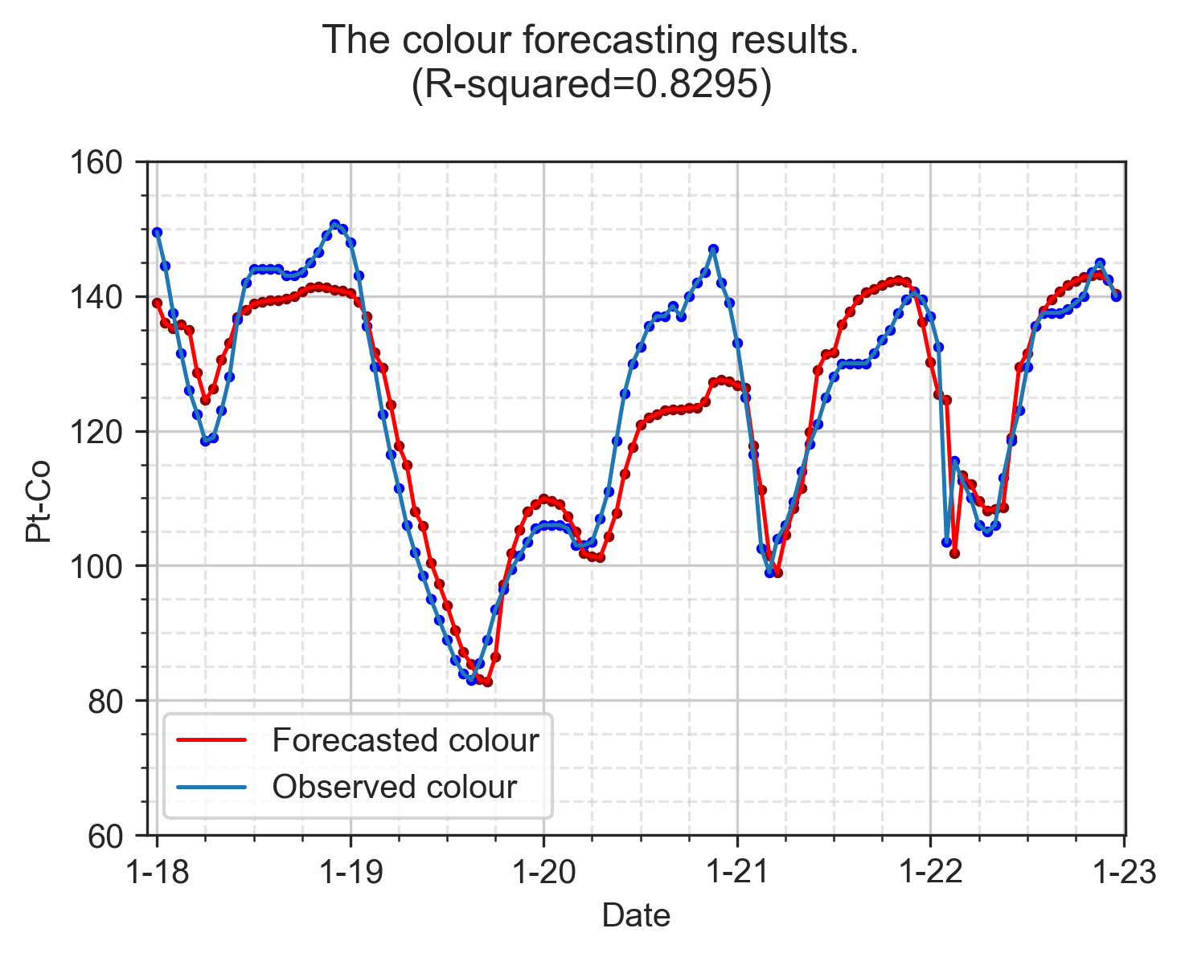

Baseline RF model forecasting colour levels.

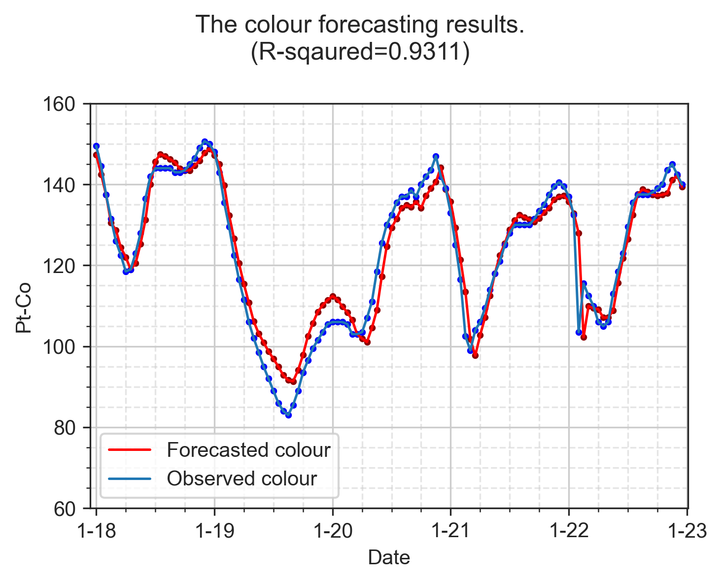

Baseline LSTM model forecasting colour levels.

## 1.2 Improved performance on forecasting models using data pre-processing techniques

### 1.2.1 Models trained by pre-processed datasets

In this study, we investigate whether the datasets treated by the proposed data pre-processing methods can improve the baseline model performance using the same hyperparameter settings. As shown in Table. [tab:baseline-result-jan-nh3] and Table. [tab:baseline-result-jan-colour], we listed all the test loss values of five machine learning algorithms trained with each proposed pre-processed methods for ammonia concentrations and colour levels forecasting. The machine learning algorithm trained by datasets which were applied with SG filters at different window sizes are denoted as model-sg5, model-sg7, model-sg9; the naming rule applies the same to datasets applied with EWMA filters; for the method of outlier removal for ammonia data is denoted as model-or; models trained with the raw datasets are denote as model-obs (i.e., observed dataset).

lcclcc Model-Dataset & Test loss & Valid loss & Model-Dataset & Test loss & Valid loss  
GRU-sg7 & 0.0383 &1.2508&RNN-or & 0.0432&1.6345  
GRU-sg5 & 0.0385 &1.2644&RNN-ew3 & 0.0434&1.6041  
LSTM-ew3 & 0.0388 &1.0796&RNN-obs & 0.0440&1.6734  
LSTM-sg5 & 0.0388 &1.2346&RNN-sg9 & 0.0442&1.7046  
LSTM-sg7 & 0.0388 &1.1804&DNN-obs & 0.0561&3.2383  
GRU-ew2 & 0.0389 &1.1891&DNN-sg5 & 0.0562&3.2170  
GRU-ew4 & 0.0391 &1.2390&DNN-ew2 & 0.0563&3.1677  
GRU-ew3 & 0.0392 &1.2199&DNN-ew3 & 0.0569&3.2317  
LSTM-ew2 & 0.0392 &1.0969&DNN-sg7 & 0.0570&3.2014  
LSTM-ew4 & 0.0395 &1.1219&DNN-ew4 & 0.0571&3.2188  
GRU-sg9 & 0.0396 &1.3097&DNN-or & 0.0572&3.1972  
LSTM-or & 0.0398 &1.2612&DNN-sg9 & 0.0574&3.2484  
LSTM-obs & 0.0405 &1.3993&RF-obs & 0.1158&-  
GRU-or & 0.0405 &1.2366&RF-sg9 & 0.1196&-  
LSTM-sg9 & 0.0410 &1.3076&RF-ew2 & 0.1286&-  
GRU-obs & 0.0414 &1.3638&RF-or & 0.1294&-  
RNN-sg5 & 0.0415 &1.5088&RF-sg5 & 0.1298&-  
RNN-ew2 & 0.0421 &1.5425&RF-ew3 & 0.1313&-  
RNN-sg7 & 0.0423 &1.6267&RF-sg7 & 0.1409&-  
RNN-ew4 & 0.0432 &1.5992&RF-ew4 & 0.1441&-

The improvements on the performance of ammonia forecasting models are most significant with the use of SG filters. GRU-sg5 and GRU-sg7 reduced 7.0% and 7.4% in the test loss compared with GRU-obs, while LSTM-sg5 and LSTM-sg7 reduced 4.2% of the test loss compared to LSTM-obs. Both data smoothing filters reduced the test loss and the improvements can be attributed to the modified relationships bewteen each datapoints. The SG filters modified the original datapoints by covoluting with both previous and the following datapoints, which resembles the working mechanisms of recurrent neural networks, while the EWMA filter modified the datapoints by averaging the value of current datapoint with previous ones. The performance of RF models was the poorest in the baseline model performance compared to other models. The results presented in Table. [tab:baseline-result-jan-nh3] indicate despite RF models were trained with data pre-processing methods, the model performance in test loss was still much higher than the poorest deep learning model, which is DNN-sg9 in this case.

Empirically, when different models are evaluated by the same testing dataset, the best Model-Dataset combination shold have both the lowest values of test and validation loss. For instance, GRU-sg7 model in forecasting ammonia has the lowest test loss of 0.0383, yet the validation loss of 1.2508 only ranks the tenth from the smallest validation loss vlaues. The models with top three lowest values of the validation loss are LSTM-ew3, LSTM-ew2 and LSTM-ew4. This finding points to the potential of the heterogeneity between the trianing and testing datasets. This hypothesis was the explanation with the highest likelihood when no overfitting was observed in the training datasets. Further tests were carried out using testing dataset from October to examine how the Model-Dataset ranks of test and validation loss values will change into. To the best of my understanding, the comparisons between testing and validation loss are not discussed on the currently available research papers in modelling of wastewater treatment industry.

As shown in Table. [tab:baseline-result-oct-nh3], the top three ranks of Model-Dataset in the lowest validation loss is the same to the top three ranks in the test loss values. This is in good agreement with how the heterogeneity of the datasets can impact on the model performance. The evluations of the ammonia forecasting models in October 2021 showed a complete different outcomes compared to the one in January 2022. Surpirsingly, the top three ranks of Model-Dataset in the lowest validation loss are the same of the lowest test loss, which are 0.0158 from LSTM-ew3, 0.0161 from LSTM-ew2, and 0.0163 from LSTM-ew4. Instead of GRU, LSTM becomes the best model for training ammonia forecasting model. The most remarkable results in Table. [tab:baseline-result-oct-nh3] is that EWMA filter seems to be the most ideal pre-processing methods for traning deep learning models as LSTM-ew3, GRU-ew3, RNN-ew4 and DNN-ew3 models showed the best model performance in test loss compared to the same models trained by other data pre-processing methods.

lcclcc Model-Dataset & Test loss & Valid loss & Model-Dataset & Test loss & Valid loss  
LSTM-ew3 & 0.0158 & 1.0796 & RNN-or & 0.0197 & 1.6345  
LSTM-ew2 & 0.0161 & 1.0969 & RNN-sg7 & 0.0201 & 1.6267  
LSTM-ew4 & 0.0163 & 1.1219 & RNN-sg9 & 0.0205 & 1.7046  
LSTM-sg5 & 0.0166 & 1.2346 & RNN-obs & 0.0206 & 1.6734  
GRU-ew3 & 0.0167 & 1.2199 & DNN-ew3 & 0.0316 & 3.2317  
GRU-ew4 & 0.0169 & 1.2390 & DNN-or & 0.0316 & 3.1972  
GRU-ew2 & 0.0170 & 1.1891 & DNN-sg7 & 0.0316 & 3.2014  
GRU-sg9 & 0.0174 & 1.3097 & DNN-ew2 & 0.0318 & 3.1677  
LSTM-obs & 0.0175 & 1.2366 & DNN-ew4 & 0.0319 & 3.2188  
LSTM-or & 0.0177 & 1.2612 & DNN-obs & 0.0319 & 3.2383  
GRU-sg5 & 0.0178 & 1.2644 & DNN-sg5 & 0.0319 & 3.2170  
GRU-sg7 & 0.0180 & 1.2508 & DNN-sg9 & 0.0319 & 3.2484  
LSTM-sg7 & 0.0180 & 1.1804 & RF-sg9 & 0.1307 & -  
GRU-or & 0.0187 & 1.3993 & RF-sg7 & 0.1311 & -  
LSTM-sg9 & 0.0188 & 1.3076 & RF-sg5 & 0.1343 & -  
GRU-obs & 0.0189 & 1.3638 & RF-ew2 & 0.1346 & -  
RNN-ew4 & 0.0190 & 1.5992 & RF-ew3 & 0.1368 & -  
RNN-ew2 & 0.0191 & 1.5425 & RF-obs & 0.1443 & -  
RNN-ew3 & 0.0193 & 1.6041 & RF-ew4 & 0.1451 & -  
RNN-sg5 & 0.0195 & 1.5088 & RF-or & 0.1477 & -

The test loss values of the colour forecasting models are presented in Table. [tab:baseline-result-jan-colour]. The best performed colour forecasting models are the LSTM models trained by EWMA filters, which are 0.0136 from LSTM-ew4, 0.0138 from LSTM-ew2 and LSTM-ew3. Interestingly, LSTM models trained by EWMA also showed the best performance in ammonia forecasting models. The top three ranks of Model-Dataset in the lowest validation loss ranks the 6th, 20th, and 1st from the lowest test loss values. However, we don’t have extra testing datasets for re-evaluating the colour forecasting models. Compromises have to be made during the analysis of colour forecasting models.

lcclcc Model-Dataset & Test loss & Valid loss & Model-Dataset & Test loss & Valid loss  
LSTM-ew4 & 0.0136 &0.7515&RNN-obs & 0.0160 &1.0623  
LSTM-ew2 & 0.0138 &0.8011&LSTM-sg7 & 0.0161 &0.7439  
LSTM-ew3 & 0.0138 &0.7547&LSTM-sg5 & 0.0168 &0.8355  
GRU-ew3 & 0.0140 &0.8068&DNN-sg5 & 0.0180 &1.4702  
GRU-ew2 & 0.0142 &0.8330&DNN-sg7 & 0.0180 &1.4823  
GRU-ew4 & 0.0143 &0.7694&DNN-sg9 & 0.0180 &1.4574  
LSTM-sg9 & 0.0143 &0.7137&DNN-ew4 & 0.0181 &1.4632  
RNN-ew3 & 0.0144 &0.8492&DNN-ew3 & 0.0182 &1.4716  
RNN-ew4 & 0.0147 &0.8476&DNN-ew2 & 0.0183 &1.4946  
RNN-sg9 & 0.0147 &0.8363&DNN-obs & 0.0186 &1.5397  
LSTM-obs & 0.0148 &0.9744&RF-sg9 & 63.6847&  
GRU-obs & 0.0149 &0.9927&RF-sg7 & 73.8263&  
RNN-ew2 & 0.0150 &0.9083&RF-ew3 & 75.1974&-  
GRU-sg9 & 0.0151 &0.7575&RF-ew4 & 77.8829&-  
RNN-sg5 & 0.0158 &0.8846&RF-obs & 78.5296&-  
RNN-sg7 & 0.0158 &0.8755&RF-ew2 & 78.8753&-  
GRU-sg7 & 0.0159 &0.7791&RF-sg5 & 81.0696&-  
GRU-sg5 & 0.0160 &0.8080& - & - &-

By comparing the baseline performance and the influences of data pre-processing methods on machine learning models, our findings appear to be well substantiated the use of LSTM models for training ammonia and colour forecasting models due to it’s outstanding model performance evaluated by test loss values. Although EWMA filters showed surprising effects on improving the performance of most models, the influence of pre-processing methods are still not consistant across different models and training datasets. Thus, in the testings of the proposed model training processes will include all the pre-processing methods for model training, and LSTM will be used as the only machine learning model.

### 1.2.2 The effect of window size of data smoothing filters

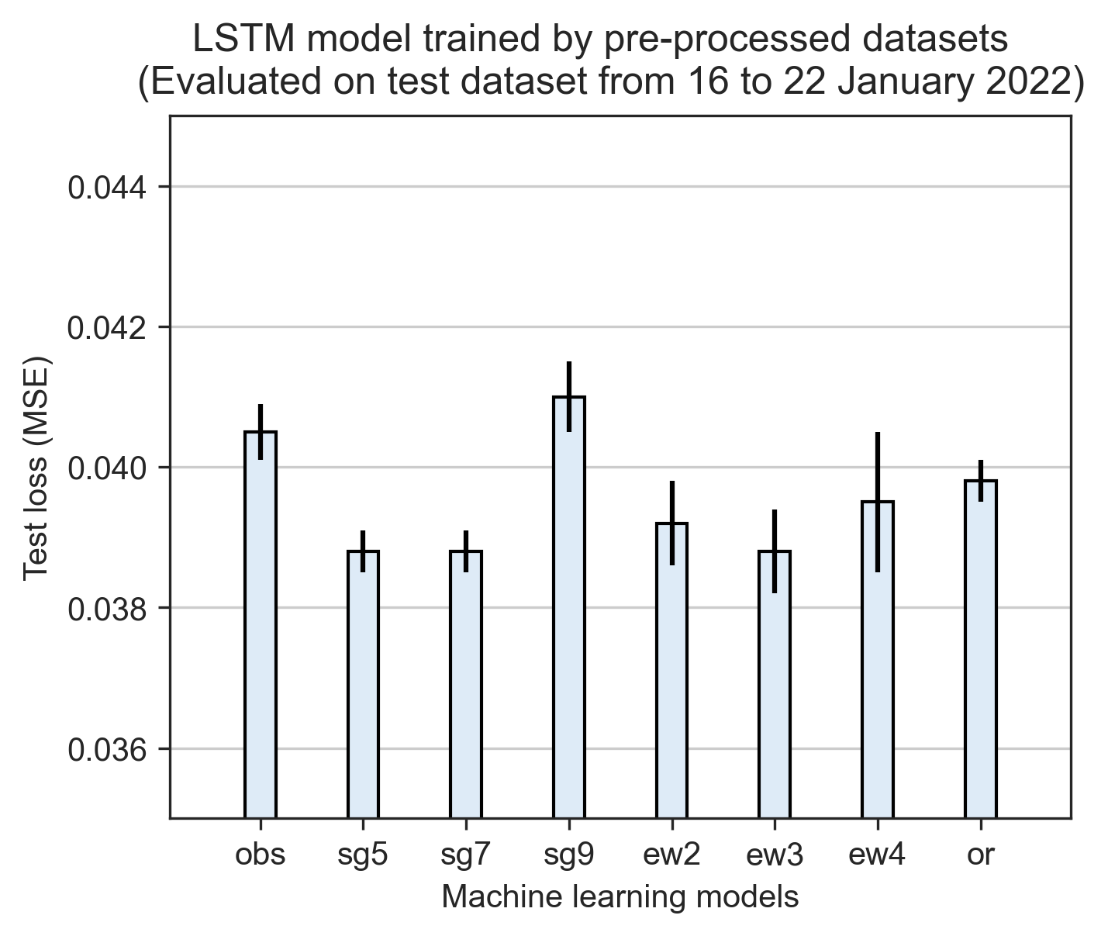

Baseline performance of ammonia forecasting models trained by LSTM.

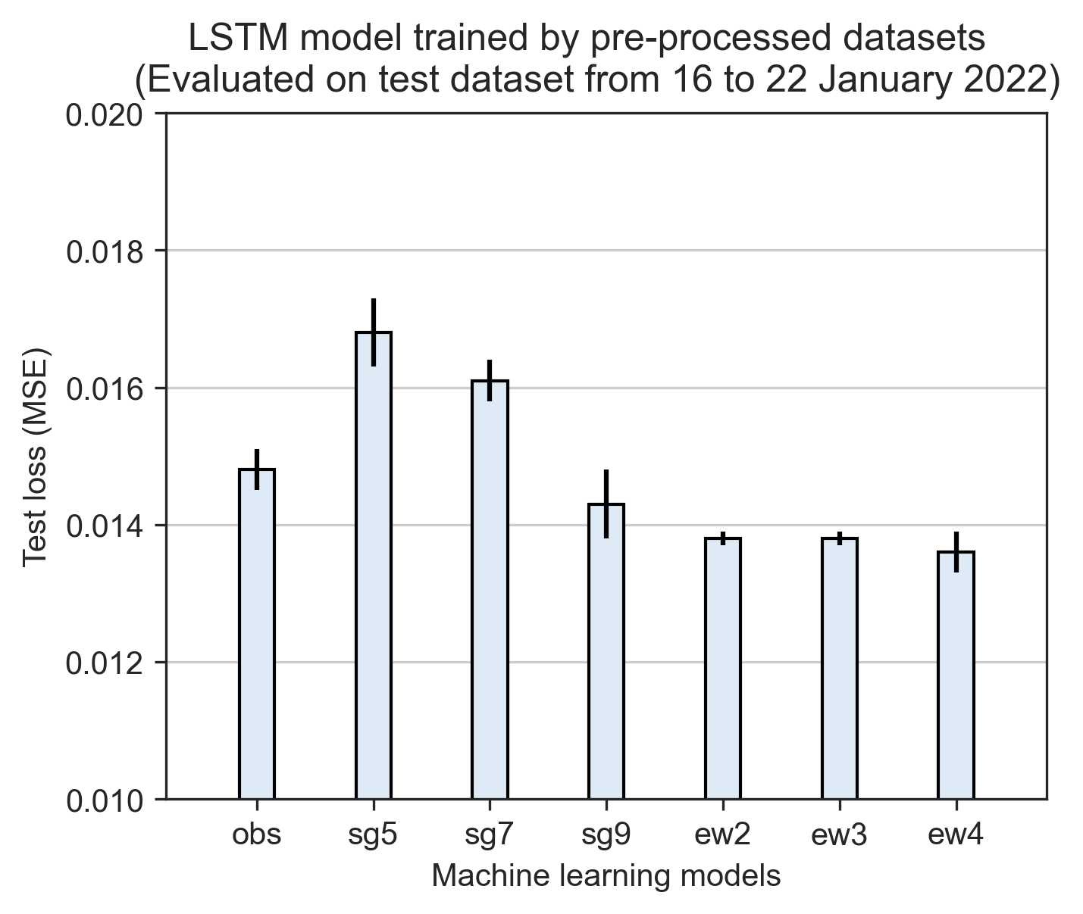

Baseline performance of colour forecasting models trained by LSTM.

The influences of window sizes in data smoothing process are investigated using LSTM models and illustrated in Fig. [fig:preprocessing-comparison]. SG window sizes of higher and lower have different impacts on ammonia and colour forecasting models. For instance, LSTM-sg5 performed better than LSTM-sg9 in forecasting ammonia, LSTM-sg9 outperformed LSTM-sg5 in forecasting colour. The similar pattern can be observed in models trained by EWMA filters as well For ammonia forecasting model, LSTM-ew3 is better, while for colour forecasting model, LSTM-ew3 is better. Therefore, the window sizes of the data smoothing filters needs to be carefully selected. The unpredictable influences of applying data smoothing filters on forecasting models impedes the determination of the optimal data smoothing method in the subsequent experiments. For the futher studies, all the pre-processing methods will be applied on the LSTM models.

## 1.3 Exploit hidden patterns in MBR effluent water quality to enhance model performance

### 1.3.1 Ammonia forecasting models

In the section of feature engineering, we have introduced the selection and creation of the extra input features for training forecasting models as shown in Fig. [fig:feature-selection]. In this study, a forecasting model trained by 1 input is called an univariate model and denoted as LSTM-1; a forecasting model trained by 2 inputs is called a multivariate model and denoted as LSTM-2. For models trained by 3 and 4 inputs are denoted as LSTM-3 and LSTM-4. In Fig. 1.9, the performance of ammonia forecasting models trained by 2 to 4 inputs (i.e., LSTM-2, LSTM-3, LSTM-4) are compared with the baseline performance (i.e., LSTM-1-obs) to demonstrate how the feature engineered features influenced on the model outputs.

Leaving out the potential influences of heterogeneity between training and testing datasets on comparing the model performance, interesting resutls were still observed. As shown in Fig. 1.9, LSTM-4-obs showed the highest test loss, followed by LSTM-3-obs, LSTM-2-obs and LSTM-1-obs. This result indicate that for LSTM models trained with more input featues can result in a poorer model performance. Based on our understandings to the extra features such as color levels and sine/cosine features, models trained with more inputs are expected lower test values. The model performance from LSTM-sg7 and LSTM-sg9 fits well with what we hypothesized. The results showed the test loss values of the LSTM models trained by datasets applied with sg7 and sg9 filters followed the trend of LSTM-4LSTM-3LSTM-2LSTM-1. The most remarkable results are from LSTM models trained by datasets applied with SG filters at window size of 7. Comparing to the baseline model performance (i.e., LSTM-1-obs), the test loss values of LSTM-1-sg7, LSTM-2-sg7, LSTM-3-sg7 and LSTM-4-sg7 reduced by 4.2%, 6.4%, 7.9%, and 8.9%, respectively.

Our findings in the results of ammonia forecasting models suggests that colour level is an indispensible input for improving the model performance. LSTM-2 models trained by datasets applied with any pre-processing methods showed lower test loss compared to LSTM-1, except LSTM-2 trained by dataset without applying any methods. There is a strong probability leads us to believe that the flucturation of ammonia concentration is highly correlated with the colour level in SHWEPP influent even without the direct evidence.

The methods of training LSTM models on pre-processed datasets have proved it’s benefits in improving baseline model performance, yet the test loss values were only reduced slightly for those models trained with EWMA filtered datasets. As shown in Fig. 1.9, LSTM-3-ew2, LSTM-4-ew2, LSTM-3-ew4 and LSTM-4-ew4 shared very similar test loss values to LSTM-1-obs, indicating the advantages of enhanced quality in training dataset were not fully reflected on the model performance when LSTM models were trained by EWMA filtered datasets.

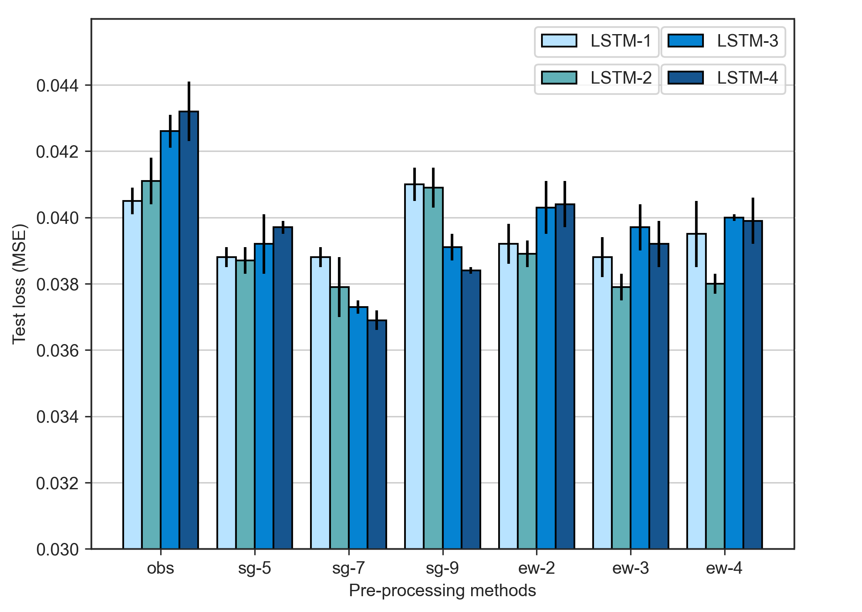

Comparisons of the model performance in forecasitng ammonia concentrations.

### 1.3.2 Colour forecasting models

As shown in Fig. 1.10, most of the proposed pre-processing methods improved the performance of colour forecasting models. All the LSTM models trained by EWMA filtered datasets have lower test loss compared to the baseline model performance, while part of the LSTM models trained by SG filtered datasets showed improvement on the model performance. The performance of models trained by SG filtered datasets was rather disappointing. We observed that the test loss of LSTM-sg5, LSTM-sg7 and LSTM-sg9 showed much higher values of standard deviations, and this was probably as a result of the poor quality of the raw colour data.

From the results of ammonia forecasting models, we thought that LSTM models trained by datasets applied with sg7 will generate the lowest test loss in LSTM-4, however, the results in the colour forecasting models revealed that the lowest test loss was generated from LSTM-3-sg9, with test values of 0.0121, a 28.6% improvement in model performance compared to the baseline model performance. Contrary to expectations, datasets trained by four inputs failed to generate the lowest test loss. The fact of having higher test loss in LSTM-4 compared to LSTM-3 is evident and can be found in Fig. 1.10 except LSTM-4-sg7. It is very likely that including ammonia concentrations as an input features worsened the quality of the training dataset and resulted in a poorer performance for colour forecasing models.

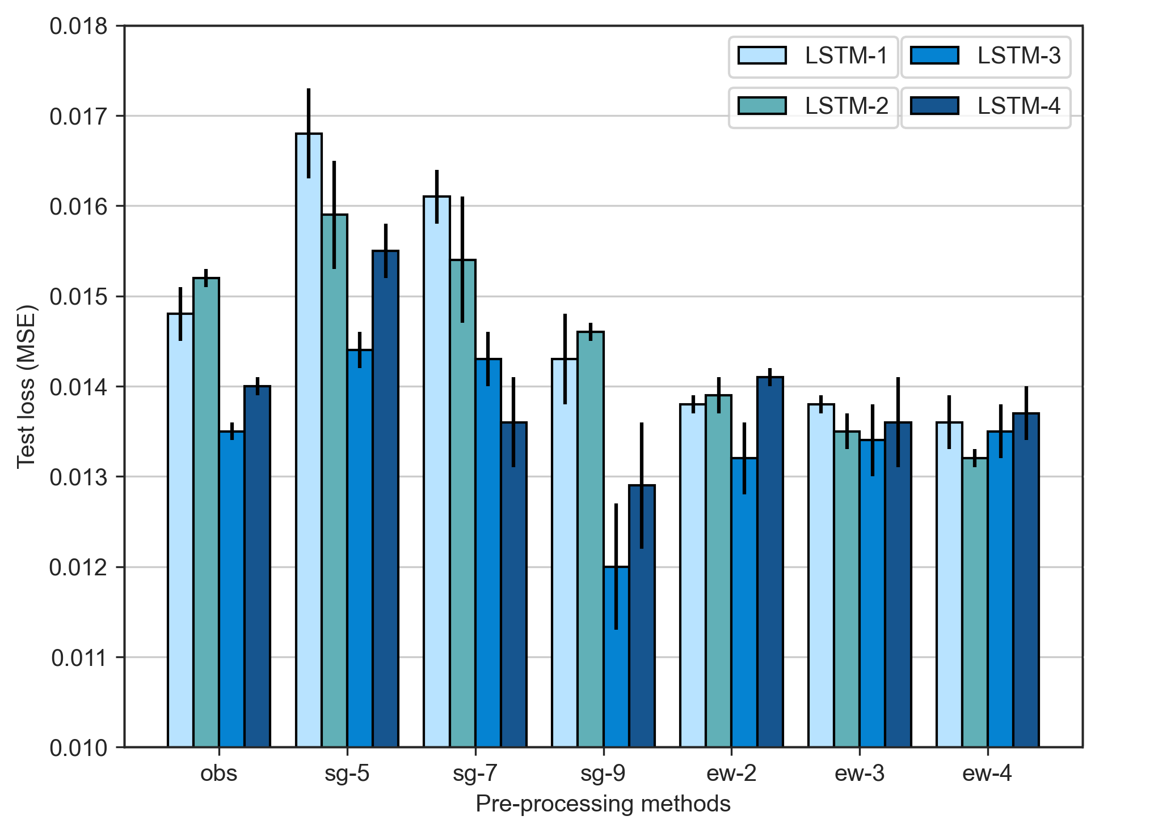

Comparisons of model performance in forecasting colour levels.

# 2 Conclusions and Recommendation

## 2.1 Conclusions

### 2.1.1 Machine learning models vs deep learning models

The selection of using which machine learning and deep learning models was not widely discussed to the best of our knowledge in the modelling of wastewater treatment industry. This study has investigated on the model performance of machine learning model of RF, and four other deep learning models of DNN, RNN, GRU and LSTM on forecasting ammonia concentrations and colour levels in reclaimed water system for assisting treatment operation and management. The evidence from this study suggests deep learning models are much capable in learning from the historical data and generate more accurate forecasting results. In both ammonia and colour forecasting models, the test loss values of RF are much higher than the values from the least performanced deep learning model of DNN. Among all the deep learning models, the results indicate LSTM and GRU models have the lowest test loss of 0.0405 and 0.0414, respectively. However, the further research works suggest LSTM models trained with pre-processing methods generate the lowest test loss compared to GRU, making the LSTM model the most promising recurrent neural network model for training forecasting models.

### 2.1.2 Data pre-processing techniques

Our research also highlighted the importance of how the model performance can be improved from applying data pre-processing and feature engineering techniques. Generally speaking, all the proposed data smoothing and outlier removal methods reduced the test loss values compared to the baseline model performance (i.e., the window sizes of the filters need to be carefully selected), as showin in Fig. [fig:preprocessing-comparison]. It is believed that the convoluted datapoints generated from data smoothing filters enable the recurrent neural networks to predict the future values more easily.

### 2.1.3 Feature engineering

This study is the first step towards enhancing our understanding to the potential benefits of using created features for model training. The thorough examinations of the Geomap nearby the SHWEPP and the investigation of water composition in the public sewege system helped us to hypothesize that the change of ammonia concentrations and colour levels are dependent to each other. With the help of additional colour/ammonia data for ammonia/colour forecasting model, the test loss reduced by 6.4% (i.e., LSTM-2-sg7 compared to LSTM-1-obs) and 10.8% (i.e., LSTM-2-ew4 compared to LSTM-1-obs), respectively.

Moreover, the similarity between the household consumption patterns and the daily fluctuation of ammonia concentrations have unexpectedly helped us to formulate the time features via positional encoding. The influence of the sine and cosine hour features on the model perfromance showed tremendous improvements on both ammonia and colour forecasting models. In the former, test loss dropped by 8.9% (i.e., LSTM-1-obs compared with LSTM-4-sg7) while the latter reduced by 28.6% (i.e., LSTM-1-obs compared with LSTM-3-sg9). The remarkable use of positional encoding features is it is not limited to just ammonia and colour forecasting models. Any time series data characterized with daily fluctuation patterns can adopt the use of the features of sine and cosine hour as long as the patterns are based on actaul events. In addition, the positional encoding features are not limited to hour, we can encode features into from seconds to weeks, and even years, the application of it is infinite. However, the feature engineering method clearly has some limitations. In the results of ammonia forecasting models, LSTM-2-obs, LSTM-3-obs and LSTM-4-obs showed higher tess loss compared to LSTM-1-obs, indicating when the models were trained by any features other than ammonia, the model performance worsened. In addition to that, when extra features were train with EWMA filters, the test loss increased, and the worsening of model performance also occured on colour forecasting models trained by EWMA filters. Our results suggest that feature engineering needs to be carefully evaluated and experimented before the real use. Despite the limitations, the combination use of feature engineering in building ammonia and colour forecasting models in this study has fully proved it’s advantages.

## 2.2 Recommendations for future research

Due to the insufficient ammonia and colour data, we cannot differentiate whether the undesired model performance was caused by the heterogeneity of the training and testing datasets or caused by the pre-processing and feature engineering methods we applied on the datasets. It is recommended a larger dataset (e.g., dataset with the size of 2 months or longer) should be used in the future study when evaluating the proposed methods in this study. The insufficient amount of data could also lead to the unstable performance of different models trained by the same data smoothing methods. For instance, LSTM-4-sg7 and LSTM-3-sg7 have the lowest test loss among LSTM-4 and LSTM-3 models, however, LSTM-2-ew4 has the lower test loss than LSTM-4-sg7. We failed to explain what has caused such outcome.

All the forecasting models in this study only focus on predicting ammonia concentration and colour levles, and in the futher study, more water quality parameters should be included. In reclaimed water system, the concentration of water quality parameters such as turbidity and E. coli are also regulated by Water Supply Department. The violation of any water quality parameter will directly lead to the disqualification of being used as reclaimed water. Moreover, The hidden correlations reside between each water quality parameter will most likely be helpful in building any water quality forecasting models.