Table of Contents

# 1 RESULTS

## 1.1 Exp-1 (NH $​_{3}$ N baseline model)

### 1.1.1 Keys

* ☐ The benefit of data pre-processing by comparing validation and test loss.
* ☐ The selection of best model by comparing validation and test loss.
* ☐ Test data could be in poor quality.
* ☐ Show another test data results and compare the test and valid loss.

### 1.1.2 Fig and table

Writd a little large, and when put in the same row they cannot fit into one slide. Is it possible to control the size of the image? Thanks, it works. But I have another problem now. My images are a little large, and when put in the same row they cannot fit into one slide. Is it possible to control the size of the image? Thanks, it works. But I have another problem now. My images are a little large, and when put in the same row they cannot fit into one slide. Is it possible to control the size of the image?

Table 1.1: Validation/test loss comparison from 1/16 to 1/22.

| Model-dataset | Validation Loss | Model-dataset | Test loss | asdfadsf |
| --- | --- | --- | --- | --- |
| LSTM-ew3 | 1.0796 | GRU-sg7 | 0.0383 | adfsdfasd |
| LSTM-ew2 | 1.0969 | GRU-sg5 | 0.0385 | adfsdfasd |
| LSTM-ew4 | 1.1219 | **LSTM-ew3** | 0.0388 | adfsdfasd |

Table 1.2: Validation and test loss comparison from 1/16 to 1/22.

| Model-dataset | Validation Loss | Model-dataset | Test loss |
| --- | --- | --- | --- |
| LSTM-ew3 | 1.0796 | **LSTM-ew3** | 0.0158 |
| LSTM-ew2 | 1.0969 | **LSTM-ew2** | 0.0161 |
| LSTM-ew4 | 1.1219 | **LSTM-ew4** | 0.0163 |

Table 1.3: Schematic for restriction digestion with a single restriction enzyme. Some really long text that shows how the caption is formatted when it takes multiple lines.

| Reagent | Amount |
| --- | --- |
| Appropriate Buffer (10x) | 1x |
| DNA | 50-500ng |
| Restriction Enzyme | 1*U* |
| Water | - |

## 1.2 Exp-2

## 1.3 Exp-5

## 1.4 Exp-6

# 2 Result

## 2.1 sdfas

Table 2.1: Validation and test loss comparison from 1/16 to 1/22.

| Model-dataset | Validation Loss |
| --- | --- |
| LSTM-ew3 | 1.0796 |
| LSTM-ew2 | 1.0969 |
| LSTM-ew4 | 1.1219 |

## 2.2 asdf

Table 2.2: Validation and test loss comparison from 1/16 to 1/22.

| Model-dataset | Validation Loss | Model-dataset | Test loss |
| --- | --- | --- | --- |
| LSTM-ew3 | 1.0796 | GRU-sg7 | 0.0383 |
| LSTM-ew2 | 1.0969 | GRU-sg5 | 0.0385 |
| LSTM-ew4 | 1.1219 | **LSTM-ew3** | 0.0388 |

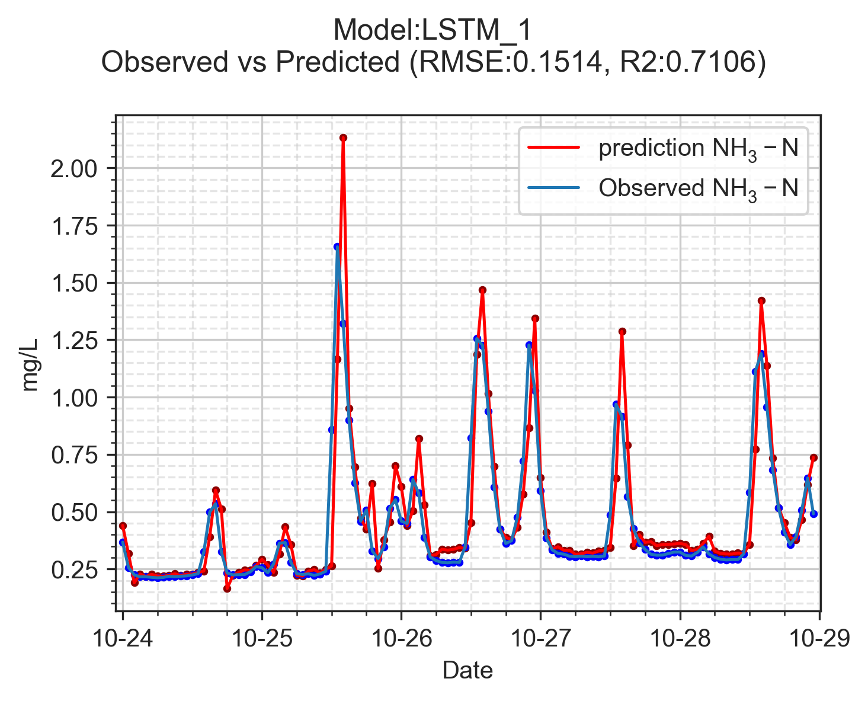

Figure 2.1: test

Thanks, it works. But I have another problem now. My images are a little large, and when put in the same row they cannot fit into one slide. Is it possible to control the size of the image? Thanks, it works. But I have another problem now. My images are a little large, and when put in the same row they cannot fit into one slide. Is it possible to control the size of the image? Thanks, it works. But I have another problem now. My images are a little large, and when put in the same row they cannot fit into one slide. Is it possible to control the size of the image? Thanks, it works. But I have another problem now. My images are a little large, and when put in the same row they cannot fit into one slide. Is it possible to control the size of the image?



Figure 2.2: tesst

Thanks, it works. But I have another problem now. My images are a little large, and when put in the same row they cannot fit into one slide. Is it possible to control the size of the image? Thanks, it works. But I have another problem now. My images are a little large, and when put in the same row they cannot fit into one slide. Is it possible to control the size of the image? Thanks, it works. But I have another problem now. My images are a little large, and when put in the same row they cannot fit into one slide. Is it possible to control the size of the image?