Place directories as shown below.
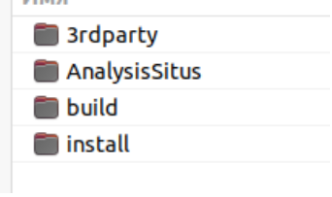
Build AnalusisSitus.
Go to install/bin and run the command:

chmod +x asiExe.sh
Move 3 files AnalysisSitus.desktop, AppRun, asitus_setup_image.svg from AnalysisSitus\docs\AppImage directory to install directory. install directory will be used as AppDir.
Don't forget to run command:

chmod +x AppRun
Download the appImage packages with the following command (call the console in the directory where install, build, AnalysisSitus is located):

wget -P appimage/ https://github.com/AppImage/AppImageKit/releases/download/continuous/appimagetool-x86_64.AppImage https://github.com/linuxdeploy/linuxdeploy/releases/download/continuous/linuxdeploy-x86_64.AppImage https://github.com/linuxdeploy/linuxdeploy-plugin-appimage/releases/download/continuous/linuxdeploy-plugin-appimage-x86_64.AppImage
Go to the appimage directory and run command

chmod +x *.AppImage
Download mesa and some other libraries:

apt install libglu1-mesa-dev libfontconfig1-dev libxmu-dev libxi-dev
Create an AppImage file (call the console in the directory where install, build, AnalysisSitus is located):

./appimage/linuxdeploy-x86_64.AppImage --appdir=./install -l /usr/lib/x86_64-linux-gnu/libOpenGL.so.0 -l /usr/lib/x86_64-linux-gnu/libGL.so.1 -l /usr/lib/x86_64-linux-gnu/libGLX.so.0 --desktop-file ./install/AnalysisSitus.desktop --icon-file ./install/asitus_setup_image.svg --output=appimage

