Tutorial on re-lighting the maps in Berserker@Quake2
- Launch the game with the following parameters:
Berserker.exe +set sv_stopclock 1 +set developer 1 +map {map name} +notarget +give all +use super shotgun +noclip +set scr_texture 1 +set scr_fps 1 +set r_editor 1 +set map_nochecklit 1 r_editor – {enables editor}
map_nochecklit – does not check the lit-file checksum
sv_stopclock – disables the game processes on server-side (elevators, cars remain on their initial positions, the monsters are stopped). Has to precede the map launch (<+map>)!
developer – beyond the service messages there will be server-side messages, such as entity/func/event that has activated targetname. It is convenient to recall targetname for the light source initiated by a depressed button, for example. Do not forget to assign the target- lights the style of 32 or more in the sequence of available values to communicate to the server! The editor will write the number of the first available style. In order to enable strobing for such resources use cl_style variable.
Notarget – monsters will ignore you. (when sv_stopclock=1, unnecessary)
Give all and Use super shotgun - will not have flashlight
Noclip – unrestricted move across the map (through walls)
Scr_texture – enables the color of the lamps texture, lava, and other glowing objects.
Scr_fps – controls the indicator of FPS

- After loading the map, open the console and type:
Delete notageted – in order to delete common light sources
Or,
Delete All – removes all light sources
Frequently execute the command savelights in order to save your progress (in the folder titled Maps there will be created file named map_name.lit). Remember that vid_restart reloads the map and lighting all together.
- In order to automate the creation of static light sources with certain size and color execute Createflarelights command. Then just edit the radius of the aforementioned light sources. Be careful, the glowing surfaces can be subdivided to multiple planes. Coincidently, there will be several light sources (emitters) created automatically, which will negatively impact the rendering. In order to identify the double entities use the r_showtris 3 (one will see the nearby light sources). Such groups of entities should be replaced with one light entity of the appropriate size. If the Createflarelights is given a value, it will determine the multiplier of brightness.
To delete light sources created automatically via Createflarelights use Deleteflarelights command.
Once the glowing surfaces work is finished begin creating the rest of the light entities.

- The list of light entity editing commands:
Savelights – saves all light entities into the file named name_map.lit (can use other filename)
Ambient - <r,g,b> - cancels lightmap and sets ambient light. 0,0,0 – enables lightmaps. To create total darkness use small values, i.e. 0.01
Switch – sets the editor to work with the liked light entities and vice versa
Select <#> - selects the light # as current. -1 – Cancels any choice.
Select_nearest – selects nearest light source
Next – cycles through the next light entity in the list
Prev – goes to the previous light entity in the list
Delete – deletes the selected light source. Can also be set to ALL (deletes all light sources) or Notargeted (deletes lights sources that are NOT controlled by server-side)
Copy – copies the attributes of the light to clipboard.
Cut – Copy+Delete.
Paste – creates light entity with the settings from the clipboard
Paste2camera – creates the light entity at the camera position
Paste2current – copies the light settings into selected light
Create – creates default light entity at the camera position
Radius <r or x,y,z> - can either use one setting for the radius (sphere) or 3 settings (for elliptical light source)
Origin <x,y,z or origin> - set the coordinates for selected light. Setting Camera moves selected light to camera position
Color - <r,g,b> - set color
Pipette – sets color equal to an average color of the texture that is being looked at.
Angles - <a,b,c> - sets 3 angles of the light entity:
First setting: Pitch (up/down)
Second setting: Yaw (left/right)
Third setting: Roll (about longitudinal axis)
Speed <a, b, c> – set the rate of change of the 3 angles
Cone <#> - sets angle tangent between the light direction and cone surface. 0 – no setting. 1 – 45 degrees (for lights with color filter on one face). 999999999 (any number close infinity, but in reasonable range for floating point) - 90 degrees (not necessary but it noticeably speeds up the clipping off of unlit faces) (is forced to null if the Filter = 0)
Style <#> - sets the flickering style or used in connection with an event (targeted light):
0 normal
1 FLICKER (first variety)
2 SLOW STRONG PULSE
3 CANDLE (first variety)
4 FAST STROBE
5 GENTLE PULSE 1
6 FLICKER (second variety)
7 CANDLE (second variety)
8 CANDLE (third variety)
9 SLOW STROBE (fourth variety)
10 FLUORESCENT FLICKER
11 SLOW PULSE NOT FADE TO BLACK
32-62 are assigned by the light program for switchable lights
Remember that the switch mechanism <style 32…> does not work in Deathmatch!
63 testing
(There can be used up to 255 styles)
cl_lightstyle <num> <string> - sets user defined rule changing the light brightness of the emitter steam intensity. Num must be more than 0. String - alpha string a to z.
cl_style <#> - sets user defined flickering style. It is recommended to use a mixture of server-side and user defined lightstyles (they become multiplied) in order to create flickering light entities that can be turned on/off.
Filter <N> or <start end> - set the number N for light filter or set the sequence from start to end (can also be set as a reverse sequence)
0 – none
There numbered light filter textures in texture/lights folder . Suffix markers _dm, _up and others refer to the texture position on a 6-faced cubemap.
Framerate <N> - set the amination speed of the light filter, if <start end> are set. N – the number of frames per second.
Start – on/off light entity when the map is launched. Is applied to targeted lights that need to be off when the map is launched.
Noshadow – on/off drop shadow from the map elements cause by the selected light entity. Be careful with this setting, use only in the areas that will not or should not have shadows. This setting increases the FPS.
Noshadow2 – on/off drop shsadows from the models caused by the selected light entity.
Nobump – on/off bump/gloss map of the selected light. This is used to create a light local ambient light.
Targetname <string> - set the light entity name in order to control server.
Move_x, Move_y, Move_z <#> – move selected light # units along a respective axis. This setting can be negative as well.
Add _r <#> - change the radius of the selected light entity # units. The setting can be of negative value as well.
Аdd_r_x, Аdd_r_y, Аdd_r_z <#> - changes the radius of the selected light entity along a respective axis # units. The setting can be of negative value as well.
Rot_a, Rot_b, Rot_c <#> - rotate selected light entity in the respective angles by # degrees. This setting can be set negative.
Direct – set the angles A and B in order to point the light into the camera. Selected light entity will create a direction arrow pointing towards the camera.
Trace on/off – on/off switch interactive control of the position and orientation of the current light entity.
Pick – uses cursor to choose nearest visible light.
Opaquesky – on/off opacity for any skybox face light selected by cursor. Is useful when blocking “bleedthrough” of outside light through the walls.
Ignore_ligtsurf – disables unwanted flares from light-surf
Createflarelights – creates static light entity in front of every light-surf; size and color are set automatically.
Deleteflarelights – deletes all light entities created by Createflarelights.

There are commands operating with surfaces:
Showsurf <N> - select a group of surfaces that belong to texinfo N. If N is not set then it will select the group pointed out by the cursor. N=1 cancels surface selection.
Nordawsurf <N> - makes a group of surfaces belonging to texinfo N invisible. If N is not set then makes invisible group pointed out by cursor.

- List of commands that operate brushes:
Showbrush <#> - show brush number #. If it is in the visible area it will blink in yellow wireframe. At the same time the coordinates and angles will be displayed. When set to 0 – cancels the brush selection.
SelectBrush – selects the brush that is being looked at. Much more useful then the previous command.
UnSelectBrush – cancels the brush selection. Same as Showbrush 0.
Nextbrush / Prevbrush – cycles through next / previous brush.
NoDrawBrush – makes visible/invisible selected brush. In order to prevent shadow drop from the brush set SURFACE FLAGS (in Radiant) – NoDraw.
Labelbrush <model name> - sets the brush name so that the objects might be linked to it in the future. The command also validates the name against already taken names.

- Commands that operate the sun:
Sun <#> - create sun at the current camera coordinates. Setting # (0,1,2) determines the type of sun.
Sun_addx, Sun_addy, Sun_addz <#> - move sun along the respective axis by # units. Setting # san be of negative value. Is used to move sun from the current location far up or far side (make # very large)
Sunpos <x,y,z> - manually set the sun coordinates.

7. Linking of the light entities (using the Train.bsp map as an example)
There are two carts moving in the map. Let’s launch the game:
Berserker.exe +set sv_stopclock 1 +map train +give all +notarget +noclip +set r_editor 1
Moving around the mineshafts one can’t find the carts. Moving outside the map there can be seen a separate room that holds the wanted brushes. ☺
Our goal is to link to each of the carts one light entity. Look at the cart and execute selectbrush command which will highlight the brush in yellow wireframe. Note be displayed:
BrushModel “*4” org(420,388,-64) ang(0,0,0)
Set the name for cart model, let’s say labelbrush train4.
Then switch to linked light mode by executing switch command.

Create light entity at the cart and set the necessary settings. That’s it – the light is attached to the cart.☺
PS: the limits of the linked light: non elliptic, non targeted, and do not have noshadow, noshadow2, nobump flags.

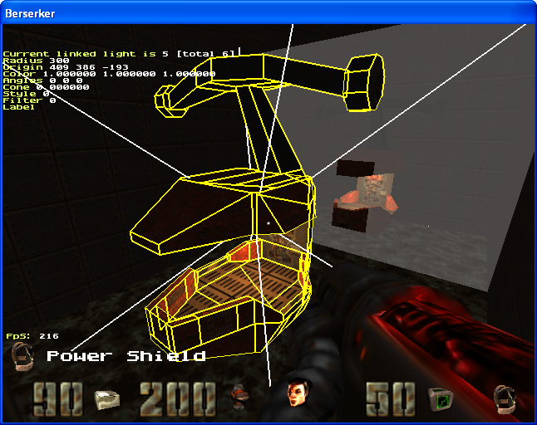

8.Commands that operate the particle emitters:
The following commands are similar to the respective light entities commands:
Createemit, originemit, moveemit_x, moveemit_y, moveemit_z, styleemit, cl_styleemit, deleteemit, nextemit, prevemit, select_nearest_emit, selectemit, copyemit, cutemit, pasteemit, paste2cameraemit, paste2currentemit, traceemit, pickemit.
The next set of commands is either new or modified:
Typeemit – sets the type of the emitter:
0 – common white particles with gravity.
- blood, stains the walls
- smoke (when going through water - bubbles)
3 – big smoke
4 – water dropplets, disappear when hit the water
5 – bubbles, disappear when in the air
6 – fast drying blood
Coneemit – same as the light entity determines the tangent of the particle spread angle.
Speedemit – same as light entity determines the rotation speed but only in two angles A and B (pitch and roll)
Numemits – the number of particles emitted per 1 think frame. Thelarge the number the more condensed is the stream.
StartColorEmit / EndColorEmit <r,g,b> - determines respectively the beginning and ending colors of the emitter. Setting the red color in the beginning and yellow at the end, one can make something looking like fire☺.
LifeTimeemit <n> - sets the lifetime of the emitter (when n=0 the default setting is uded)
GravityEmit <+/-n> - sets the gravitation of the emitter. +sign means falling and _sign means rising (when n=0 the default setting is used)
Anglesemit – same as the light entity determines the angles of the stream direction, but only A and B angles (pitch and roll)
Velemit – rate of particles emission. The larger the setting the longer the jet stream.
Rotemit_a, Rotemit_b – same as the light entity changes the angle but only in the A and B angles (pitch and roll)
DirectEmit – sets the A and B angles so that the emitter is directed into the camera. (Selected emitter will have an arrow pointing in the direction)
Labelemit – sets the name of the emitter same as the name of the current brush model. This way the emitter gets linked to the brush.

9. Commands operating with decals:
CreateDecal – creates decal on the surface under the cursor. The current decal begins to blink and display over the entire screen.
DeleteDecal – deletes current decal.
Select_Nearest_Decal – selects the nearest decal.
UnSelectDecal – cancels decal selection.
PickDecal – select decal via cursor.
TypeDecal <n> - select decal’s texture (see folder Textures\decals\<numbers 0..99>.jpg)
BlendDecal <add |mul> - select the decal blending type (overlay mode). Add – set over glow spots; mul – over cracks, burns, etc.
AngleDecal <ang> - sets the decal rotation angle in its plane.
Rot_Decal <+/-ang> - rotate decal in its plane.
The following commands operate with or relate to the clipboard:
CopyDecal, PasteDecal, CutDecal – same as light entities ☺ no comments…
SizeDecal <n> - set decal size.
ReSizeDecal <+/-n> - change the decal size by N units.
TraceDecal <on|off> on/off mouse movement of the decal;) – very useful!
Styledecal <#> - same as style but for decals.
Cl_styledecal <#> - same as cl_style, but for decals.

Placing decals on dynamic parts of the world (brush-models) has a few nuances:
- if the brush does not accept a decal, then perhaps the model does not have zero coordinates. Set brush as current via selectbrush. Now the decal placement should be possible.
- if the adjacent brushes have null coordinates (selectbrush will show necessary info), say it is a door, then it is recommended placing decals without selecting any brushes (using unselectbrush command). In this case the decal will overlay over all brushes that it comes in contact with.

The following decal description needs to be written in the relight file:

"classname" "decal"
"origin" "decal center coordinates” (calculated automatically)
"angle" "angle of decal rotation"
"filter" "decal texture number"
"style" "0 - add | 1 - mul"
"volume" "decal size"
"dir" "normal to surface on which the decal is placed" (calculated automatically)
“frame” “styledecal”
“cl_style” “cl_styledecal”

10. Model operation commands (md2, md3, sp3, and also ASE):
createmodel <filename> - full path to model including the filename extention, such as models/monsters/bitch/tris.md2
deletemodel – delete current model
select_nearest_model – select the nearest model
changemodel <filename> - change selected model
anglemodel <a b c> - set the rotation angles of selected model
originmodel <x y z| camera> - set the coordinates of selected model
rotmodel_a/b/c <+/-n> - rotate selected model
movemodel_x/y/z<+/-n> - move selected model
nextmodel/prevmodel – select next/previous model
labelmodel – set the name of the current model, identical to the current brush name. That way the model gets linked to the brush
If the “label” string gets deleted in the.lit file, then the model will be excluded by the editor and will be computed on the server-side (and naturally tax the network communication).
framemodel <n> - set the model frame number (has not been tested on md3)
framendmodel <n> - set the last model frame number (has not been tested on md3)
If frame model is less than frameendmodel then framemodels sets the beginning frame number.
When the animation is launched the frames will be changing from framemodel to frameendmodel.
nextframemodel / prevframemodel – set the next/previous frame of the current model.
Skinmodel <n> - select skin (for multiple skinned md2) via skin number.
nextskinmodel / prevskinmodel – set next/previous skin for selected model.
animframemodel – on/off animation
copymodel / pastemodel / paste2cameramodel / cutmodel – work via clipboard
niosemodel <sound filename> - set the filename if it is desired that the model produces “noise”. Empty quotation marks (“”) turn sound off
Tracemodel – move selected model via cursor.
PickModel – select model when its bounding box is in the path of the cursor.
Invertmodel – invert selected model.
Scalemodel – set the scale of selected model.

A few more advises for those familiar with Q2 GameX86.dll architecture:
-if manually inserting “targetname” in the .lit-file , then it is possible to turn on/off model animations. Of course it has to be a “server-side” model, i.e. does not have “label” attribute. The ”client-side” model should not have targetname!
-if when moving the model the editor displays “Warning: Out of BSP” then this is just a warning that the model may not show on the map (because it might be completely in the solid content, 9-point test – bounding box +center point)
-It is not recommended deleting “label” for off-center models, because the server most likely will reject such models

- it is not recommended to place tall models that intersect visible faces because when approaching the faces the models will get lit up from the top or bottom (a minute artifact)
-Server-side models from the .lit file will be dropped when executing “savelights” command that is why they need to be set as a final step.

11. Cubemap lightfilter textures orientation:
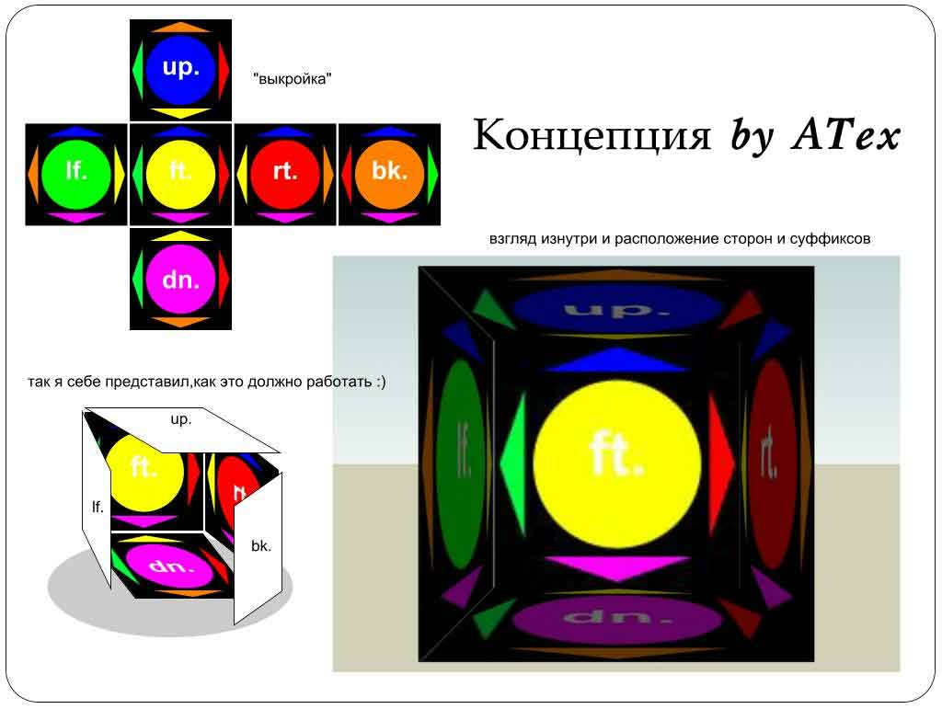

12. Creating fog areas:
Createfog – creates null fog entity, borderless and with default settings.
Deletefog – delete current fog entity
Fog_color – sets the fog color
Fog_density – set the fog density (distance, at which the fog will be opaque)
Fog_origin0 – moves one of the corner vertices of the fog bounding box to camera
Fog_origin1 – moves second corner vertices of the fog bounding box to camera
Add_fog_origin0 – moves one of corner vertices of the fog bounding box to x,y,z.
Add_fog_origin1 – moves second corner vertice of the fog bounding box to x,y,z.
Selectfog - makes current the fog area at camera position
Unselectfog – cancels selected fog area
Note: the described process of creating fog area is a “hack” because the top surface will be missing. Use carefully.

13. Setting an isolated part of the map (with walls and static alias-models) as part of the skybox:
sky_clear – turn off “skybox” mode
sky_viewcenter – x,y,z |camera – set the position to display the skybox on the map
sky_move_viewcenter_x/y/z <n> - enlarges sky_viewcenter on the respective axis.
Sky_origin – x,y,z | camera – set coordinate in the skybox.
Sky_move_origin_x/y/z <n> - enlarges sky_origin on the respective axis.
Both aforementioned coordinates set the projection vector of skybox display on the map.
Sky_angle – rotates “skybox along Z-axis. Turns skybox mode on.
Sky_rotate – set the roation speed along Z-axis. Turns skybox mode on.
Sky_scale – set the scale of the skybox along Z-axis. Turns skybox mode on.
Use for creating decoration effects such as “factory outside the window” providing relative motion. The factory scaled model can be small, but by setting the sky_scale there can be obtained an illusion of a huge factory. Map movement is also translated into a scaled movement of the skybox camera. To light up the skybox world it is necessary to place a light source inside the skybox.
Restrictions:
-light sources from the map do not interact in anyway with the skybox objects.
-models from the skybox cannot be linked.
-label skybox models =”SkyModel”
-when simultaneously using skybox and mirrors do not allow seeing skybox and mirrors at the same time in order to avoid visual artifacts.

14. Lightfilters are subdivided into two groups: 1 to 128 – global (affect all maps) and 129-256 – local (affect only one map, located at textures/lights/MAPNAME/)
Decals are subdivided into two groups: 0 to 127 – global (affect all maps), 128-256 – local (affect only one map, located at textures/decals/MAPNAME/)
Subsequently, it is possible to create up to 128 unique lightfilters (including animated) and decals.

15.The editor also permits placement of a new item: item_ivisibility.
In order to perform this, at the very last stage (when there no more saves are planned for the .lit file via savelights command) one can add the following:

{
"classname" "item_invisibility"
"origin" "X Y Z"
}
It is impossible to add the item during the gameplay (during editing) because this is a server-side item. Savelights command overwrites the .lit file and erases the item related code references.

16. Commands for locating current model’s triangles:
select_model_mesh # - selects mesh. Not for md2 models.
Select_model_tri # - selects the triangle in the current model (and in the current mesh if the model is not md2).
If the setting # is a plain number then the commands just select mesh/triangle
If the setting # is a number accompanied by + or – sign, then the commands select next/previous mesh/triangle (determined by the value of #)
Selected triangle is blinking. Distort triangles are not displayed.
Aforementioned commands are intended only as helpers when assigning light entities to models and do not affect relight in any way.

17. There is a large group of c_var ‘s, called ed_* which contain the info about the objects being edited.

18. Note a few things:
- the engine specifics require each light to redraw the space within its radius. That is why it is advised to place the lights with as little overlap as possible. On average 2-3 overlaps is enough. Of course, everything depends on the individual circumstances.
- if the light is located so it does not produce shadows then set noshadow (and noshadow2 if there are not going to be any alias-models, monsters, weapons, players, etc) This will increase the FPS slightly.
-Wide use of the lightfilters will definitely decorate the map. Most of the filters have one face (besides filter #2 – full cubemap). Set cone=1 for one faced lights (to increase FPS). If the light is not visible then check the angle settings. For example, the light pointing straight down will have the settings of (90,0,0)
- if there is an unlit area, it is possible to lighten it up a bit by placing a soft light entity with nobump setting. Usually, such entities also get noshadow2 setting. Noshadow can be set if there aren’t many noticeable artifacts.
-once the noshadow is set it is recommended to fly around and examine the area for artifacts: pseudo-shadows that occur at the edge of the visible and invisible zones of the light entity. If such exist remove noshadow.
- use elliptical lights if the lighted geometry is elongated. For example, there is a deep well and it needs to be lit up by the sun light. Create a vertically elongated light entity that would reach the edge of the well and the bottom. The side tunnels of the well, which are in the shadows anyway, will not be taken into the consideration by the renderer, which will benefit the FPS rate.
-r_showtris=3 with show how many lights are drawn in the current screen. This will help examine why a particular area is affecting the FPS rates.
- if one area has too many lights it is not necessary to place light entity for each light fixture. This can be replaced with one large entity. The illusion will be complete and with much better FPS rates.
- It is not recommended to place light too close to the surfaces as this might cause some visual artifacts.
- the retexturing FX files usually do not have “mirror” attribute. If a mirror is needed in the map place the texture and its FX file in overrides/<mapname>/ folder.
- the sun needs to be always placed against the sky.
- use Copy/Paste abundantly☺. Study and remember relight commands.
- in order to prevent a noticeable drop in FPS rates do not set very large numbers for numemits, and also use fast drying blood for thick streams (or long drying blood if the blood is just dripping)
- The relight editor is not available during the net session or during multiplayer gameplay.
- connecting to server with relight map during the multiplayer session is only possible when the local client has an identical relight (checksum control; provides even odds for all players)
- When everything is done, perform a run-through, examine and self-critique all areas, then either post it in the forum or email megabers@mail.ru.

Questions should be addressed at http://forums.quakegate.ru/index.php?board=9.0
or via ICQ 9393838.
English translation 07/29/2012 by Alien_911. Corrections, suggestions related to translation only must be directed to Alien_911 (mailto:valera75@yahoo.com)

