**Serious Sam: The Sequel**

**Manual**

**What is this mod?**

Basically, I got tired of Croteam resorting to making prequels and prequels to their prequels and retconning shit. So I decided that I’d make my own sequel, in the classic engine. Now, there are plenty of fanmade sequels, with varying quality. Well, I am confident that I can pull it off.

My aim was to create the Serious Sam game of my dreams.

**The story**

The idea was to create a Serious Sam continuity, that includes every major Serious Sam entry. No alternate timelines, just one single, sort of linear, timeline. So as the timeline goes, it’s Serious Sam 4 (including Siberian Mayhem), 3, First Encounter, Second Encounter, Serious Sam 2 and then this mod. As far as “The Sequel” is concerned every mainline game is canon. Though a few liberties are going to have to be taken, to make that work.

First of all, Siberian Mayhem is not an alternate timeline. Sam lands on the oil rig, travels to Siberia, kills Howard Brand, then lands in Tunguska, just in time to kill Ugh-Zan VI and destroy the portal. Fast forward a bit and we get to Serious Sam 3, where Sam goes to Egypt and enters the Timelock, just as Mental is about to “Moon” the Earth.

First Encounter goes as normal and is followed by Second Encounter. Now, a little bit of change is necessary to make Second Encounter work. First of all, the portals Sam enters are actually additional Timelocks. These weren’t discovered in modern Earth, but back in their time, they worked. They were created by Sirians, to combine faster than light travel, with time travel. Their idea was to go back to Sirius before Mental’s invasion and stop it in time. They went extinct through mysterious circumstances and the protection of their artifacts fell onto the Arc-Al-Magi, who managed to preserve some of them.

Sam was only able to aimlessly travel between these additional timelocks. They were set to specific points in time and space and Sam had no way to control them. All he could do is hope that he eventually lands near the holy grail. Not a good plan, sure, but he didn’t exactly have time to come up with any grand plans.

Mental itself, being a galactic demigod, is able to see beyond the fabric of time and it recognizes Sam in First Encounter. The reason Mental doesn’t destroy the Earth right there is because first, it has already tried that and it didn’t work. And second, it was focusing all its attention on Sam, knowing that the rest of humanity and the remaining Sirians pose much smaller threat than he does alone. So killing Sam was its primary objective.

Mental eventually figured out, that trying to stop Sam was futile. But since it was already lead to the Timelocks, Mental decided to use one itself and go back to the future, in order to stop Sam that way. But having done so much time travel, Sam also temporarily gained the ability to see past the fabric of time, allowing him to predict the events of Serious Sam 3 and successfully repel Mental’s attack.

Okay, the part about going to the future to stop someone in the past needs some explanation. I didn’t bother with that in the intro. Instead glossed over it with a Doctor Who reference. Because as the Doctor says, time is “more like a big ball of wibbly-wobbly, timey-wimey, stuff.” It twists and turns and folds back upon itself. You know the old cliché of time being the fourth dimension? That is exactly the case. It is entirely possible to kill your grandfather before he was born, but still be born yourself. You going back in time, is just going to be part of the timeline. Think of a Sonic video-game, where you can run into a loop-de-loop and end up running on the ceiling. You’re still pushing forward on the controller, but end up traveling in all kinds of directions. That is how time-travel works.

So now we’re back in modern day Earth and Mental has been successfully fought back. Sam is about to take a break, but is teleported away by the last surviving Sirians and they send him across the galaxy, liberating planets of old allies of Sirius, who were conquered by Mental. Eventually Sam arrives on Planet Sirius and in Mental’s headquarters, but discovers that it is in hiding.

And that is when The Sequel comes in, where Sam is sent to find the Galactic Triangulators, that will help him locate Mental and finally destroy it.

Now onto the new entities.

**Tools:**

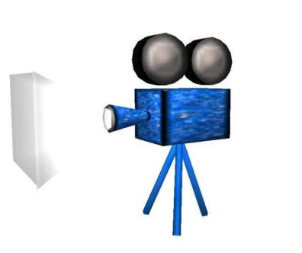**CameraNoView**

Icon:

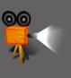

This is a camera entity that doesn’t transfer the player’s view. It can be used to move things much smoother than a moving brush or hidden enemy would. Also provides the view target function.

Works exactly the same as a normal camera, you just don’t have to do workarounds, to prevent the player from seeing through them and there’s no stupid flicker between views.

**Custom Enemy Collision (CEC)**

Icon:

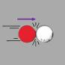

Originally created as a way to give custom bosses interactive collisions. Normally, you’d use a moving brush, that detects damage, but this is extremely limited, as it provides no crosshair interaction, nor does it give feedback to the player, that it’s being shot. The CEC also counts as an enemy, meaning that it actually follows the player on its own. You also have full control over its properties, such as health, speed, size, damage particles, score, flying or ground movement, as well as triggers for different health states. You can set its radius of attack to zero and you have a perfect collision box.

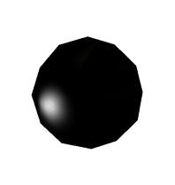

It uses the headman bomb model, because it has a reliable collision box. You can check the 'invisible' box and it'll be totally invisible. Uncheck it for easier editing.

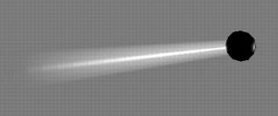For this mod, a new feature has been added: Particle trail. It was originally planned to be an entity similar to the Particles Holder, but trails only seem to work properly with moving entities, so I added it to this. This particle trail function also brought a whole lot of new functions as well, that might need some explaining. Most particles (Romboid, Bomb trail, Firecracker, Coloured stars, Fireball, Grenade, Blood, Lava, Spiral, Running Dust) don't have any customizing functions. This is because they only need the parent entity set for them and nothing else. The particle size function is only applicable to a select few trail types (Rocket, Lava bomb, all three beast related particles, Afterburner). Particle speed ratio is only for the cannon trail. Count particles is only for the beast and beast big projectile trails. ZOffset and YOffset are only used by the Beast big projectile trail. Height is only used by the beast projectile trail.

Make sure to have damagers set up, so it doesn’t mess with the kill counts.

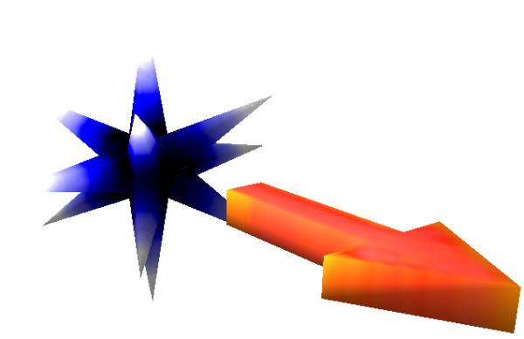**Enemy Spawner**

Icon:



This is just your normal enemy spawner. But it also went through a couple changes. Namely a “template for easy” function. It’s similar to template for serious, but for easy (and tourist) difficulty.

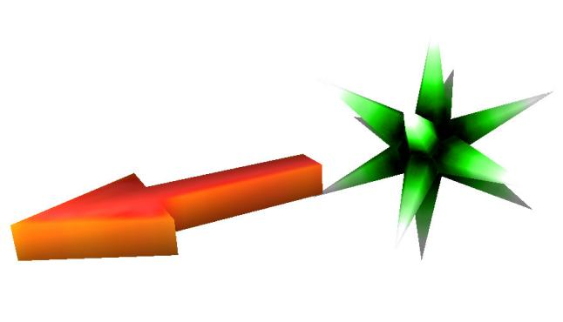**Enemy Launcher**

Icon:

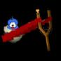

This is an enemy spawner, that launches the enemy it spawns, without the need for unreliable bouncers. You can set a circle and each enemy spawned in the circle will be equally launched. It can also launch flying enemies.

You can set horizontal and vertical speed, to adjust the angle and speed of the launch. By default, it is set to launch the same direction that the arrow is pointing at.

Watch out, because launched enemies will take damage from falling. Sometimes, even from the launch itself, if it’s powerful enough.

**Enemy Projectile**

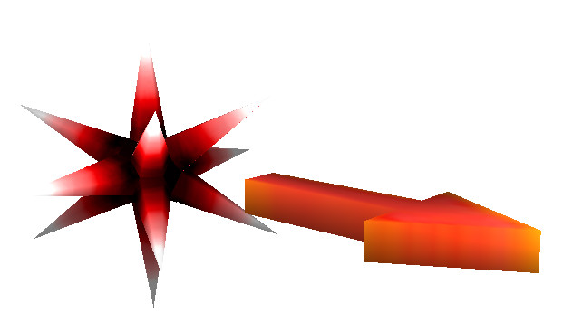Icon:



This enemy spawner shoots Mordekai’s spawner projectile. It works in much the same way the Enemy Launcher does; you can set vertical and horizontal speed. By default, it is set to launch the same direction that the arrow is pointing at.

Fewer options to customize however, due to how the spawner projectile works. No range circle, so it can only spawn from one point. And only the Triggered and Simple types work. (Teleport works as well, but it’s a bit broken.) You can still set the delays and counts as normal, but you have limited options and you’re gonna have to do a few things manually. Patrol target and tactics don’t work either.

(Originally wanted to make this an option for the Enemy Launcher, but it just wouldn’t work. That is because the spawner projectile is an enemy spawner by itself and copying over its stats, would break the rest of the spawner.)

**Fireworks**

Icon:

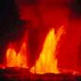

This is an entity that has been a part of the code already, but never ended up being used. All it has is a range variable. When the entity is triggered, a firework explosion will go off at a random point within its range. It has to be manually triggered for each explosion.

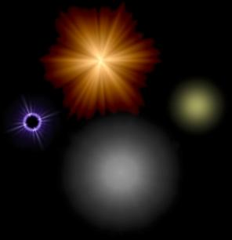**Light**

Icon:

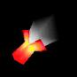

Added four extra lens flare options: Catman fire glow, projectile star glow, projectile white bubble and projectile yellow bubble.

**Parametric Particles**

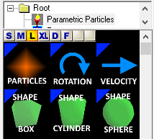

Credit goes to SeriousAlexej for developing these entities.

Advanced particle entities, that give you an extreme amount of options to customize particles. They allow you to create almost any kind of particle effect, from rain and fire to butterflies and magic light effects.

This mod is quite complicated and I have a very limited amount of experience with it. So I think it’s going to be more constructive to just link here [the github page](https://github.com/SeriousAlexej/ParametricParticles), which has the whole manual.

**Player Parenter**

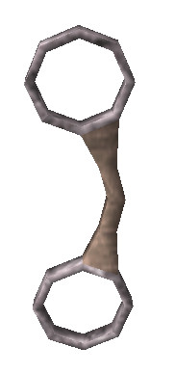Icon:

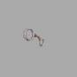

Credit goes to Uni Musuotankarep for developing this entity.

This entity allows you attach things directly to the player. You only need to set a target in ‘entity to parent’ and then trigger the player parenter. That’s all there is to it.

**Range Damager**

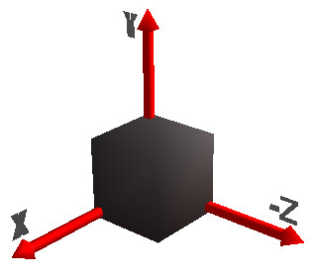Icon:



For the occasions when you want to create an explosion, with an area of damage, but don't want eruptors pointing at the ground. The range damager, lets you adjust the range of the damage (fall off, hot spot), in addition of the damager's normal properties. It has the axis model, so you can better judge the center of the area of damage. You can even set the damage type to spike stab or abyss, it's all customizable.

Kept the "entity to damage" function, for my own convenience. It does nothing.

Important: you must raise the entity up from the ground. If it's sitting directly on a brush, the brush will absorb the damage and nothing happens.

**Shooter**

Icon:

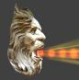

Expanded its shooting capabilities, with several new features. Two new nuke ball options (one for the scrapped secondary of the SBC cannon, the other is the one I ended up using). Both use the regular cannonball’s properties.

The Devastator’s projectile, which is technically a cannonball, but doesn’t have any customization.

The twister, which has its own properties: Duration, grow (no idea what this actually does), launch speed (how fast the twister is launched), moving allowed, size (the bigger the more powerful) and spin direction (if you set it to 360, it will reverse projectiles).

Bullet, which uses the damage and jitter values. (Jitter is 1000 by default; I had to set the bullet’s distance an absurdly high number, to make sure it works on the entire map. As a result, you have to work with large numbers in this field.)

The airwave, shot by the original mamut. It has no variable properties.

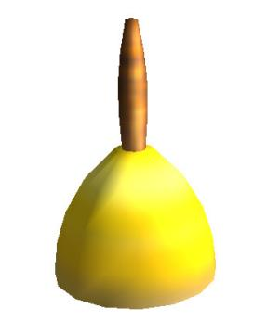**Sound Holder**

Icon:

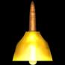

Functions exactly the same as before, but has the ‘pitch’ function added. This was actually always available in the game’s code, but it was just ignored. All I did is add the variable.

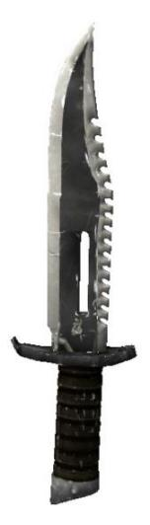**Weapons:**

**Knife**

- **Model credit**: HD port model by T-ReXx

- **Code:** n/a

- **Damage**: 100 (melee)

- **Max ammo**: n/a

- **Effective against**: Gnaars, beheadeds, harpies, mamutman monks, singular large enemies with wound animation

Nothing changed in its functions, just a different viewmodel.

**MR MKII Pistol**

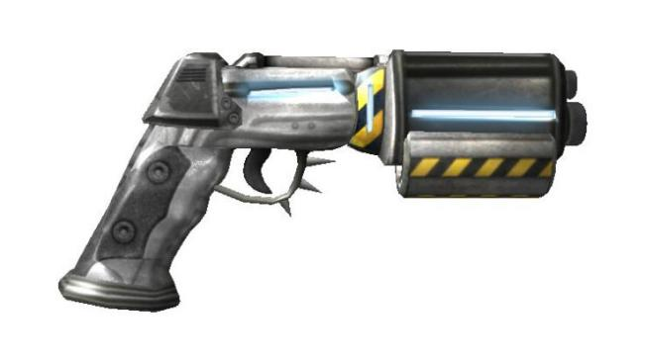- **Model credit**: Ar2R-devil-PiNKy

- **Code:** n/a, 4 (double)

- **Damage**: 10 per bullet

- **Max ammo:** n/a

- **Effective against:** Groups of weak enemies, singular medium enemies.

Faster fire rate than the base pistol. Reloading has been turned off as well, making it much stronger than before.

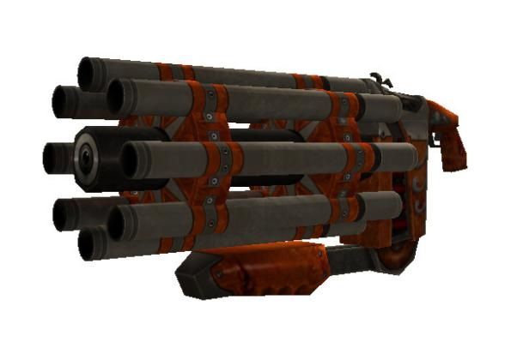**Automatic Indexing Shotgun a.k.a "The Clockgun"**

- **Model credit:** SS2 port model by Dr. Trigger

- **Code:** 8

- **Damage:** 10 per bullet (x 7)

- **Max ammo:** 100 shells

- **Effective against**: weak enemies in groups or singular, medium enemies in small groups or singular

Has a tighter spread and faster fire rate, than the single shotgun, which means it’s more effective at distance, making it a pretty versatile weapon.

**DP-24 Double Barrel Pump Shotgun**

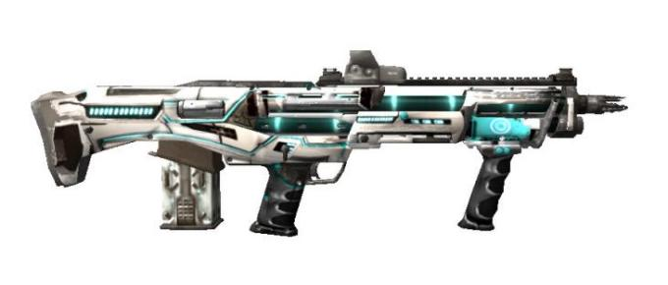- **Model credit:** Model by zorgpro2013, texture by RCK5_WSG45.DOS

- **Code:** 16

- **Damage:** 10 per bullet (x 14)

- **Max ammo:** 100 shells

- **Effective against:** kleers, mid tier enemies, singular high tier enemies

Also has a tighter spread and faster fire rate, making it more effective against larger groups of enemies (especially Kleers).

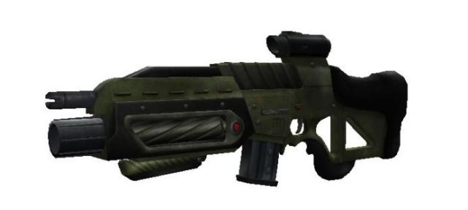**XM8 Scion Assault Rifle**

- **Model credit:** zorgpro2013

- **Code:** 32

- **Damage:** 10 per bullet, rapid fire

- **Max ammo:** 500 bullets

- **Effective against**: weak enemies in large groups, medium enemies in small groups

Functionally identical to the Tommygun, but the slow down bug has been fixed.

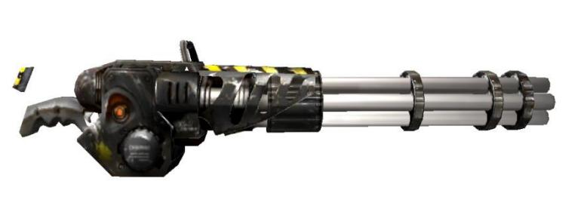**XM4000 Minigun**

- **Model credit:** Next Encounter port model by Mazuto, sound by Maxsis_Specifications

- **Code:** 64

- **Damage**: 10 per bullet, very rapid fire

- **Max ammo:** 500 bullets

- **Effective against:** Large groups of weak and medium enemies, high tier enemies

Functionally identical to the base minigun.

**PML-1 Trident Rocket Launcher**

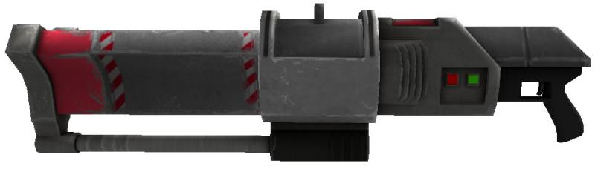- **Model credit:** drinfested from CGTrader

- **Code:** 128

- **Damage:** 50 direct hit, 100 explosion (primary), 200 direct hit, 25 explosion (secondary)

- **Max ammo:** 50 rockets

- **Effective against**: low and mid tier enemies in large groups, high tier enemies

Added a secondary fire: Seeking rockets. They follow the enemy closest to the player’s crosshair. A direct hit deals massive damage, but the explosion is very weak. They also take up two rocket ammo. And they glide on surfaces, to make sure they actually reach their target, instead of blowing up on a wall. This secondary fire can be very effective against high tier enemies.

Flipped the damage of the primary rockets. They still deal the same amount of damage overall, but the explosion is more powerful, while a direct hit is less powerful. This is to make the primary rocket still useful, even with the significantly deadlier secondary rocket. This does make rocket jumping almost impossible though.

**MK V Grenade Launcher**

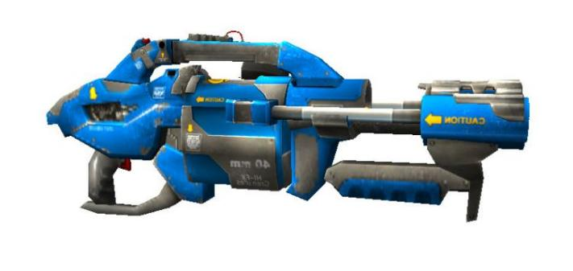- **Model credit:** SS2 port model by Dr. Trigger

- **Code:** 256

- **Damage:** 75 direct hit, 100 explosion (primary)

50 direct, 50 explosion (secondary)

0 direct, 100 explosion x 5 (cluster)

- **Max ammo:** 50 grenade

- **Effective against**: low and mid tier enemies in large groups, high tier enemies

Also flipped explosion and direct damage, but also has a higher splash radius, just to make sure it remains more powerful than the rocket launcher, making it super effective against large groups of enemies.

Also added a secondary fire. A single big grenade, that explodes into five smaller grenades, that explode on impact. This is very effective against tightly packed enemies, but if you do it right, you can explode every grenade into a single enemy for massive amounts of damage.

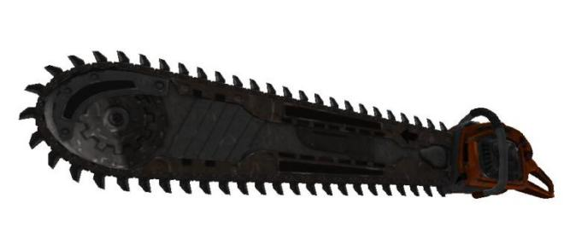**'Bonecracker' P-LAH Chainsaw**

- **Model credit:** HD port model with improvement by Ar2R-devil-PiNKY

- **Code:** 512

- **Damage:** 200 per second (melee)

- **Max ammo:** n/a

- **Effective against**: gnaars, marsh-hoppers, any small or medium enemy that runs towards you

No changes in mechanics.

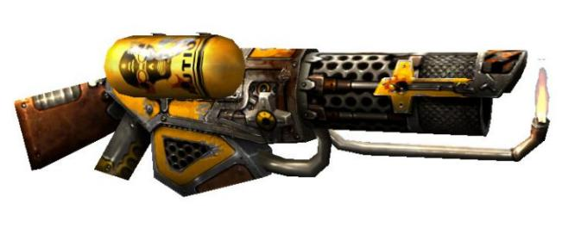**XOP Flamethrower**

- **Model credit:** Hand model from Revolution

- **Code:** 1024

- **Damage**: 30 on direct hit, 0.25 - 25 continuous

- **Max ammo:** 500 napalm

- **Effective against:** Large groups of medium enemies

No changes in mechanics. Added hand onto view model.

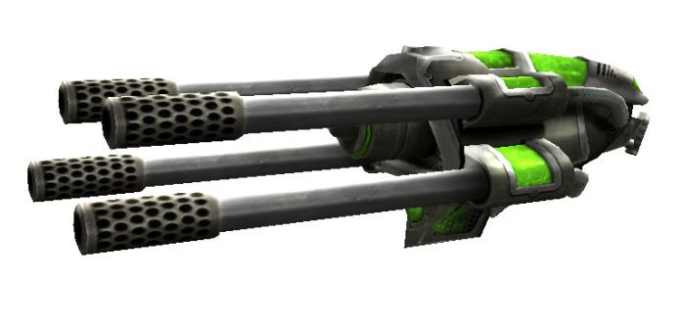

**XL3 Lasergun**

- **Model credit:** Ar2R-devil-PiNKY

- **Code:** 2048

- **Damage:** 20 per laser, rapid fire

- **Max ammo:** 400 electricity

- **Effective against**: weak and medium enemies in large groups, high tier enemies

Functionally identical to the base lasergun, but weapon slow down bug has been fixed.

**RAPTOR Arctic Warfare EDF Sniper**

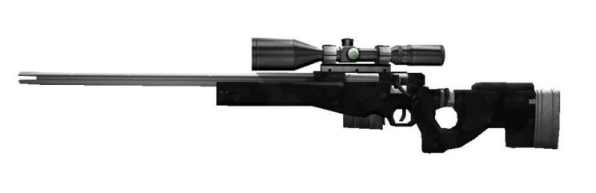- **Model credit:** LevC and Kote

- **Code:** 4096

- **Damage**: 200 per bullet (300 against specific enemies)

- **Max ammo:** 50 bullets

- **Effective against:** mid and high tier enemies, far away enemies

Bullet damage reduced from 300 to 200, but sniper resistances removed from enemies. So reptiloids, demons and walkers take fewer hits than before. Arachnoids, zumbuls, werebuls, have been made weaker against sniper shots, to ensure they still take one shot. Unzoomed shots still scatter, but do the same damage as zoomed shots.

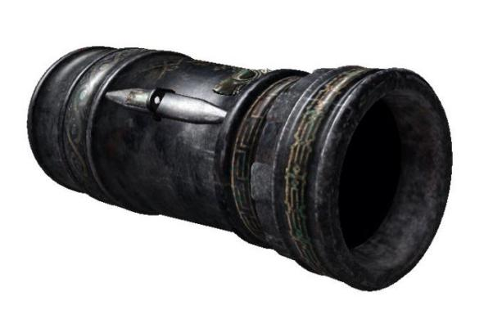

**SBC Cannon, Prototype**

- **Model credit:** SS4 port by JesterOfDestiny

- **Code:** 8192

- **Damage:** 400-750, 25 explosion (primary)

400, 1000 explosion (secondary)

- **Max ammo:** 30 cannonballs

- **Effective against**: large groups of low-mid tier enemies, high tier enemies

Added the nuke ball function back in, as an alt fire, but made it weaker. In the Alpha, this nuke ball would deal a massive damage in an explosion that happens 13 times. This lead to all kinds of balance issues. The new nuke ball functions the same way, but the damage has been lowered, while splash radius has been raised. It still decimates smaller enemies, but its sheer damage is actually lower now than the regular cannonballs. Can also be kinda wasteful, since one nuke ball takes up 5 cannonballs. But if you do it right, you can quickly annihilate very large groups of enemies.

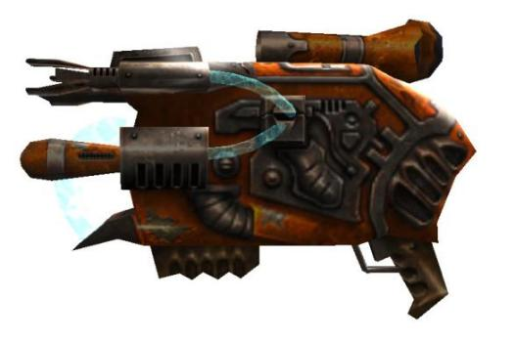So now, against larger enemies, it’s actually more useful to stick to regular cannonballs. But a large horde of smaller enemies, with a big one in the middle, might warrant a nuke ball. Granted, you’re far away enough to be outside explosion range. Just make sure you charge it properly.

**CDF-ST-005 Plasmathrower**

- **Model credit:** Model from Seriously Warped Deathmatch

- **Code:** 16384

- **Damage:** 15 per projectile, 30 explosion, x8 in alt fire

- **Max ammo:** 300 plasma

- **Effective against**: tight clusters of weak enemies, high tier enemies

Faster fire rate and higher ammo capacity (compared to Revolution), no weapon slow down bug, slightly tighter spread in alt fire. Direct and explosion damage are also flipped, to make sure it’s more effective against groups of monsters.

**XL4-P 'Ghostbuster' Beam Gun**

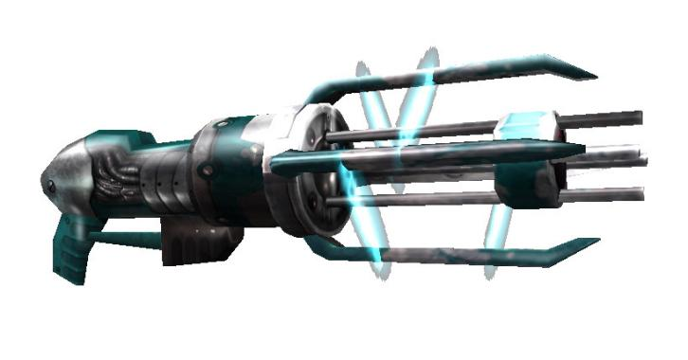- **Model credit:** Model from Revolution, improvement by Ar2R-devil-PiNKY

- **Code:** 32768

- **Damage:** 15 per "bullet", very rapid fire

- **Max ammo:** 400 electricity

- **Effective against**: large groups of low-mid tier enemies, singular high tier enemies

Way better than the Revolution version. No piercing bullets, but it does actually hit the enemies consistently. It also destroys projectiles and keeps its high damage output from Alpha. On top of all that, its range has been improved. Still limited range, but you don’t have to climb up the monsters’ asses. All of that making it a pretty reliable crowd control weapon, but can also be effective against larger enemies.

Also has a much more satisfying sound, than the that dinky ‘bzzz’ noise it was making previously.

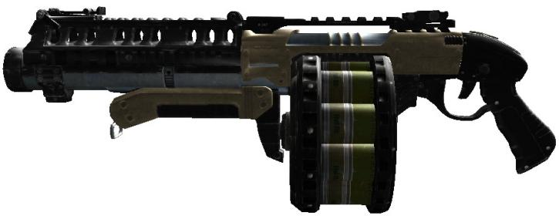

**AS-24 Devastator**

- **Model credit:** Model port by JesterOfDestiny

- **Code:** 65536

- **Damage:** 140 per projectile, 20 explosion

- **Max ammo:** 100 devastator shells

- **Effective against**: tight clusters of weak enemies, medium tier enemies, far away high tier enemies

The fan favourite weapon from Serious Sam 3 and 4. Functions pretty much the same way, with some of the classic engine limitations added.

There’s a fun glitch with it, that I decided to keep as a feature of the weapon. The way cannonballs deal damage is very weird. If the cannonball hits something, right the moment it is launched, the damage is counted twice, for some reason. Due to the Devastator’s projectile being a very fast cannonball, this is even more pronounced. Now you can deliberately go close to enemies and finish them in half as many shots as normal. Just don’t get too cocky.

**HP-3 Hydro Gun**

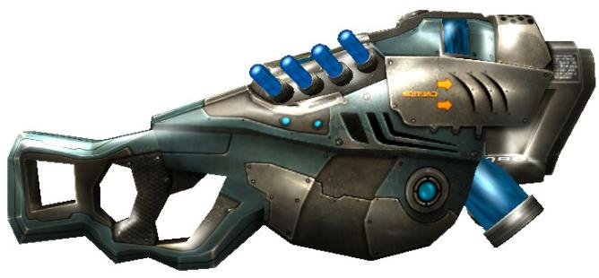- **Model credit:** SS2 port model by Dr. Trigger

- **Code:** 131072

- **Damage:** 0 per projectile, 45 explosion

- **Max ammo:** 300 plasma

- **Effective against**: large groups of low-mid tier enemies, singular high tier enemies

This is mostly here, because I wanted all 9 numbers to contain 2 weapons. And since I really love the Serious Sam 2 design of the lasergun, I decided to add it in, as kind of a callback to the Alpha’s Lava Rocks Gun.

The projectiles fired by the Hydro Gun don’t do damage on their own, only a small range splash damage. This makes it extremely effective against tight clusters of weaker enemies, but even stronger enemies might end up gibbed by it. More powerful than its sister weapon, but might use more ammo for the same damage, due to smaller splash range and faster fire rate.

**Enemies**

There are some overall changes made to the enemy base entity. Mainly in the difficulty modifiers. Serious Sam always gave enemies speed bonuses based on difficulty. In this mod, these bonuses are increased. So in tourist difficulty, enemies move half as fast, while in serious, they move almost twice as fast. Charging enemies, such as the werebull, were given an exception on this, but that is no longer the case. (The only exception being the mamutman.) Enemy reaction time is also affected, meaning that on Serious, enemies attack twice as often, while only half as often on Tourist. That means, tourist and easy are easier than before, but hard and serious (and mental) are also more difficult.

There are more enemies with the ability to drown now. Previously, only certain smaller enemies were allowed to drown. The only exception to that are amphibious enemies (crabmen, dum-dums, fishmen, mantamen, kalopsies, lurkers and water golems), monsters that don’t need to breathe (cyborgs, floaters, kleers, temple guardians, rams and portents of doom) and enemies that don’t have any other way of functioning (the electro fish).

Added a ‘count as kill’ function, though it only concerns templates spawned by other enemies, such as Mordekai, or the Monster Replicator, to make sure they don’t mess up the kill count. That’s the only time it works. Otherwise, the kill counter still counts it, it just doesn’t get added when killed, making it a broken kill. So use it only for spawner enemies.

Also, unique gibs with extra satisfying splat sounds.

**Classic enemies:**

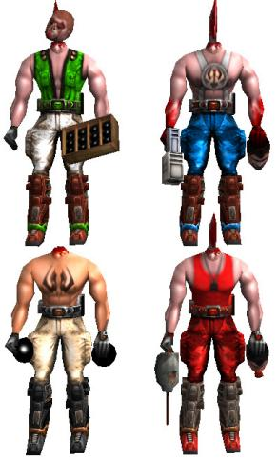**Beheaded Sirians**

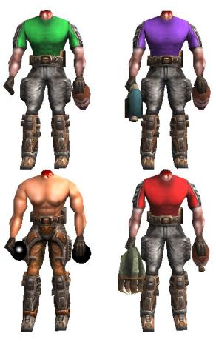- **Health**: 20

- **Damage**: 5 (Rocketman), 4 (Firecracker), 10 direct, 15 explosion (Bomber), 30 explosion (Kamikaze)

- **Roles**: cannon fodder, ranger, charger (Kamikaze)

- **Special ability**: -

- **Best weapon**: colt, single shotgun, tommygun

Their base movement speed and attack range has been increased, making them ever so slightly less useless. A style function has also been added, with the classic and alpha variety. Alpha style made by Rakanishu.

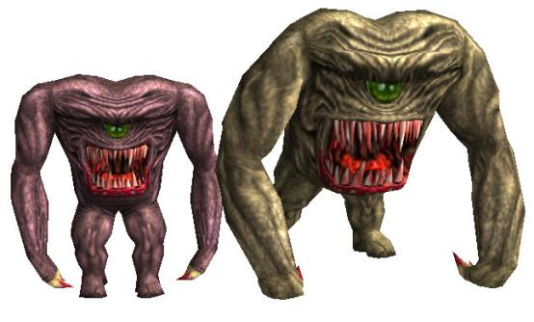**Gnaars**

- **Health**: 60 (Male)

100 (Female)

80 (Belcher)

50 (Boomer)

250 (Brute)

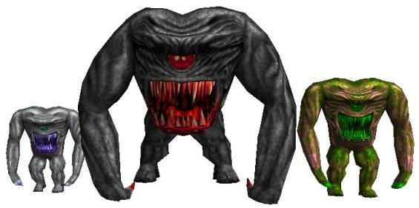- **Damage**: 5 per hit, 10 per bite (Male)

10 per hit, 20 per bite (Female)

5 per hit, 10 per bite, 8 per projectile (Belcher)

3 per hit, 6 per bite, 20 explosion (Boomer)

20 per hit, 40 per bite (Brute)

- **Roles**: cannon fodder, early game threat, meat shields, distraction, weak kleer (belcher)

- **Special ability**: Exploding after death (Boomer), ranged attack (Belcher)

- **Best weapon:** knife, chainsaw, single shotgun, double shotgun, rocket launcher, minigun

Slightly higher movement speed, attack range and damage, so they’re marginally more dangerous than the base gnaar. Female and Brute varieties also received a new look, along with heightened stats.

AREP varieties (Brute, Belcher, Boomer) have been added. The Belcher has relatively slow movement speed, but has a weak projectile. The Boomer explodes after death. The Brute has high health and damage.

Environmental varieties (Snow and Lava) for Male and Female have been added.

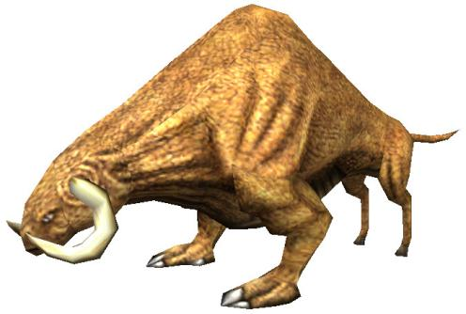**Werebulls**

- **Health:** 250

- **Damage:** 20-ish per hit

- **Roles:** charger

- **Special ability:** knocking players and monsters in the air

- **Best weapon:** double shotgun, rocket launcher, grenade launcher, minigun, ghost buster, sniper, cannon, devastator

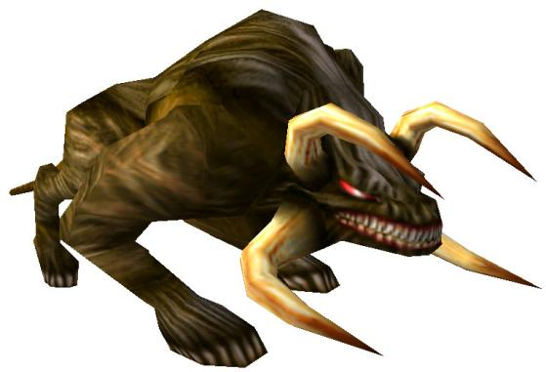

The base Werebull sees no change, but a ‘character’ function has been added, allowing you to use both classic and Next Encounter variety. Keep in mind, the Next Encounter variety is slightly faster.

Environmental varieties (summer and winter) are available for both.

**Arachnoids**

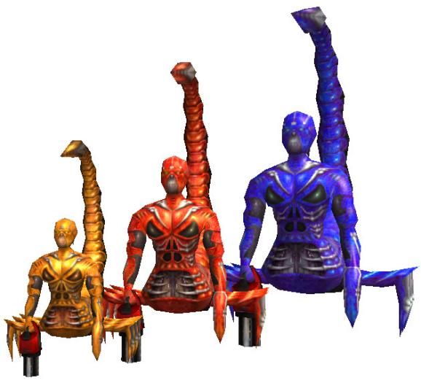- **Health**: 300 (juvenile)

600 (adult)

1200 (ancient)

- **Damage**: 3 per bullet (juvenile and adult)

6 per bullet (ancient)

- **Roles**: hitscan ranger, miniboss (ancient)

- **Special ability:** rapidfire hitscan

- **Best weapon**: minigun, rocket launcher, sniper, cannon

Monster variety, recovered from disabled alpha code, has been added. It has a longer attack sequence, with higher damaging bullets.

The two base varieties remain the same, but ‘boss’ function is available.

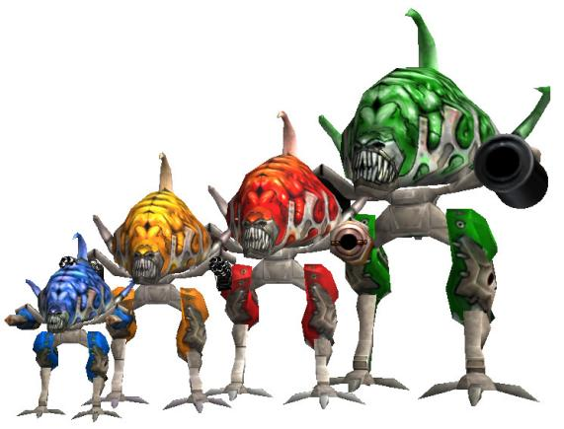

**Biomechanoids**

- **Health:** 150 (minor)

450 (gunner)

750 (major)

1000 (artillery)

- **Damage:** 10 per laser (minor)

3 per bullet (gunner)

100 direct, 50 explosion (major)

400-750, 25 explosion (artillery)

- **Roles:** ranger, tank (major and artillery), miniboss (artillery)

- **Special ability:** -

- **Best weapon:** rocket launcher, grenade launcher, sniper, laser, plasma thrower, cannon

As far as the minor and major variety goes, there is no change, beyond the addition of the boss function and a fix to an obscure bug, where the fight music keeps playing, long after the walker has died. There are two extra varieties: the gunner and artillery. The gunner has a hitscan attack, while the artillery (developed by Rakanishu) fires cannonballs.

Sidenote: the gunner variety has no NETRICSA model. I ran out of space in the CompModels file and had to delete a few things. The gunner got the cut, since I didn’t plan on actually using it myself, but it’s still fully functional for those who do want to use it.

**Harpy**

- **Health:** 100

- **Damage:** 8 per projectile, 20 per melee hit

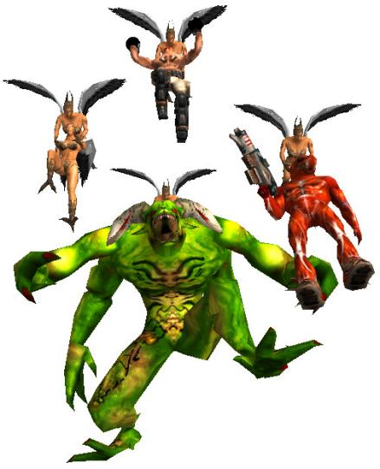- **Roles:** flying enemy, cannon fodder

- **Special ability:** enemy carrying

- **Best weapon:** knife, tommygun, minigun, rocket launcher, sniper

Nothing is different in the harpy, except for its carry function. Previously, it was able to carry and drop kamikazes. Now, with the help of Dreamy Cecil, it is able to carry any enemy. This function works much the same way that an enemy spawner does. You select the template enemy and it’ll be spawned, counting towards the kill count. You can even set the carried enemy’s animation and position.

**Reptiloids**

- **Health:** 400 (common and electric)

3000 (highlander)

6000 (bride)

- **Damage:** 10 per projectile, 40 per slap (common)

20 direct hit, 10 explosion, 40 per slap (electric)

20 per projectile, 80 per slap (highlander)

20 per projectile, 1200 per slap (bride)

- **Roles:** sniper, ranger, early/mid-game threat, miniboss (highlander and bride)

- **Special ability:** homing projectile, bouncing projectile (electric)

- **Best weapon:** minigun, rocket launcher, sniper, laser, devastator, cannon

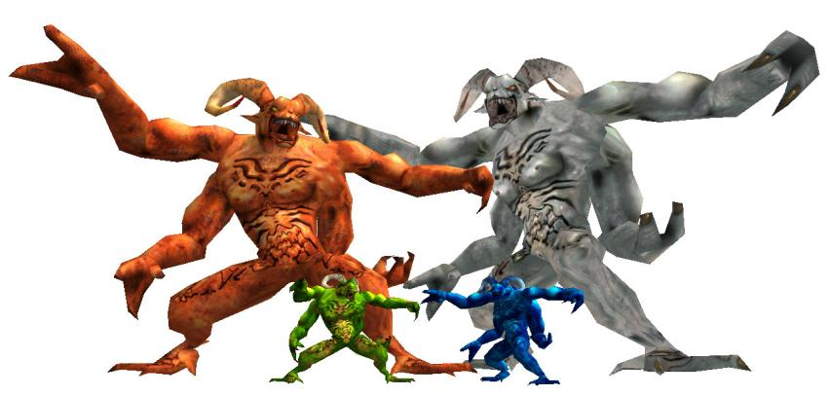A new function has been added (version) which lets you chose between the First Encounter and Second Encounter mechanics. In SE, the reptiloid was given a resistance to cannonballs, so it wouldn’t go through the common reptiloid and the highlander takes more cannonballs to kill. In FE, the highlander also has a different projectile, more similar to the common reptiloid’s projectile, as opposed to the demon’s boomerang-like fireball in SE. With the version function, you are able to choose between these two varieties. You can also choose a mixed version, that gives the highlander the boomerang fireballs, but without the cannonball resistance.

A new type is also available, first developed for the Alpha Reimagined Enemy Pack mod: The electric reptiloid. It fires bouncing plasma projectiles similar to the exotech larva, except weaker. This variety is actually more effective on the ground or in closed spaces; the projectile has more opportunity to hit the player. It also has a unique interaction with melee enemies, such as gnaars. They keep following the player and getting hit by the plasma projectiles, which causes the projectile’s explosion to hit the player.

The projectile is incredibly powerful; it kills beheadeds instantly and can finish off wounded enemies (even itself). Don't spawn too many of them at once, because it could get very overwhelming.

**Zorgs**

- **Health:** 40 (mercenary)

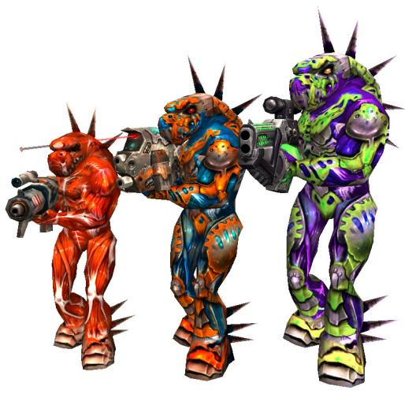 60 (commander)

80 (sniper)

- **Damage:** 10 per projectile

- **Roles**: cannon fodder, ranger (mercenary and commander)

sniper, enhanced footsoldier (sniper)

- **Special ability:** spreadfire (commander), homing projectile (sniper)

- **Best weapon:** single shotgun, tommygun, minigun, flame thrower, laser, plasma thrower

The base zorg’s attack distance has been increased, making them more effective at range. Friendly fire has been turned off as well, because I always found it annoying that they keep killing each-other in larger groups. But you can turn that back on, if you so wish.

A new variety has also been added: the sniper. It is slightly stronger and has a homing projectile, making it a decent sharpshooter. Though, this projectile is rather short lived and may get confused when it’s very far away. It is similar to the orc destroyer from SS2, except more powerful. I don’t recommend putting too many of them down at once, because their homing projectiles can be very overwhelming.

**Zumb’ul**

- **Health:** 200 (normal)

460 (rocketeer)

700 (warlord)

- **Damage:** 10 direct hit, 10 explosion (normal and rocketeer)

25 direct hit, 25 explosion (warlord)

- **Roles:** early game threat, ranger, limited-range sniper

early stage miniboss, heavy ranger, heavy sniper

- **Special ability:** multiple explosive projectiles

- **Best weapon:** minigun, rocket launcher, sniper, laser, cannon

Beyond the two new varieties, its attack range has been increased and a boss function has been added.

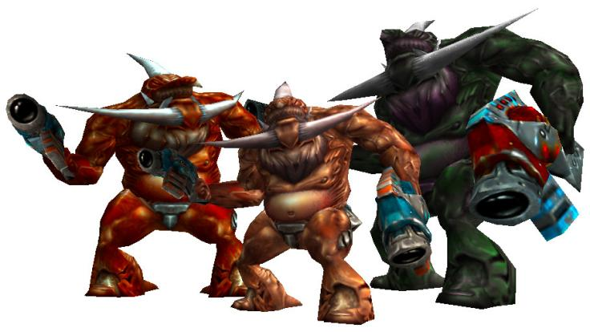

The rocketeer variety shoots volleys of multiple projectiles, all in a straight line, not unlike the Mancubus from Doom. Obviously, it is significantly more dangerous than the basic Zumb’ul.

The warlord is even more dangerous, because it fires volleys of four grenades, that can be difficult to avoid, depending on how distracted the player is. Do not take them lightly.

**Demons**

- **Health:** 500 (normal)

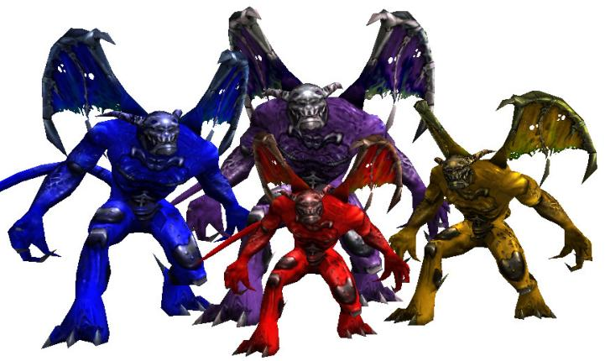 800 (storm)

700 (arch-ville)

3000 (summoner)

- **Damage:** 20 per projectile (normal)

n/a per twister (storm)

70 explosion (arch-ville)

100 direct damage, 100 explosion (summoner)

- **Roles:** sniper (normal),

distraction, heavy support (storm)

heavy sniper (arch-ville)

miniboss, spawner (summoner)

- **Special ability:** boomerang projectile (normal)

twisters (storm)

devastating hitscan attack (arch-ville)

devastating projectile, summoning spells (summoner)

Statue state (all)

- **Best weapon:** minigun, grenade launcher, laser, ghost buster, sniper, plasma thrower, cannon

A new statue function has been added, which is similar to the arachnoid’s sleeping function, except it also makes the demon invulnerable. It basically just swaps the demon’s texture to a statue texture and turns it totally stationary and nonreactive. This is just because I have played with this idea before, of demon statues coming to life, so I just included that as part of the demon’s mechanics.

Boss function is also available, along with three new varieties.

The storm demon might be familiar to those who downloaded my Alpha Reimagined Enemy Pack. It throws Kukulkán’s twisters, which throw the players, monsters and projectiles around. Not dangerous by itself, but can turn a battlefield into chaos. Make sure to prevent enemies from flying out of bounds and give the player a way to come back in case of a hefty throw. Don't use too many of them at once.

I made the arch-ville variety mostly just to see if I could. Its ranged attack functions the same as the Arch-vile from Doom. It is, indeed, powerful as hell. Although, it does deal damage to surrounding enemies as well, which is pretty funny. But you must give the player enough cover to avoid its attacks. Doesn’t have a NETRICSA model, since I didn’t plan on using it at all, but it is available for mappers. Might make a comeback, if I decide to make a Doom mod.

The summoner has two different ranged attacks. One is a meteor, which deals a massive amount of damage and has a pretty big range, but is relatively slow. So definitely give the player plenty of room to run around to avoid it. The other attack is spawning three enemies at once. Only has three templates, so it's always the same three enemies. This one can be very dangerous, so handle them with care.

**Alpha enemies:**

**Zibakandi (Catman)**

- **Health**: 70 (hunter)

150 (assassin)

300 (terminator)

- **Damage**: 5 per laser, 15 leap, 10 melee (hunter)

25 per bomb, 25 leap, 20 melee (assassin)

50 per grenade, 35 leap, 30 melee (terminator)

- **Roles**: late game cannon fodder, limited sniper, early game threat, kleer (hunter)

support ranger, limited sniper, early game threat, strong kleer (assassin)

strong ranger, limited sniper, early to mid game threat (terminator)

- **Special ability**: triple laser (hunter)

double bombs (assassin)

really powerful grenades (terminator)

- **Best weapon**: tommygun, flamethrower, chainsaw, grenade launcher (hunter)

tommygun, minigun, rocket launcher, flamethrower, sniper (assassin)

minigun, sniper, laser, cannon (terminator)

(Model made by Kirill Kotliar, claw model by KingJohaan on Sketchfab.)

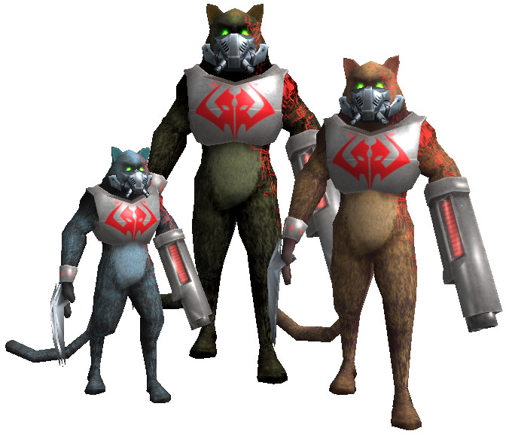Originally, in the Alpha Reimagined Enemy Pack, the catman was built to be an alternative to kleers. But this mod gives them the ability to turn partially invisible when engaged in combat and it has become a less versatile enemy.

Yes, when it has a target, it turns partially invisible and only becomes visible while attacking. There is usually a pause and a sound to give players enough time to react. And while they do not turn fully invisible, they do become difficult to deal with in a more hectic battle. Therefore, a bit more care is required when working with them. Simply put, don’t rely on them too much, otherwise it becomes annoying and overwhelming.

The hunter variety is weak, but very fast and shoots three projectiles, spread out in an angle. They have decent range, so they’re good at stationary attacking as well. Just be careful with spamming them, because their projectiles can be overwhelming. Though once the player gets powerful rapidfire weapons, they can start appearing in larger groups.

The assassin is stronger, but slower. They shoot two explosive projectiles. Their range has been improved, by lowering their shooting angle, making them more effective in closed spaces. Which also means, that their projectiles are now much faster and harder to avoid, so keep that in mind.

The terminator variety is very dangerous. They shoot powerful grenades, which can kill the player in one hit. However, they’re relatively weak, compared to other enemies of this tier. So they can become more numerous towards the end of the game. But keep their numbers very limited, until then.

**Cyber-hive (Cyborg)**

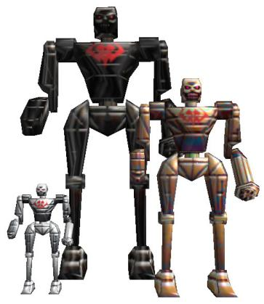- **Health**: 70 (primary drone)

175 (assault drone)

600 (juggernaut)

- **Damage**: 5 per laser, 20 melee (primary drone)

10 per laser, 40 melee (assault drone)

20 per rocket - direct hit, 80 melee (juggernaut)

- **Roles**: cannon fodder, sniper, early game threat (primary drone)

support ranger, sniper, early game threat (assault drone)

strong ranger, sniper, early to mid game threat (juggernaut)

- **Special ability**: four projectiles, explosive death, hoverbike

- **Best weapon**: tommygun, minigun, laser, flamethrower (primary drone)

minigun, laser, grenade launcher, sniper, cannon (assault drone)

rocket launcher, grenade launcher, sniper, cannon (juggernaut)

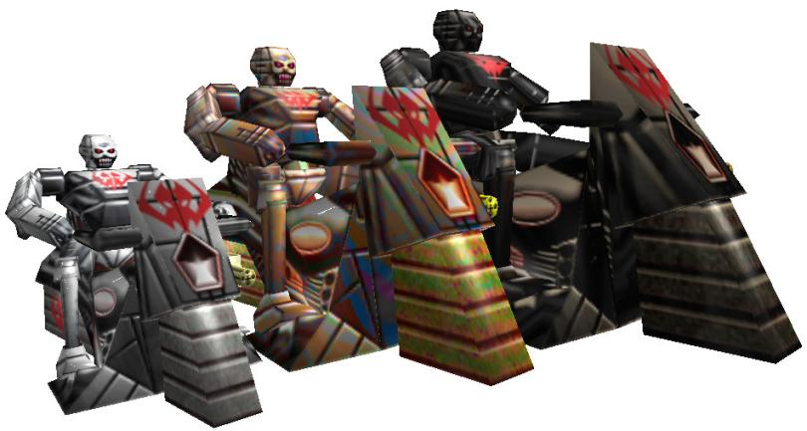Slow, but potent rangers, with a very high attack range. They have powerful melee attacks and explode on death, which makes them quite effective in close range as well. But they can also serve as primary targets, because their dying explosions can help kill other enemies as well.

The two small variants shoot lasers, while the juggernaut shoots zumb’ul rockets. And since it shoots them from above the player, they can be very difficult to dodge. That variant needs a bit more care when designing a fight.

As far as flying varieties go, I recommend using only the primary drone’s flying variety. They’re very fast and can get themselves in a range where their attacks become difficult to dodge. As such, the bigger ones, especially the juggernaut, can become extremely dangerous and difficult to deal with.

The assault drone and juggernaut don’t have NETRICSA models. I wanted to cut back on some of the enemy variety and those two got the cut.

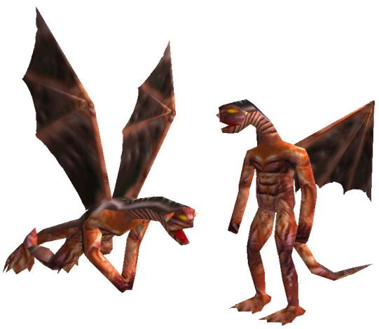**Vermilion Dragon (Dragonman)**

- **Health**: 500

- **Damage**: variable, 35 melee

- **Roles**:early game miniboss, very powerful flying enemy

- **Special ability**: fire attack

- **Best weapon**: minigun, grenade launcher, sniper, cannon

Ridiculously high potential damage. The flames cling to the player and continue to do damage. Be sure to have lots of health pick-ups; small ones, because it's better to keep replenishing health being burned away, then wait for the flames to go out and almost die in the process. Having water around is also a good bet, because it extinguishes the flames.

It may be a good idea to start them out from far away, so the player can eliminate them before danger arrives. Once the player has a sniper rifle or a minigun, the dragonmen become easier to deal with. But the grenade launcher and cannon can also work wonders.

There’s no NETRICSA model, because the devil stallion makes this enemy pretty much obsolete. But the enemy is still there if you want to use it.

**Vodyani (Fishman)**

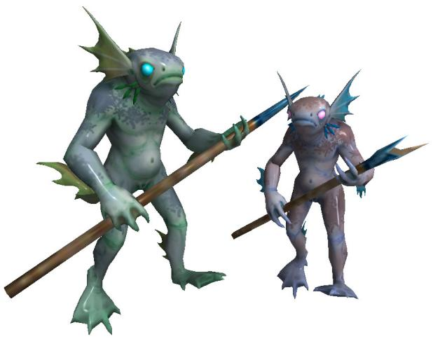- **Health**: 30 (clansman)

90 (berserker)

- **Damage**: 5 per projectile, 6 per leap (clansman)

10 per projectile, 12 per leap (berserker)

- **Roles**: cannon fodder, underwater kleer

- **Special ability**: fast swimming

- **Best weapon**: single shotgun, tommygun, rocket launcher, grenade launcher, chainsaw, double shotgun, minigun, flamethrower

(Model by coremort on Sketchfab.)

Gave them a new model, because the original had confusing animations. For one thing, the running animation had them jump high into the air, yet their hitbox remained on the ground, making them confusing to fight with. Their aquatic animations were also too indistinct, so it was difficult to tell what they were doing and when to stop shooting them. This new model has much more defined and accurate animations.

They have similar behaviour to Kleers. They shoot two projectiles and have a charge attack, but can also swim and breathe underwater. They don’t have a simple melee attack though, only a leap attack. The small variety is very weak and may be replaced by the bigger one, as the game progresses. But even that one is weaker than the Kleer.

**Ophidian (Huanman)**

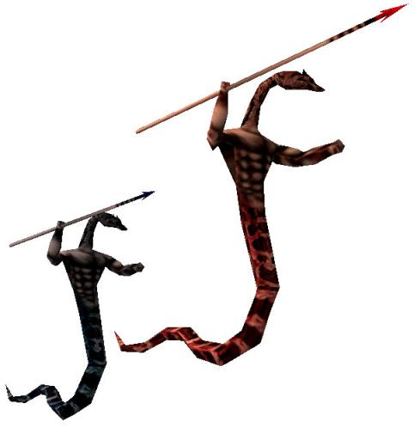- **Health**: 100 (assasin)

1000 (zealot)

- **Damage**: 20 per hit (assasin)

40 per hit (zealot)

- **Roles**: cannon fodder, early game threat, miniboss (zealot)

- **Special ability**: -

- **Best weapon**: knife, tommygun, minigun, chainsaw, grenade launcher, flamethrower, cannon

A very fast melee only enemy. Marginally more dangerous than Gnaars, but have lower range, so their attacks are easier to avoid. The big one is very dangerous; their attacks are difficult to avoid, due to their high range. They’re high priority targets, but they can become more numerous when the player gets the cannon. (They have a built-in weakness against cannonballs, so they die in one shot.

**Altajbeest (Mamut)**

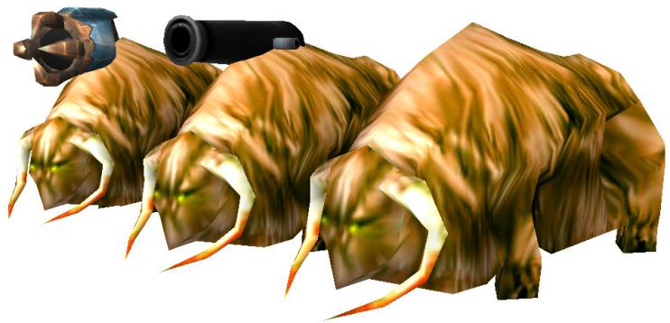- **Health**: 800

- **Damage**: 50 ranged melee, 400-750 direct hit, 25 explosion

- **Roles**: tank, heavy sniper (cannon)

spawner (summoner)

- **Special ability**: stomp attack, knocking the player into the air, predictive aim, cannonball, enemy spawning

- **Best weapon**: minigun, laser, cannon, hydrogun

High health, high damage, decently high speed. Can weather more than one cannonball. All of that make it a very potent tank enemy. Having powerful attacks is on top of all that.

The normal one is technically a melee enemy. Its stomp is a melee attack, but it uses range damage, as opposed to direct melee damage. It launches players and monsters into the air, which can be disorienting. It can also destroy rockets and grenades.

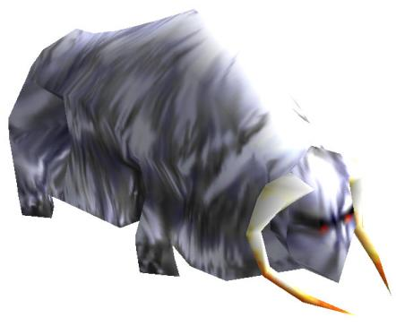The cannon variety uses predictive aiming. They have long range, which makes them very powerful snipers. The summoner variety has three different template options, which you gotta fill, otherwise the game crashes..

Has a weird elongated hitbox. If it turns around too quickly next to a model or enemy, it will launch itself. They might also get stuck in thin crevices. Just make sure they have lots of empty space to run around in.

Summer and winter environmental variants are available.

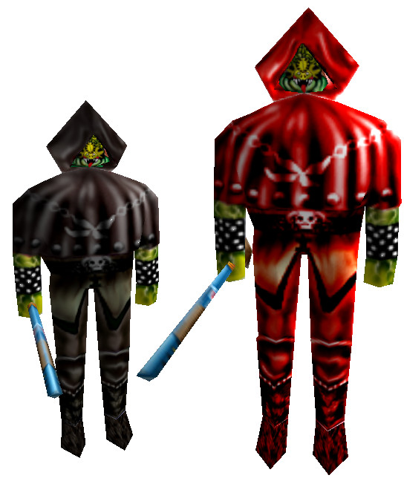**Krutek (Mamutman)**

- **Health**: 70 (monk)

180 (cardinal)

- **Damage**: 10 projectile, 10 melee (monk)

10 projectile, 20 melee (cardinal)

- **Roles**: early game threat, cannon fodder, light sniper (monk)

support ranger, limited range sniper (cardinal)

- **Special ability**: teleportation

- **Best weapon**: knife, tommygun, rocket launcher, grenade launcher, minigun, sniper, cannon

Big change from the AREP version. Originally, the monk variety teleported after taking damage. Now, they teleport after every ranged attack, just like the cardinal. Which makes them more annoying than before, but their lowered health and raised wound chance makes them slightly easier to deal with. Neither of them are viable as regular swarm enemy, although the monk can become more numerous later in the game.

The cardinal shoots five projectiles in a sweeping pattern, similar to the zorg commander. Both of them are effective as ground attackers, but also as stationary rangers.

They require summoner markers to work. Had to program in a safety procedure, because if they have no markers to teleport to, the game will crash. This makes them a bit more difficult to set up, because each area needs its own set of summoner markers. It's nothing complicated, but makes them better suited for arena type environments.

They need at least 3 markers!

You might encounter a few glitches with them. If you kill them in a very specific window right before they teleport, they will keep running around and shooting, despite not registering in your crosshair. It is a rare bug, that I couldn't even intentionally recreate. It only just gives them a single extra shot anyway. Also had to program in an exception for difficulty modifiers. The way their teleportation works, makes the restart their main sequence function. But difficulty modifiers are added when the main sequence starts, so the modifiers would get multiplied after each teleportation, resulting in the enemy slamming itself against a wall and dyeing, or becoming completely stationary in easy.

**Mobulon, flying drone (Mantaman)**

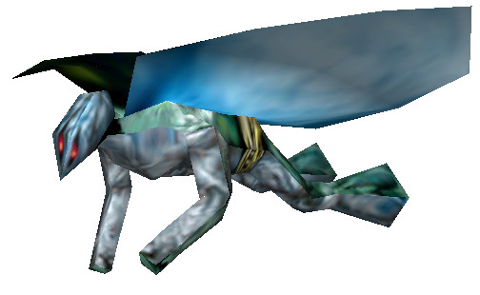- **Health**: 170

- **Damage**: 5 direct hit, 10 explosion, 20 melee

- **Roles**: non-spam flying enemy, underwater ranger

- **Special ability**: explosive projectile

- **Best weapon**: minigun, sniper, grenade launcher

A flying enemy, that’s also fit for aquatic environments. Strictly fly only, since they have no ground animation. Though they might actually be slightly less dangerous under water.

They shoot explosive projectiles, which can be difficult to avoid, when the enemy is above the player. When the player can maneuver around it, the projectile becomes easier to avoid as well. That is, when you’re not in a too closed off space.

If you ever find yourself making extensive underwater sections, then the mantaman is perfect in the role of the zum'bul, bomber, small lava golem and other explosive or tanky ranged enemies. On dry land, they’re essentially beefed up harpies. They take multiple rockets to kill, though the seeking rockets are a good bet. Grenades too, if you’re a grenade god. Spamming is not recommended, because they can be overwhelming in large numbers.

Has a sleeping function.

**Sirian Sentry**

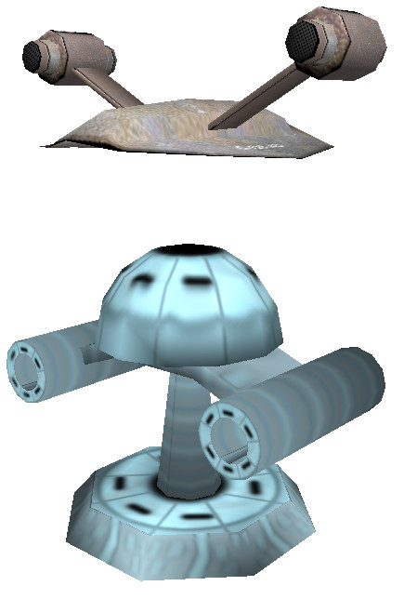- **Health**: 40 (turret)

20 (floater)

- **Damage**: 5 per laser

- **Roles**: ranger, cannon fodder, flying enemy (floater)

- **Special ability**: -

- **Best weapon**: colts, tommygun

These two are essentially obsolete. The floater was made before I knew how to port models from SS2 into classic. But now that I have done it, the Floater has taken its place. And the turret is just a purely stationary attacker. Kind of boring, to be honest. For that reason they don’t have NETRICSA models either. But they’re available for mappers regardless.

**Water golem**

- **Health**: 50 (small)

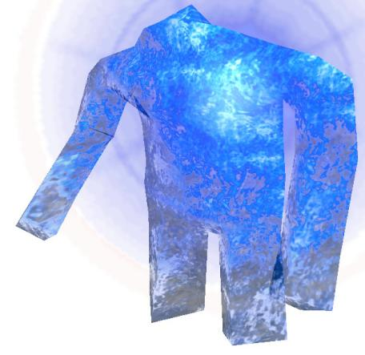500 (big)

5000 (boss)

- **Damage**: 7 per projectile, 20 melee (small)

20 per projectile, 60 melee (big)

20 per projectile, 100 melee (boss)

- **Roles**: cannon fodder, annoyance (small)

support ranger, tank, early game threat (big)

miniboss (boss)

- **Special ability**: sweep attack, shape-shifting, bullet resistance

- **Best weapon**: chainsaw (small only), rocket launcher, laser, ghost buster, plasma thrower, cannon, hydrogun

One of the fastest enemies in the roster. It shape-shifts into a puddle and slides around rapidly. This can make them easy to lose track of in a more hectic battle. Bullets also do half as much damage on them, which might not be an issue with the small one, but the big ones become difficult to deal with without explosives or energy weapons (though the chainsaw is still effective). Bigger ones spawn small ones, only after death.

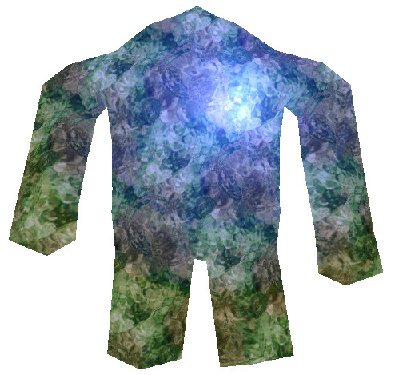

All three variants shoot multiple projectiles in a sweeping motion. Small ones shoot five, in a wave in front of them. Big ones shoot eighteen, in a circle around them. The boss variety throws twenty, in so densely packed waves, that it can be impossible to dodge. And they do two sweeps as well.

For the most part, this attack only looks intimidating, but the projectiles are slow, can be misdirected by uneven terrain and it’s unlikely that they’ll hit the player multiple times in a single attack. The boss is, of course, the exception, but with sufficient distance, it becomes much less dangerous. But they are all really fast, which allows them to use melee attacks, which can be devastating in the case of larger varieties.

Includes a float function. Though the water golem can swim just fine, the "float" function allows them to walk on water. Be aware though, that when they split into smaller parts in the water, the small ones may take some time to wake up. If you kill them in this state, they will wake up with no health registered. One hit with anything will kill them in this state, but still, it's a rather unwieldy bug. It’s better to just turn off spawning.

A "dirty" environmental variety is also included, for sewers and swamps and other dirty environments.

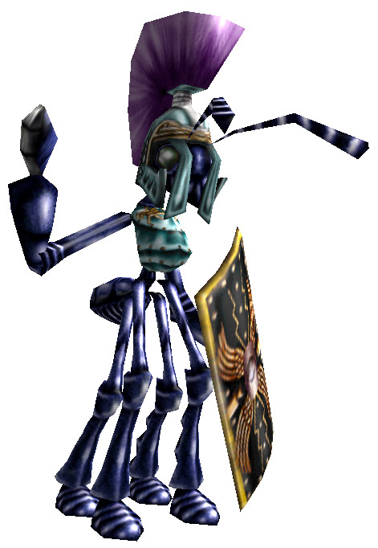**Next Encounter enemies:**

**Bombardier ant**

- **Health**: 50

- **Damage**: 10 directly, 15 explosion

- **Roles**: low-tier sniper, ranger, support

- **Special ability**: bombs, bullet immunity from one side, area attack

- **Best weapon**: colts, single shotgun, tommygun, minigun, laser, ghost buster

A complete reinterpretation of the Legionnaire Ant; instead of a simple weak ranged enemy with some minor gimmicks, the bombardier ant is a decently effective low-tier enemy. It tosses bombs, instead of spears, which gives it some decent power. It also comes in three different types: Normal, which just walks around and throws bombs. Phalanx, which stays in one place and shields itself. This shield makes it immune to bullets from the front, though it does lower it to attack, opening itself up. And the bomber, which is fast and throws eight bombs all around itself.

The normal one can serve as a simple footsoldier. Spamming is not recommended, because their bombs can become overwhelming. It has a pretty low range, so they have to get close. The phalanx is a stationary attacker with a high range, but with lower aggression. Both are sort of like stronger versions of the beheaded bomber. The bomber functions more as a kamikaze, because it has to get close to perform its explosive attack. But instead of a short-range suicide attack, it throws eight bombs in a circle around itself, which can be difficult to avoid and also damages enemies around itself. Don't use too many of them at once, because it'd get very hectic.

You can get very tactical with the placement of these. Maybe have a row of phalanx ants defending another row of stationary normal ants. Maybe have a bomber ant sneak up on the player in a large battle. But you can definitely just put a couple ants in a battle, the same way you'd do a beheaded bomber.

**Diesel Amazon, Archer**

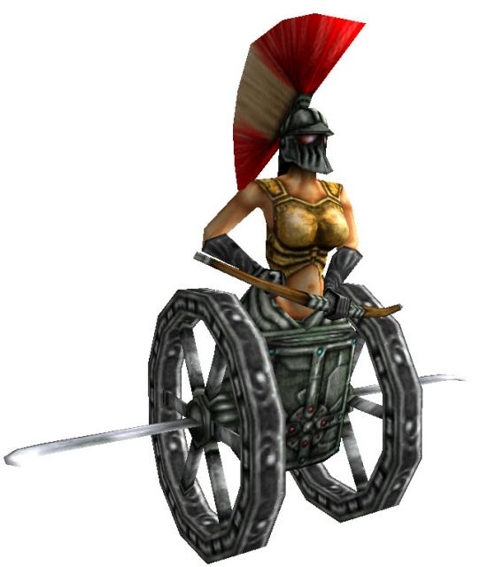- **Health**: 120

- **Damage**: 15 ramming, 10 directly, 15 explosion

- **Roles**: charger, support ranger, limited range sniper, kleer

- **Special ability**: charger with a ranged attack

- **Best weapon**: double shotgun, minigun, flame thrower, laser, ghost buster, cannon

Had to reinterpret some of their mechanics, due to engine differences. I also thought it was lame that they only had 90 health, so I raised it to 120. Then gave them loud engine sounds, that work similarly to the cucurbito's chainsaw noise. What we got is an enemy more reminiscent of the Kleer, except faster and with explosive projectiles.

Slightly more dangerous than the Kleer. Their higher speed makes their lounge attack more difficult to avoid. Although this same high speed sends them further away from the player. Their explosive arrows don't pose too much of a threat, but they can be scary when a lot of them are flying from many different directions.

Give them lots of space, otherwise they end up smashing into the walls and taking damage. Their projectiles may also hit the ceiling and decorations. It's generally better suited for open space combat.

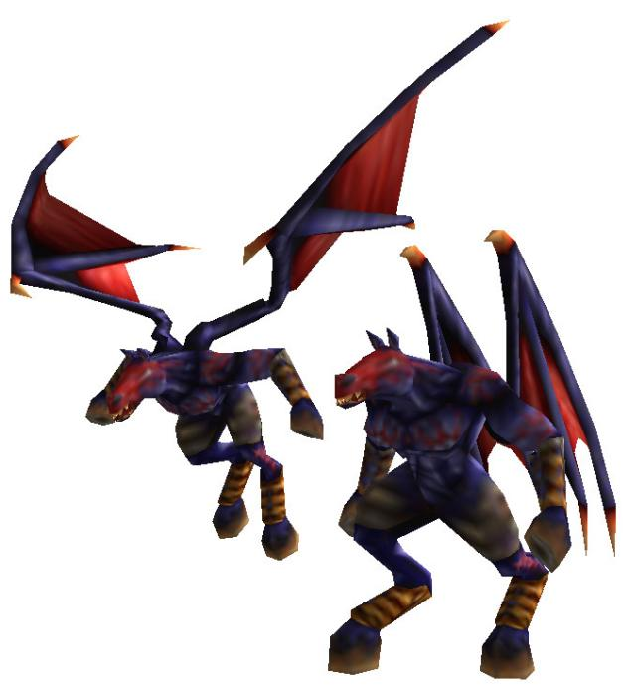

**Devil Stallion**

- **Health**: 500

- **Damage**: 20 directly, 30 explosion (projectile), lots (fire breath)

- **Roles**: massive flying bastard, dragonman replacement

- **Special ability**: biomech rockets from the air, fire breath

- **Best weapon**: rocket launcher, sniper, laser, cannon

Easily the most dangerous flying enemy. Its projectile is about as powerful as a biomech rocket, except it comes from the air, so it's harder to avoid getting hit. In close range, it uses a a fire breath, which will annihilate the player if they're not careful. Just being hit by the flame is damaging enough, but it also clings to the player and will continue to do damage. Not only that, it also moves while doing its fire-breath (at least when it's in the air). And when they get in close distance, it's very hard to get rid of them.

Just one or two is already dangerous, though if you give the player enough distance to take them out, then it should be fine. Always keep small health pickups, when this enemy is around. Some water would be helpful too, because it extinguishes the flames. Becomes somewhat less dangerous once the sniper, cannonballs and homing rockets are in play. The double shotgun is also a good weapon once they get close. The laser can also destroy their projectiles. But multiples of them are always going to be devastating.

A little less effective on the ground, due to the fact it can't move while breathing fire.

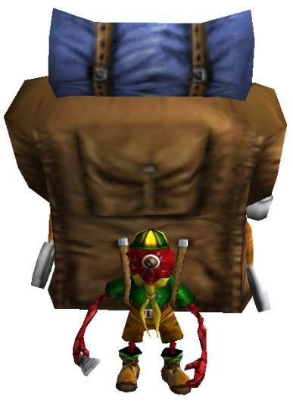**Dib-dib Dum-dum**

- **Health**: 70

- **Damage**: 5 melee

- **Roles**: special enemy

- **Special ability**: spawning items

- **Best weapon**: colt, tommygun, minigun

Found it kinda lame that these enemies do nothing, so I gave it Santa Sam's ability to spawn items when it gets hurt. There is no time limit, so you can mow them down with the minigun and get all items, but you still miss a lot when you just outright kill it. Also had to make it immune to fire, so you don't spawn more items than you should (which is 5). It's also not mandatory to give it item spawns. You can just have it not do anything.

**Dum-Dum and Tweedle Dum-Dum**

- **Health**: 40

- **Damage**: 3 melee

- **Roles**: tiny melee attacker, swarmer

- **Special ability**: -

- **Best weapon**: anything except the knife, colt, the shotguns and the sniper

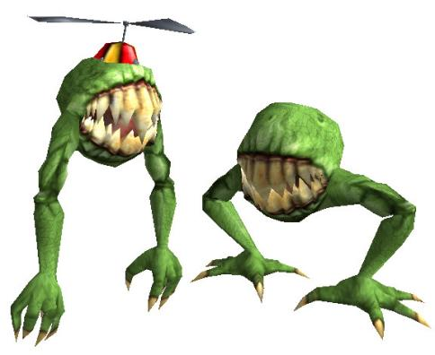

A melee only enemy even more useless than the Gnaar. They do have more health than the beheadeds, but have no ranged attack and are even slightly slower than the gnaar, so a player that keeps in motion can outmaneuver them without even trying. Don't for a second think that these pose any threat whatsoever. Sure, they can surround a player, especially if both ground and flying variants are present, but the player has to really screw up to get into this situation. Freely spammable, though large swarms can get tedious to deal with, without any rapid-fire weapons.

Also included invisibility option, because removing it would have been more work. These can actually be pretty sneaky.

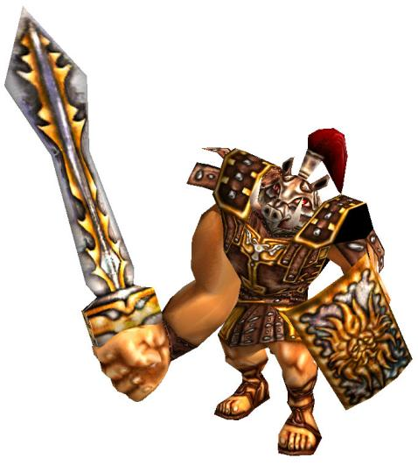**Porcine Berserker**

- **Health**: 140

- **Damage**: 10 direct + 20 range (charge hit), 20 melee

- **Roles**: small charger

- **Special ability**: weird melee attack

- **Best weapon**: anything except the knife, chainsaw and colt

It has a weird elaborate charge attack. First of all, it charges and if it hits the player, it deals 10 damage. But it also creates a small area at the tip of its sword and deals 20 in the center. So that's potentially 30 damage in a single charge, although it's unlikely it will ever deal the full damage. And because the damage center is in front of it, as opposed to directly on its hitbox, simply running backwards isn't enough to avoid its attacks. You have to sidestep.

It has a normal melee attack as well. If the player is too close for a charge attack, the porcine berserker will slash with its sword, dealing 20 damage. This can reach pretty far, so it's best to really keep your distance from this enemy. Give the player enough room to run around. Generally less dangerous than something like the cucurbito, due to its slower speed, but has a much higher damage potential.

No NETRICSA message, because I had to make room for other less jank enemies.

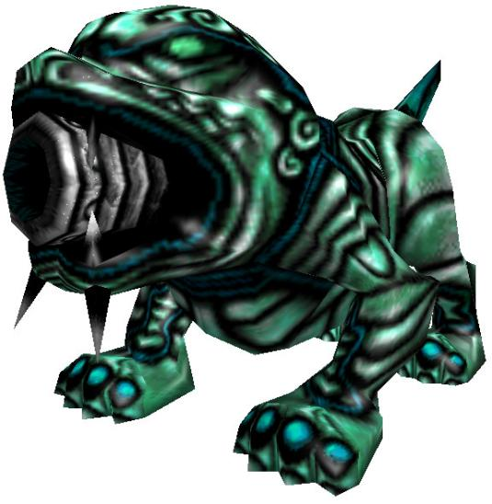**Jade Guardian**

- **Health**: 400

- **Damage**: 0-100 cannonballs

- **Roles**: heavy ranger, tank

- **Special ability**: cannonballs, different attack on lower health

- **Best weapon**: minigun, rocket launcher, grenade launcher, laser, ghost buster, plasma thrower, cannon

Another one that I greatly reinterpreted. Thought that a monster about as strong as the kleer shooting insanely powerful cannonballs was kinda dumb. So I made it stronger, but with a weaker cannonball, along with a slightly different attack pattern. Made a new type of cannonball, which is literally just a weak cannonball, that explodes faster and does significantly less damage. Still, it's not pleasant to get one in the face. And when its health lowers below the halfway point, it will start shooting volleys of four less powerful cannonballs.

Can be effective as a stationary attacker, but with limitations The cannonballs have heavy dropoff, so it's not very accurate. They also bounce around too much, making them kinda useless at an elevated position. It also doesn't have very good range; the cannonballs only stay around for two seconds. You can choose its attack type, so it can stick to either attack indefinitely, if you so wish. Just keep in mind, that it's more effective on the ground. And try not to put too many of them at once. They become very difficult to keep track of.

Also added a statue function, similar to the demon. It renders the monster motionless and invulnerable, perfect for a theatric entrance.

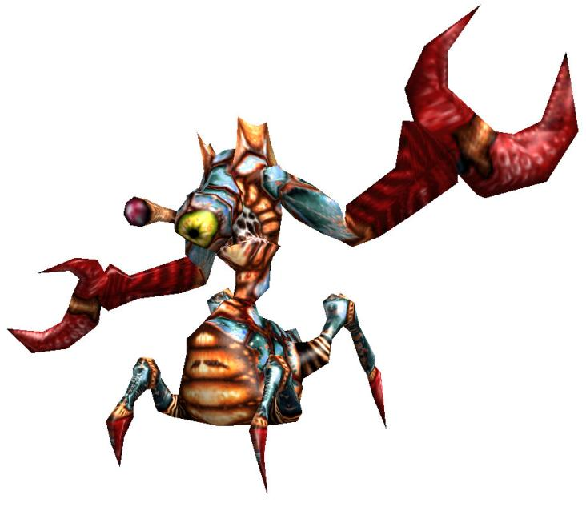**Carcinus Lurker**

- **Health**: 600

- **Damage**: 40 and 30 melee, 0-75 beam

- **Roles**: sniper

- **Special ability**: beam attack

- **Best weapon**: minigun, rocket launcher, sniper, laser, ghost buster, cannon

Couldn't do the sweeping beam attack it was supposed to be doing; I don't know how to make a beam source move and I certainly didn't feel like calculating the eye movement. What we're left with is a much more dangerous monster than the original. It now aims its beam directly at the player, who is forced to keep moving. Preferably sideways, because running away or towards the Lurker, may actually grant it a hit.

Do not put to many of them at once, because avoiding the beams becomes that much more difficult. It is a high priority target with a lot of health, so it requires a lot of attention. Give the player lots of room to move around in, but the Lurker as well. If there are other enemies blocking its view, then its going to start having difficulties landing its beam attack. It is more effective as a stationary attacker. (Though its melee capabilities ain't nothing to sneeze at.)

**Butcher Ape**

- **Health**: 80

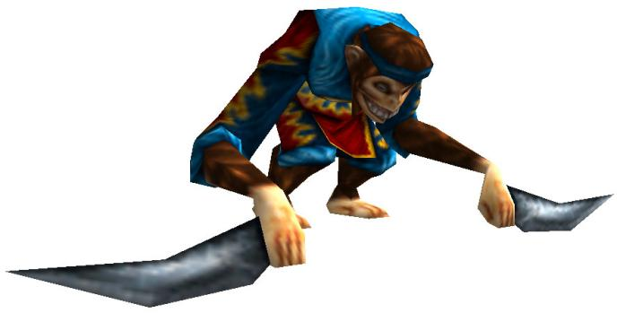- **Damage**: 15 melee

- **Roles**: melee attacker, small charger

- **Special ability**: leap attack only, "shadow form"

- **Best weapon**: double shotgun, minigun, rocket launcher, flame thrower, ghost buster, cannon

Think of this enemy as a partially wounded Kleer, that has no ranged attack. Although they are a lot faster as well, which makes them more difficult to deal with in close quarters. They don't have a real melee attack, only the leap attack. Which makes them fly all over the place. Definitely an enemy you have to spam responsibly. Once the player has a strong arsenal, you can start going nuts.

I also gave it the ability to turn invisible. I call it a shadow form. And unlike gnaar's invisibility, this doesn't make them glow in the dark. It turns them pitch black and makes them look like a shadow. Which actually makes them easier to detect in brighter environments, but harder to see in darkness.

**Steel Scorpion**

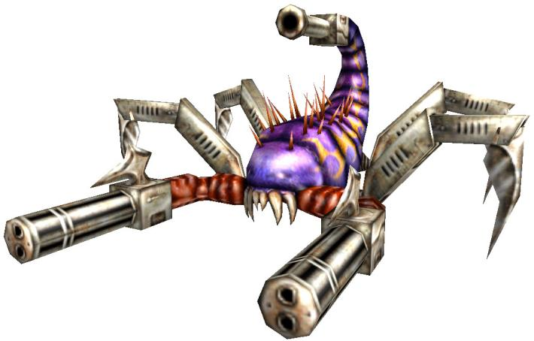- **Health**: 700

- **Damage**: 5 bullet, 30 laser, 50 melee

- **Roles**: sniper, heavy ranger, tank

- **Special ability**: switched attacks

- **Best weapon**: minigun, rocket launcher, sniper, laser, ghost buster, plasma thrower, cannon

A very versatile high tier sniper, that is effective in both close quarters and long distances. It has a hit-scan attack that fires from both arms, with higher scatter than a regular arachnoid, but shoots two bullets at a time. It also has a projectile attack similar to the demon's fireball. It will automatically switch between these attacks based on distance. It can be used both in place of a demon and an arachnoid (and the design philosophy of both applies), just be aware of its high health.

When the player is in range of 50, it will only use its miniguns. Between 50 and 150, it will choose randomly. In distances over 150, it will only use its laser attack. A good indicator is the enemy's sound. Its sounds have a range of 150; if you can still hear it, then either attack is possible. If you can no longer hear it, then expect projectiles. If you're inside its sound hot-spot, then its minigun time.

But if you have a preferred attack pattern, you can choose one too. The Type field allows you to select which attack you'd prefer it to use.

**Future Enemy Pack enemies:**

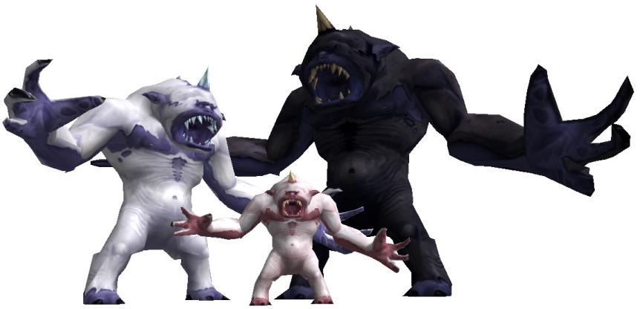**Albino Cyclops**

- **Health**: 700 (normal)

1500 (elder)

3000 (ancient)

- **Damage**: 20 projectile

30 melee (normal)

60 melee (elder)

90 melee (ancient)

- **Roles**: heavy assault, heavy sniper, miniboss

- **Special ability**: homing projectile

- **Best weapon**: minigun, rocket launcher, laser, ghost buster, hydrogun, cannon

(Model made by Ded Kadath, coding done by Rakanishu. Also included in Rakanishu's bestiary enemy pack.)

A tankier version of the reptiloid. It has a lot of health, has powerful attacks, so it draws the player's attention. As such, you shouldn't put down too many of them at once. Even two at once can be overwhelming, due to their high speed homing projectiles, especially if they're far away and the player doesn't have a proper way to get rid of them. This is the kind of enemy, that really draws the player’s attention.

Despite the small one being much stronger than the base reptiloid, the bigger ones are significantly weaker than their reptiloid counterparts.

**Centaur**

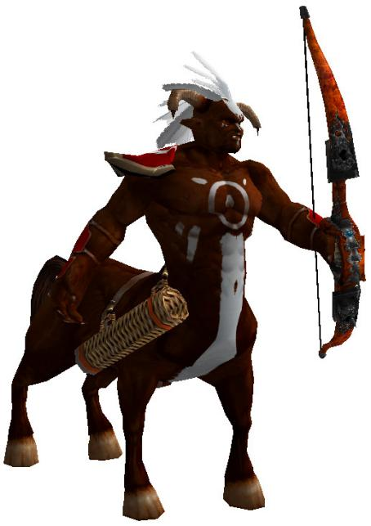- **Health**: 130

- **Damage**: 10 (projectile), 20 (melee)

- **Roles**: charger, ranger, limited range sniper, kleer

- **Special ability**: predictive aiming

- **Best weapon**: Double shotgun, rocket launcher, grenade launcher, minigun, cannon

Originally, in my “future enemy pack” the centaur had explosive projectiles, with predictive aiming. Which made them super dangerous. So for this mod, I gave them a regular arrow projectile. The predictive aiming still makes it dangerous, but now it is much closer to a Kleer in danger level.

It is still hella fast though and their melee attacks knock the player into the air, which can make close quarters combat very disorienting. So use a tactics holder and try to prevent them from dogpiling the player. Their high attack range also makes them decent stationary attackers.

Option for the original black texture is available.

**Cerberus**

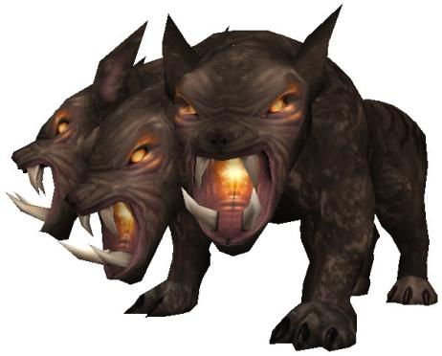- **Health**: 125

- **Damage**: 20-ish (charge), 15 (melee)

- **Roles**: small charger

- **Special ability**: maneuverability

- **Best weapon**: Double shotgun, grenade launcher, flame thrower, cannon

A charger enemy that is weaker than the cucurbito, but is technically faster. While the cucurbito and the werebull take ages to turn around after a missed charge, the cerberus can turn around instantly and charge again. This makes them slightly more dangerous, even if their damage and health are lower.

Treat them like any other charger enemy: don't put too many down, because they'll just get in each-other's way. And give the player enough space to maneuver around them. Unlike most charger enemies though, you can get away with putting them in closed spaces, since they don't need a kilometer just to make a turn.

**Sirian Floater**

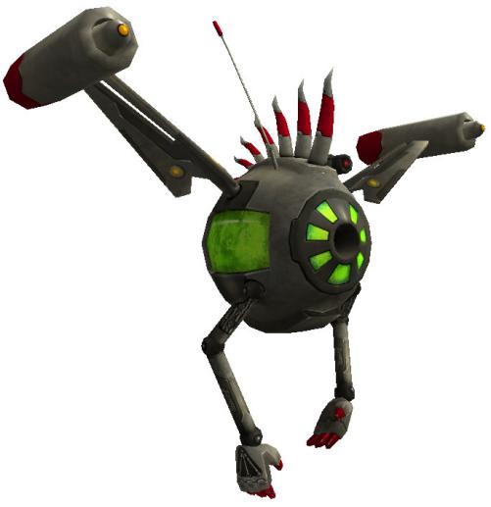- **Health**: 30

- **Damage**: 5 per projectile, 3 per melee hit

- **Roles**: that annoying flying enemy every fps has

- **Special ability**: speed

- **Best weapon**: single shotgun, tommygun

A very weak flying enemy, that actually poses a little bit of a threat. They can be difficult to hit due to their speed and relatively small hitbox. As such, they can be rather annoying, but are pretty easy to deal with. Feel free to spam them, just be aware that they can be annoying.

Since they're quick, they don't bunch up as well as harpies do, which can make them difficult to kill with explosives. But the single shotgun and tommygun are perfect at taking them down. Even the colts and chainsaw, if no other option is around.

They can also move underwater.

**Lich harpy**

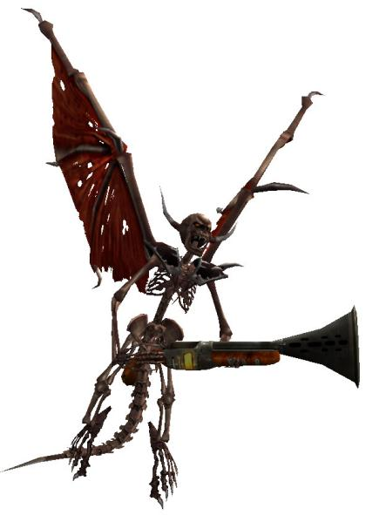- **Health**: 125

- **Damage**: 14 per projectile, 20 per melee hit

- **Roles**: flying kleer

- **Special ability**: FLYING KLEER

- **Best weapon**: tommygun, minigun, flame thrower, laser, sniper

Do not underestimate the flying kleer. Its stats may be the same as the regular kleer, but the fact that they can fly makes them much more dangerous. They're not nearly as easy to kill as harpies are and they're also more difficult to hit, due to their maneuverability.

So yeah, not nearly as spammable as regular kleers or even harpies are. Keep their numbers limited.

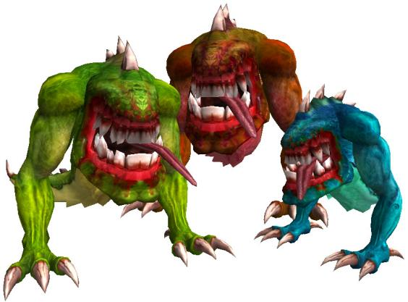

**Lingu Gizard**

- **Health**: 60 (normal)

30 (spitter)

140 (king)

- **Damage**: 15 Melee (normal and spitter)

5 projectile (spitter)

25 melee (king)

- **Roles**: cannon fodder, charger (king)

- **Special ability**: Long range leap attack

- **Best weapon**: single & double shotgun, tommygun, minigun, hydrogun (normal and spitter)

Double shotgun, rocket launcher, grenade launcher, sniper, cannon (king)

While gizards are really not a threat at any stage of the game, their leap attack is far reaching. And since they push the player around with each attack, they can be somewhat disorienting to deal with. Other than that, their low health and damage makes for an ideal spam enemy, in the same box as gnaars and marsh hoppers. The spitter variety is more of a rocketman alternative, though they do have the same long-range leap attack.

The big gizard needs more careful considerations. While they're not as tough as other charger enemies, they can get very vicious in close quarters. The range on their leap attack is crazy.

Give the player plenty of room to maneuver around the gizard. It fares better in large rooms and open spaces. Especially the big one.

The spitter has no NETRICSA model. It just ended up being a crappy fishman, so I scrapped it.

**Kalopsy**

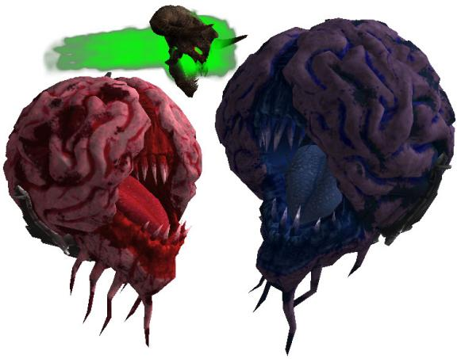- **Health**: 40 (necro-wisp)

250 (beholder)

400 (rehovart)

- **Damage**: 10 charge (necro-wisp)

7 projectile (beholder)

n/a (rehovart)

- **Roles**: that annoying flying enemy, cannon fodder

support ranger, early game threat

heavy ranger, spawner

- **Special ability**: homming projectiles

damage shooting

spawning

- **Best weapon**: single shotgun, tommygun, minigun, ghost buster

Chainsaw, rocket launcher, grenade launcher, sniper, cannon

minigun, laser, sniper, cannon

The beholder variant behaves pretty much the same way as the kalopsy is supposed to. It fires homing projectiles as its attack, but also when wounded and dying. Rapid fire weapons are not recommended against it. Though the chainsaw is actually pretty useful, because it can easily destroy the projectiles right after they've been fired. Just like the reptiloid, don't put too many of them down at once, because their projectiles will get very overwhelming.

The rahovart does not fire projectiles when it's wounded, but it does spawn necro-wisp. These aren't particularly dangerous, but left unchecked they can become overwhelming. And unlike the pain elemental in Doom, this one does not have a spawn limit. So definitely keep their numbers limited.

The necro-wisp is pretty much the same as the lost soul from Doom. It has lower health, so a well-placed shotgun blast will kill them instantly. But that doesn't make them any less annoying. Actually, they're slightly worse, because their charge attack can't be interrupted, due to how that function has been coded. It does however hurt itself when it hits something, which is pretty funny. They can be freely spammed similarly to marsh hoppers, although they're definitely more annoying to deal with. Try to not put them in heavy fog or haze, because they'll just charge in and out of visibility and it'll get very frustrating. They can also get stuck on the level geometry, so if they're linked to a trigger count, the last few will be difficult to pick off. In other words, feel free to spawn a lot of them at once, but definitely be mindful about it, because of how annoying they can be.

They can also attack fine under the water, though the lost soul does have difficulty in hitting its target.

**Zunkladyte**

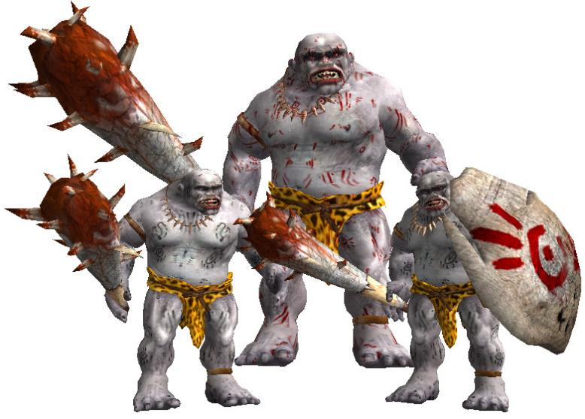- **Health**: 100 (+50 with shield, technically)

630 (colossus)

- **Damage**: 15 melee

0-50 melee (colossus)

- **Roles**: early game threat, cannon fodder

heavy melee (colossus)

- **Special ability**: extra health bar (shield), AoE melee (colossus)

- **Best weapon**: knife, minigun, rocket launcher, grenade launcher, flame thrower, plasma thrower, ghost buster, cannon

The two small types, shielded and runner, have pretty much the same stats, but due to their different attacking behaviour, they require different tactics and design philosophy.

The shielded one technically has 150 health, because the shield itself has 50 health. They're not particularly dangerous, but they can soak up damage and block your shots. They're quick, but don't require too much room to operate. Can be used as a stronger alternative to gnaars. Dropped shields might make movement slightly more difficult, both for the enemies and for the player.

The runner has a charge attack, that flings it all over the battlefield. Explosives aren't recommended against them, because they catch up quickly and hordes easily scatter. They do require lots of room, but they're also effective at sneak attacks. Can be used as a weaker alternative to kleers.

The giant one can be rather dangerous. Their melee attack is similar to the lava golem's, except the epicenter of the damage is slightly in front of them. That means, just simply backing away from them is not as effective, because you're still going to be in the area of effect. It's much better to circle around them. As such, they need lots of room. But leading enemies into their attacks is pretty fun.

Boss option available.

**Mogwai**

- **Health**: 70 (nymph)

140 (adult)

600 (elder)

- **Damage**: 6 per projectile, 15 melee (nymph)

6 per projectile, 30 melee (adult)

10 direct hit, 5 explosion, 50 melee (elder)

- **Roles**: cannon fodder, weak kleer (nymph)

cannon fodder, strong kleer (adult)

heavy ranger, tank (elder)

- **Special ability**: multiple projectiles

- **Best weapon**: shotguns, tommygun, grenade launcher (nymph)

double shotgun, minigun, rocket launcher, grenade launcher (adult)

minigun, sniper, laser, cannon (elder)

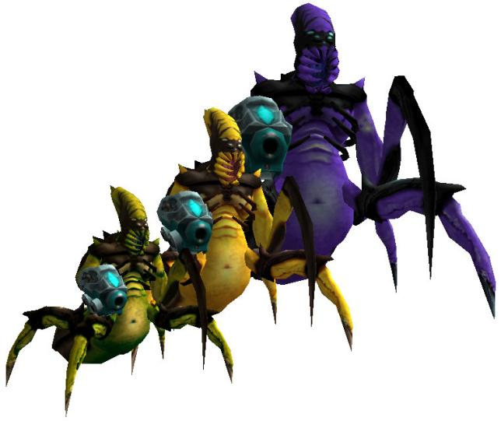So I slightly put my own spin on this one. Since the scorp soldier was originally meant to be an arachnoid replacement, I wanted it to be even more distinct from the arachnoid. This is mainly just about having different colours (though the regular colours are available, in case you prefer that), but also that they're a lot faster, making them better crowd enemies.

The small one is based on the fact that they often came in a "damaged" variety in Serious Sam 2. It wasn't a separate enemy, but the small scorp often showed up shrunk with about just a bit more than half of its health. This small variety is that. They're more dangerous than beheadeds and zorgs, but are just slightly below kleers and fire three projectiles. Freely spammable enemy. (Though it might be a bit annoyingly small.)

The medium one is a bit tougher. They can pose an actual threat, when the player doesn't have an extensive arsenal yet, but becomes spammable rather quickly. They fire 5 projectiles, which can add up to 30 potential damage (which is 60 on serious), so do be careful. Perfect alternative to kleers, though slightly tougher. But they're also more vulnerable to explosions, because they bunch up more, due to being much slower. Also effective stationary attackers. It's just a very versatile enemy in general.

The big one is very dangerous. Though their health and damage isn't super high, compared to other enemies of this tier, their explosive projectiles do have a lot of potential. It's just difficult to avoid taking damage. So just like any enemy of this tier, keep their numbers limited. They're pretty versatile and can be effective both as stationary enemies (they have the guffy's range), but also as ground attackers. Though their projectiles might collide with ceilings.

Boss option available.

**Monster Replicator a.k.a. DNA Scrambler**

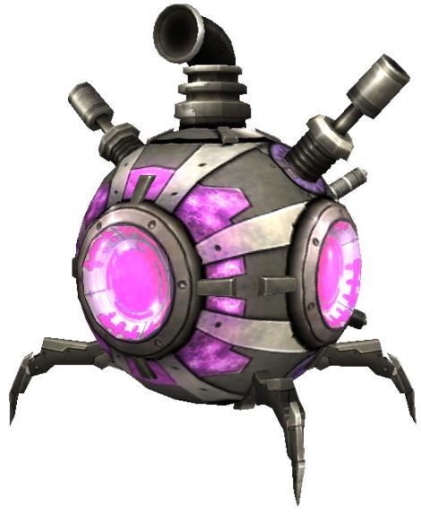- **Health**: 700

- **Damage**: n/a

- **Roles**: heavy support, spawner

- **Special ability**: spawning enemies

- **Best weapon**: cannon

Had to reduce their health from their original counterpart. In SS2, the spawner has 1000 health, making them a very tanky opponent, able to withstand a fully charged cannonball. This however made them very annoying, so I had to make them a single cannonball enemy. This does make them a bit more versatile, since now you can use them more often.

They have five options for templates and you're going to have to fill each one. This isn't like Mordekai, who picks random options from a group. The spawner cycles through its templates at random. If you don't fill one, you risk the game crashing. At least, you would be risking it, if I didn't put in preventative measures.

I recommend using small enemies, such as beheadeds, gnaars, lizards, marsh hoppers, zorgs, small spiders, fishmen, etc. More dangerous varieties might even be allowed to spawn kleers, harpies, cucurbitos, catmen and scorp soldiers. They can totally spawn any type of enemy, but it looks kinda dumb when it launches a major biomech. Plus, even two can quickly become overwhelming. They spawn three enemies each attack cycle, which can quickly add up, especially when paired with other enemies.

And unlike in SS2, it’s got no regular attack. Its only attack is spawning enemies. Because honestly, otherwise this is a pretty lame enemy and nobody cares about its non-spawning function.

**Thunder spider**

- **Health**: 25 (hatchling)

250 (adult)

1000 (brood mother)

- **Damage**: 5 per charge, 10 melee (hatchling)

20 per charge, 30 melee (adult)

n/a, 80 melee (brood mother)

- **Roles**: cannon fodder (hatchling)

early game threat, medium ranger, strong kleer (adult)

heavy support, tank, massive kleer (brood mother)

- **Special ability**: avoidable hitscan, spawning little ones (brood mother)

- **Best weapon**: chainsaw, colts, single shotgun, tommygun (hatchling)

minigun, rocket launcher, sniper, cannon (adult)

sniper, plasma thrower, cannon (brood mother)

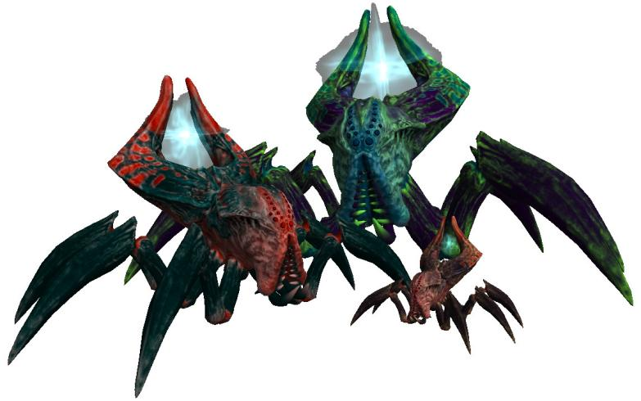Yes, this is a hitscan enemy, but it's actually very easy to avoid their shots. They attack similarly to the electro-fish, but they deal direct damage (the fish does damage based on range). It is possible to avoid it, by just moving around, for the most part. If there's a lot of them coming from multiple sides, then they will be able to land a couple hits. Other than that, as long as you're not standing still, they won't be able to hit you, until they get in melee range.

The small one isn't much to write home about. Low health, low damage, they can be freely spammed. The big one however, is very dangerous. They're quick, so even if they can't land a ranged attack, they can still get in range to deliver their powerful melee attacks. They're actually more dangerous than werebulls; their ranged attacks push you about as hard as well and can deal additional damage by slamming you against walls. You can spam them once the player has the cannon, but any earlier than that, you keep their numbers limited. Also make sure the player can spot them early, because surprise electrocutions are really not pleasant.

Now the largest variety is a very unique spawner enemy. It spawns little spiders, which isn't that much of a threat, but they do it pretty often. Plus, they're very fast and can get themselves in range to deliver their devastating melee attacks. This is not an enemy you take lightly. (You can also put them in a stationary position and let them spawn spiders potentially endlessly.)

Boss function available.

**Spider mechanoid**

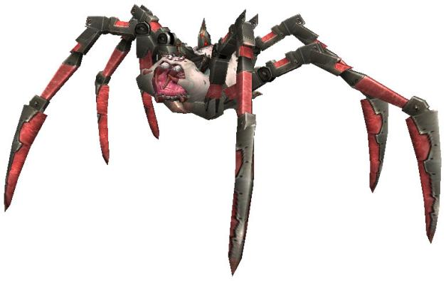- **Health**: 100 (soldier)

2500 (mommy)

- **Damage**: 10 per projectile, 10 melee (soldier)

30 per projectile (direct hit), 100 melee (mommy)

- **Roles**: versatile cannon fodder (soldier)

miniboss (mommy)

- **Special ability**: spawning small ones (mommy)

- **Best weapon**: single and double shotgun, tommygun, minigun, flame thrower (soldier)

rocket launcher, laser, plasma thrower, cannon (mommy)

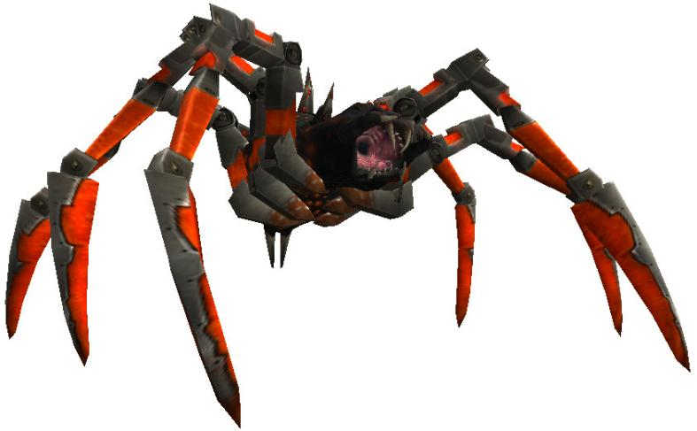The small one is a great generalist. They have low health, but aren't laughably easy to kill. They have a ranged and a melee attack; its projectile is fast, so the player actually has to consciously avoid them and since their movement speed is rather high, they get many chances to use their melee attacks too. They're pretty effective in small numbers, but can also be freely spammed.

The big one is very dangerous however. They take a lot of ammo to kill and their attack sequence is vicious. They shoot three very fast high-damage projectiles, aimed where the player is going. The player really has to maneuver around the battlefield to avoid them. They also have a second attack, in which they spawn three small spiders. Which is easier to avoid, but also gets the mommy spider moving sooner, which could get them into melee range easier. They're not nearly as fast as the highlander, but they can't be simply outrun either. Even just one can be a serious threat. Two at once can quickly become chaos. Any more than that is insane (but can be fun with a serious damage).

Boss function available.

**Mecha-khnum**

- **Health**: 300 (minotaur)

1200 (moloch)

5000 (apis)

- **Damage**: 10 per projectile, 25 melee, 40 explosion (minotaur)

150-ish per projectile, 100 melee, 60 explosion (moloch)

150-ish per projectile, 200 melee, 120 explosion (apis)

- **Roles**: early game threat, medium ranger (minotaur)

heavy ranger, tank, miniboss (moloch)

miniboss (apis)

- **Special ability**: explosive death

- **Best weapon**: minigun, rocket launcher, laser, cannon (minotaur)

grenade launcher, laser, plasma thrower, cannon (moloch and apis)

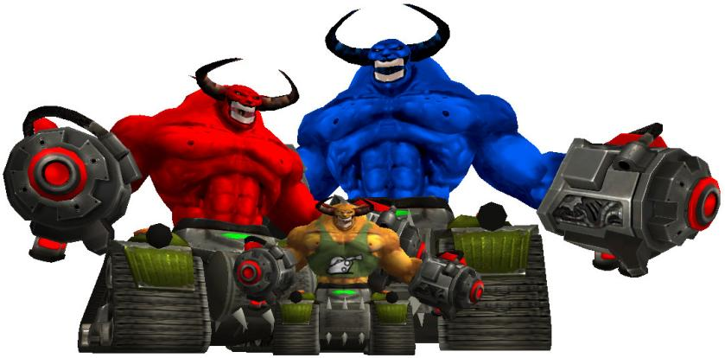

They act pretty much the same as in SS2. One small change is that they explode on death, damaging everything around them. So leave lots of room for the player to get away from their explosions and powerful melee attacks. Small ones can become more numerous as the game goes and the player gathers more potent weaponry. Essentially a great alternative to zumbuls, but also a tougher variety of the minor biomech.

The larger variants are far more dangerous, though the general variety has been significantly nerfed compared to its SS2 counterpart. I thought they were too much like highlanders, so I lowered their health and made them more of a tank enemy, like an upgraded major biomech, as opposed to strictly a miniboss. Their rockets are more powerful though, at least the range of their explosions.

The huge one is very dangerous. Not just for its amount of health, but also its speed, which gets it in melee range very quickly. It is kind of unreasonably huge. Definitely an enemy that needs some more care. It really is a miniboss.

Boss function available.

**The Sequel exclusive enemies:**

**Brachyan**

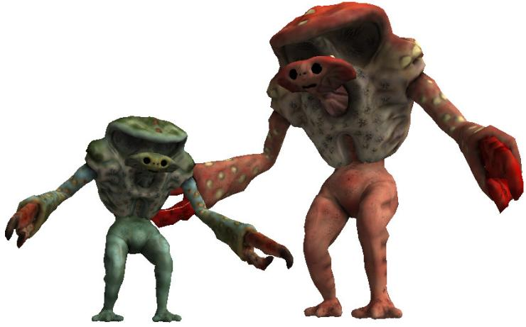- **Health**: 300 (sporeling)

600 (fungal giant)

- **Damage**: 15 per hit (sporeling)

30 per hit (fungal giant)

- **Roles**: early game threat, bullet sponge, heavy melee

- **Special ability**: temporary invulnerability, knockback

- **Best weapon**: Double shotgun, rocket launcher, grenade launcher, sniper, cannon

(Model made by VadikZ from TurboSquid.com.)

A melee only enemy with high speed and damage. They have the ability to turn invulnerable for a second for every wound animation. This makes rapidfire weapons partially useless against them, making slow but high damaging weapons a priority. Not a particularly dangerous enemy, but can be tedious to deal with in large numbers. They can also keep pace with the player, even when serious speed is involved.

They attack like gnaars, doing one damage with each arm, but the second hit will always knock the player backwards. That does make them extra dangerous over instakill areas. Plus, the big one has high enough reach to almost always guarantee at least one hit. And they're fast enough to get the player into "self-explode" distance. So keep the big ones' numbers very limited.

The double shotgun is surprisingly effective against them. Their defense animation is exactly as long as the double shotgun's reload animation, so you can keep wailing on them.

This enemy has been scrapped, so it has no NETRICSA model. There is a bug regarding its temporary invulnerability, where they stay invulnerable permanently. Didn’t know how to fix it, not a fun mechanic anyway, so I just scrapped the enemy altogether.

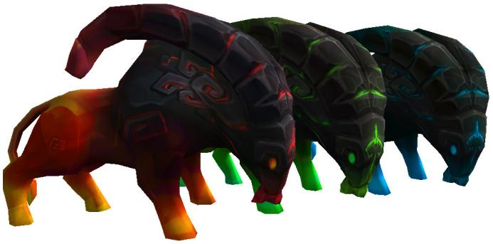

**Kleerstone Battering Ram**

- **Health**: 400

- **Damage**: 30-ish (charging)

- **Roles**: heavy charger, miniboss

- **Special ability**: bullet resistance

- **Best weapon**: rocket launcher, sniper, plasma thrower, hydrogun, cannon

(Model made by OmiTheYellow from TurboSquid.com.)

This enemy behaves exactly the same way as the werebull, BUT it is not a good alternative to the werebull. It’s much faster, much tougher and way more difficult to avoid (can actually outrun the player even with serious speed). Plus, it's resistant to bullets (if shot from the front) and immune to fire. Give the player enough room to focus on them; they're an effective miniboss for early in the game. Once the player gets weapons that are effective against it, their numbers can rise. Even then, two or three is already a challenge. Much easier to deal with when powerups are involved.

Three environmental variants are included: Frost (blue), fire (red) and fel (green).

**Portent of Doom, Hellhound**

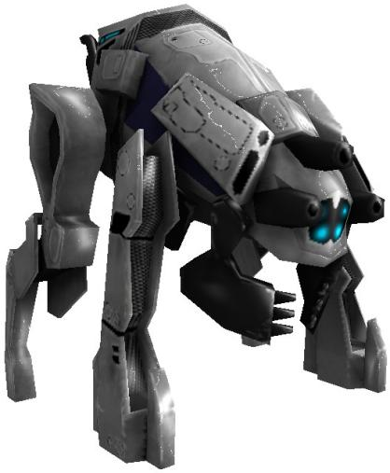- **Health**: 200

- **Damage**: 10 directly, 15 explosion, 25 per charge

- **Roles**: charger, very strong kleer

- **Special ability**: triple predicted projectile, post-mortem explosion

- **Best weapon**: single shotgun, minigun, rocket launcher, sniper, ghost buster, plasma thrower, cannon

(Model made by Row Video Games from TurboSquid.)

Low health, but high damage, with a dangerous attack cycle. They shoot three explosive projectiles, each with predictive aiming, which can be very difficult to avoid. Plus, they're quite fast as well, easily getting into charging range (though their charge attack may actually be less effective than their ranged attack). And though their health is low, they have just enough health to withstand multiple shots. Similarly to the cucurbito, lower tier weapons always leave just enough health for them to survive. Although the auto shotgun is fast enough to keep them flinching and unable to move.

Not particularly dangerous individually, but can be dicey when they catch the player by surprise. And multiple of them can be very deadly.

**Portent of Doom, Infernobot**

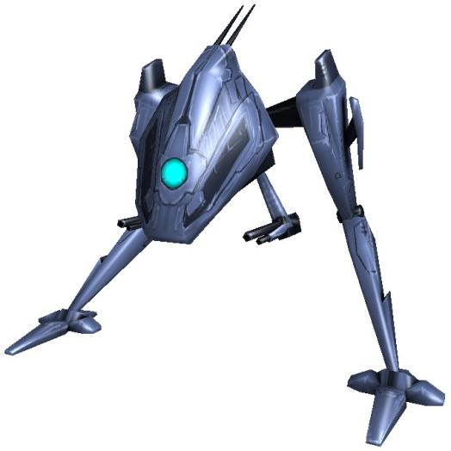- **Health**: 250

- **Damage**: 10 per laser, variable per flame

- **Roles**: very strong kleer

- **Special ability**: long distance lasers, short distance fire

- **Best weapon**: double shotgun, rocket launcher, minigun, ghost buster, plasma thrower, cannon

(Model made by Row Video Games from TurboSquid.com.)

While it doesn't have too much health, it does deal immense amount of damage and can be difficult to hit from a distance, due to its speed. And I can't stress enough just how much damage this thing deals. Its attack cycle consists of 8 projectiles, which it shoots 2 of each time. Each of those projectiles deal 10 damage, so that's basically 2x10x8... potential 160 damage every attack cycle. And I didn't even mention its dual flamethrowers. Yes, dual. You know how powerful the dragonman's fire attack can be? Yeah, that times two. And they're fast enough to keep up with serious speed. And they can attack from very far away, with very fast projectiles.

So yeah, easy to kill, but very dangerous regardless. Keep their numbers limited.

**Portent of Doom, Annihilator**

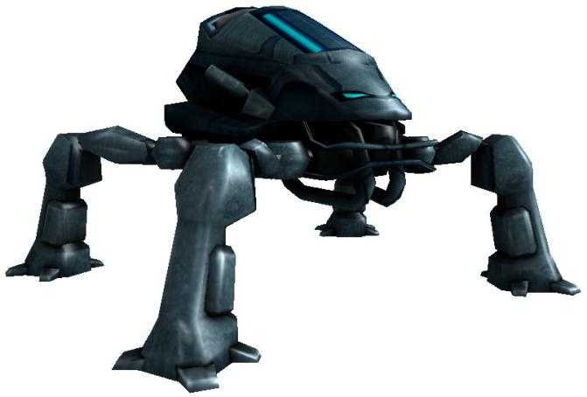- **Health**: 2300

- **Damage**: 10 direct hit, 40 explosion, around 50 per beam

- **Roles**: miniboss, massive tank

- **Special ability**: seeking rockets, death beam

- **Best weapon**: Ghost buster, plasma thrower, cannon

(Model made by Row Video Games from TurboSquid.)

Relatively easy to deal with as far as extreme tier enemies go. Its beam attack can be avoided as long as you keep moving and its seeking rockets can be lead into walls and constantly avoided by sidestepping. That is, as long as they're not paired up with other enemies (especially the other Portents of Doom). As soon as there are other projectiles to avoid, the Mecha becomes that much more dangerous. The player will get caught in its rockets' explosions and will find themselves running into the beam more often. They simply require a lot of attention.

Treat them like a highlander. Just one can already pose grave danger. Only use multiple in really insane battles.

**Bosses**: