**Macro Homework**

**Tianli Xia**

1-5 GDP as spending approach and income approach:

We have several findings:

1. US economy is an import economy.
2. The consumption is the dominant factor of economic growth and ususally very high and is increasing recently
3. Government spending is over 20%, which is very high
   1. A small question: is transfer payment counted into government
4. Investment and government expenditure are usually <?>
5. Captial contrivution to GDP is over 80%, and is increasingly intensive recently.
6. During recent recession (2008):
   1. consumption share is stable;
   2. private investment share drops;
   3. government spending share increases;
   4. capital contribution in GDP increases.

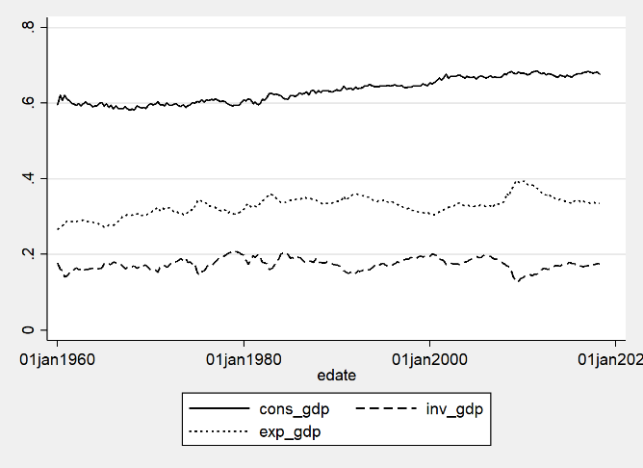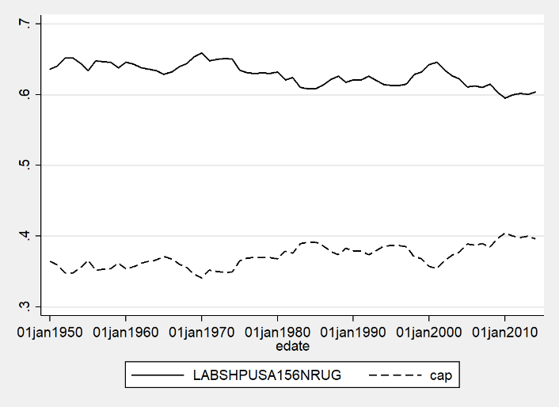

|  |  |  |  |  |  |
| --- | --- | --- | --- | --- | --- |
|  | cons_gdp | inv_gdp | exp_gdp | labor_gdp | cap_gdp |
| mean | 0.632846 | 0.174988 | 0.328723 | 0.628523 | 0.371477 |
| standard error | 0.002131 | 0.001026 | 0.00166 | 0.001976 | 0.001976 |
| max | 0.684813 | 0.208222 | 0.395896 | 0.65911 | 0.404768 |
| min | 0.581095 | 0.127696 | 0.265795 | 0.595232 | 0.34089 |

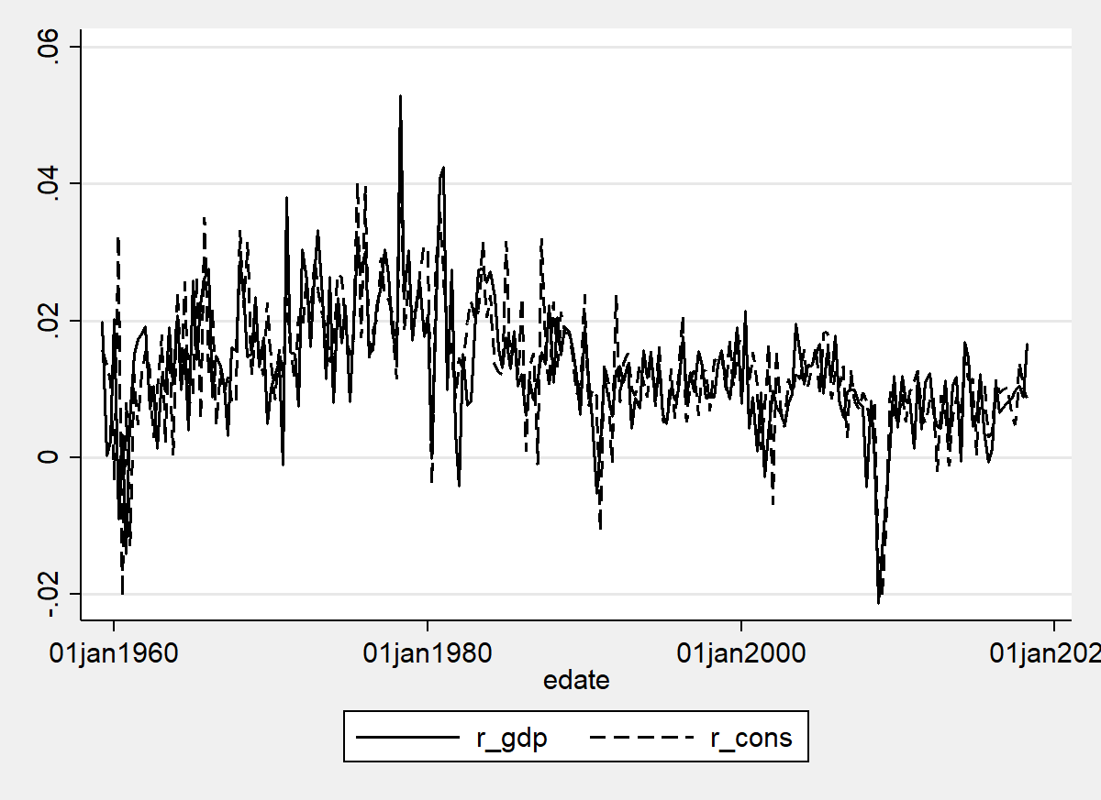 We plot the growth rate of GDP and consumption in the figure above, we find that:

1. Consumption behavior is very pro-cyclical, at good time, consumption growth rate increases. At good times, an individual tends to consume more. (Correlation is 0.6371)
2. On average, they both grow at a rate of 1.3% each year in the long run.
3. During the recession, they both droped substantially (from 1% to -2%, and gradually restored from that).

|  |  |  |
| --- | --- | --- |
| id | r_gdp | r_cons |
| mean | 0.012812 | 0.013311 |
| se | 0.000605 | 0.000613 |
| max | 0.052877 | 0.045496 |
| min | -0.02132 | -0.02045 |

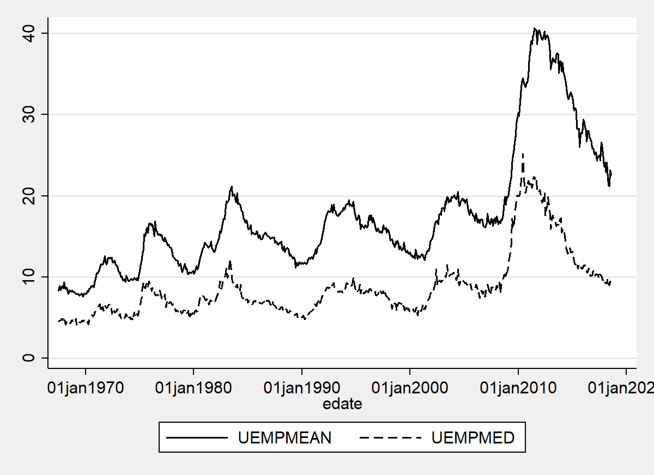

Finally we plot the unemployment situation, both the mean time to find a new job (UEMPMEAN) and median time (UEMPMED):

1. They are very cyclical, and show a slightly upward trend in the long run.
2. During the recession, they both increase a lot.
3. Mean days are usually more conservative measure of unemployment, probably because unemployment suffers from a right heavy tail (conditional on people who cannot find a job in the average unemployment time, they will stay much longer).

|  |  |  |
| --- | --- | --- |
| id | uempmean | uempmed |
| mean | 17.60961 | 8.722964 |
| se | 0.312256 | 0.161389 |
| max | 40.7 | 25.2 |
| min | 7.6 | 4 |