Project Ridiculous

Help Files

Core

March 20, 2007
[ Bundling ]
Bundling packs all resources so that when accessed on a different computer the project will keep all materials with the Max file and render with all materials added.

How to Bundle:
- Go to the utilities panel.

- Then click on more. 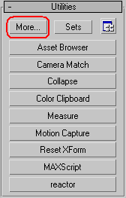

- That will bring up a panel click on Resource Collector and press ok. 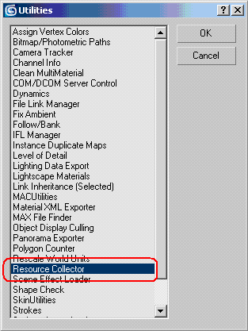

- This will create a panel below the Utilities called Parameters. You must have all boxes checked. The out put path should by default be: \\fatfiler\Shared$\ITA_Share\ClassShare\Project Ridiculous\max\archives if it isn’t you will have to change it to this path. 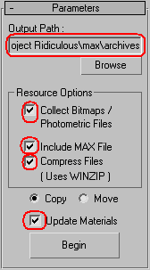

- When you click Begin you will have to zip it and you will be prompted to save the max file click no.

