Zoo Escape

Wiki Page Outlines

Psychology

04/19/07
[Outline]

Team
I Title
II Heading 1
III Team name (link)
i member name
ii “
IV Team name (link)
i member name
ii “
V Team name (link)
i member name
ii “
VI Team name (link)
i member name
ii “
VII Team name (link)
i member name
ii “
VIII Team name (link)
i member name
ii “
IX Team name (link)
i member name
ii “
X Team name (link)
i member name
ii “
XI Team name (link)
i member name
ii “
Pages
I Title
i Picture
ii description
(This is a basic outline, each team’s page will obviously look different from the others.)

Game play
I Title
II Subheading
i Description
III Paragraph

Enviroment
I Title
II Subheading
I Description
i Picture
ii Small description
(Repeat for each picture.)
[Text]

Team
I The Team
II Meet the Team behind Zoo Escape
III Core (link)
i Ian Kinsey
ii Jesse Martinez
iii William Harshbarger
iv James Williams
IV Progamming (link)
i Spencer Allen
ii Cameron Catterfeld
iii Vitaly Maximov
V Utilities (link)
i Ryan Williams
ii Jacob Placensia
iii Ryan Bates
iv Rob Burt
v Shane Yarbrough
VI Worlds (link)
i Cindy Swift
ii Alex Whitbey
iii Kim Mann
iv Kyle Corcoran
VII Documentation (link)
i Jeff Clark
ii Tim Potesan
iii Sean Coffman
iv Sarah Otto
VIII Psychology (link)
i Robert Criswell
ii Matt Pettersen
iii Liz Andersen
iv David Armi
IX Book (link)
i Shannon Gleghorn
ii Sabrina Romero
X Art (link)
i Crystal Williams
ii Justin Her
iii Shaylee Pizana
XI Cut scenes (link)
i Christopher Flynn
ii Juan Lopez
iii Ker Thao
Pages
I Core
II Ian Kinsey
i Picture
ii For this project I would really like to see a product which is viable for use in a professional setting (school, business, etc.) for its intended purpose. Also, I want the experience of having lead a project this intricate and massive.

III Jesse Martinez
i Picture
ii As a Core Team member, my goal is to ensure the success of the team through setting deadlines and guiding the project towards completion. Furthermore, it is my goal to make sure every member of the team meets their goal to or above what they wish to accomplish.
IV William Harshbarger
i Picture
ii My goals are to gain more experience in leadership and have some experience in game development. Also something cool to add to my résumé
V James Williams
i Picture
ii My goal for the core team would be able to get the project done and to also get a good idea on how to do team management. I would also like a better idea on scheduling. I really hope this project gets done or is close to getting done.
I Programming
II Spencer Allen
i Picture
ii I would like to have a working game...
III Cameron Catterfeld
i Picture
ii I would like to have a working game…
IV Vitaly Maximov
i Picture
ii Well I definitely want to learn new stuff. I don't want to be grinding with what I already know. I hope we will have something to showboat by the end of the project, even if it’s just simple environment interaction, like walking up to a cage and causing it to open, any kind of reaction/feedback, something beyond a flight simulator but simple enough to not melt our brains. I also want to see what’s happening with the engine.
I Utilities
II Ryan Williams
i Picture
ii Hi! I’m Ryan Williams. I would like to pwn in 3ds Max and make a great game in project ridiculous. I want to get a good grade in the class and put Game Design on the map.
III Jacob Placensia
iPicture
ii My goals are to learn more about the programs Max. and flash if I learn more about these two then I may consider going into the gaming industry I’m not entirely sure yet. Another goal to learn everyone’s name before we all go our separate ways.
IV Ryan Bates
iPicture
ii I wish to become proficient with the max program as well as create a fun game. I want to set a standard for the other game design classes to follow ours. I want to become familiar with animation and programming. I want to have a fun and successful year.
V Robert Burt
iPicture
ii I want to see what goes into making a game and to learn how to use 3D programs like MAX more proficiently.
VI Shane Yarbrough
i Picture
ii I’d like to get used to using 3ds and become good with it, as well as better with modeling, if possible I’d also like this project to come out as well as possible and to look good as well, I look forward to the finished game.
I Worlds
II Cindy Swift
i Picture
ii I'd really like to get a handle on 3DS Max before the end of the project (and I assume you guys want me to, as well, since I am on the World's team). I'd also like to be able to say I was a part of a project this big, especially if it is a success - I want something to show not only my family and friends, but also potential employers. Even if we don't complete the entire game by May, I still hope to have accomplished a lot by then.
III Alex Whitbey
i Picture
ii I would like to be able to design above-average models by the end of this project. If by the end of the project I can design models that actually look like they could be marketed, I’d be happy.
Kim Mann
iPicture
ii My goals are to get a better understanding of 3ds Max and to learn more in general about 3D. I also want a project that I could put in a portfolio when I apply for college
V Kyle Corcoran
iPicture
ii For this project I would like to become an expert in Max and take over the world. If this doesn't happen I will be satisfied with completing this game and making it successful. I would be happy knowing that a game I helped create is being put to good use at CART in the future.
I Documentation
II Jeff Clark
i Picture
ii Getting it done and making it look good.
III Timothy Potesan
i Picture
ii I want to be a dependable member of my team. I would also like to learn as much as possible when it comes to industry standard conventions. Hopefully, whatever information I take away from this project, I can use later in life.
IV Sean Coffman
iPicture
ii My goals for this project are to just complete all the tasks I’m given and to help my team as much as possible.
V Sarah Otto
iPicture
ii I would like to reach new heights with my school work and yeah that’s it
I Psychology
II Robert Criswell
i Picture
ii Basically, I want to learn how a real game is made so I will be more prepared in the future if I decide to make a career out of it. Learning SVN and other such skills would also be important for many other jobs in a growing technological society and I want to keep up with the world.
III David Armi
i Picture
ii My goal within this project is to better understand the overall psychology behind the making of video games for future application within the psychology aspect of the gaming industry.
IV Liz Anderson
I Picture
ii My goal in this project is to express my creativity while still comforming to my teams needs, and to have a finnished product, that expresses all of our hard work, by the deadline..
V Matt Pettersen
i Picture
ii I want to find out the psychological mindsets that are used by people who play games, so I can better get a grasp on the target audience and the way that they think while playing a game.

I Psychology
II Shannon Gleghorn
i Picture
ii I’d like to see the documentary to turn out very presentable. If we don't finish the game I’d still like to finish the documentary.
III Sabrina Romero
i Picture
ii Create a good Documentary of the game, keep Book down to a T, and help as many people as I can.
I Art
II Sabrina Romero
i Picture
ii My goals are to improve with my artistic skills and speed without sacrificing quality. I look forward to the experience of working on a team of artists for the duration of this project and that we can share techniques and skills.
III Shaylee Pizana
i Picture
ii I want one of my goals to be me saying flamingo instead of penguin. Another goal would be to see this project succeed. I would also like to successfully revert to Justin's style of drawing through the whole game.
IV Justin Her
i Picture
ii make a life like model in 3dsmax and uh...yea that’s it...
I Cut scenes
II Christopher Flynn
i Picture
ii For project ridiculous I would like to create something that everyone in the class can be proud of, something that we can show off. Personally I would like to learn more about creating websites and animation in Max.
III Ker Thao
i Picture
ii My goal is to complete every task given to me and give 120% effort.
IV Juan Lopez
i Picture
ii My goal is to finish the website and do it to the best of my abilities, and to see a finished game by the deadline

Game play
I Game play
II What is this page?
i This is a page giving a basic outline of how the game is played.
III Zoo Escape is exclusive to the computer, it will be played with a combination of mouse clicks and key presses. The party interface is controlled through a process of drag and dropping characters with a mouse. Using a combination of key presses and mouse buttons players can pick up items, select them in their inventory, and use the selected item. The game will be viewed in the third-person perspective of the Flamingo, Poncho. The player can make the flamingo move about and shoot party poppers by using various different keys on the keyboard. The player can click on any animal to begin a dialogue with them, from this point it will bring up a screen that will allow the player to choose the response that they will give, allowing them to bend the conversation in any way they wish. There are a number of different choices that are present within the game, you can choose whether or not to save certain animals, and which animals you wish to use to save said animals. You can also choose different ways to play the game, such as, you can choose to scare guards away, or you can sneak past them to avoid alerting them to your presence. There are certain main objectives that the player must complete to win the game, however they can choose to take different routes to achieve these goals, and they can also choose to do extra objectives and save extra animals, if they choose to do so. This makes the game very open-ended and leaves room for accurate psychoanalysis of the player and their actions.

Enviroment
I Environment
II Picture name
i Picture
ii Description
(Repeat for each picture.)
(Can’t write at this time due to a lack of pictures to post, will be completed ASAP)

[Diagram]

The Team

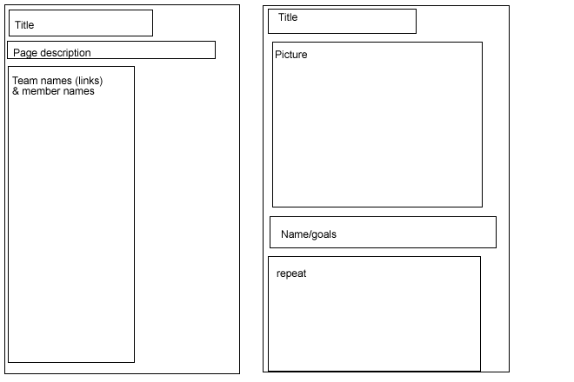

Gameplay:

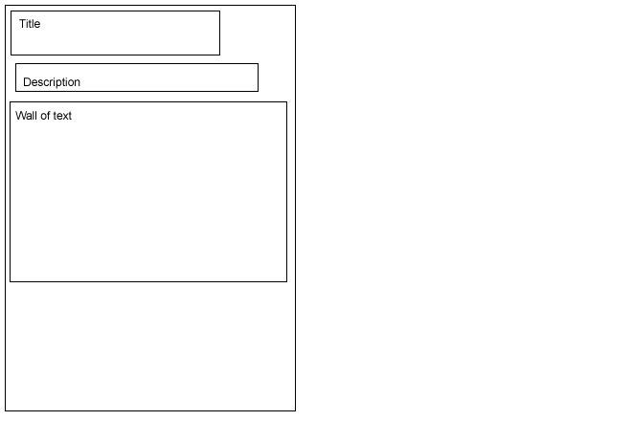

Environment:

