Zoo Escape

Wiki Page Outlines

Psychology

04/20/07
[Outline]

Documentary
I Title
i Page description
II Picture
i Brief description
(Repeat)

Programming
I Title
i source link
ii description
II Links
i Link – Description
ii Link – Description
ii Link – Description
iv Link - Description
[Text]

Documentary
I Documentary
i This page is dedicated to our Book (Link) team's behind the scenes documentary.
II Picture
i This is a screen shot from our PM documentary team, Sabrina Romero, editing the worlds portion of the documentary.
III Picture
i This is a screen shot of Ker Thao from the PM cutscenes group doing his interview for the documentary, explaining his responsibilities, strengths and weaknesses in the part of the project that he was assigned.
IV Picture
i This is what the film and music for the documentary looks like when being edited with "Sony Vegas" by our AM documentary team, Shannon Gleghorn.
Programming
I Programming_Code
i Click here (link) to view the source code for Zoo Escape.
ii This shot is programming for rendering the guards that patrol the zoo.↓
II Picture
i This is some code that basically starts up the engine for the game.↓
III Picture
i This code renders models and lighting for the player model, the skydome, and the land map.↓
IV Picture
i These are all the programs used to program Zoo Escape. Click on a link to go to that programs webpage if you are interested.
V Links
i OpenGL 2.0 (link) – Created by SGI
ii GlueGen 1.0 (link) – Created by Sun Microsystems
iii OpenGL Java Bindings 1.1.0 RC4 (link) – Created by Sun Microsystems
iv JCreator LE 3.00.092 (link) – Created by Xinox Software

[Diagram]

Documentary:

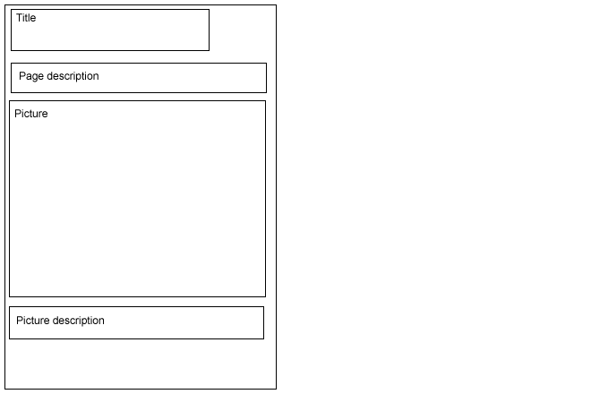

Programming_Code:

