Zoo Escape

Wiki Page Outlines

Psychology

04/17/07
[Outline]

Purpose
I Title
II Heading 1
i Paragraph 1

Main Page
I Title
II Subheading 1
i One sentence
III Subheading 2
i Link
ii Link
iii Link
iv Link
v Link
vi Link
vii Link
viii Link
ix Link
x Link
IV Game poster
i Caption
V Ad
i Caption
VI Cart logo
VII Blue Star logo

Story
I Title
II Heading 1
i Paragraph 1
ii paragraph 2
II Heading 2
i Paragraph 1
ii Paragraph 2
[Text]

Purpose
I Purpose
II Why are we making this game?
i As a class we decided to make this game with the purpose of challenging ourselves to do something that has never done before. In the name of education we undertook the task to learn as much new information as is necessary to create a full-fledged game from scratch. We are here to make our mark on the video gaming industry’s history books by creating a game unlike any other, one that analyzes the player and can make accurate predictions about their tendencies. Having very limited industry standard game creating experience is an obvious hindrance to our team, but we stake our reputation as a class on the confidence that we will be able to overcome our weaknesses.

Main Page
I Main Page
II Purpose
i This Wiki was created to help notify the public about the Center of Advanced Research and Technology’s Interactive Game Design Lab’s newest project, entitled Zoo Escape.
III Links
i Art
ii Characters
iii Environment
iv Story
v Game play
vi Purpose
vii Team
viii Video
ix Story Board
x Programming
IV Poster
i Zoo Escape, including images of all of the major characters.
V Cart logo
VI Blue Star logo

Story
The Boulder Zoo’s animals are in danger. The owner of the Zoo, with backing from the corrupt zoo executives, has decided to sell out and make money off the exotic animals in captivity. The zoo owner is going to sell the animals to Zoo’d Food, a company that professes to return these animals to the wild when in fact they turn exotic animals into delicacies for the rich and powerful.

Twelve hours before the truck is to arrive and transport the animals to certain death, Poncho the flamingo overhears two guards discussing the fate of the animals. Poncho knows it is up to him to formulate a plan to get all the animals to freedom. He must free the animals one by one, using each animal’s unique skills to help free the other animals. Can you help the unfortunate animals at the Boulder Zoo escape, or will you fail, sealing their doom?

The game progresses when the player uses each animal’s individual, class specific, skills. An example would be Poncho the flamingo is only able to free the turtles (Jorge, Santiago, Miercoles). The turtles are then able to free the kangaroo, panda, or the giraffe. If the player decides to free the kangaroo, he or she must then free the meerkat’s, then the woodpecker, and lastly the elephant who is able to open the main gate in that order. If the player decides to free the panda, he or she must then free the tiger, penguin and lastly again the elephant in that order. If the player chooses neither the kangaroo nor the panda, that leaves just the giraffe to free, then the meerkat, tiger and elephant in that order.

[Diagram]

Main Page:

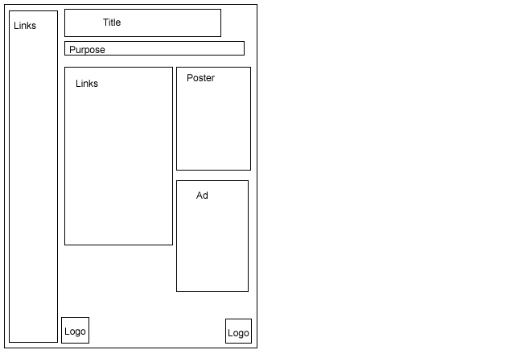

Purpose: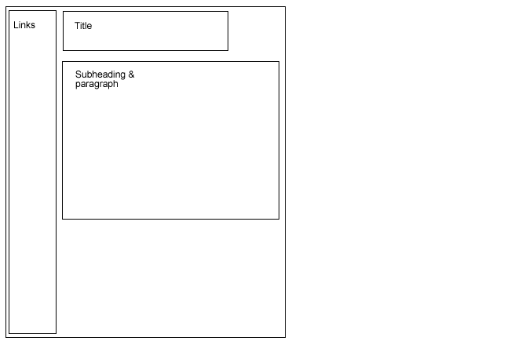

Story:
