[Level Progression]
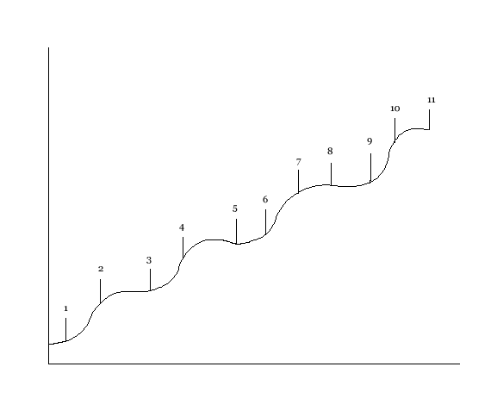
Increasing difficulty
Increasing time (player skill)

1- This is when you free the first animal and it is relatively easy, the guards are fairly simple to get around

2- The second task is the next animal you have to free; this animal is a little bit trickier to free seeing as there are more guards around the cage and they are more alert

3- Your next task is yet another animal to free;
4-
5-
6-
7-
8-
9-
10-
11-

