[Level Progression]
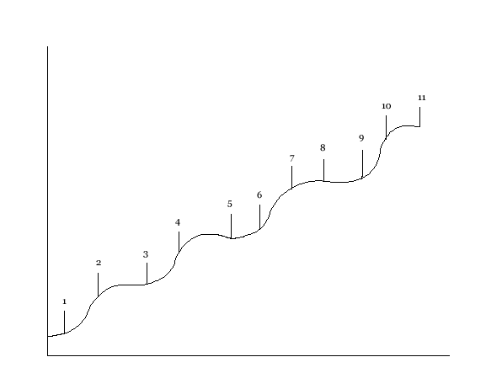
Increasing difficulty
Increasing time (player skill)

1- This is when you free the first animal and it is relatively easy, the guards are fairly simple to get around

2- The second task is the next animal you have to free; this animal is a little bit trickier to free seeing as there are more guards around the cage and they are more alert

3- Your next task is to free yet another animal; the guards are faster and their range of sight is broader than the last task

4- The next task is to free another animal; the guards patrolling have keener eye sight and have faster reflexes than the last level

5- The next task is an animal that you have to free; this animal is a trickier due to the fact that there are even more guards patrolling the cages

6- The next task is to free another animal; not only is the cage is a lot harder to get into, and the guards are more aware of what is going on and slightly suspicious

7- Your next task is to free another animal; the guards are getting more suspicious by the minuet and are starting to join forces to keep an eye on things

8- This task is a another animal to free; the guards at this time are aware that something is going on but they don’t know what it is so they are acutely aware of noises

9- The next task is to free another animal; the guards patrolling are very suspicious now and are looking for anything at seems out of the norm

10- Your next task is to free the last animal; the guards are now noticing that there are animals missing from the cages and are on the look out

11- The last task is to escape from the zoo; the guards are frantic by this time and are running everywhere to find out where are the animals have gone

*not every single level is going to be accomplished
**each cage you have to breach is a puzzle so that’s one of the difficulties in its self

