[ Polygon counter ]
This tool is used to show the total polygons used on a single object and in the entire world.

How to Open and use the Polygon Counter

- Go to the Utilities panel.

- Open More under the Utilities panel. 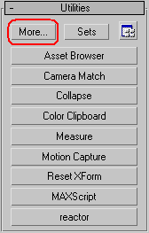

- Under the window that opens click and open Polygon Counter. 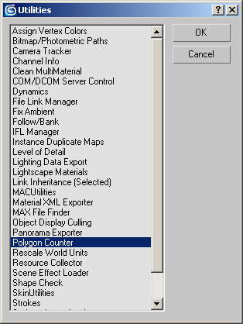

- With this window open you can see the poly count of the current and the world’s poly count. 