[Quest Log]

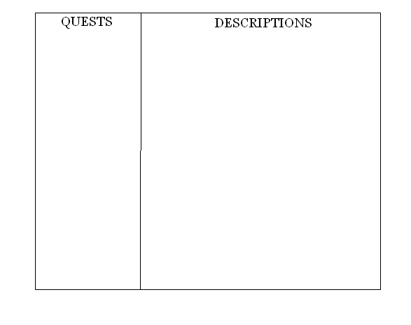
Under the quests column, all quests which have been initiated should be listed. An example would be: Free Panda.

If the player clicks on the quest name, the description for that quest should appear in the second column.

If the quest is completed, it works exactly the same as before in the log, except it says FINISHED next to the title and on the description.

The two columns are part of one quest menu GUI. They cannot be separated.

