Zoo Escape

Wiki Page Outlines

Psychology

04/19/07
[Outline]

Character
I Title
II Subheading 1
i Paragraph
III Subheading 2
i Link
ii Link
iii Link
iv Link
v Link
vi Link
vii Link
viii Link
ix Link
x Link
Links
I Title
i Paragraph
II Picture

[Text]

Character
I Characters
II Page Description
i Click on a Link to go to that characters page containing a pic of the character along with a back ground story.
III Links
i Poncho the Flamingo (Link)
ii The Turtles (Jorge, Miercoles, Santiago) (Link)
iii Jerry the Woodpecker (Link)
iv Abella the Tiger (Link)
v Marvin the Giraffe (Link)
vi Rodger the Kangaroo (Link)
vii Daisy the Meerkat (Link)
viii Mei Ling the Panda (Link)
ix Billy the Penguin (Link)
x Vladikov the Elephant (Link)
Links
I Flamingo
i Poncho the Flamingo is a very serious bird. Throughout his life, he has been teased for having a rather large head, which has resulted in him having slight feelings of dislike for the other animals. He would never, however, wish for their demise, and immediately sets out to save them after he learns of the plot to sell the zoo animals.He sometimes seems demanding, but has only the best intentions at heart.
II Picture
I Turtles
i The Turtles are an old and grumpy group, and don’t like being disturbed. It is not uncommon for the turtles to sit around and complain about the younger animals and how they are too unruly. They spend most of their time lying perfectly motionless underwater, and this extends into their personality; they never really like to have to move or do anything. They have a tough and cold outside, but they’re still caring very, very deep down, and are willing and ready to act if it’s for an important cause.
II Picture
I Woodpecker
i The Woodpeckers are a strange group in that they are nearly insane from constantly jarring their brains by pecking trees. They have a habit of talking at insane speeds, mostly because they live by the credo that everything they do needs to be as fast as possible. Eccentric as they are, however, they still view themselves as friends of the other animals, and will save them before escaping themselves if they can.
II Picture

I Tiger
i A wise and powerful animal, Abella spends most of her time riddling and making complex plans to escape to freedom. She is a predator by nature, but is glad to help the other animals to escape so long as she can get out as well. As the only major predator in the zoo, she is distrusted by most of the animals, but she is also respected for her intelligence and stealthy nature.
II
I Giraffe
i The oldest animal in the zoo, Marvin is constantly complaining about his bad back. He also complains about his bad neck. In fact, he complains about just about everything. He wants to see the outside of the zoo before he dies, however, so even though he has a habit of trying to weasel his way out of doing anything, he will still gladly help the other animals.
II Picture
I Kangaroo
i Youthful and energetic, Rodger is excited at the prospect of being a hero, and is literally jumping with anticipation every time he thinks he has a chance. He looks to the other animals as older siblings, and is more than glad to help them in any way he can.
II Picture
I Meerkat
i By far the smallest of the animals, Daisy is very shy and nervous around the others. Her tiny size and the knowledge that she’s defenseless compared to the others makes her sometimes stutter and always look around shiftily. She knows that the other animals need her help, however, and she views helping them escape as a way to prove that she is valuable to the other animals of the zoo.
II Picture
I Panda
i One of the oldest animals at the zoo, Mei Ling is a slow and cautious mammal. She thinks every action through as systematically as possible. She never does anything without first considering every outcome and spontaneity is not part of her charm. This doesn’t change the fact that she is a valuable asset, however, because she still has incredible strength and a cool mind.
II Picture
I Penguin
i Billy is a prankster, and loves to play jokes on other animals. His most recent effort has been trying to get a snowball from his enclosure to hit Tiger. He is somewhat annoying to the other animals because of his love of practical jokes, but he views all of them as good friends, and will do whatever he must to save them from being made into meals.
II Picture
I Elephant
i Inarguably the most massive animal in the zoo, Vladikov is strong and, due to his life being spent in a cage, bad tempered. He is constantly looking for a way out, and will be forever grateful if the animals can help him escape from the zoo.
II Picture

[Diagrams]

Character:
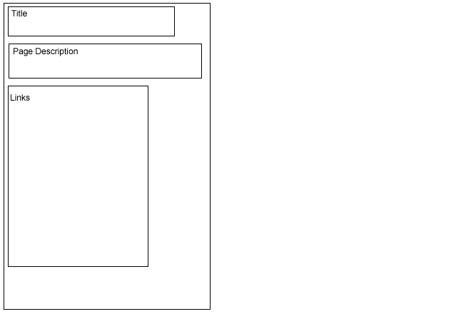

Links:
