|  |
| --- |
|  |
| Student Handbook  For Mobility Program – Hanoi |
| |  |  |  | | --- | --- | --- | | FPT University Global |  | 05/2019 | |

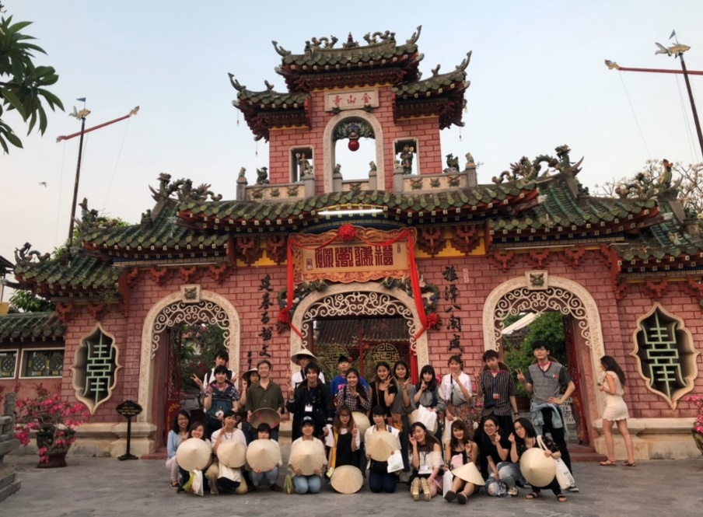

OUTLINE

# A MESSAGE FROM FPT UNIVERSITY GLOBAL 3

# PRE-DEPARTURE GUIDE 4

Passport and Visa4

Travel Arrangement4

International Insurance 5

Cell Phone5

Financial Affairs5

* Cash5
* Cards6
* Traveler’s checks 6
* Familiarize yourself with Vietnam Dong 6

Health7

Clothing and Personal Items7

Prepare for Cultural Transition 8

* What to expect8
* Tips for successful cultural transition9

Prepare for Home Support 9

Personal Language Plan9

* Useful Vietnamese phrases10
* Apply Technology 10

Important Contact Information10

* *Our FPTU Global Team*11

Final Checklist 11

# WHEN YOU ARRIVE 12

Immigration notes12

Airport pickup12

Housing 12

# EXPLORE HA NOI14

Fast Facts about Vietnam14

Hanoi Overview14

* Climate 14
* Cost of Living15
* Safety16
* Transportation: Commute around the city and Reaching out to other provinces16

City guidebook18

* Where to eat and drink18
* Where to visit 18
* Where to shop20
* Where to get medical services20

Useful Applications21

A MESSAGE FROM

FPT UNIVERSITY GLOBAL

*Dear* *Student*,

Welcome to FPT University Global. It is wonderful to have you join us at our Ho Chi Minh City campus. I hope you will make yourself at home here and enjoy your Vietnamese experience.

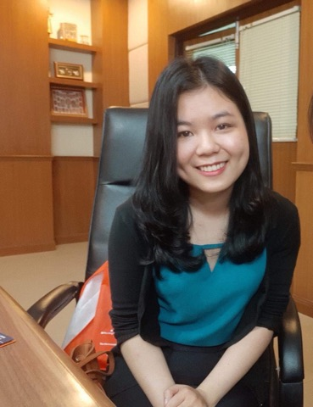

FPTU Global plays a major role in the international student affiliation and the “Go Global” approach of FPT University to increase student mobility, which is critical in the development of high-quality human resources needed for a fast-changing business world. As such, we are happy to welcome you to our new, modern facility in the most livable city of Vietnam among a community of international students from across the globe.

I hope that by the end of your stay, you will make long-lasting connections with local friends and those from other countries. I encourage you to make the best out of your time here by participating in a wide range of programs and activities that we offer in addition to your main program component, which will allow you to learn more about the local way of life and exchange cultures.

No matter how long you will be with us at FPTU Global, please know that we are glad to host you. All our staff members and I are always happy to support you in any way we can.

All the best,

Nguyen Thi Thu Hien

Director of FPTU Global

PRE-DEPARTURE GUIDE

## Passport and Visa

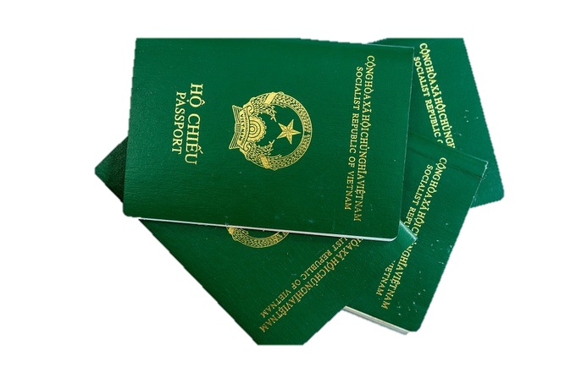You may skip this part if you have already got your visa to Vietnam. Otherwise, there are a few things that we would like to remind you:

* Check the expiry date on your passport. In order to travel abroad, your passport must be valid for at least six months after your return date.
* If your passport does not have the validity as mentioned or you have not got passport yet, go apply for one immediately.
* If you need to apply for visa to participate in a program in Vietnam, here are the documents you need:
* Original passport
* The visa pre-approval letter (FPTU Global will send this to you via email)
* NA1 Form – print out and fill that form
* 2 identity photos (4cmx 6cm)
* Fee by cash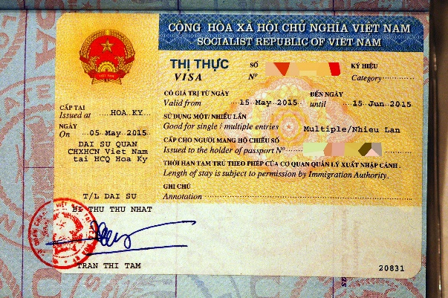

Please note that there will be detailed instructions regarding visa application provided by our Student Visa Department via email to you or your university coordinator. For more information and detailed guidance about visa application, please visit the website of Vietnam Immigration Department at <https://xuatnhapcanh.gov.vn/en> or email your FPTU Global Program Coordinator.

You should make color copies of your passport. Leave one copy at home with a trusted family member or friend. While in Vietnam, remember to keep your passport in a safe and secure place and always carry your passport and/or a photocopy of your passport when you travel.

## Travel arrangement

If flights are not arranged by your university or a travel agent, you might want to book your air tickets far in advance to save your budget. Tips for travel arrangement can be found as follows:

* Check carefully your program agenda or contact with your Program Coordinator to make sure you depart/return from the right and same airport with other students (if you go with a group).
* Google Flights is a good tool to predict flight rates and suggest lower fares dates.
* Try to book your flight that arrives in the morning because navigating during daytime is much easier.
* Figure out inner-country transportation from the airport you arrive in advance. This will help if airport pickup service is not provided or provided but you get lost. See How to commute (page 18) for more information about transportation in Ho Chi Minh City.

**International insurance**

For your own safety, please make sure you have insurance covering the duration of your program in Vietnam in case of sickness/accidents. Check with your home university if you have to buy one or whether your home university will take care of this.

As per FPTU Global’s regulations, insurance is a ***required*** document so if you don’t have insurance, you are not accepted to join the program.

Don’t forget to make a copy of travel insurance certificate and bring it with you to Vietnam.

**Cell phone**

You can consider following options for using cell phone while in Vietnam:

* Use roaming services with your current phone plan: Contact your current service provider at your home country to buy roaming services for your phone. This can be very convenient as you will not have to purchase a new phone and/or local SIM card but also the most expensive options with huge fee for roaming.
* Buy a local SIM card: Check if your phone has an accessible SIM card slot. Usually, an unlocked phone GSM is needed to use a local SIM card, with prices ranging from **VND150,000-200,000** (around USD 6.5 - 8.5). You can buy a SIM card at the airport when you arrive or go to our Student Service Department to get one with instructions from buddy team/coordinator. Please note that you might need local SIM in order to use some important local applications (Foody, Grab, etc.)
* Use free messaging apps that work through Wi-Fi: This option has limited use as it depends on your access to Wi-Fi. For your information, Wi-Fi is provided in the accommodation and campus. Wi-Fi is also available in almost all restaurants/coffee shop.

**Financial Affairs**

It is advised that you use a combination of cash, credit/debit and, ATM cards during your time in Vietnam.

Cash

* We recommend that you prepare some cash in VND in advance and suggest around USD 150-200 (average living cost per month, not including housing fees in Hanoi city) to start off.
* Buy VND at banks or currency exchange location in your home country before you depart. This will allow you to have local currency in case of emergency.
* Try to avoid Cash Exchange Counters at airports if you can as their exchange rates are higher than most other locations.

Cards

* If you plan to withdraw cash in Vietnam, notify your bank about the destination and duration of your stay.
* Check if there are any cash withdrawal limits and fees.
* Make sure you understand the foreign currency conversion fees
* Don’t rely entirely on ATM services. If your card is stolen, you will not have any means withdrawing money.

Traveler’s Checks

* Most major banks will provide traveler’s checks. Be sure to order them several weeks in advance.
* When signing traveler’s checks, make sure the signature matches the name on your passport.
* Only cash traveler’s checks at banks. Do not cash them at hotels or stores.
* Traveler’s checks are not meant for making purchases. They must be cashed first at a bank.

Familiarize yourself with Vietnam Dong

Vietnam’s official currency is called Vietnam Dong (VND, in short). Vietnam Dong comes in these following denominations:

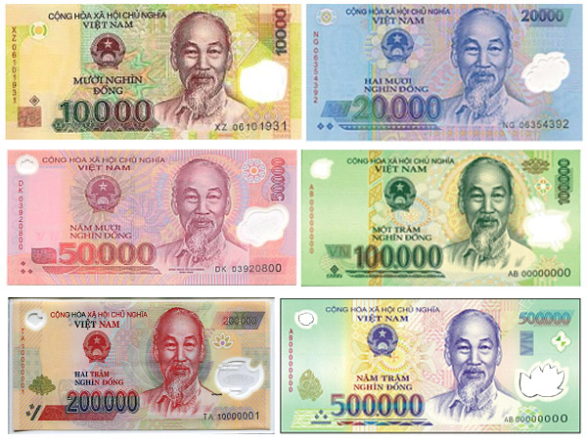

**500,000** (~USD 25)

**200,000** (~USD 10)

**100,000** (~USD 5)

**50,000** (~USD 2,5)

**20,000** (~USD 1)

**10,000** (~50 cents)

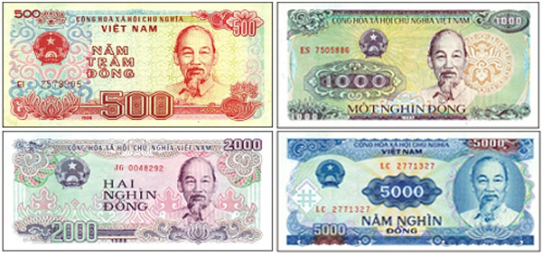**5,000** (~25 cents)

**2,000** (~10 cents)

**1,000** (~5 cents)

**500** (~2.5 cents)

*Note*: You will rarely see 500 notes, sometimes the supermarket will give you candies instead of VND 500.

*Common mistakes by newcomers:*

It might take a bit of time for you to get used to all the zeros of VND. Common mistakes you should be really careful are:

* 100,000 and 10,000 because of similar numbers
* 500,000 and 20,000 because of similar color.
* 200,000 and 10,000 because of similar color.
* VND notes from VND10,000 and above are made of polymer and can often stick together. Therefore, make sure you flick and count the notes before you pay.

**Health**

To fulfill the program, you should make sure you take care of your health carefully. Here are some reminders for you to do if applicable:

* Visit your doctor and dentist for a check-up before you depart.
* Get vaccinated: It is recommended that you get vaccination for Malaria, TB, Hepatitis A, B, rabies, meningitis, etc. before you depart to Vietnam. Contact your doctor for more recommendations.
* If you have any medical conditions that need medications, make sure you check with your doctor and get advice. Don’t forget to bring necessary quantities of medications and be sure to carry a written prescription from your doctor.

**Clothing and Personal Items**

On average, the temperatures in Hanoi city are always high, hence bring your clothes suitable for this weather. Essential items are hats, sunscreen, summer shoes and water bottles.

Recommended clothing items:

* Your university uniform, traditional costumes for closing ceremony or cultural events at FPTU Global
* Formal clothes suitable for the workplace if you come for the internship (Specific requirements will be provided in your Internship Agreement)
* Clothes for hot weather (April – August) and cold weather (September – February)
* Thin long sleeve shirts or jackets as ultraviolet (UV) ray may be strong.
* It is also wise to bring enough clothes for a few days up to a week in case you are not able to wash and dry your clothes in time.

Check the list of appliances that are available in your dormitory room (see page 13) and figure out what else you need to pack.

*Consider this:*

* Put luggage tags on both your checked and hand luggage.
* 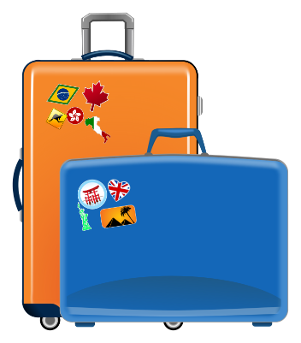Pack enough clothes in your hand luggage to last 03 days in case your checked suitcase is delayed. Don’t forget to check your airline’s baggage and weight requirement.

***Note:***

* Electric appliances in Vietnam run on 220 volts current. Check if you need a travel adapter.
* You should bring your own laptop, especially if you come for the internship or training courses as you might need to do a presentation.

**Prepare Yourself for Cultural Transition**

What to expect:

As you start living in a country different from your home, adjusting to the new culture and living environment is a normal process. You may go through stages of cultural adjustment as described below. However, also note that not all people go through each and every stage and in that exact order.

1/ You have just arrived in Vietnam. Everything is so exciting—Ho Chi Minh is awesome, the beaches are so beautiful and the people are so friendly. You can’t wait to explore the city, make some travel plans and have a great time here!

2/ You realize that living in a different country is not as fun and easy as you thought… It’s hard to get around by bus, by bike and on foot; local people don’t understand you when you try to explain something; and you miss your home foods… This is when you may feel homesick, lonely, or overwhelmed.

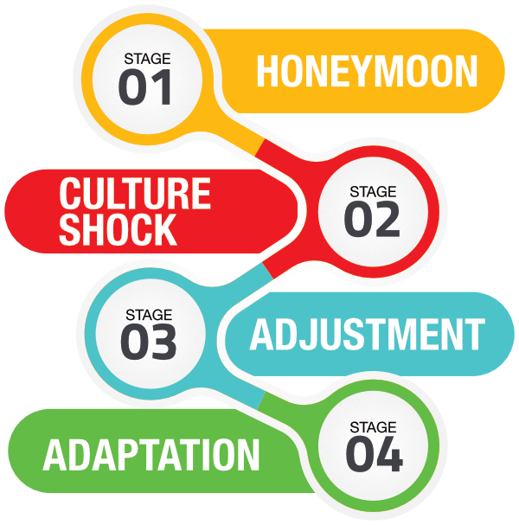

3/ As time goes by, you begin to figure out ways to manage your life in Vietnam. Now you can use Grab to get around the city so efficiently and cost-effectively. Google Translate becomes your great assistant when you want to buy something at a local shop. And hey, you learn about a shop that sells ingredients you can use to make your home foods!

4/ Now you find that living in a totally different culture is actually not that difficult. You can both enjoy exploring the local community while also maintaining connection with your home culture!

1. Adaptation stage:

Tips for successful cultural adaptation:

Before your arrival:

* Familiarize yourself with some basic understanding of the Vietnamese culture via the internet, TV or newspaper
* Ask students you know who have been to Vietnam or have participated in the same program as yours for tips and advice

While you are here:

* Exchange conversations with local Vietnamese - this is a great way to not only understand the local community better but also introduce your home culture.
* Find people with whom you feel comfortable sharing your feelings and experience with.
* Stay in contact with your friends and family at home
* Balance work and fun in your everyday life
* Seek support if you need to. There will be difficulties moving to a new country and it is normal. The Student Experience Manager, your Program Coordinator, FPTU Global staff and the buddy team are available for assistance.

**Preparing Your Home Support System**

Bear in mind that going abroad is a great opportunity to experience the world not only for you but also your family and friends, they might want to get involved in your international experience. Plus, they might be worried and want to hear updates about you when you are away. Therefore, it is advisable to discuss with your family and friends to set expectations for both sides during the time you go abroad.

Here are some points you can consider during your discussions:

* What are your worries about me going abroad? What can we do to address your concerns?
* How often should we communicate? Should we set a schedule?
* Don’t forget this is the time for you to immerse in a new culture. You also have program schedule with many activities and/or tasks to follow. Therefore, you should consider limiting contact back home.
* Am I expected to share my experience abroad? If so, how?
* You can consider using social media platform like Facebook, Instagram, Twitter, Viber, Line, etc. Like communication, try to limit social media usage to maximize your new cultural experience.
* What can you do if you cannot contact me as scheduled?
* Don’t forget to provide your family with the contact of your home university’s coordinator and important contacts of FPTU Global people (see page 11) before you depart, so they know whom to contact if they cannot reach you.
* How can you respond/support me in case of emergency cases (robbery, accident, sickness, etc.)?

**Personal Language Plan**

The official language of Vietnam is Vietnamese. There is an increasing number of young people with fluent English capacity, but often you can find it hard to communicate with local people in Ho Chi Minh because they cannot speak English. Therefore prepare yourself with some vocabularies and be smart at using technology.

Useful Vietnamese Phrases

You might have personal goals for yourself about language, whether it is memorizing and using simple phrases for daily communication or attaining higher level of local language fluency, especially if you stay in Vietnam for months.

For the former goals, please check some useful Vietnamese phrases as below. You can practice it before you come to Vietnam as it is always impressive if you can speak some Vietnamese to the locals the first time you meet each other.

|  |  |
| --- | --- |
| Hello | *Xin chào* |
| My name is… | *Tên tôi là…* |
| What is your name? | *Bạn tên gì…* |
| How are you? | *Bạn khỏe không?* |
| I’m fine | *Tôi khỏe* |
| Thank you | *Cảm ơn* |
| Sorry | *Xin lỗi* |
| Excuse me, how can I get to… | *Xin lỗi, làm sao để đi đến…* |
| How much? | *Giá bao nhiêu?* |
| Too expensive! Discount please | *Đắt quá! Bớt đi* |
| Delicious | *Ngon* |

Apply Technology

Here are some applications that you can use for translating purposes: Google Translate, Papago, Waygo, etc. Install and practice in advance. Then you can have experience using the application in time of need.

**Important Contact Information**

Our FPTU Global Team

|  |  |  |  |
| --- | --- | --- | --- |
| Name | Position | Phone number | Email |
| Ms. Hien Nguyen | Director | +84. 93 562 5592 | [hienntt65@fe.edu.vn](mailto:hienntt65@fe.edu.vn) |
| Ms. Ut Nguyen | Program Coordinator | +84. 90 357 5247 | [utnt4@fe.edu.vn](mailto:utnt4@fe.edu.vn) |
| Ms. My Duong | Program Coordinator | +84. 369 252 357 | [mydtd9@fe.edu.vn](mailto:mydtd9@fe.edu.vn) |
| Ms. Hung Tran | Buddy Team Leader | +84. 93 298 8491 | Hungtt46@fe.edu.vn |

***Note****:* Get the contact information of the coordinator for your program. This person will also connect you to buddi(es) who will pick you up at the airport if this service is included in your program.

**Final Checklist**

Now you are done with the preparation, let’s go over the final checklist to make sure you don’t forget anything before your trip:



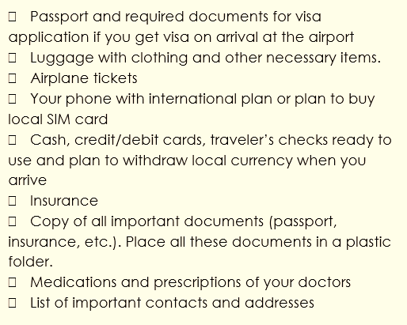

WHEN YOU ARRIVE

**Immigration**

Upon arrival, check to make sure that the seal of entry stamped by Custom officers has the same dates as stated on your visa. If there is any difference, ask the Custom officers for clarification.

**Airport pickup**

* If airport pickup is included in the program, please pay attention to our welcome board. (pic) Our shuttle bus will take you to your dormitory for check-in.
* If you cannot meet the buddies at the airport or you get lost, try to contact the buddies first, then your Program Coordinator.
* Contact Deputy Director and Director of FPTU Global if you cannot reach these above-mentioned people.
* In the worst case you cannot contact anyone (we have never encountered this incident before), please don’t panic. Find a coffee shop/restaurant around the arrival hall of the airport to take a rest and try to contact them again, then indicate the name of the coffee shop/restaurant for the buddies/staff to come to meet you.
* If airport pickup is not included in the program, you can either use Grab or Taxi to get to the dormitory. Remember to show the driver the address of the dormitory.

EXPLORE HA NOI

**Fast facts about Vietnam**

* Area: 331,690 km2 (64 cities and provinces)
* Capital: Ha Noi
* Largest city: Ho Chi Minh city
* Population: about 95 million, including 54 ethnic groups, the majority are Kinh people
* Official language: Vietnamese
* Economy: 7% annual GDP growth (second fastest growing country in Asia in 2018)
* Religion: Buddhism 85%, Christianity 8%, Caodaism 3%, Others 4%

**Hanoi Overview**

With an estimated population of 7.7 million as of 2018, it is the [second largest city](https://en.wikipedia.org/wiki/List_of_cities_in_Vietnam) in Vietnam. The [metropolitan area](https://en.wikipedia.org/wiki/Hanoi_Capital_Region), encompassing nine additional neighboring provinces, has an estimated population of 16 million. Located in the central area of the [Red River Delta](https://en.wikipedia.org/wiki/Red_River_Delta), Hanoi is the commercial, cultural, and educational centre of [Northern Vietnam](https://en.wikipedia.org/wiki/Northern_Vietnam). Having an estimated nominal GDP of US$32.8 billion, it is the second most productive economic centre of Vietnam, following [Ho Chi Minh City](https://en.wikipedia.org/wiki/Ho_Chi_Minh_City).

*(Source: Wikipedia)*

Climate:

Hanoi has four seasons, with Spring time from February-April, Summer from May-August, Fall from September-November, and Winter from December-January. Humidity levels average 79% throughout the year.

The average temperature here is 23.6 degrees Celsius

* Hottest months: July-August
* Coolest month: December-February

**Hanoi (Vietnam)**

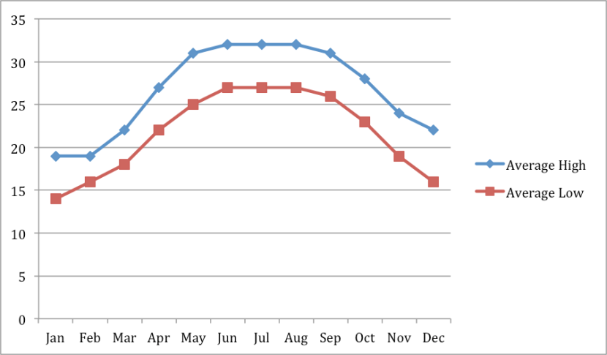

Cost of Living

|  |  |
| --- | --- |
| **Item** | **Average Price (VND)** |
| ***Restaurants*** |  |
| Meal, Inexpensive Restaurant | 50,000 |
| Meal for 2 People, Mid-range Restaurant, Three-course | 400,000 |
| Cappuccino (regular) | 40,971 |
| Coke/Pepsi (0.33 liter bottle) | 11,619 |
| Water (0.33 liter bottle) | 6,875 |
| ***Markets*** |  |
| Milk (regular), (1 liter) | 33,000 |
| Loaf of Fresh White Bread (500g) | 16,727 |
| Rice (white), (1kg) | 20,230 |
| Eggs (regular) (12) | 33,225 |
| Chicken Breasts (Boneless, Skinless), (1kg) | 85,916 |
| Beef Round (1kg) (or Equivalent Back Leg Red Meat) | 204,000 |
| Water (1.5 liter bottle) | 14,181 |
| ***Transportation*** |  |
| One-way Ticket (Local Transport) | 7,000 |
| Monthly Pass (Regular Price) | 200,000 |
|  |  |
| Taxi Start (Normal Tariff) | 12,000 |
| Taxi 1 km (Normal Tariff) | 14,000 |

*Source: numbeo.com*

Safety

|  |  |  |
| --- | --- | --- |
| **Crime Rates in Hanoi, Vietnam** | | |
| Level of crime | 33.23 | Low |
| Crime increasing in the past 3 years | 52.00 | Moderate |
| Worries home broken and things stolen | 40.39 | Moderate |
| Worries being mugged or robbed | 38.25 | Low |
| Worries car stolen | 33.66 | Low |
| Worries things from car stolen | 39.30 | Low |
| Worries attacked | 30.29 | Low |
| Worries being insulted | 31.25 | Low |
| Worries being subject to a physical attack because of your skin colour, ethnic origin or religion | 13.19 | Very Low |
| Problem people using or dealing drugs | 43.33 | Moderate |
| Problem property crimes such as vandalism and theft | 46.82 | Moderate |
| Problem violent crimes such as assault and armed robbery | 31.30 | Low |
| Problem corruption and bribery | 80.77 | Very High |

*Sources: numbeo.com*

In general, Hanoi is a safe city. However, precaution is always important. You should:

* Pay attention to your belongings in crowded places like markets, public buses.
* Always check carefully before you cross the street.
* Don’t go alone late at night.
* If you go alone to any places, make sure at least one of your friends know where you are going
* Be careful with strangers. Vietnamese people are generally very friendly; however, it is not recommended to take rides with strangers when they offer you.

Transportation

***Commute around the city***

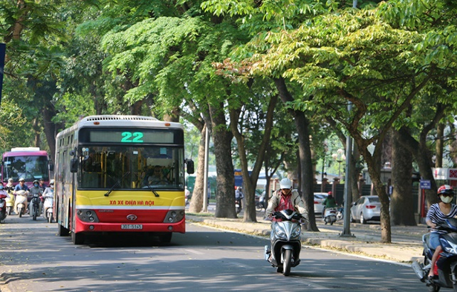 Public Transportation:

Bus

* It is one of the cheapest ways to travel around the city. The cost of each turn is just 7,000 VND with student bus pass.
* If you stay for more than 01 month, monthly bus pass is recommended to save your budget. Check if local bus pass is included in your program; otherwise please contact your Program Coordinator to register for monthly bus pass.
* The bus is clean, pretty on time and technology-friendly. To look up the route, you can install the app “timbuyt.vn” (see page 22)
* Bus driver cannot speak English. Make sure you know where to get off or give the address to the driver then they will inform you where you can get off.

Taxi

* It is easy to catch taxi at any time
* You’d better have destination written down since there are few drivers who can speak English.
* It is recommended that you have cash with you as many taxis do not accept credit/debit cards.
* Make sure the drivers turn on the meter when you get in the car. Otherwise, refuse to use their service as they can have the chance to cheat.

Starting price is around VND 12,000 - 15,000/km for the first 10 kilometers.

* Recommended taxi brands:
* Mai Linh Taxi (028 3838 3838) (Mai Linh accepts payment by cards)
* Vinasun (028 38 27 27 27)

Grab

* Grab is the most common transportation platform in Hanoi.
* You must install Grab App first and know the address of your destination.
* It is recommended that you pay by credit card so that there is no risk of scamming. If the driver asks for more than the fee you have to pay, say No and report to Grab immediately.
* Grab Bike is much cheaper than Grab Car.

Personal Transportation

Motorbike:

* It is the most popular means of transportation of Vietnamese people
* FPTU Global don’t recommend international students to drive motorbike in Vietnam and you have to bear your own risk.
* The rate of motorbike rental is around: VND 80,000 - 200,000/day or VND 1,500,000  - 3,000,000/month depending on the type of the motorbike.

***Reaching out to other cities/provinces in Vietnam:***

If you want to travel to other cities/provinces in Vietnam you can either choose intercity bus/coach, train or airplane depending on your budget. Here are some tips:

* Check if the cit(ies) you want to visit has train station and airport. All cities and provinces of Vietnam have coach stations.
* Check the expense yourself by the booking system and ask for advice from buddies/student advisor to consider appropriate means of transportation.

City guidebook

***Where to eat and drink***

* Banh cuon ba Xuan (steamed rolls): 16 Doc Hoe Nhai, Ba Dinh District
* Pho Thin: 13 Lo Duc, Hai Ba Trung District
* Xoi ba Thao (sticky rice): 41 Duong Thanh, Hoan Kiem District
* Dinh café: 13 Dinh Tien Hoang, Hoan Kiem District
* Bun cha Huong Lien (vermicelli with grilled pork): 24 Le Van Huu, Hai Ba Trung District
* Pho cuon Hung Ben (rolled Pho): 33 Ngu Xa, Ba Dinh District

*Vegetarian and vegan options:*

* Uu Dam Chay: 24 Hang Bai, Hoan Kiem District
* The Veg – Organic veto & tea: 18 Hang Chinh, Hoan Kiem District
* Vi Lai Vegetarian Restaurant: 67 Ly Thuong Kiet, Hoan Kiem District
* An Phuc Vegetarian Food: 20, Alley 113, Hoang Cau street, Dong Da District
* Tam Duc restaurant: 14 Dich Vong, Cau Giay District
* Bo De Tam restaurant: 34 Pham Huy Thong, Ba Dinh District

*Halal options:*

* P.K. Spice: 10 Hang Manh, Hoan Kiem District
* Khazaana Indian Halal Restaurant: 34 Duong Thanh, Hoan Kiem District
* Little India: 32 Hang Tre, Hoan Kiem District
* Dalcheeni: 100 Xuan Dieu, Tay Ho District
* Namaste: 46 Tho Nhuom, Hoan Kiem District
* Tandoor: 24 Hang Be, Hoan Kiem District
* Al Sultan Restaurant & Café: 21/52 To Ngoc Van, Tay Ho District

***Where to visit***

In Hanoi:

* Ho Chi Minh Mausoleum
* Hoan Kiem Lake
* Long Bien Bridge
* West Lake
* One-pillar Pagoda
* Old quarter
* Temple of Literature
* Thang Long Imperial Citadel

Nearby area:

* Ha Long Bay
* Ninh Binh
* Sa Pa
* Duong Lam Old Town

***Where to shop***

Supermarkets:

* Vinmart
* Big C
* Mega Market

Traditional Markets:

* Dong Xuan Market
* Hang Da Market
* Hom Market
* Local markets

Clothing shops:

* Shopping malls: Vincom Centers, Lotte Center Hanoi
* Ba Trieu street
* Pham Ngoc Thach Street
* Chua Boc Street
* Cau Giay Street

***Where to get medical services***

* Vinmec International Hospital
* Hanoi French Hospital
* Family Medical Practice Hanoi

#### Useful apps

 

Grab Foody



Google Translate Google Maps

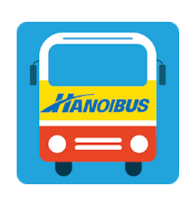

TimBuyt.Vn