Configuration-Adaptive Five-Axis Slicing and Experimental Validation for Multi-Material Fused Deposition Modeling
Tianhao Cheng ª, Xufeng Tang ^{b, c}, Lida Zhu ^{a,*}, and Zhongpeng Zheng ^{d,*}
ª School of Mechanical Engineering and Automation, Northeastern University, Shenyang, 110819, China.
^{b} Hangzhou International Innovation Institute, Beihang University, Hangzhou, 311115, China.
^{c} College of Engineering, Eastern Institute of Technology, Ningbo, 315200, China.
^{d} College of Mechanical Engineering, Tianjin University of Science and Technology, Tianjin, 300222, China.
* Corresponding authors: neulidazhu@163.com (L. Zhu); zhengzp@tust.edu.cn (Z. Zheng).

Abstract
Five-axis fused deposition modeling (FDM) reduces support demand and enables geometry-conforming deposition, but multi-material implementation requires geometric slicing, machine-axis conversion, clearance management, extrusion, and switching within one executable process. This study implements a two-stage slicing and machine-specific post-processing workflow on an AC rotary-table platform. Geometry-level position-posture paths are mapped to coordinated X/Y/Z/A/C/E/F commands, with rotary-range and continuity checks, a predefined absolute Z = 20 mm clearance move before scheduled non-deposition reorientations, and T0–T3 macros for a four-channel feeding system. Other rotary definitions were examined at the software-mapping and G-code-export levels; physical tests were confined to the AC configuration. Representative hemispherical patterned, fan-blade, curved-pipe, and impeller-like specimens were used to assess path execution, support demand, freeform deposition, material switching, defects, and representative dimensional response. For the reported curved-pipe builds, the five-axis route reduced printing time from 85 to 47 min and total filament consumption from 24.00 to 18.79 g; part and support material were not weighed separately. After one scheduled channel-preparation pause, the four-material fan and impeller builds executed four and eight macro-controlled selection commands, respectively, while a preloaded two-channel specimen completed its material transition without further operator intervention after printing began. Blade-thickness deviations ranged from -3.82% to +7.67%. Visible ripples, stringing, color carryover, and localized under-extrusion highlight the current limitations of the process. The results document successful execution of the integrated process chain under the tested AC-platform configuration and processing conditions.

Keywords: Five-axis fused deposition modeling; AC rotary-table platform; machine-specific post-processing; process integration; multi-material switching; support-reduced deposition

1. Introduction
Additive manufacturing (AM) builds components directly from digital models through successive material addition [1, 2]. Fused deposition modeling (FDM), also termed fused filament fabrication (FFF), is a material-extrusion process in which thermoplastic filament is deposited along prescribed toolpaths [3, 4]. In conventional FDM, the three-dimensional model is discretized into planar layers and fabricated sequentially through three-axis Cartesian motion. Its low equipment cost, straightforward process planning, and broad material availability have supported widespread use in rapid prototyping, customized fabrication, and engineering validation [1, 3]. These advantages, however, rely on a restrictive geometric assumption: the part must be approximated by horizontal layers referenced to a fixed build direction. Consequently, the slicing strategy and motion configuration jointly determine support demand, staircase formation, dimensional accuracy, and the orientation of bonded interfaces [3, 4]. The limitations of conventional FDM therefore arise from the coupling of planar slicing, fixed-axis motion, and layerwise deposition rather than from the printing hardware alone.
The geometric consequences of planar slicing become most pronounced in overhanging and continuously curved structures. Under a fixed three-axis deposition direction, sacrificial supports are generally required beneath overhanging regions. These structures increase material consumption and printing time, complicate removal, and may damage the adjacent part surface [5, 6]. Curved surfaces present a different manifestation of the same restriction: approximation by horizontal layers produces staircase morphology whose severity increases as the local surface orientation departs from the build plane [6, 7]. Planar stacking also fixes the orientation of layer interfaces throughout the component. Because bonding between adjacent layers is generally weaker than material continuity within a deposited layer, the resulting mechanical response becomes direction-dependent and remains sensitive to layer thickness, thermal history, deposition path, and interface quality [3, 4]. Support dependence, staircase morphology, and anisotropic bonding are therefore different consequences of the same inability to adapt the deposition orientation to local geometry.
Multi-axis and non-planar additive manufacturing address this geometric mismatch by allowing the deposition path, deposition direction, or workpiece posture to vary during fabrication. Reviews of multi-axis AM identify reduced support demand, improved tool accessibility, and an expanded manufacturable design space as its principal geometric advantages [5, 6]. Research on non-planar AM further emphasizes curved-layer path planning, machine integration, process control, and deposition on geometrically complex surfaces [7]. In five-axis FDM, two rotational degrees of freedom reorient either the nozzle or the workpiece, enabling the relative deposition direction to vary with the local surface orientation instead of remaining parallel to one global build axis. Curved-layer and directional-deposition methods have demonstrated geometry-conforming toolpaths for freeform and thin-walled structures [8-10], while posture-adjusted five-axis strategies have reduced support dependence in overhanging components [11]. Rather than approximating every surface from a single build direction, five-axis FDM uses local reorientation to establish a geometry-adaptive relationship between the deposition path and the target surface.
Five-axis FDM cannot be realized simply by appending two rotary coordinates to a conventional three-axis toolpath. A geometry-level path specifies the desired deposition position and relative orientation, but it does not directly define the axis coordinates required by a particular machine configuration. The introduction of rotational motion therefore couples slicing with machine kinematics, rotary-axis continuity, collision constraints, extrusion stability, and machine-specific post-processing [12-14]. Before physical execution, the position-posture data must be transformed into the translational and rotary coordinates of the target machine and then combined with extrusion amount, feed rate, safety motion, and auxiliary control instructions. Without this conversion, a geometrically continuous path may still produce abrupt angular changes, unreachable postures, nozzle-workpiece interference, or interrupted material deposition [15, 16]. The central implementation challenge is therefore to generate non-planar toolpaths and convert them into continuous, safety-constrained, machine-executable five-axis commands.
Multi-material fabrication introduces an additional material-state dimension into this machine-execution problem. By assigning different materials to selected regions, multi-material FDM can produce locally differentiated mechanical, thermal, electrical, visual, or other functional characteristics within a single component [17, 18]. Successful fabrication, however, depends on material selection, material affinity, processing temperature, melt adhesion, thermal compatibility, interface geometry, and residual material within the shared extrusion path [17, 19, 20]. In a single-nozzle system, each transition further requires filament unloading, channel selection, material reloading, temperature adjustment, purge control, and stable extrusion recovery [21, 22]. When combined with five-axis motion, these operations must be inserted at prescribed path locations and synchronized with rotary-axis posture, non-deposition travel, and subsequent path resumption. Inadequate coordination can cause color or material contamination, under-extrusion, interfacial gaps, or interruption of the spatial deposition path. Multi-material five-axis FDM therefore requires material switching, temperature control, extrusion recovery, and machine motion to be organized within an integrated execution sequence.
Existing research has advanced five-axis FDM through hardware development, geometry-adaptive slicing, and manufacturability-oriented process planning. At the system level, Open5x established an accessible route for converting a desktop printer into a five-axis platform and connected the modified hardware with a conformal slicing workflow [23]. Hong et al. subsequently combined five-axis motion with multi-material deposition to fabricate curved electrical traces on non-planar substrates [24]. At the method level, conformal printing, dynamic slicing, and five-axis dynamic slicing have provided different strategies for varying layer geometry and deposition orientation [25-27]. Variable-posture slicing libraries and vector-field-based curved-layer planning have further expanded the available methods for posture determination and complex toolpath generation [13, 14]. Support-free process planning and transition-layer construction have also been investigated to improve the manufacturability of overhanging and freeform geometries [12, 28]. These studies collectively demonstrate the feasibility of five-axis and non-planar material deposition. However, most validate only selected stages of the fabrication chain, such as hardware conversion, geometric slicing, posture planning, or individual specimen fabrication. The systematic connection among geometry-level slicing, machine-specific axis conversion, safety-constrained G-code generation, and physical execution remains insufficiently established.
Compared with the progress in geometric five-axis deposition, research on multi-material five-axis FDM remains limited. Existing studies have primarily examined material combinations, interfacial properties, and material partitioning under conventional planar-layer conditions [17, 19, 20]. Other investigations have focused specifically on feeding architectures and material-switching mechanisms [21, 22]. The curved electrical trace system reported by Hong et al. demonstrated that five-axis motion can be combined with multi-material deposition [24], but its workflow was developed for a specific functional application. A reusable multi-material five-axis workflow must additionally coordinate material-region assignment, switching-command insertion, filament-state confirmation, material-dependent temperature adjustment, purge and extrusion recovery, and resumption of the spatial deposition path under changing rotary postures. Geometric multi-axis slicing alone does not address these material-transition operations, while studies focused on material interfaces generally do not consider machine-specific five-axis execution. The remaining gap is therefore an experimentally verified workflow that converts material-assigned geometry into executable five-axis multi-material G-code and uses the resulting commands to fabricate physical components.
This study develops a configuration-adaptive five-axis slicing and machine-specific post-processing framework for multi-material FDM. Geometry-level position-posture paths are separated from machine-axis output and mapped to coordinated motion, extrusion, feed rate, clearance, auxiliary, and T0–T3 switching commands. Software mapping supports selectable rotary definitions and controller labels, while physical implementation is reported for the self-developed AC rotary-table platform. Hemispherical, fan-blade, curved-pipe, impeller-like, and multi-material specimens document the route from digital geometry to machine execution. The main contributions are:
(1) A two-stage architecture separates geometry-level position-posture paths from machine-axis command generation. Rotary definitions and controller labels are selected at the software-mapping level; physical implementation is reported for the AC configuration.
(2) An AC-specific post-processor converts position-posture data into X/Y/Z/A/C/E/F commands and incorporates rotary limits, continuity checks, auxiliary instructions, and a predefined absolute Z = 20 mm clearance position before scheduled non-deposition reorientations.
(3) Builds of hemispherical patterned, fan-blade, curved-pipe, and impeller-like specimens document curved-surface tracing, indexed reorientation, support reduction, coordinated A/C motion, freeform deposition, visible defects, and representative dimensional deviation.
(4) T0–T3 macros integrate material selection with five-axis execution. Four-material builds use macro-controlled switching after one scheduled channel-preparation pause, while the preloaded two-channel specimen documents unattended switching after printing began.
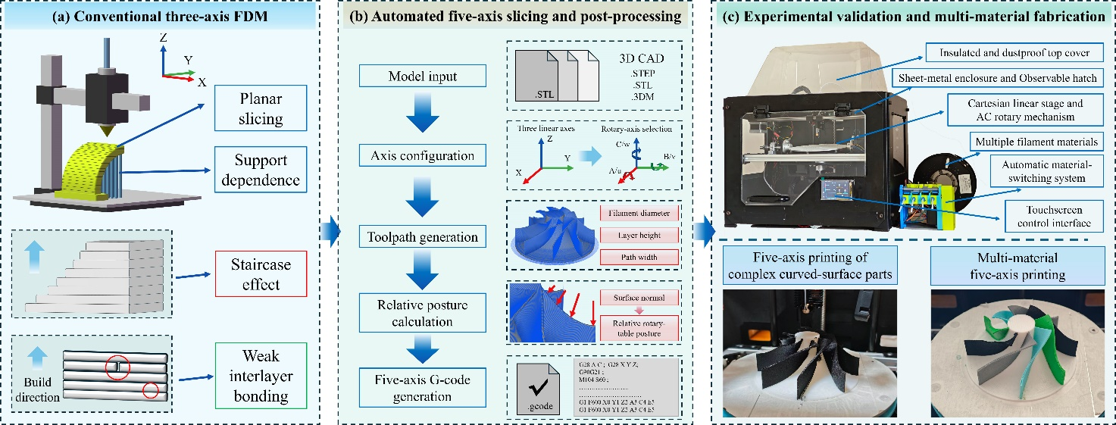
Fig. 1. Overall research framework for configuration-adaptive five-axis slicing and experimental validation of multi-material FDM. (a) Principal limitations of conventional three-axis FDM based on planar slicing and a fixed build direction, including support dependence, staircase morphology, and weak interlayer bonding. (b) Configuration-adaptive five-axis slicing and machine-specific post-processing workflow, comprising CAD model input, rotary-axis configuration, toolpath generation, relative posture calculation, process-parameter definition, and executable five-axis G-code generation. (c) Physical implementation on the self-developed AC rotary-table platform and validation through curved-surface path following, complex freeform fabrication, support-reduced deposition, and macro-controlled multi-material printing.

2. Materials and Methods

2.1 AC Rotary-Table Five-Axis FDM Platform and Processing Materials
As shown in Fig. 2, the experimental system is a self-developed five-axis FDM platform built around an AC rotary table. Instead of changing the orientation of the extrusion head, the machine obtains the prescribed nozzle-surface relationship by reorienting the workpiece. Planar nozzle positioning is provided by the Cartesian X/Y stages, whereas an independent Z-axis module regulates the nozzle-to-platform distance. The rotary table contributes the remaining two degrees of freedom: rotation about the machine X-axis is assigned to A, and rotation about the table Z-axis is assigned to C. Coordinating these translational and rotary motions produces the required five-axis deposition posture while the extrusion head retains a fixed orientation.
Mechanically, the platform integrates a Cartesian nozzle-positioning unit, an independent Z-axis module, an AC rotary table, a heated build platform, a single-nozzle extrusion unit, a four-channel filament-feeding system, and the associated motion-control hardware. Locating both rotary degrees of freedom beneath the workpiece keeps the print head compact and eliminates the need to route filament, heater wiring, and cooling components through a tilting-head structure. This arrangement simplifies the extrusion assembly, but it transfers additional requirements to coordinate transformation. Once the workpiece is rotated, the commanded Cartesian position depends on the calibrated rotary center, axis directions, coordinate offsets, and instantaneous A/C posture. Machine-specific post-processing is therefore required to preserve the intended relative position and orientation between the fixed-orientation extrusion head and the moving deposition surface.
Control is implemented through a host-controller architecture equipped with customized kinematics for the AC rotary-table configuration. The controller parses coordinated X/Y/Z/A/C/E/F commands together with T0–T3 switching macros and auxiliary instructions for initialization, homing, platform leveling, bed-mesh compensation, resonance compensation, and safety clearance. Before each printing task, three independently driven Z-axis adjustment points establish the reference plane of the build platform. Local height variation is then compensated using the measured bed mesh, whereas resonance compensation is applied to the Cartesian stages to suppress vibration-related motion errors. These calibration and compensation routines establish a consistent machine reference state before geometry-derived five-axis commands are physically executed.
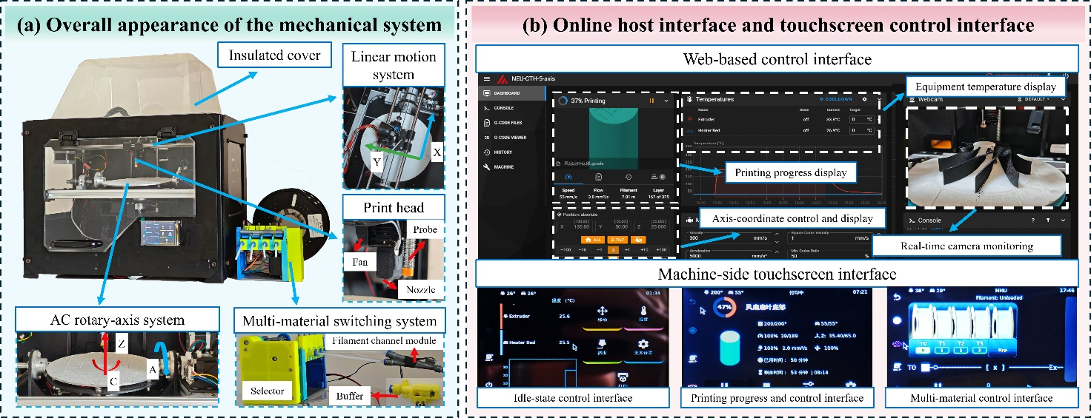
Fig. 2. Mechanical configuration and control interfaces of the self-developed AC rotary-table five-axis FDM platform. (a) Overall platform and principal functional modules, including the insulated enclosure, Cartesian positioning system, fixed-orientation extrusion head, AC rotary table, and four-channel material-feeding system. Enlarged views identify the X/Y linear-motion module, nozzle, cooling fan, probe, rotary axes, filament selector, channel module, and buffer unit. (b) Web-based host interface and machine-side touchscreen interface used for temperature monitoring, printing-progress visualization, coordinate control, real-time camera observation, machine operation, and multi-material management.
The allowable rotary ranges are -180° to 180° for A and -360° to 360° for C, and the post-processor restricts commands to these limits. Because workpiece reorientation creates a geometry-dependent swept volume, scheduled non-deposition reorientations use the prototype-specific absolute clearance position Z = 20 mm relative to the machine zero. This rule increases separation between the nozzle and the swept envelope but does not replace geometry-specific collision checking. Cumulative C-axis rotation is also restricted to limit cable twisting because the prototype does not employ conductive slip rings.
Deposition was performed using a replaceable 0.4 mm nozzle and commercial filaments with a nominal diameter of 1.75 mm. Although the heated circular build table measures approximately 180 mm in diameter, its entire surface is not available for five-axis fabrication. Nozzle accessibility, the swept volume of the reoriented workpiece, rotary-table motion, cable routing, and edge clearance reduce the usable region as the inclination angle increases. A practical printing diameter of approximately 160 mm is therefore recommended, and all specimens reported in this study were contained within an effective validation diameter of approximately 150 mm.
The fabrication experiments used four thermoplastic filaments: PLA, PETG, PA, and ABS. All filaments were maintained under the same laboratory conditions before printing, at 26 °C and approximately 50% relative humidity, without material-specific pre-drying treatment. Their inclusion was intended to test the slicing, post-processing, and switching workflow under different thermal and extrusion conditions, rather than to establish a ranking of material properties. PLA provided the baseline because of its stable printability and extensive use in FDM process investigations [29]. PETG and ABS broadened the processing range through their different thermal behavior, flow response, and dimensional sensitivity [30, 31]. PA, by comparison, introduced a relatively stiff engineering thermoplastic with a higher extrusion-temperature requirement [32]. Depending on the validation objective, these materials were used either individually or assigned to separate regions of the fan-blade and impeller-like specimens.
Reliable operation of the selector-based feeding system depends on sufficient filament axial stiffness. During loading and switching, the selected material must be pushed through the shared junction, buffer, and downstream guide before reaching the extruder entrance. Highly flexible filaments may buckle or compress along this constrained path, reducing the repeatability of channel loading and position confirmation; TPU was therefore excluded from the experiments. Within the scope of this study, multi-material FDM refers to macro-controlled switching and deposition of the relatively rigid PLA, PETG, PA, and ABS filaments after channel loading, rather than to universal compatibility with flexible polymer feedstocks [21, 22]. This limitation originates from the present feeding architecture and does not represent a general restriction of material-extrusion additive manufacturing. The principal hardware specifications, motion ranges, control functions, and validation materials are summarized in Table 1.
Table 1. Key parameters of the self-developed AC rotary-table five-axis FDM platform.
Category | Parameter | Value / Description
Machine configuration | Platform type | AC rotary-table five-axis FDM platform
Translational motion | Linear axes | Cartesian X/Y nozzle positioning with independent Z-axis control of the nozzle-to-platform distance
Rotary motion | Rotary-axis definition | A-axis rotation about the machine X-axis; C-axis rotation about the rotary-table Z-axis
Rotary motion | Allowable travel | A-axis: -180° to 180°; C-axis: -360° to 360°
Safety motion | Rotary-clearance position | Absolute Z = 20 mm relative to the machine zero before scheduled non-deposition A/C reorientation
Extrusion system | Printing head | Fixed-orientation, single-nozzle extrusion head
Extrusion system | Nozzle diameter | 0.4 mm; replaceable
Filament | Nominal diameter | 1.75 mm
Build area | Table and effective diameter | 180 mm heated-table diameter; approximately 160 mm recommended printing diameter; approximately 150 mm effective validation diameter
Calibration | Platform reference and motion compensation | Three independently driven Z-axis points for automatic platform leveling, bed-mesh compensation, and Cartesian-motion resonance compensation
Control | Command execution | Customized AC rotary-table kinematics for coordinated X/Y/Z/A/C/E/F command execution
Material handling | Feeding and switching architecture | Four-channel selector-based feeding system with T0–T3 macros, sensor confirmation, buffer compensation, and shared single-nozzle extrusion
Materials | Validation materials | PLA, PETG, PA, and ABS

2.2 Configuration-Adaptive Five-Axis Slicing and Machine-Specific Post-Processing
The workflow uses two stages. Geometry-level slicing represents deposition paths by spatial positions and relative postures without assigning a machine-specific rotary definition. Post-processing maps these data to the selected platform and adds extrusion, feed rate, material assignments, switching instructions, auxiliary macros, and clearance motions. Here, post-processing denotes the digital conversion of geometry-level paths into executable machine commands.
Configuration adaptation in this paper denotes software-level selection of rotary-axis definitions and controller address labels. For the reported experiments, the AC configuration produced X/Y/Z translations, A/C rotary angles, incremental extrusion E, and feed rate F. Other rotary definitions were examined through software mapping and G-code export; physical execution was confined to the AC rotary-table platform.
Slicing begins with model import and definition of the nozzle diameter, layer height, extrusion width, path spacing, nominal feed rate, and material assignment. Based on these settings, the processed geometry is discretized into ordered deposition paths. Let i denote the index of a sampled point along one such path. Its position in the model coordinate system is written as $P_{i}={\left[x_{i},y_{i},z_{i}\right]}^{T}$, and the corresponding local unit surface-normal vector is expressed as $n_{i}={\left[n_{x,i},n_{y,i},n_{z,i}\right]}^{T}$, $\left\|n_{i}\right\|=1$. Under conventional planar deposition, the relative tool direction remains fixed with respect to the global build axis. Five-axis slicing instead allows $n_{i}$ to vary along the path, so that each sampled point carries both spatial and orientational information. The local normal determines the workpiece reorientation required to establish the prescribed nozzle-surface relationship at $P_{i}$. The geometry-level output is therefore represented as an ordered sequence of position-posture pairs $(P_{i},n_{i})$, which provides the common input for subsequent machine-configuration mapping.
For the selected AC rotary-table configuration, each geometry-level pair $(P_{i},n_{i})$ is converted into the machine-axis command vector $q_{i}={\left[X_{i},Y_{i},Z_{i},A_{i},C_{i}\right]}^{T}$, where $X_{i}$, $Y_{i}$, and $Z_{i}$ are the commanded translational coordinates, while $A_{i}$ and $C_{i}$ define the corresponding workpiece posture. In general form, this inverse mapping is expressed as $q_{i}=f_{AC}^{-1}(P_{i},n_{i})$. Its numerical implementation incorporates the calibrated rotary-center position, transformation between model and machine coordinates, axis-zero offsets, rotary-axis definitions, and direction conventions. The commanded coordinates $X_{i}$, $Y_{i}$, and $Z_{i}$ are therefore not direct copies of the original model coordinates $x_{i}$, $y_{i}$, $z_{i}$. Instead, they compensate for the displacement introduced when the workpiece is reoriented about the calibrated rotary center, thereby preserving the intended nozzle position relative to the local deposition point.
Once $q_{i}$ has been obtained, the extrusion increment $E_{i}$ and local feed rate $F_{i}$ are appended to form a coordinated deposition command. Its generic structure can be represented as
$$G1 X\left[X_{i}\right] Y\left[Y_{i}\right] Z\left[Z_{i}\right] A\left[A_{i}\right] C\left[C_{i}\right] E\left[E_{i}\right] F\left[F_{i}\right]$$
Here, X/Y/Z specify translational positioning, A/C define the rotary-table posture, E gives the incremental extrusion amount under relative-extrusion mode, and F specifies the commanded feed rate. All target values contained in the same G1 block are interpreted as one coordinated motion segment rather than as sequential axis commands. Therefore, the written order of the X/Y/Z/A/C/E/F fields does not define the execution order of the individual axes. The Cartesian axes, A/C rotary axes, and extrusion axis are coordinated within the same motion block, enabling simultaneous nozzle positioning, workpiece reorientation, and material deposition.
Deposition blocks were combined with customized start and end sequences, homing and calibration instructions, bed-mesh activation, resonance-compensation settings, temperature commands, scheduled Z-axis clearance motions, and T0–T3 switching macros. These instructions prepare the machine state, execute the geometry-derived motion, and close the task after deposition. Their inclusion converts the sliced path into an executable program for the AC rotary-table platform.
Rotary continuity is evaluated after the initial AC solution is obtained. For consecutive deposition points, equivalent angle representations are compared within the allowable A- and C-axis ranges, and unnecessary changes from the preceding posture are reduced where possible. Small A/C increments remain coordinated with X/Y/Z motion and extrusion in the same G1 block. Scheduled non-deposition reorientations are treated separately: extrusion is paused, the Z-axis moves to the prototype-specific absolute clearance position Z = 20 mm, and rotary motion begins after this separation. The rule reduces interference risk from the swept workpiece envelope but does not provide geometry-specific collision checking for every posture. Cumulative C-axis rotation is also restricted to limit cable twisting because the prototype does not use conductive slip rings.
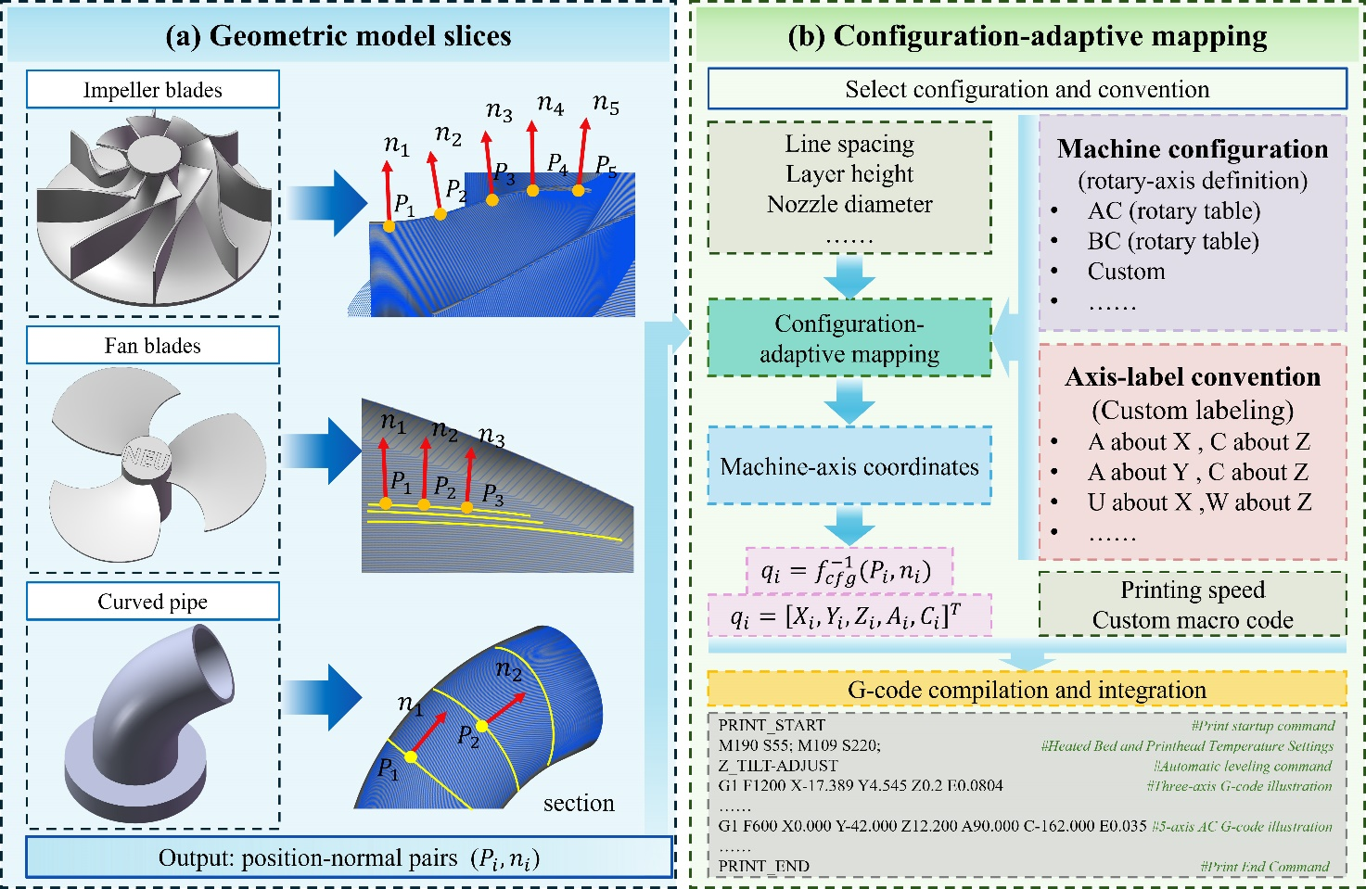
Fig. 3. Geometry-level path representation and configuration-adaptive mapping for five-axis FDM. (a) Impeller-blade, fan-blade, and curved-pipe geometries discretized into sampled positions $P_{i}$ and corresponding local surface-normal vectors $n_{i}$, producing ordered position-posture pairs $(P_{i},n_{i})$. (b) Machine-configuration mapping in which the rotary-axis definition and controller label convention are selected to transform each geometry-level pair into the machine-axis vector $q_{i}={\left[X_{i},Y_{i},Z_{i},A_{i},C_{i}\right]}^{T}$. Extrusion amount, feed rate, safety motion, and custom control instructions are subsequently incorporated to compile executable G-code for the selected AC rotary-table platform.

2.3 Four-Channel Material Feeding and Macro-Controlled Switching
Four material channels are connected to a shared single-nozzle extrusion path through the selector-based feeding module. T0, T1, T2, and T3 correspond to PLA, PETG, PA, and ABS, respectively. Compared with a multiple-nozzle arrangement, this architecture eliminates inter-nozzle offset calibration and avoids interference from inactive nozzles. The shared downstream path, however, increases the importance of reliable channel engagement, filament-position detection, residual-material removal, and extrusion recovery [21, 22]. Rather than treating the selector mechanism as an independent mechanical contribution, the present work evaluates it as a material-delivery subsystem integrated into five-axis G-code execution.
Channel selection is performed by a servo-driven rotary cam. Each of the T0–T3 commands corresponds to a predefined servo angle at which the cam presses one feeding arm into engagement with the common drive gear. The feeder stepper motor can then advance the selected filament while the other three channels remain mechanically disengaged. From the selector, the active filament travels through the shared five-way junction, buffer unit, and downstream guide toward the extruder entrance.
Filament state is monitored at two levels. Individual channel sensors verify material presence before selection, whereas a downstream outlet sensor confirms arrival at the reference position near the shared extrusion path. Prior to printing, an automatic calibration routine advances each filament into the junction and subsequently retracts it to a predefined parking position. This procedure establishes a repeatable starting distance for loading and reduces uncertainty in the subsequent switching stroke. Material loading is thereby treated as a sensor-confirmed positioning operation rather than an uncontrolled forward feed.
Continuous material delivery at the nozzle is governed by the downstream extruder motor, which provides the principal pulling force during deposition. Directly synchronizing this motor with the upstream feeder would transfer speed mismatch and transient loading into the extrusion path. A buffer is therefore placed between the selector module and the extruder entrance. As filament is consumed, the buffer state gradually changes until the refill threshold is detected; the upstream feeder then advances an additional segment and restores the prescribed operating state. Replenishment occurs intermittently, whereas the extruder continues to draw material according to the commanded deposition rate. The buffer consequently decouples upstream feeding from nozzle extrusion, allowing filament replenishment without interrupting the five-axis deposition path.
Once the required filaments have been loaded into their respective channels, material transitions are executed through T0–T3 macros inserted at predefined locations in the five-axis G-code. Upon activation of a switching macro, extrusion and toolpath execution are suspended while the current A/C posture is maintained. The cutter sequence first introduces a relative separation of 20 mm along the Z-axis before moving the extrusion assembly to the cutting station. This displacement differs from the absolute clearance position of Z = 20 mm used before scheduled non-deposition rotary movements. The outgoing filament is severed and retracted to its predefined parking position, after which the shared downstream path is checked and the selector servo engages the requested channel. The incoming filament is subsequently advanced through the five-way junction and buffer until its arrival is confirmed by the downstream sensor. During the switching interval, the nozzle-temperature setpoint is updated according to the selected material, and the system waits until the prescribed temperature is reached. Purge extrusion then removes residual material from the shared nozzle path and re-establishes a stable flow condition. Five-axis deposition resumes only after filament arrival, thermal stabilization, and extrusion recovery have been confirmed. The purge length and recovery parameters can be adjusted for different material transitions, enabling the same macro framework to coordinate cutting, retraction, channel selection, temperature regulation, sensing, purging, and subsequent path continuation.
The present study addresses the integration of macro-controlled material switching with five-axis toolpath execution; it does not attempt to characterize the mechanical behavior of dissimilar-material interfaces. Compatibility among the selected polymers remains an important consideration in multi-material FDM [17, 19, 20], while interface geometry, processing temperature, thermal history, and bonding conditions can substantially influence interfacial strength [33, 34]. Accordingly, the experiments were designed to determine whether four-channel feeding, T0–T3 macro execution, and coordinated five-axis deposition could operate within an integrated fabrication workflow, rather than to quantify interfacial mechanical performance. Tensile, shear, and fracture tests of the material-transition regions were therefore outside the scope of the present investigation. The evaluation instead considers successful switching completion, sensor-confirmed filament delivery, thermal and extrusion recovery, deposition continuity, visible transition morphology, local defect formation, and representative blade-thickness deviation. These observations provide process-level evidence for the compatibility of the feeding mechanism, switching macros, and five-axis execution framework.
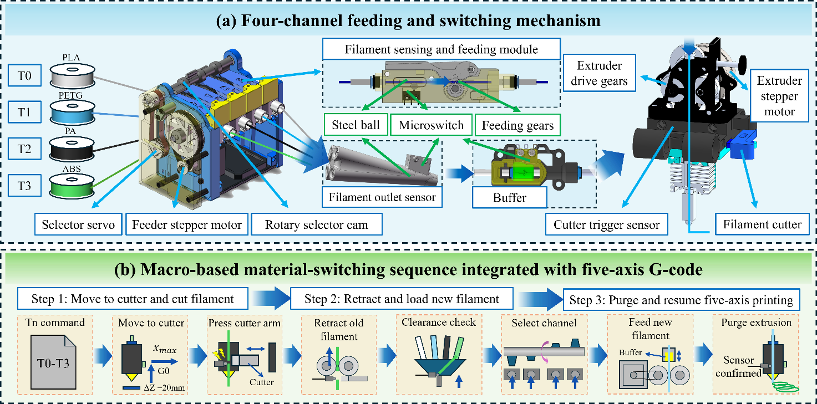
Fig. 4. Four-channel material feeding mechanism and T0–T3 switching sequence integrated into the five-axis G-code. (a) Selector-based feeding system consisting of a selector servo, feeder stepper motor, rotary selector cam, channel sensing and feeding modules, shared five-way junction, downstream filament sensor, buffer unit, extruder drive gears, and mechanically actuated cutter. Channels T0, T1, T2, and T3 correspond to PLA, PETG, PA, and ABS, respectively. (b) Material-switching sequence executed after the required filaments have been loaded into their respective channels. One of the T0–T3 macros suspends deposition while retaining the current A/C posture, introduces a relative Z-axis separation of 20 mm, and moves the extrusion assembly to the cutter station. This cutter-specific displacement differs from the absolute Z = 20 mm clearance position used before scheduled non-deposition A/C movements. The outgoing filament is cut and retracted before the target channel is engaged and the incoming filament is advanced through the shared junction and buffer. The nozzle-temperature setpoint is updated for the selected material. Following sensor confirmation, thermal stabilization, purge extrusion, and flow recovery, the interrupted five-axis deposition path is resumed.

2.4 Validation Specimens and Experimental Protocol
The experimental program was organized across three connected levels: digital file verification, machine execution, and printed specimen assessment. Digital verification examined the position-posture mapping, continuity of consecutive A/C-axis commands, extrusion information, and insertion of auxiliary control instructions. At the machine level, the evaluation covered homing and calibration, coordinated X/Y/Z/A/C motion, execution of clearance motions, extrusion continuity, and completion of the prescribed material-switching sequences. The printed specimens were subsequently assessed in terms of forming success, support requirement, visible surface morphology, local defects, representative dimensional deviation, and material-transition quality. Taken together, these tests were intended to establish the feasibility of the complete processing workflow, rather than to optimize a particular mechanical property or demonstrate statistically representative manufacturing capability. Surface morphology and local defects were therefore evaluated qualitatively, while selected dimensional measurements were treated as representative indicators of geometric fidelity [35, 36].
The specimen set was selected to challenge four distinct capabilities of the proposed workflow: deposition on a preformed curved substrate, thin-wall fabrication following a discrete posture change, support-sensitive curved-pipe printing, and coordinated deposition over complex freeform geometry. Within this set, the hemispherical patterned specimen shown in Fig. 5(a) was used to verify A/C-axis rotation and rotary-center positioning before examining local path following on an existing curved surface. Because the patterned trajectory contained multiple separated deposition regions, this specimen also provided a direct means of observing extrusion continuity and start-stop behavior at the local path boundaries. The thin-walled fan-blade specimen in Fig. 5(b) introduced a sequential fabrication process in which the base tube was printed first, the workpiece was reoriented by 90°, and the blades were subsequently deposited on its outer surface. This geometry therefore tested adhesion between the base tube and the added blades, coordinated motion after reorientation, and the stability of thin-wall deposition. Its material-assigned variant additionally examined whether the predefined material assignments for different blade regions could be implemented using the prescribed T0–T3 channels within the same five-axis geometry.
The curved-pipe specimen shown in Fig. 5(d) served as the principal comparison between conventional three-axis fabrication and the proposed five-axis strategy. Its continuously changing geometry produces support-sensitive overhanging regions when deposition is constrained to a fixed vertical build direction. Using the same curved-pipe geometry for both strategies enables the influence of workpiece reorientation on support demand and process efficiency to be evaluated directly. For five-axis fabrication, the model was divided into successive local sections, and the AC rotary table reoriented the workpiece between sections to keep each active deposition region accessible to the fixed-orientation extrusion head. The comparison considered support requirement, printing time, filament consumption, and forming success. The curved-pipe experiment therefore provides a physical basis for evaluating the support-reduction potential of posture-adaptive deposition [11].
The impeller-like specimen shown in Fig. 5(c) was selected as the most demanding freeform geometry in the validation set. It combines a central hub, multiple curved blades, narrow blade edges, blade-root transitions, and spatially varying surface orientations. Compared with the hemispherical and curved-pipe cases, these features impose greater demands on position-posture mapping, A/C-axis coordination, rotary-center accuracy, clearance management, and extrusion continuity. The generated G-code was therefore required to coordinate repeated posture changes across multiple blade regions while maintaining stable deposition along the curved surfaces and blade-root transitions. The specimen serves as a methodological validation geometry rather than an aerospace-grade functional impeller. Its role is to examine whether the complete connection from configuration-adaptive slicing and AC rotary-table post-processing to physical five-axis execution can be maintained for a complex multi-blade structure.
Four-material assessment used material-assigned fan-blade and impeller-like specimens. After the white PLA base had been fabricated, printing was paused once to manually load PLA, PETG, PA, and ABS into channels T0–T3, respectively. Printing then resumed, and the corresponding channel was selected according to the predefined material assignment of each blade region. From that point, the macros controlled filament cutting and retraction, target-channel selection, nozzle-temperature adjustment, sensor confirmation, purge, flow recovery, and return to the five-axis path. The reported automation concerns macro-controlled switching after this channel-preparation step and does not denote unattended four-material fabrication from the first layer.
The blue-on-white hemispherical patterned specimen used two filament channels that were preloaded before printing began. After completion of the white base region, the prescribed transition to the blue filament was executed without intermediate manual loading or further operator intervention. Across the multi-material specimens, the assessment recorded completion of the prescribed selection sequence, visible transition morphology, deposition continuity, local defects, and representative blade-thickness deviation. The two preparation modes distinguish macro-controlled four-channel switching after one pause from unattended switching between two channels that were available at task initiation.
All validation specimens were fabricated using a nozzle diameter of 0.4 mm and a filament diameter of 1.75 mm. To maintain consistent geometric deposition conditions, a layer height of 0.2 mm and an extrusion width of 0.4 mm were applied throughout the experiments. The nominal commanded deposition speed was set to 150 mm/s for PLA, PETG, PA, and ABS, although the instantaneous machine speed remained subject to acceleration, deceleration, and posture-transition requirements. Thermal parameters were adjusted according to the selected material: the nozzle and build-table temperatures were 195 °C and 45 °C for PLA, 235 °C and 80 °C for PETG, 275 °C and 95 °C for PA, and 250 °C and 90 °C for ABS, respectively. Accordingly, the PETG curved-pipe specimens were printed at 235 °C with the build table maintained at 80 °C. During stand-alone ABS fabrication, the insulated enclosure remained closed and the build-table temperature was held at 90 °C to limit premature cooling and environmental thermal disturbance.
The four-material fan-blade and impeller-like specimens were fabricated on PLA base structures, which remained the only regions in direct contact with the build table. For these specimens, the build-table setpoint was governed by the PLA base and was therefore maintained at 45 °C, whereas the nozzle temperature changed according to the material assigned to each blade region. When a T0–T3 macro selected a new channel, the controller automatically updated the nozzle setpoint to the corresponding material-specific temperature and suspended subsequent deposition until thermal stabilization was achieved. Purge extrusion and five-axis path execution resumed only after the prescribed nozzle temperature had been reached. Maintaining the build table at the PLA setting avoided repeated thermal cycling and does not imply that 45 °C is the preferred bed temperature for stand-alone PETG, PA, or ABS fabrication. The control architecture can also modify the build-table setpoint automatically and wait for temperature stabilization when the platform-contact material changes, as may occur in large planar multi-material parts; this function was not invoked for the reported fan-blade and impeller-like specimens.
For each case, the CAD geometry and prescribed material regions were imported, sliced into geometry-level position-posture paths, and converted to AC-specific G-code. Preview inspection covered geometric consistency and deposition-path continuity. Command-level checks covered the required X/Y/Z/A/C/E/F fields, compliance with A- and C-axis travel limits, continuity between consecutive rotary commands, insertion of scheduled moves to the absolute Z = 20 mm clearance position, and placement of T0–T3 macros. After the digital checks, machine initialization performed axis homing, three-point Z leveling, bed-mesh calibration, activation of Cartesian resonance compensation, initial filament positioning, and temperature stabilization before deposition.
Machine execution was monitored for coordinated translational and rotary motion, unintended A/C jumps, observed nozzle-workpiece interference, and extrusion interruption. Multi-material records covered completion of the prescribed cutting, retraction, channel-selection, temperature-adjustment, purge, recovery, and path-resumption sequence. After fabrication, overall and local photographs documented specimen form, support condition, visible surface morphology, material transitions, and local defects. Blade thickness was measured using a micrometer at the same predefined location on each sampled blade. Three repeated readings were obtained for each blade. For the impeller-like specimen, two blades were sampled for each material, whereas one blade was sampled for each material in the fan-blade specimen. These measurements were treated as representative indicators rather than statistical estimates of process capability or printing repeatability. The actual printing time was recorded for each curved-pipe build, and total filament consumption was determined from the difference in filament mass before and after printing. The reported consumption included both the part and support material, which were not weighed separately.
Table 2. Validation cases and corresponding evaluation criteria.
Specimen type | Main purpose | Evaluation focus
Hemispherical patterned specimen | Validate local deposition on a preformed curved substrate | A/C-axis rotation, rotary-center positioning, local path following, start-stop behavior, and deposition continuity
Thin-walled fan-blade specimen | Validate sequential fabrication after 90° workpiece reorientation | Blade-to-base deposition continuity, coordinated A/C-axis motion, thin-wall deposition stability, and representative blade-thickness deviation
Curved-pipe specimen | Compare conventional three-axis and five-axis fabrication strategies | Sectionwise deposition, support requirement, printing time, filament consumption, and forming success
Complex impeller-like specimen | Validate fabrication of spatially varying freeform geometry | Position-posture variation, A/C-axis coordination, rotary-center accuracy, clearance management, curved-blade continuity, and local forming defects
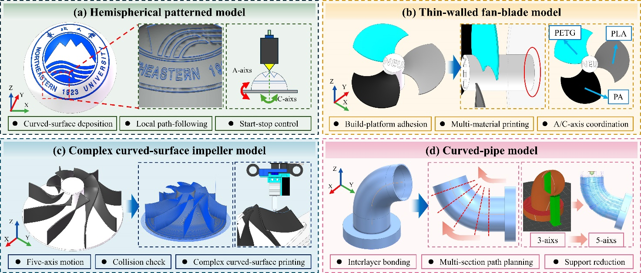
Fig. 5. Geometric models, representative toolpath-planning features, and validation roles of the experimental specimens. (a) Hemispherical patterned model deposited on a preformed hemispherical substrate to examine A/C-axis rotation, rotary-center positioning, local path following, and start-stop continuity. (b) Thin-walled fan-blade model involving base-tube fabrication, 90° workpiece reorientation, subsequent blade deposition, coordinated A/C-axis motion, and material-region assignment. (c) Complex impeller-like model used to evaluate spatially varying position-posture mapping, rotary-axis coordination, scheduled clearance handling, and continuous deposition along curved blades. (d) Curved-pipe model incorporating successive section planning and section-interface transitions for comparison of support requirements under conventional three-axis and five-axis fabrication strategies.

3. Results and Discussion

3.1 Machine-Executable Five-Axis G-Code Generation and Verification
The implemented framework generated controller-readable five-axis G-code for the curved-pipe, fan-blade, impeller-like, and hemispherical patterned cases, including the prescribed multi-material variants. For each geometry, the sliced position-posture sequence was mapped to the kinematic definition of the AC rotary-table platform. The resulting commands combined X/Y/Z translational coordinates, A/C rotary angles, incremental extrusion E, and feed rate F within the same deposition sequence. Machine initialization, homing and calibration routines, temperature commands, scheduled moves to the absolute Z = 20 mm clearance position, and T0–T3 macros were incorporated where required. The controller parsed these files for the corresponding fabrication tasks. Assessment focused on conversion of a geometry-level path into a complete machine-execution sequence rather than display of a nominal five-axis trajectory.
Fig. 6 presents the implemented slicing interface together with a representative machine-executable G-code output. As shown in Fig. 6(a), the software allows the user to import the target geometry and define the nozzle diameter, layer height, extrusion width, path spacing, feed rate, and material regions. The generated five-axis trajectory can then be inspected through the toolpath display, path-progress navigation, statistical summary, and global isometric preview. Before export, the rotary-axis configuration and controller address convention are selected independently of the geometry-level toolpath. For the experiments reported here, the AC rotary-table definition converted each position-posture sample into X/Y/Z translational coordinates and A/C rotary-axis commands, as illustrated by the output in Fig. 6(b). Other rotary-axis definitions and address mappings were examined at the software export level; however, physical machine execution was reported only on the developed AC rotary-table platform.
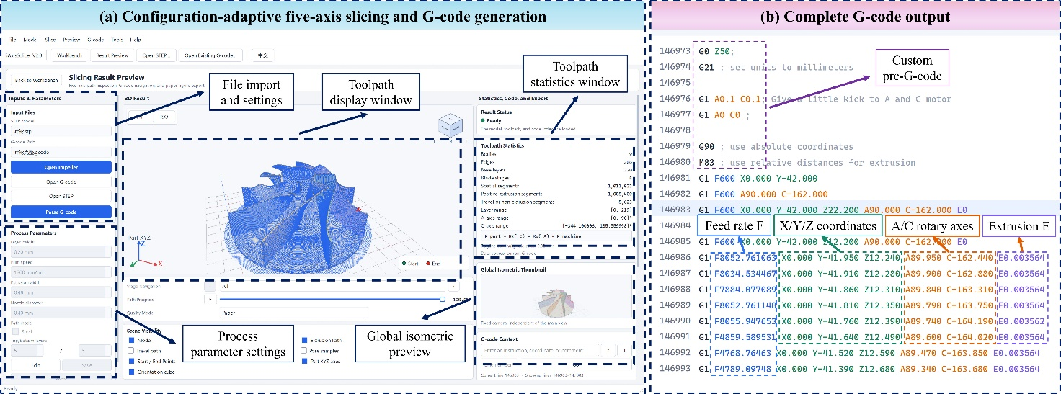
Fig. 6. Implementation of the configuration-adaptive five-axis slicing software and generation of machine-executable G-code. (a) Software interface integrating model import, process-parameter definition, five-axis toolpath visualization, path-progress navigation, toolpath statistics, and global isometric preview. (b) Representative output file containing customized initialization instructions and coordinated X/Y/Z translational coordinates, A/C rotary-axis commands, incremental extrusion amount E, and feed rate F.
A representative deposition command generated by the machine-specific post-processor is:
G1 F1313.212489 Y21.57 X0 Z25.67 A32.24 C37.93 E0.003563
Within this command, X, Y, and Z define the Cartesian position of the nozzle, whereas A and C specify the simultaneous posture of the rotary table. The E field provides the incremental extrusion amount under the adopted relative-extrusion mode, and F specifies the local feed rate interpreted by the controller. Because each numerical value is associated with an address letter, changing the order of the fields does not alter the command meaning. This single G1 block therefore coordinates Cartesian translation, workpiece reorientation, material extrusion, and feed-rate control within one deposition segment. Together with the initialization, calibration, temperature-control, safety, and material-switching instructions contained in the complete file, the command illustrates why a geometrically valid five-axis trajectory must be converted into a machine-aware execution sequence before physical fabrication [15, 16].
Table 3. File characteristics and rotary-axis behavior of the generated five-axis G-code.
Validation case | File size (MB) | G-code lines | A-axis motion | C-axis motion | Material-switching mode
Curved-pipe specimen | 20.9 | 679,277 | 0° to 70.513° | Fixed at 0° | No material switching
Thin-walled fan-blade specimen | 178.2 | 2,936,409 | Maintained at 90° during blade deposition | Repeated sweeps with amplitudes increasing from approximately 70° to 90°; representative interval from -140° to -50° | Multi-channel macro sequence after base fabrication
Complex impeller-like specimen | 59.8 | 1,021,059 | Repeated motion between 0° and 90° | Repeated sweeps of approximately 70°; representative interval from -160° to -90° | T0–T3 sequence repeated twice after channel preparation, corresponding to eight selection commands
Hemispherical patterned specimen | 5.4 | 151,619 | Limited angular variation | Circumferential C-axis rotation | One automatic transition between two preloaded channels
Table 3 shows the different rotary-motion and data requirements of the four files, ranging from a fixed C-axis position for the curved pipe to circumferential C-axis rotation for the hemispherical patterned specimen and multi-million-line paths for the blade specimens. Before machine execution, each A/C sequence was checked against the allowable ranges. Equivalent-angle representations were compared to limit abrupt rotary discontinuities, while cumulative C-axis rotation was reviewed to reduce cable twisting in the absence of conductive slip rings. Scheduled non-deposition posture changes were preceded by motion to the prototype-specific absolute clearance position Z = 20 mm, increasing separation from the rotary sweep envelope before A/C reorientation. These checks formed the digital inspection stage for the files used in Section 3.2.

3.2 Platform Calibration and Physical Five-Axis Execution
Following digital inspection, the generated command files were executed on the AC rotary-table platform. Machine-level assessment examined whether initialization, calibration, scheduled clearance, motion, extrusion, and auxiliary-control instructions operated as an ordered sequence under the implemented kinematics. Before deposition, the platform completed customized homing, three-point Z leveling, bed-mesh calibration, and activation of Cartesian resonance compensation. During fabrication, the controller interpreted X/Y/Z/A/C/E/F fields while coordinating Cartesian positioning, workpiece reorientation, extrusion, scheduled clearance motions, and the required macros. Successful execution confirmed that the post-processed commands were compatible with the implemented AC rotary-table kinematics.
Fig. 7 summarizes the platform-calibration and filament-handling checks conducted before the fabrication trials. In Fig. 7(a), a calibration cone was used to align the nozzle reference with the rotary center, after which the three independently actuated Z-axis adjustment points established the reference plane of the build platform. The four-channel test shown in Fig. 7(b) examined filament loading, retraction, and positioning at the common parking point upstream of the extrusion unit. The multi-point scan presented in Fig. 7(c) characterized residual height variation across the heated bed and generated the compensation map applied during deposition. Finally, the cutting and withdrawal operations presented in Fig. 7(d) verified actuation of the material-removal sequence for the tested rigid filaments. Together, these procedures established the geometric reference and material-channel readiness required before physical five-axis deposition.
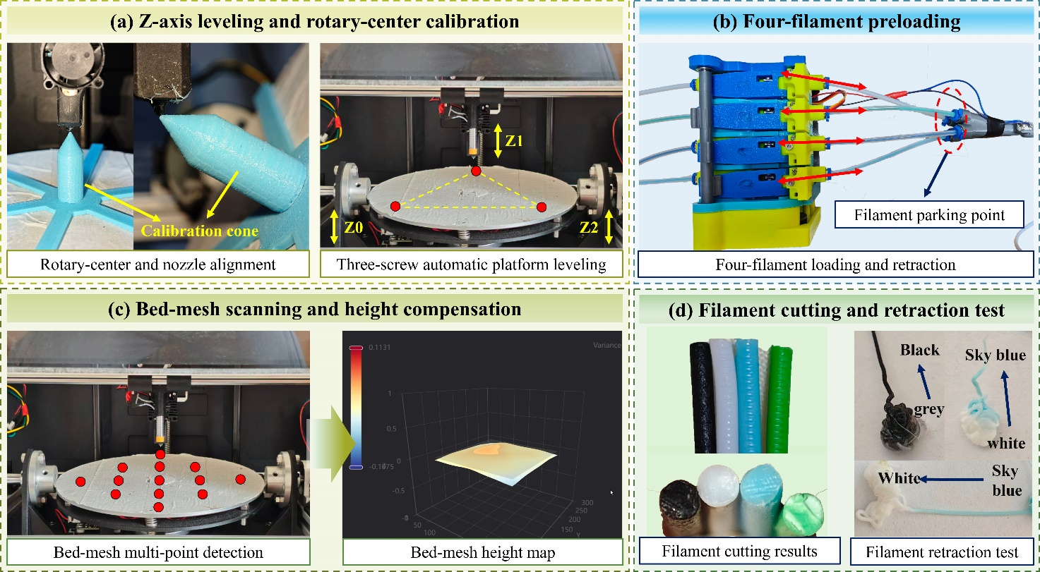
Fig. 7. Calibration and filament-handling tests on the developed AC rotary-table five-axis FDM platform. (a) Rotary-center alignment using a calibration cone and three-point automatic Z-axis leveling of the build platform. (b) Four-channel filament preloading, retraction, and positioning at the common parking point. (c) Multi-point bed-mesh scanning and the resulting height map for local Z-axis compensation. (d) Filament cutting results and residues recovered after withdrawal from the tested channels.
The machine-level checks applied before and during deposition are summarized in Table 4. Homing established the reference positions of the translational and rotary axes, whereas three-point automatic Z-axis leveling and bed-mesh calibration defined and compensated the build surface. Resonance compensation was activated for Cartesian motion. Before scheduled non-deposition posture changes, the nozzle was commanded to the predefined absolute clearance position Z = 20 mm, after which the A/C axes performed the required reorientation within their allowable ranges. Extrusion continuity was evaluated concurrently with the coordinated translational and rotary motion. These observations show that physical five-axis execution depends on the ordered integration of calibration, safety clearance, rotary positioning, and extrusion control, rather than on geometric toolpath generation alone. This requirement is consistent with recent multi-axis additive manufacturing studies that emphasize machine-aware and collision-conscious execution planning [15, 16].
Table 4. Machine-level calibration, safety, and execution checks on the developed platform.
Check item | Verification objective | Observed result
Homing and reference establishment | Establish the reference positions of the translational and rotary axes | The customized homing sequence was completed, and reference positions were established for the X/Y/Z and A/C axes.
Three-point automatic Z-axis leveling | Establish the reference plane of the build platform | Automatic adjustment through the three Z-axis points was completed before deposition.
Bed-mesh calibration | Compensate for local height variation across the heated bed | Multi-point scanning generated a bed-height map, which was activated for local Z-axis compensation.
Resonance compensation | Reduce vibration-related errors during Cartesian motion | The configured compensation profile was enabled before the fabrication trials.
Z-axis safety clearance | Separate the nozzle from the rotary sweep envelope before scheduled non-deposition reorientation | The nozzle moved to the predefined absolute position Z = 20 mm before the scheduled A/C-axis movements.
Coordinated A/C-axis execution | Verify continuous rotary-table reorientation from the post-processed commands | The commanded A/C-axis sequences were executed without unintended angular jumps during the completed platform tests.
Extrusion during coordinated motion | Verify material deposition during simultaneous translational and rotary motion | Deposition remained synchronized with the executed motion sequence; localized defects are assessed separately in Section 3.5.
The checks in Table 4 are functional observations of the integrated execution sequence rather than a quantitative characterization of axis accuracy or process repeatability. They document invocation of platform initialization and compensation functions, insertion of scheduled clearance motions before designated reorientations, coordination of translational and rotary commands, and integration of extrusion and filament handling. Independent trajectory tracking and repeated-cycle statistical tests were not conducted; rotary positioning accuracy, trajectory error, repeated-cycle stability, and long-term process capability therefore cannot be inferred from these observations. The table records what the implemented functions did during the reported tasks and separates those observations from specimen-level results. Section 3.3 reports the descriptive geometric assessment of the fabricated specimens.

3.3 Geometric Fabrication Performance and Three-Axis/Five-Axis Comparison
Geometric assessment covered the hemispherical patterned model, thin-walled fan blades, the impeller-like specimen, and paired curved-pipe builds. The cases involved deposition on an existing curved substrate, 90° workpiece reorientation before thin-wall formation, repeated A/C coordination across curved blades, and sectionwise deposition along support-sensitive curvature. The curved pipes provided the direct three-axis/five-axis comparison of printing time, total filament consumption, visible localized support, and damage introduced during support removal. Overall form and surface morphology were assessed descriptively; surface roughness was not treated as a quantitative metric because no dedicated roughness measurement was conducted.
Fig. 8 documents representative deposition stages for the four validation geometries. In Fig. 8(a), A/C-axis rotation and rotary-center positioning were verified before the blue paths were deposited onto the white hemispherical substrate, thereby examining local path following and start-stop control on an existing curved surface. For the thin-walled fan-blade specimen in Fig. 8(b), the cylindrical base was first fabricated with the build platform in its initial orientation. The platform was subsequently reoriented by 90°, allowing the blades to be deposited directly onto the outer surface of the base. Fabrication of the impeller-like specimen in Fig. 8(c) involved coordinated A/C-axis motion during blade deposition, together with clearance and multi-material printing tests. Fig. 8(d) records the curved-pipe fabrication sequence, including initial Z-axis deposition, controlled transitions between adjacent sections, and deposition continuity across the inclined section interfaces. Taken together, these cases show that the same AC rotary-table platform could execute curved-surface tracing, indexed workpiece reorientation, coordinated five-axis deposition, and multi-section construction through geometry-specific command sequences.
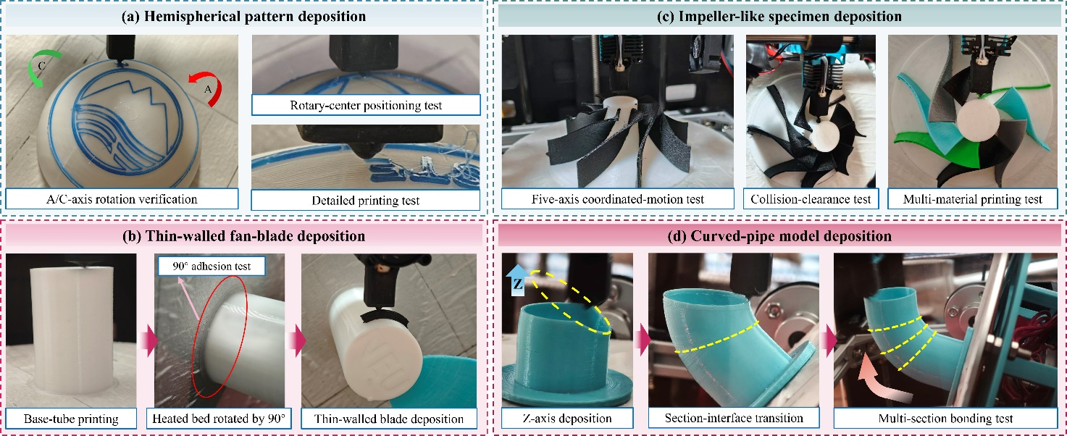
Fig. 8. Representative deposition processes for the four validation geometries on the developed AC rotary-table five-axis FDM platform. (a) Hemispherical pattern deposition comprising A/C-axis rotation verification, rotary-center positioning, and local path following on an existing curved substrate. (b) Thin-walled fan-blade fabrication through cylindrical-base deposition, 90° workpiece reorientation, and subsequent blade deposition. (c) Impeller-like specimen fabrication involving coordinated five-axis motion, execution of scheduled clearance motions, and multi-material deposition. (d) Curved-pipe fabrication through initial Z-axis deposition, controlled transitions between adjacent sections, and deposition continuity across inclined section interfaces.
Table 5 summarizes the reported pair of curved-pipe builds. With the same target geometry and nominal deposition parameters, three-axis printing required 85 min and 24.00 g of total filament, whereas the five-axis route required 47 min and 18.79 g. This corresponds to reductions of 44.7% in printing time and 21.7% in total filament consumption. Part and support material were not weighed separately; the values represent total consumption for each build. Fig. 9(d) shows visibly reduced localized support for the five-axis route. The added A/C reorientation and clearance motions did not offset the time associated with support generation for this geometry and processing condition. Both routes completed the target geometry, but support removal visibly affected the conventionally fabricated specimen. The comparison does not isolate motion overhead from deposition time and does not estimate build-to-build variance. It documents the net outcome of the two implemented strategies for one reported pair of specimens under the stated nominal settings.
Table 5. Comparison of three-axis and five-axis fabrication results for the curved-pipe specimen.
Evaluation item | Three-axis FDM | Five-axis FDM | Difference or observation
Deposition strategy | Fixed workpiece orientation with conventional planar layers | Multi-section deposition with A/C-axis workpiece reorientation | Posture adaptation reduced the unsupported overhang during deposition
Printing time (min) | 85 | 47 | Reduced by 38 min (44.7%)
Total filament consumption (g) | 24.00 | 18.79 | Reduced by 5.21 g (21.7%)
Support requirement | Large support structure beneath the overhanging region | Localized support with a visibly smaller volume | Qualitative reduction shown in Fig. 9(d)
Overall forming result | Complete curved-pipe geometry obtained after support removal | Complete curved-pipe geometry obtained with reduced support demand | Both strategies completed the target geometry; the five-axis build used visibly less localized support.
The reductions reported in Table 5 demonstrate that workpiece posture adjustment can provide a measurable advantage for geometries that would otherwise require extensive support. In the curved-pipe case, the reduction in support demand lowered both the total material consumption and the printing time, which is consistent with previous studies on support-reduced multi-axis FDM [11, 37]. Five-axis deposition, however, is not inherently more efficient for every geometry. Each posture transition introduces additional rotary travel, safety-clearance motion, and coordination requirements at the interfaces between adjacent deposition sections. The observed advantage is therefore geometry dependent rather than an intrinsic speed benefit of five-axis motion. For the curved pipe examined here, the time saved by reducing support generation and deposition exceeded the additional machine-motion overhead. This interpretation agrees with non-planar FFF studies showing that the effects of posture adaptation on build time and visible surface formation depend strongly on geometry and toolpath organization [38, 39].
Fig. 9 consolidates the final fabrication results and representative local features of the validation specimens. The blue-on-white hemispherical patterned specimen in Fig. 9(a) followed the curved substrate across the central emblem and circumferential lettering, while the enlarged regions show the continuity of the deposited path and the behavior near a start-stop location. The impeller-like specimen in Fig. 9(b) retained the central hub and repeated curved-blade arrangement, with enlarged views providing local observations of the blade-tip and blade-root regions. Fig. 9(c) extends the geometric validation to the multi-material thin-walled fan-blade and impeller-like specimens fabricated using PLA, PETG, PA, and ABS; the corresponding material-switching behavior is discussed separately in Section 3.4. The paired curved pipes in Fig. 9(d) visually confirm the difference in support demand between the conventional three-axis and five-axis strategies quantified in Table 5.
Among these cases, the impeller-like geometry imposed the most demanding combination of repeated curved blades, hub-to-blade transitions, spatially varying surface orientations, A/C-axis coordination, and collision-clearance requirements. Such features reflect the posture-planning and accessibility constraints commonly encountered in collision-aware multi-axis additive manufacturing [15, 16]. Completion of this specimen provides the principal physical evidence that the geometry-level toolpath, AC kinematic mapping, safety motions, and extrusion commands could operate as an integrated workflow for complex freeform fabrication. The specimen is nevertheless treated as a geometric validation part rather than as an aerospace-grade functional impeller.
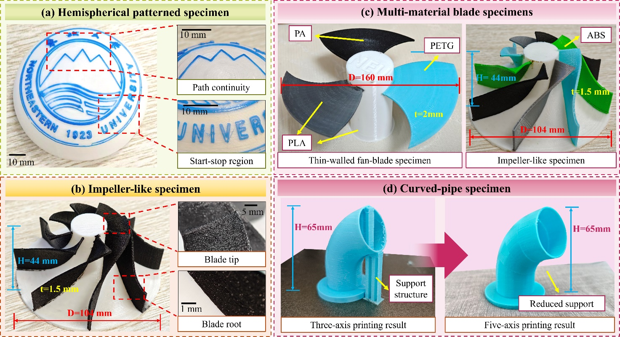
Fig. 9. Overall fabrication results and representative local features of the validation specimens. (a) Blue-on-white hemispherical patterned specimen, with enlarged views of the path-continuity and start-stop regions. (b) Impeller-like specimen retaining the central hub and curved-blade arrangement, with enlarged views of the blade-tip and blade-root morphologies. (c) Multi-material thin-walled fan-blade and impeller-like specimens combining PLA, PETG, PA, and ABS within the assigned blade regions. (d) Curved-pipe specimens produced using conventional three-axis and five-axis strategies, showing the extensive support required under a fixed build orientation and the reduced localized support obtained through A/C-axis workpiece reorientation.
The impeller-like build provided a qualitative assessment of coordinated execution and geometric formability. During fabrication, the post-processed file completed the prescribed translational and A/C sequence without observed nozzle-workpiece interference or uncontrolled rotary motion. Scheduled moves to the absolute clearance position Z = 20 mm preceded the designated non-deposition reorientations. As shown in Fig. 9(b), the specimen retained the central hub, repeated curved-blade arrangement, and connections across the blade-root regions. Enlarged views nevertheless show nonuniform local morphology at the blade tips and roots, so completion of the global form did not imply uniform local deposition.
Repeated-build statistics, independent trajectory tracking, and a complete dimensional survey were not conducted for this specimen. The observations document geometric formability and process-chain execution at specimen scale, without quantifying positioning accuracy or manufacturing repeatability. Local limitations were evaluated separately from the overall specimen photograph. This distinction prevents global form completion from being used as a proxy for local accuracy. Section 3.5 discusses possible associations with toolpath direction, rotary motion, extrusion response, and deposition accessibility using the defect morphologies in Fig. 10 and sampled blade-thickness measurements in Fig. 11.

3.4 Multi-Material Switching and Fabrication
The multi-material tests examined whether T0–T3 commands could be integrated with post-processed five-axis motion while allowing deposition to resume after each transition. Assessment covered completion of the prescribed selection sequence, filament withdrawal and loading, temperature stabilization, deposition recovery, and visible material separation. The tests addressed process integration and did not characterize the mechanical response of interfaces between dissimilar polymers. Command records and specimen photographs were therefore interpreted as execution evidence, not interface tests.
Two preparation modes were examined. The four-material fan and impeller used a white PLA base and one scheduled pause to prepare the four channels with their assigned filaments. After printing resumed, T0–T3 macros controlled cutting, withdrawal, channel selection, loading, temperature adjustment, stabilization, purge, flow recovery, and return to the five-axis path. The pause established channel availability; it was not counted as an automated switching event. Subsequent selection commands were issued by the G-code according to the material regions. In the two-channel hemispherical patterned specimen, white and blue filaments were preloaded before task initiation, and the prescribed transition was completed after the base region without further operator intervention. These preparation modes define the automation boundary used when interpreting the four-, eight-, and one-transition records.
For the fan-blade specimen, one T0 → T1 → T2 → T3 cycle issued four selection commands. The impeller-like specimen repeated the same sequence twice, giving eight commands. After the scheduled channel-preparation pause, the macros carried out filament withdrawal, channel selection, temperature adjustment, loading, purge, and return to the corresponding five-axis paths without further manual intervention. The preloaded two-channel hemispherical patterned specimen also completed its prescribed transition after printing began. The four-material fan retained the white PLA base and three visually distinct blade regions, while the impeller retained its hub and eight colored blade regions. These observations record completion of the prescribed selection sequences and recovery of deposition. They do not provide a switching success rate because repeated switching trials were not performed. Color carryover and incomplete extrusion recovery remained visible at local transitions.
Table 6 summarizes the adopted channel-preparation modes, prescribed selection sequences, and automated operations. The four-material cases used one scheduled preparation pause before macro-controlled switching, whereas the two-channel case was preloaded before printing. Each prescribed sequence returned control to the corresponding deposition path. Switching success rates and purge lengths are not reported because the tasks were not repeated as a statistical switching study and the transition extrusion was not measured independently. Visible material regions are described in the accompanying text, together with the observed contamination and extrusion-recovery defects.
Table 6. Execution characteristics of the multi-material validation tasks.
Validation task | Material configuration and channel preparation | Automatic selection sequence | Automated operations
Thin-walled fan-blade specimen | White PLA base fabricated first; T0–T3 channels prepared during one scheduled pause | T0 → T1 → T2 → T3, corresponding to four selection commands | Channel selection, filament withdrawal and feeding, nozzle-temperature adjustment, stabilization waiting, and deposition resumption
Multi-material impeller-like specimen | White PLA base fabricated first; T0–T3 channels prepared during one scheduled pause | T0 → T1 → T2 → T3 repeated twice, corresponding to eight selection commands | Channel selection, filament withdrawal and feeding, nozzle-temperature adjustment, stabilization waiting, and return to the five-axis path
Preloaded two-channel test | Two channels prepared before printing began; no intermediate loading pause required | One automatic transition between the preloaded channels after base deposition | Filament exchange, temperature stabilization, extrusion recovery, and automatic continuation of deposition

3.5 Defect Morphology and Dimensional Assessment
The representative specimens retained their intended global geometries, while local inspection revealed forming irregularities that were not captured by build completion alone. Fig. 10 classifies the principal visible morphologies across curved, thin-walled, and multi-material regions, and Fig. 11 reports sampled blade-thickness deviations for the impeller-like and fan specimens. Global process-chain execution and local forming quality were therefore evaluated separately. Because synchronized trajectory-error measurements, extrusion-pressure records, and thermal histories were not collected, the morphologies are discussed as possible process associations rather than assigned to a confirmed mechanism. Surface roughness is treated qualitatively because no dedicated roughness measurement was conducted.
Fig. 10 groups the visible defects into five categories. Radial surface ripples with locally wavy patterns appear on the curved blade surfaces in Fig. 10(a). Their radial distribution and alignment with the local deposition direction suggest possible associations with path spacing, bead overlap, and changes in relative nozzle-workpiece motion, although the visual evidence does not isolate the contribution of each factor. Stringing in Fig. 10(b) spans non-deposition travel regions within the tubular specimen and between separated features of the hemispherical patterned specimen, consistent with incomplete interruption of melt flow during travel. In Fig. 10(c), detached filament fragments remained within the deposition region and became embedded in the surface. The green-to-sky-blue and black-to-white contamination in Fig. 10(d) documents material carryover through the shared extrusion path after switching. Localized under-extrusion and interfacial gaps in Fig. 10(e) occur in curved and multi-material regions where flow recovery and bead contact may be more difficult to maintain. These observations show motion- and path-related surface nonuniformity together with transition-related contamination and extrusion instability.
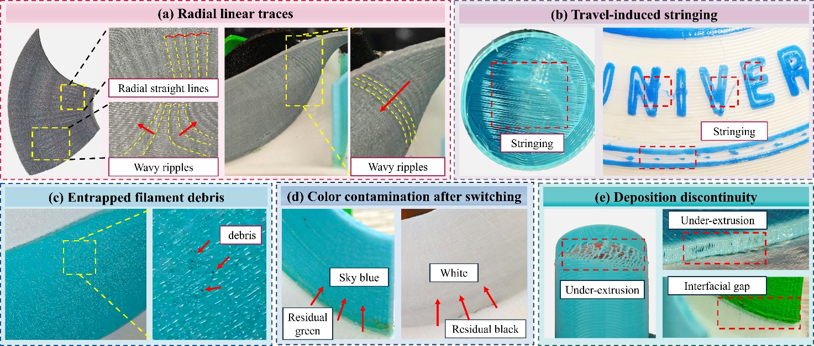
Fig. 10. Representative defect morphologies observed during five-axis multi-material FDM experiments. (a) Radial surface ripples exhibiting radially distributed and locally wavy patterns on the curved blade surfaces. (b) Travel-induced stringing within the tubular specimen and between separated features of the hemispherical patterned specimen. (c) Entrapped filament debris embedded in the deposited surface. (d) Color contamination after material switching, including residual green and black material in the subsequent sky-blue and white regions, respectively. (e) Local deposition discontinuities characterized by under-extrusion and interfacial gaps.
Fig. 11 reports descriptive blade-thickness measurements. For the impeller-like specimen with a nominal thickness of 1.500 mm, the mean thicknesses of the PLA, PETG, PA, and ABS blades were 1.492, 1.569, 1.599, and 1.443 mm, corresponding to -0.56%, +4.57%, +6.60%, and -3.82%, respectively. For the fan blades with a nominal thickness of 2.000 mm, the mean thicknesses of the PLA, PETG, and PA blades were 1.997, 2.103, and 2.153 mm, corresponding to -0.17%, +5.13%, and +7.67%, respectively. For the impeller, three micrometer readings were taken on each of two sampled blades per material; the plotted error bars describe blade-to-blade dispersion of the two means. For the fan, three repeated readings were taken on one sampled blade per material, so the corresponding error bars describe measurement repeatability for that blade. The sampling schemes differ, and neither set of error bars represents printing repeatability across independent builds. The measurements identify local over-thickness and under-thickness within the sampled specimens. They do not support population-level material ranking because the number of blades was limited, independent builds were not repeated, and geometry, posture, and material effects were not separated experimentally.
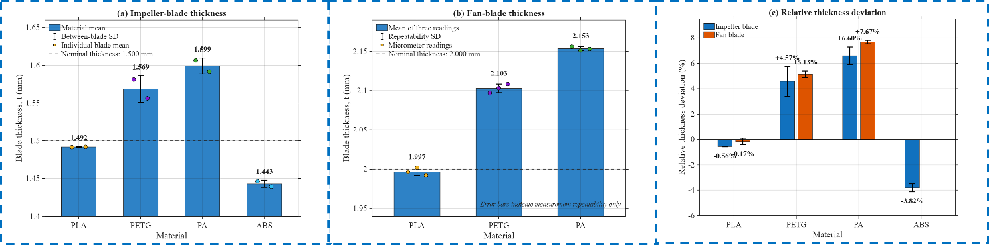
Fig. 11. Blade-thickness measurements and relative dimensional deviations for the impeller-like and fan specimens. (a) Thicknesses of impeller blades fabricated from PLA, PETG, PA, and ABS. Each marker represents the mean of three micrometer readings obtained from an individual blade; the bars and error bars denote the mean and standard deviation across two blades of the same material, respectively. The dashed line indicates the nominal thickness of 1.500 mm. (b) Thicknesses of fan blades fabricated from PLA, PETG, and PA. The markers show three repeated micrometer readings for each blade, while the bars and error bars represent the corresponding mean and standard deviation. These error bars characterize measurement repeatability rather than printing repeatability. The dashed line indicates the nominal thickness of 2.000 mm. (c) Relative deviations of the mean blade thicknesses from their corresponding nominal dimensions. Positive and negative values indicate over-thickness and under-thickness, respectively. No ABS result is reported for the fan specimen because an ABS fan blade was not fabricated.

3.6 Process Limitations and Improvement Directions
The experiments document integration of software-level configuration mapping, AC post-processing, machine execution, and macro-controlled material selection for the reported specimen set. Visible defects and blade-thickness deviations show that command completion does not ensure uniform local deposition. The scope of the reported evidence is limited by four conditions: only the AC configuration was executed physically; the absolute Z = 20 mm clearance rule is specific to the prototype and scheduled postures; independently repeated builds and synchronized trajectory measurements were not conducted; and material-transition interfaces were evaluated visually rather than mechanically. These boundaries separate process-chain executability from broader claims of manufacturing accuracy, collision safety, switching reliability, or interface performance.
Geometric accuracy on the AC rotary-table platform depends on the relationship among the rotary center, Cartesian coordinate frame, and commanded A/C posture. Rotary-center offset, angular error, backlash, and structural compliance can produce posture-dependent displacement, particularly near blade roots and edges where orientation changes frequently. Blade thickness is also affected by bead formation, material response, build orientation, and local deformation [40]. Because synchronized rotary-error and material-flow records were not collected, their contributions cannot be separated from the sampled deviations. Repeated builds with multi-posture calibration and dimensional inspection are required before accuracy or repeatability can be quantified.
Rotary execution is constrained by cable management and clearance. Without slip rings, feasible A/C commands depend on both axis limits and accumulated rotation, so equivalent angles must be evaluated relative to the preceding posture. Designated reorientations may also bring the swept workpiece envelope near the nozzle or machine structure. The scheduled absolute Z = 20 mm position increased separation during the reported builds but did not constitute comprehensive geometry-specific collision checking. A broader implementation would require cumulative-angle tracking, cable-winding constraints, and geometry-aware accessibility assessment [15, 16, 41]. The present clearance rule should therefore be interpreted as a prototype-specific scheduled motion.
Complex freeform deposition also couples posture continuity with material delivery. Geometrically continuous path points can still generate changes in A/C velocity around blade roots, narrow edges, and high-curvature regions. The resulting variation in relative nozzle-workpiece speed may alter bead width or flow recovery because extrusion does not respond instantaneously. This mechanism may be associated with the radial surface ripples and localized discontinuities in Fig. 10, but synchronized axis-velocity and extrusion-flow data were not recorded. Posture smoothing, speed planning, extrusion compensation, and local accessibility checks remain candidate improvements rather than effects demonstrated by the present experiments [15, 16].
Shared-nozzle transitions impose a separate quality limit. The T0–T3 macros completed the prescribed channel selection, sensor confirmation, buffer compensation, purge, flow recovery, and return to the five-axis path. Visible color carryover in Fig. 10(d) documents residual material within the shared extrusion route, while discontinuities in Fig. 10(e) show nonuniform local recovery. Transition quality may depend on material order, temperature, affinity, interface geometry, and purge conditions [21, 33, 34]. Recent interface studies further demonstrate the importance of material pairing and interfacial processing conditions [42, 43]. Purge length, transition waste, thermal history, extrusion pressure, and interface strength were not measured. The evidence therefore covers prescribed sequence completion and visual transition quality, without establishing switching reliability or mechanical interface performance.
These limitations define the scope of the reported evidence. The experiments document executable G-code generation, coordinated AC motion, support-reduced curved-pipe fabrication, freeform deposition, and macro-controlled material selection for the tested specimens. Configuration adaptation beyond AC was examined only at the software-mapping and export levels. The absolute Z = 20 mm position remained a scheduled prototype rule, and shared-nozzle transitions were evaluated from sequence completion and visible morphology. Printing time, total filament consumption, and blade thickness are descriptive measurements rather than statistical estimates of manufacturing capability. Repeated builds, synchronized trajectory and extrusion records, geometry-aware clearance analysis, and controlled interface measurements are the evidence needed to extend these specimen-level observations.

4. Conclusions
This study implemented a configuration-adaptive slicing and machine-specific post-processing route for multi-material FDM on an AC rotary-table platform. The route connects geometry-level position-posture paths with X/Y/Z/A/C/E/F commands, scheduled clearance motions, auxiliary instructions, and T0–T3 switching macros. The experiments covered command inspection, machine-function execution, representative specimen fabrication, material-selection sequences, visible defects, and sampled dimensions. The principal findings are:
(1) A machine-specific mapping stage converted geometry-level position-posture paths into executable five-axis G-code. For the AC configuration, each sampled state was mapped to X/Y/Z translations and A/C angles with extrusion, feed rate, scheduled clearance, auxiliary, and T0–T3 commands. File inspection documented the required fields, compliance with the prescribed rotary ranges, and continuity under the implemented continuity checks. Separating geometry-level paths from controller output also allowed rotary definitions and address labels to be selected at export. Other definitions were examined through software mapping; physical execution was limited to AC.
(2) Coordinated five-axis deposition was implemented with a fixed-orientation extrusion head and AC workpiece reorientation. Homing, three-point Z leveling, bed-mesh compensation, and Cartesian resonance compensation prepared the platform. Scheduled moves to the prototype-specific absolute position Z = 20 mm increased separation before designated rotary reorientations. The reported builds documented coordinated Cartesian, rotary, and extrusion execution on this platform, while the clearance rule remained a scheduled machine-specific measure rather than comprehensive geometry-specific collision checking.
(3) The reported curved-pipe builds document a geometry-dependent reduction in support demand. Three-axis fabrication required 85 min and 24.00 g of total filament, while the five-axis route required 47 min and 18.79 g with visibly reduced localized support. The corresponding differences were 44.7% in time and 21.7% in total filament consumption. Part and support material were not weighed separately, and the values apply to the tested geometry and processing conditions. The comparison is based on a single pair of builds and therefore does not establish a general efficiency ratio for five-axis deposition.
(4) The impeller-like specimen documented coordinated execution for a complex freeform geometry. The hub and repeated curved blades were retained, while local ripples, stringing, embedded debris, under-extrusion, and gaps remained visible. Blade-thickness deviations ranged from -3.82% to +6.60% for the impeller and from -0.17% to +7.67% for the fan. These sampled measurements describe local dimensional response and do not establish printing repeatability or population-level material differences. The observed morphologies indicate where trajectory, extrusion, and thermal records are needed in later process studies.
(5) T0–T3 macros integrated material selection with five-axis path execution. After one scheduled four-channel preparation pause, the fan and impeller builds executed four and eight macro-controlled selection commands, respectively. The preloaded two-channel specimen completed one transition without further operator intervention after printing began. Visible color carryover and localized deposition discontinuities highlight the current limitations of the material-transition quality. The observations document completion of the prescribed sequences; switching success rates, purge requirements, and interface mechanics were not evaluated.
The contribution lies in integrating geometric planning, machine-axis conversion, scheduled clearance, extrusion control, and material switching within one executable process chain. Configuration adaptation was examined at the software-mapping level, while physical execution covered the AC platform and selected specimens. The reported measurements describe these builds and do not establish statistical manufacturing capability, general collision safety, switching reliability, or dissimilar-material interface performance. Future work should focus on repeated builds, synchronized motion and extrusion measurements, geometry-aware clearance planning, and quantitative evaluation of material-pair transitions.

References
- Ngo TD, Kashani A, Imbalzano G, Nguyen KTQ, Hui D. Additive manufacturing (3D printing): A review of materials, methods, applications and challenges. Composites Part B: Engineering. 2018;143:172-196. https://doi.org/10.1016/j.compositesb.2018.02.012.
- Kumar MB, Sathiya P. Methods and materials for additive manufacturing: A critical review on advancements and challenges. Thin-Walled Structures. 2021;159:107228. https://doi.org/10.1016/j.tws.2020.107228.
- Daminabo SC, Goel S, Grammatikos SA, Nezhad HY, Thakur VK. Fused deposition modeling-based additive manufacturing (3D printing): techniques for polymer material systems. Materials Today Chemistry. 2020;16:100248. https://doi.org/10.1016/j.mtchem.2020.100248.
- Gao X, Qi S, Kuang X, Su Y, Li J, Wang D. Fused filament fabrication of polymer materials: A review of interlayer bond. Additive Manufacturing. 2021;37:101658. https://doi.org/10.1016/j.addma.2020.101658.
- Yao Y, Cheng L, Li Z. A comparative review of multi-axis 3D printing. Journal of Manufacturing Processes. 2024;120:1002-1022. https://doi.org/10.1016/j.jmapro.2024.04.084.
- Tang P, Zhao X, Shi H, Hu B, Ding J, Yang B, Xu W. A review of multi-axis additive manufacturing: Potential, opportunity and challenge. Additive Manufacturing. 2024;83:104075. https://doi.org/10.1016/j.addma.2024.104075.
- Hu Z, She Y, Hua L, Dong K, Chen M, Wang Y, Qin X. Non-planar additive manufacturing: A comprehensive review of path planning, system integration, process control, and applications. Additive Manufacturing. 2026;115:105059. https://doi.org/10.1016/j.addma.2025.105059.
- Chakraborty D, Reddy BA, Choudhury AR. Extruder path generation for curved layer fused deposition modeling. Computer-Aided Design. 2008;40(2):235-243. https://doi.org/10.1016/j.cad.2007.10.014.
- Tunc LT, Sheikhi M, Moldovan C, Gutiu E, Balc N. Non-planar 5-axis directional additive manufacturing of plastics: Machine, process, and tool path. Manufacturing Letters. 2024;41:959-964. https://doi.org/10.1016/j.mfglet.2024.09.119.
- Maissen S, Zürcher S, Wüthrich M. Adaptation of conventional toolpath-generation software for use in curved-layer fused deposition modeling. Journal of Manufacturing and Materials Processing. 2024;8(6):270. https://doi.org/10.3390/jmmp8060270.
- Han X, Wu G, Liu X, Li W, Song X, Cui L. Research on the five-axis support-free additive manufacturing method for overhanging parts. Actuators. 2025;14(2):99. https://doi.org/10.3390/act14020099.
- Xiao X, Joshi S. Process planning for five-axis support free additive manufacturing. Additive Manufacturing. 2020;36:101569. https://doi.org/10.1016/j.addma.2020.101569.
- Tong Z, Yu X, Yang C, Shen H. A comprehensive support-free slicing method library for variable posture additive manufacturing. Additive Manufacturing. 2024;94:104508. https://doi.org/10.1016/j.addma.2024.104508.
- Li Y, He D, Yuan S, Tang K, Zhu J. Vector field-based curved layer slicing and path planning for multi-axis printing. Robotics and Computer-Integrated Manufacturing. 2022;77:102362. https://doi.org/10.1016/j.rcim.2022.102362.
- Nishat RI, Bahoo Y, Georgiou K, Hedrick R, Urbanic RJ. Collision-free multi-axis tool-path for additive manufacturing. Computer-Aided Design and Applications. 2023;20(6):1094-1109. https://doi.org/10.14733/cadaps.2023.1094-1109.
- Jayakody DPVJ, Lau TY, Kim H, Tang K, Thomas-Seale LEJ. Topological awareness towards collision-free multi-axis curved layer additive manufacturing. Additive Manufacturing. 2024;88:104247. https://doi.org/10.1016/j.addma.2024.104247.
- Nazir A, Gokcekaya O, Billah KMM, Ertugrul O, Jiang J, Sun J, Hussain S. Multi-material additive manufacturing: A systematic review of design, properties, applications, challenges, and 3D printing of materials and cellular metamaterials. Materials & Design. 2023;226:111661. https://doi.org/10.1016/j.matdes.2023.111661.
- Han D, Lee H. Recent advances in multi-material additive manufacturing: Methods and applications. Current Opinion in Chemical Engineering. 2020;28:158-166. https://doi.org/10.1016/j.coche.2020.03.004.
- Lopes LR, Silva AF, Carneiro OS. Multi-material 3D printing: The relevance of materials affinity on the boundary interface performance. Additive Manufacturing. 2018;23:45-52. https://doi.org/10.1016/j.addma.2018.06.027.
- García-Collado A, Blanco JM, Gupta MK, Dorado-Vicente R. Advances in polymers based multi-material additive-manufacturing techniques: State-of-art review on properties and applications. Additive Manufacturing. 2022;50:102577. https://doi.org/10.1016/j.addma.2021.102577.
- Wang Z, Wang L, Tang F, Chen J. Multi-material additive manufacturing via fused deposition modeling 3D printing: A systematic review on the material feeding mechanism. Proceedings of the Institution of Mechanical Engineers, Part E: Journal of Process Mechanical Engineering. 2025;239(6):3865-3880. https://doi.org/10.1177/09544089231223316.
- Zaidi AA, Muzamil M, Ali MA, Asif M, Laghari RA, Peng J, Khan SZ. Advances in multi-material polymer 3D printing depositions: Techniques, materials combinations, challenges, and emerging applications. Frontiers in Mechanical Engineering. 2026;12:1802237. https://doi.org/10.3389/fmech.2026.1802237.
- Hong F, Hodges S, Myant C, Boyle D. Open5x: Accessible 5-axis 3D printing and conformal slicing. In: Extended Abstracts of the 2022 CHI Conference on Human Factors in Computing Systems. 2022:1–6. https://doi.org/10.1145/3491101.3519782.
- Hong F, Lampret B, Myant C, Hodges S, Boyle D. 5-axis multi-material 3D printing of curved electrical traces. Additive Manufacturing. 2023;70:103546. https://doi.org/10.1016/j.addma.2023.103546.
- Alkadi F, Lee KC, Bashiri AH, Choi JW. Conformal additive manufacturing using a direct-print process. Additive Manufacturing. 2020;32:100975. https://doi.org/10.1016/j.addma.2019.100975.
- Huang J, Qin Q, Wen C, Chen Z, Huang K, Fang X, Wang J. A dynamic slicing algorithm for conformal additive manufacturing. Additive Manufacturing. 2022;51:102622. https://doi.org/10.1016/j.addma.2022.102622.
- Wang M, Zhang H, Hu Q, Liu D, Lammer H. Research and implementation of a non-supporting 3D printing method based on 5-axis dynamic slice algorithm. Robotics and Computer-Integrated Manufacturing. 2019;57:496-505. https://doi.org/10.1016/j.rcim.2019.01.007.
- Isa MA, Lazoglu I. Five-axis additive manufacturing of freeform models through buildup of transition layers. Journal of Manufacturing Systems. 2019;50:69-80. https://doi.org/10.1016/j.jmsy.2018.12.002.
- Chacón JM, Caminero MA, García-Plaza E, Núñez PJ. Additive manufacturing of PLA structures using fused deposition modelling: Effect of process parameters on mechanical properties and their optimal selection. Materials & Design. 2017;124:143-157. https://doi.org/10.1016/j.matdes.2017.03.065.
- Hsueh MH, Lai CJ, Wang SH, Zeng YS, Hsieh CH, Pan CY, Huang WC. Effect of printing parameters on the thermal and mechanical properties of 3D-printed PLA and PETG, using fused deposition modeling. Polymers. 2021;13(11):1758. https://doi.org/10.3390/polym13111758.
- Algarni M, Ghazali S. Comparative study of the sensitivity of PLA, ABS, PEEK, and PETG’s mechanical properties to FDM printing process parameters. Crystals. 2021;11(8):995. https://doi.org/10.3390/cryst11080995.
- Dimitrellou S, Iakovidis I, Psarianos DR. Mechanical characterization of polylactic acid, polycarbonate, and carbon fiber-reinforced high-temperature polyamide specimens fabricated by fused deposition modeling. Journal of Materials Engineering and Performance. 2024;33:3613-3626. https://doi.org/10.1007/s11665-024-09144-9.
- Frascio M, Zafferani A, Monti M, Avalle M. Investigating enhanced interfacial adhesion in multi-material filament 3D printing: A comparative study of T and Mickey Mouse geometries. Progress in Additive Manufacturing. 2024;9:2113-2122. https://doi.org/10.1007/s40964-024-00570-8.
- Goh GL, Lee S, Cheng SH, Goh DJS, Laya P, Nguyen VP, Han BS, Yeong WY. Enhancing interlaminar adhesion in multi-material 3D printing: A study of conductive PLA and TPU interfaces through fused filament fabrication. Materials Science in Additive Manufacturing. 2024;3(1):2672. https://doi.org/10.36922/msam.2672.
- Sukindar NA, Md Yasir ASH, Azhar MD, Md Azhar MA, Abd Halim NFH, Sulaiman MH, Ahmad Sabli ASH, Mohd Ariffin MKA. Evaluation of the surface roughness and dimensional accuracy of low-cost 3D-printed parts made of PLA-aluminum. Heliyon. 2024;10(4):e25508. https://doi.org/10.1016/j.heliyon.2024.e25508.
- Kónya G. Investigating the impact of productivity on surface roughness and dimensional accuracy in FDM 3D printing. Periodica Polytechnica Transportation Engineering. 2024;52(2):128-133. https://doi.org/10.3311/PPtr.22952.
- Han X, Wu G, Liu X, Song X, Cui L. Research on a support-free five-degree-of-freedom additive manufacturing method. Micromachines. 2024;15(7):855. https://doi.org/10.3390/mi15070855.
- Elkaseer A, Müller T, Rabsch D, Scholz SG. Impact of nonplanar 3D printing on surface roughness and build time in fused filament fabrication. In: Scholz SG, Howlett RJ, Setchi R, editors. Sustainable Design and Manufacturing 2020. Smart Innovation, Systems and Technologies, vol. 200. Singapore: Springer; 2021. p. 285-295. https://doi.org/10.1007/978-981-15-8131-1_26.
- Sebbe NPV, Costa JPMM, Lucas RR, Pinto AMG, Pedroso AFV, Silva FJG, Sales-Contini RCM. Improving surface quality and mechanical strength through the optimization and enhancement of fused deposition modelling (FDM) for non-planar 3D printing. CIRP Journal of Manufacturing Science and Technology. 2025;63:375-392. https://doi.org/10.1016/j.cirpj.2025.10.003.
- Equbal A, Murmu R, Kumar V, Equbal MA. A recent review on advancements in dimensional accuracy in fused deposition modeling (FDM) 3D printing. AIMS Materials Science. 2024;11(5):950-990. https://doi.org/10.3934/matersci.2024046.
- Kipping J, Kleibrink T, Schüppstuhl T. Development of a print head for non-planar additive manufacturing of carbon fiber-reinforced polymers. The International Journal of Advanced Manufacturing Technology. 2025;139:5697-5714. https://doi.org/10.1007/s00170-025-16079-5.
- Pahari S, Melenka GW. Analysis of the interface properties of multi-material fused filament fabricated (FFF) printed polymer composite structures. International Journal of Adhesion and Adhesives. 2025;142:104074. https://doi.org/10.1016/j.ijadhadh.2025.104074.
- Dağlı S. Mechanical characterization and interface evaluation of multi-material composites manufactured by hybrid fused deposition modeling (HFDM). Polymers. 2025;17(12):1631. https://doi.org/10.3390/polym17121631.

