Rubick CAST
Technical Documentation
Last updated: 21 May 2026

This document explains the CAST repository, runtime architecture, setup commands, data contracts, dispatcher and worker flows, marketplace mappings, and the configured quality checks. The explanations are written in plain language and include implementation notes where the current code needs review.
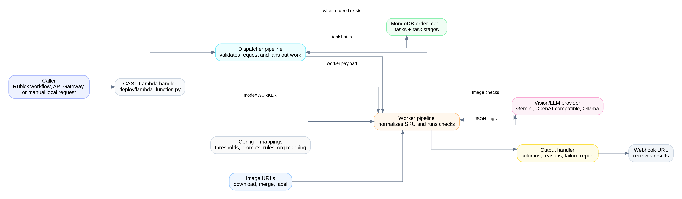
CAST runtime architecture

Contents
- Overview
- Repository map
- Setup and local run commands
- Request and response contracts
- Dispatcher, worker, and batch flows
- Marketplace routing and field mapping
- Rule execution engine
- All checks explained
- Text and nomenclature flows
- Size chart and compliance flows
- Image and vision flow
- Output and webhook flow
- Excel and helper flows
- Deployment and production operations
- Troubleshooting and implementation notes

Overview
CAST is a product-catalog quality analysis service. It receives SKU data, chooses marketplace-specific rules, runs configured checks, and sends pass/fail results with reasons back to a webhook. The easiest way to understand the system is as a four-stage pipeline: receive data, normalize it, run checks, and return output columns.
Metric | Value | Meaning
Configured checks | 83 | Text, image, nomenclature, size, legal, spell, and marketplace-specific rules
Primary marketplaces | 2 | Myntra and TataCliq are mapped in configuration
Input modes | 2 | Mongo order mode and direct payload mode
Vision clients | 3 | Gemini, OpenAI-compatible APIs, and Ollama

Repository map
Most runtime behavior is controlled by src/pipeline.py, analyzer classes under src/analysis, and configuration files under config.
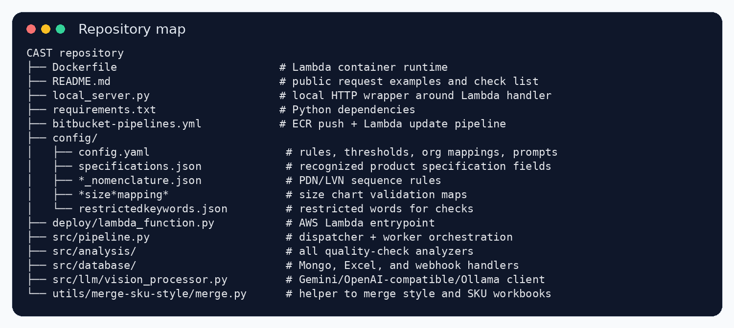
Rendered repository map
Area | Contains | Why it matters
Root files | `Dockerfile`, `local_server.py`, `requirements.txt`, pipeline config | Runtime image, local wrapper, dependency list, CI/CD entry points
`config/` | Rules, thresholds, prompts, mappings, restricted keywords, nomenclature, size charts | Controls what CAST checks and how marketplace fields are interpreted
`deploy/` | Lambda entrypoint | Receives AWS events and routes to dispatcher or worker mode
`src/pipeline.py` | Dispatcher, worker, document builder, rule execution map | Main orchestration file
`src/analysis/` | Title, description, image, legal, size, spell, nomenclature analyzers | The checks live here
`src/database/` | Mongo readers, Excel helpers, output/webhook handler | Input/output plumbing
`src/llm/` | Vision client | Talks to Gemini, OpenAI-compatible APIs, or Ollama
`utils/merge-sku-style/` | Workbook merge helper | Combines style and SKU size data for spreadsheet workflows

Setup and local run commands
Use Python 3.9 for parity with Lambda. Docker is required for the production-like local container run. Java 11 is only required when LanguageTool spell checks are enabled.
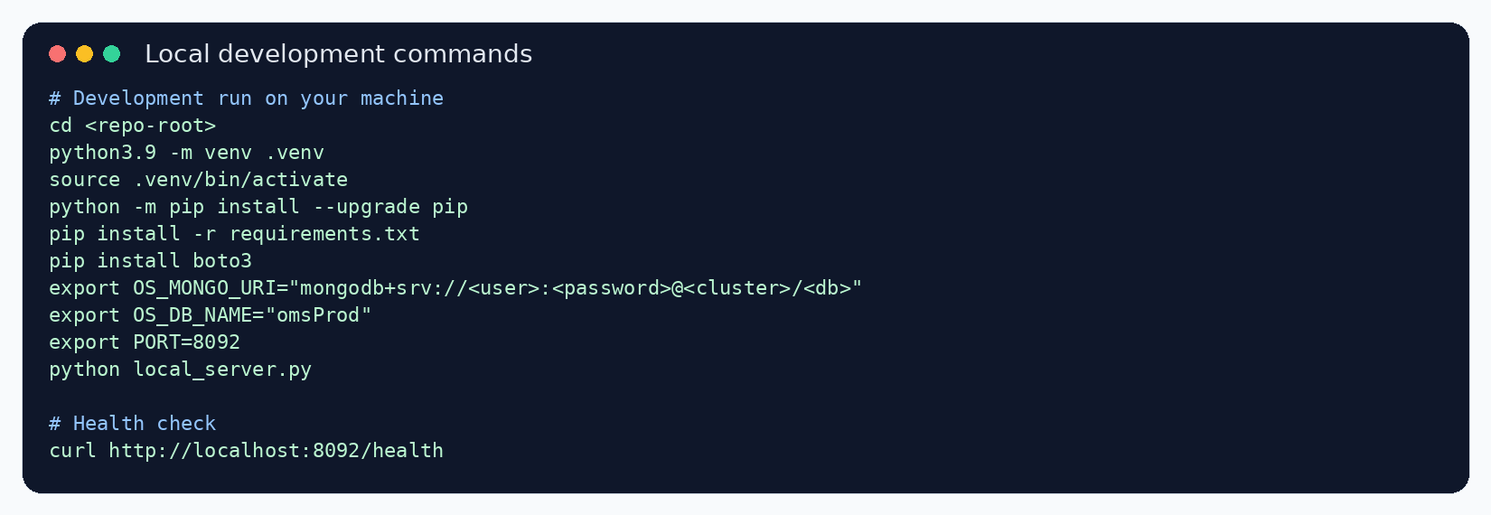
Development setup and run commands
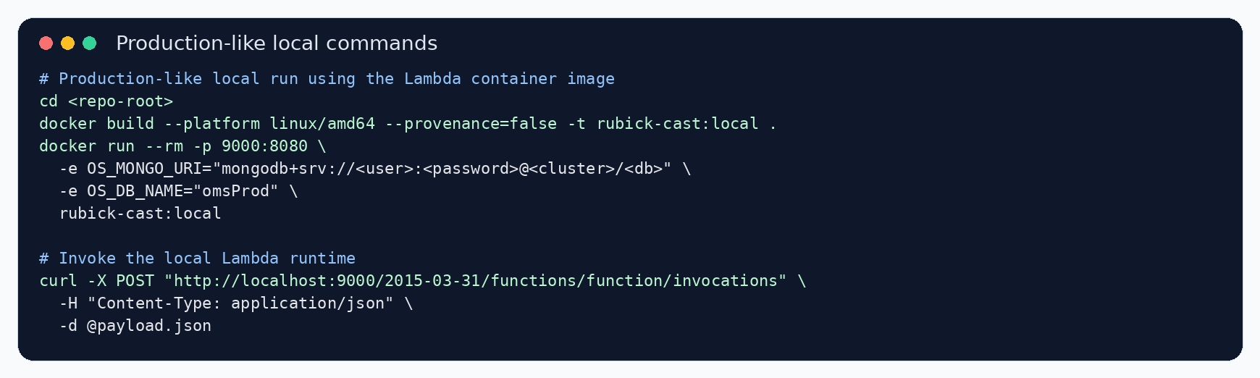
Production-like local Docker commands

Development commands
cd <repo-root>
python3.9 -m venv .venv
source .venv/bin/activate
python -m pip install --upgrade pip
pip install -r requirements.txt
pip install boto3
export OS_MONGO_URI="mongodb+srv://<user>:<password>@<cluster>/<db>"
export OS_DB_NAME="omsProd"
export PORT=8092
python local_server.py

Development test commands
curl http://localhost:8092/health
curl -X POST http://localhost:8092/ -H "Content-Type: application/json" -d @payload.json

Production-like local commands
cd <repo-root>
docker build --platform linux/amd64 --provenance=false -t rubick-cast:local .
docker run --rm -p 9000:8080 -e OS_MONGO_URI="mongodb+srv://<user>:<password>@<cluster>/<db>" -e OS_DB_NAME="omsProd" rubick-cast:local

Production-like local invoke command
curl -X POST "http://localhost:9000/2015-03-31/functions/function/invocations" -H "Content-Type: application/json" -d @payload.json

- Install boto3 locally before using local_server.py because it imports boto3 but the dependency list does not include it.
- Use environment variables or a secret manager for sensitive provider and database values.
- Use the repository-root Dockerfile for the local Lambda container build.

Request and response contracts
Request-to-webhook data contract
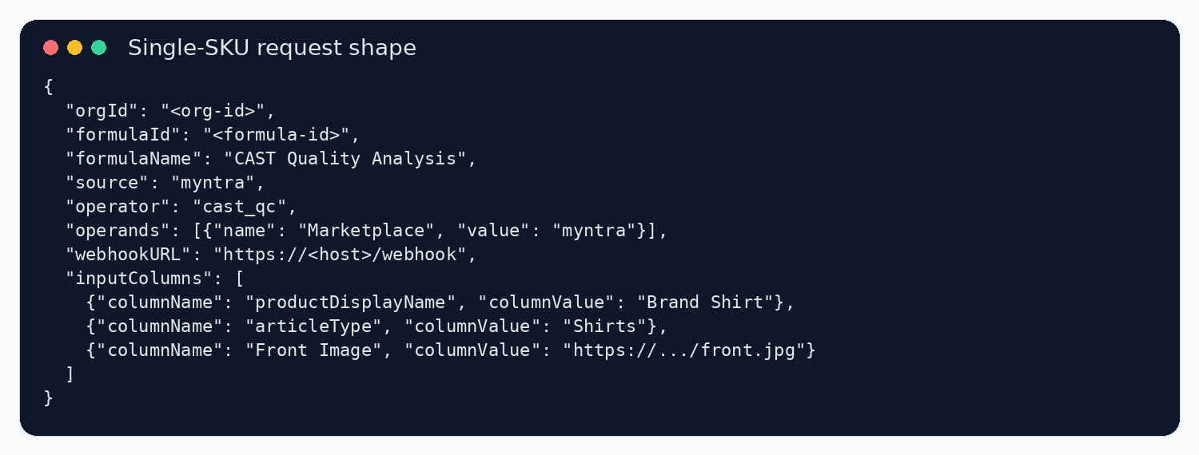
Rendered single-SKU request shape
Object | Contains | Used by
`root_meta` | Request metadata such as org, formula, source, operands, webhook URL | Carried into webhook response and marketplace selection
`document` | One SKU: `styleId`, `attributes`, and original columns | Input for every analyzer
`config` | Thresholds, prompts, mappings, rules, and external JSON files | Controls analyzer behavior
`_processing_context` | Per-SKU cache, token counters, LLM failure flag | Reused during image checks and output generation
`analysisResults` | Check values and reasons | Converted into output columns
`outputColumns` | Result columns plus reason columns | Sent to the webhook

Dispatcher, worker, and batch flows
The Lambda handler routes requests into dispatcher mode or worker mode. Dispatcher mode fans out work. Worker mode processes one SKU and posts its result.
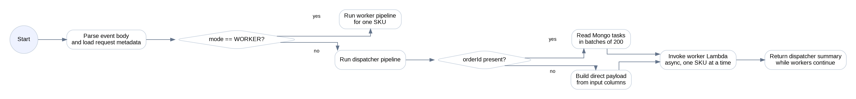
Dispatcher decision flow
Worker processing flow

Order/Mongo mode data path
From | Data moved | To
Caller | Sends request with `orderId`, `orgId`, `formulaId`, `operands`, and `webhookURL` | Lambda handler
Dispatcher | Reads Mongo tasks matching the order | MongoDB `tasks` collection
Dispatcher | Looks up stage data for every task | MongoDB `taskstages` collection
Dispatcher | Builds one worker payload per task/SKU | Same Lambda function, async invocation
Worker | Runs checks and builds output columns | Output handler
Output handler | Posts result payload | Webhook URL supplied in request

Direct payload mode data path
From | Data moved | To
Caller | Sends request with `inputColumns` and webhook metadata | Lambda handler
Dispatcher | Builds CAST documents directly from supplied values | Worker payloads
Worker | Normalizes source columns to CAST fields | Analyzer registry inside pipeline
Analyzers | Run all active rules for the marketplace | Analysis results dictionary
Output handler | Adds result columns, reason columns, and failure summary | Webhook URL

Implementation note: in direct payload mode, test request shaping carefully because the dispatcher path currently treats inputColumns as items to dispatch when no order id is present.

Marketplace routing and field mapping
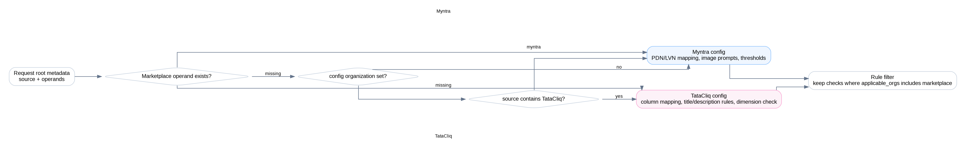
Marketplace selection flow
CAST first checks the Marketplace operand, then configured organization, then source text. Marketplace selection changes thresholds, prompts, field mapping, and active checks.
Marketplace | PDN/title length | Description length | LVN length
Myntra | 90 | 250 | 30
TataCliq | 100 | 600 | 30

Representative field mapping
Marketplace | CAST internal field | Source column/value expected
myntra | Country Of Origin | Country Of Origin
myntra | Manufacturer Details | Manufacturer Name and Address with Pincode
myntra | Importer Details | Importer Name and Address with Pincode
myntra | Packer Details | Packer Name and Address with Pincode
myntra | Net Quantity | Net Quantity
myntra | Net Quantity Unit | Net Quantity Unit
myntra | Package Contains | Package Contains
myntra | Images | Front Image, Side Image, Back Image, Detail Angle, Look Shot Image, Additional Image 1, Additional Image 2, Additional Image 3, Additional Image 4, Additional Image 5
myntra | Brand Name | brand
myntra | Article Type | articleType
myntra | Fit | Fit
myntra | Multipack Set | Multipack Set
myntra | title | productDisplayName
myntra | description | Product Details
myntra | List View Name | listViewName
myntra | Material & Care | materialCareDescription
tatacliq | styleId | Seller Article SKU
tatacliq | title | PRODUCT TITLE
tatacliq | Brand Name | Brand Refer LOV List
tatacliq | description | PRODUCT DESCRIPTION
tatacliq | color | Brand Color
tatacliq | mrp | MRP INR
tatacliq | Net Quantity | Pack Quantity
tatacliq | Country Of Origin | Country Of Origin
tatacliq | Manufacturer Details | Manufacturer
tatacliq | Importer Details | Importer
tatacliq | Packer Details | Packer
tatacliq | Fit | Fit Refer LOV List
tatacliq | Fabric | Fabric
tatacliq | Color | Color
tatacliq | Model fit | Model Fit
tatacliq | Waist Rise | Waist Rise
tatacliq | images | Image 1, Image 2, Image 3, Image 4, Image 5, Image 6, Image 7, Image 8, Image 9
Mongo task mode | Country Of Origin | Country Of Origin
Mongo task mode | Manufacturer Details | Manufactured By
Mongo task mode | Importer Details | Imported By
Mongo task mode | Packer Details | Marketed By
Mongo task mode | Net Quantity | Net Qty
Mongo task mode | Package Contains | Package Contains
Mongo task mode | Images | Image 1, Image 2, Image 3, Image 4, Image 5, Image 6, Image 7, Image 8, Image 9, Image 10
Mongo task mode | Multipack Set | Multipack Set
Mongo task mode | Brand Name | Brand Name
Mongo task mode | Article Type | Commodity
Mongo task mode | Fit | Fit
Mongo task mode | title | title
Mongo task mode | description | Additional Details
Mongo task mode | Material & Care | Care, Wash, Wash Care

Rule execution engine
Every configured rule has a group, key, output key, display name, enabled flag, and optional applicable marketplace list. The worker filters rules for the active marketplace, maps each rule to an analyzer method, and executes checks serially for the SKU.
Analyzer | Responsible for | Source module
TitleAnalyzer | PDN/title length, Unicode, article type, content match, TataCliq title rules | src/analysis/title_analyzer.py
DescriptionAnalyzer | Description length, Unicode, bullets, content match, TataCliq description rules | src/analysis/description_analyzer.py
NomenclatureAnalyzer | PDN/LVN presence, sequence, ideal-name match | src/analysis/nomenclature_analyzer.py
SizeChartAnalyzer | Size availability, valid standard sizes, measurement ranges | src/analysis/size_chart_analyzer.py
LegalComplianceAnalyzer | Country of origin and mandatory compliance details | src/analysis/legal_compliance_analyzer.py
CountryOriginChecksAnalyzer | Restricted countries and address validation | src/analysis/country_origin_checks_analyzer.py
ImageAnalyzer | Image availability and vision flags | src/analysis/image_analyzer.py
AdditionalChecksAnalyzer | Minimum image count, material/fabric, restricted keywords, dimensions | src/analysis/additional_checks_analyzer.py
SpellcheckAnalyzer | LanguageTool title and description checks | src/analysis/spellcheck_analyzer.py

All checks explained
The following sections describe every configured check and the data each check uses.

PDN and LVN nomenclature
Check | Marketplaces | What it does | Main data used | Runtime note
PDN Presence Check (pdn_presence_check) | myntra | Builds the expected Product Display Name ingredients from the nomenclature JSON rule and verifies the required attributes are present in the PDN. | PDN/title, article type, brand, pack, fit, fabric, and nomenclature JSON rules | Runs when marketplace filtering keeps this rule active.
PDN Sequence Check (pdn_sequence_check) | myntra | Checks whether the PDN follows the expected sequence of brand, product, article type, pack, fit, sleeve, fabric, or other configured parts. | PDN/title, article type, brand, pack, fit, fabric, and nomenclature JSON rules | Runs when marketplace filtering keeps this rule active.
LVN Presence Check (lvn_presence_check) | myntra | Builds the expected List View Name ingredients and verifies the required values are present in the LVN. | LVN, article type, product attributes, and LVN nomenclature JSON rules | Runs when marketplace filtering keeps this rule active.
LVN Sequence Check (lvn_sequence_check) | myntra | Checks whether the LVN follows the sequence defined for the product article type. | LVN, article type, product attributes, and LVN nomenclature JSON rules | Runs when marketplace filtering keeps this rule active.
PDN Ideal Match (pdn_ideal_match_check) | myntra | Compares the actual PDN with the ideal PDN assembled by CAST from configured attributes and nomenclature rules. | PDN/title, article type, brand, pack, fit, fabric, and nomenclature JSON rules | Runs when marketplace filtering keeps this rule active.
LVN Ideal Match (lvn_ideal_match_check) | myntra | Compares the actual LVN with the ideal LVN assembled by CAST from configured attributes and nomenclature rules. | LVN, article type, product attributes, and LVN nomenclature JSON rules | Runs when marketplace filtering keeps this rule active.

Title checks
Check | Marketplaces | What it does | Main data used | Runtime note
PDN Length (title_char_length) | myntra, tatacliq | Counts the cleaned title characters and checks the organization threshold, such as 90 characters for Myntra and 100 for TataCliq. | Title/PDN, brand, article type, description, and mapped specification fields | Runs when marketplace filtering keeps this rule active.
Title Unicode (title_unicode_chars) | myntra, tatacliq | Finds non-standard Unicode characters in the title so invisible or unsupported symbols do not reach catalog pages. | Title/PDN, brand, article type, description, and mapped specification fields | Runs when marketplace filtering keeps this rule active.
Article Type In Title (title_article_type_match) | myntra, tatacliq | Checks whether the product article type is represented in the title using exact, singular, plural, keyword, and fuzzy matching. | Title/PDN, brand, article type, description, and mapped specification fields | Runs when marketplace filtering keeps this rule active.
Title Casing (title_casing_check) | myntra, tatacliq | Classifies the title casing pattern. It currently reports the casing status rather than blocking the SKU. | Title/PDN, brand, article type, description, and mapped specification fields | Runs when marketplace filtering keeps this rule active.
Title Content Match (%) (title_product_match) | myntra, tatacliq | Compares title words with product data such as brand, article type, description, and specifications to estimate whether the title describes the same SKU. | Title/PDN, brand, article type, description, and mapped specification fields | Runs when marketplace filtering keeps this rule active.
LVN Length (lv_title_char_length) | myntra | Checks whether the List View Name stays inside the configured short-title threshold. | Title/PDN, brand, article type, description, and mapped specification fields | Runs when marketplace filtering keeps this rule active.
Brand Title Flag (brandTitleFlag) | tatacliq | TataCliq-specific check that verifies the brand name is included in the product title. | Title/PDN, brand, article type, description, and mapped specification fields | Runs when marketplace filtering keeps this rule active.
Special Characters Title Flag (specialCharsTitleFlag) | tatacliq | TataCliq-specific check that fails titles containing restricted characters such as question mark, slash, hash, at sign, underscore, or hyphen. | Title/PDN, brand, article type, description, and mapped specification fields | Runs when marketplace filtering keeps this rule active.
Double Spaces Title Flag (doubleSpacesTitleFlag) | tatacliq | Detects double spaces inside the title. | Title/PDN, brand, article type, description, and mapped specification fields | Runs when marketplace filtering keeps this rule active.
Title Nomenclature Flag (titleNomenclatureFlag) | tatacliq | Checks that configured product attributes are present in the title when those attributes are available. | Title/PDN, brand, article type, description, and mapped specification fields | Runs when marketplace filtering keeps this rule active.

Description checks
Check | Marketplaces | What it does | Main data used | Runtime note
Description Length (description_char_length) | myntra, tatacliq | Counts cleaned description characters after HTML cleanup and compares the result with the organization threshold. | Description, title, brand, HTML/text content, and mapped specification fields | Runs when marketplace filtering keeps this rule active.
Description Unicode (description_unicode_chars) | myntra, tatacliq | Finds unsupported Unicode characters in the description. | Description, title, brand, HTML/text content, and mapped specification fields | Runs when marketplace filtering keeps this rule active.
Description Bullets (description_bullet_points) | myntra | Checks whether the description is organized as bullet points or line-separated feature points and meets the minimum count. | Description, title, brand, HTML/text content, and mapped specification fields | Runs when marketplace filtering keeps this rule active.
Description Content Match (%) (description_product_match) | myntra, tatacliq | Compares description content with the title, brand, and specification fields to ensure the description is about the same product. | Description, title, brand, HTML/text content, and mapped specification fields | Runs when marketplace filtering keeps this rule active.
Brand Description Flag (brandDescriptionFlag) | tatacliq | TataCliq-specific check that verifies the brand name is present in the description. | Description, title, brand, HTML/text content, and mapped specification fields | Runs when marketplace filtering keeps this rule active.
Special Characters Description Flag (specialCharsDescriptionFlag) | tatacliq | TataCliq-specific check that fails descriptions containing restricted characters such as question mark, slash, hash, at sign, underscore, or hyphen. | Description, title, brand, HTML/text content, and mapped specification fields | Runs when marketplace filtering keeps this rule active.
Double Spaces Description Flag (doubleSpacesDescriptionFlag) | tatacliq | Detects double spaces inside the description. | Description, title, brand, HTML/text content, and mapped specification fields | Runs when marketplace filtering keeps this rule active.
Description Nomenclature Flag (descriptionNomenclatureFlag) | tatacliq | Checks whether important title words also appear in the description, after removing skip words. | Description, title, brand, HTML/text content, and mapped specification fields | Runs when marketplace filtering keeps this rule active.

Attribute coverage
Check | Marketplaces | What it does | Main data used | Runtime note
Specification Count (attribute_specification_count) | myntra, tatacliq | Counts non-empty attributes that are recognized as specification fields in the specification mapping file. | Attribute dictionary and specification mapping file | Runs when marketplace filtering keeps this rule active.

General product content
Check | Marketplaces | What it does | Main data used | Runtime note
Material Care Info (material_care_check) | myntra | Verifies that the Material and Care field is available and not blank. | Material and Care field | Runs when marketplace filtering keeps this rule active.

Size chart checks
Check | Marketplaces | What it does | Main data used | Runtime note
Size Chart Available (size_chart_availability) | myntra, tatacliq | Checks whether the standard size information is available. One-size products pass when marked correctly. | Standard Size, article type, age group, fit, and size measurement columns | Runs when marketplace filtering keeps this rule active.
Standard Sizes In Chart (size_chart_standard_sizes) | myntra | Verifies that the submitted standard sizes are valid for the article type, age group, and fit combination. | Standard Size, article type, age group, fit, and size measurement columns | Runs when marketplace filtering keeps this rule active.
Size Measurements In Range (size_chart_measurement_ranges) | myntra, tatacliq | Parses inch-based measurement values and checks them against allowed min-max ranges for the matching size and fit. | Standard Size, article type, age group, fit, and size measurement columns | Runs when marketplace filtering keeps this rule active.

Legal compliance checks
Check | Marketplaces | What it does | Main data used | Runtime note
Country Of Origin Available (coo_availability) | myntra, tatacliq | Checks whether Country of Origin is present. | Country of Origin and configured compliance detail fields | Runs when marketplace filtering keeps this rule active.
Manufacturer Details Available (manufacturer_details_availability) | myntra, tatacliq | For India-origin products, checks whether manufacturer details are present. | Country of Origin and configured compliance detail fields | Runs when marketplace filtering keeps this rule active.
Importer Details Available (importer_details_availability) | myntra, tatacliq | For imported products, checks whether importer details are present. | Country of Origin and configured compliance detail fields | Runs when marketplace filtering keeps this rule active.
Packer Details Available (packer_details_availability) | myntra, tatacliq | Checks whether packer details are present. | Country of Origin and configured compliance detail fields | Runs when marketplace filtering keeps this rule active.
Net Quantity Available (net_quantity_availability) | myntra, tatacliq | Configured compliance rule for net quantity availability. The current legal analyzer does not execute this method yet. | Country of Origin and configured compliance detail fields | Configured but not currently wired to a method in the legal analyzer.
Net Quantity Unit Available (net_quantity_unit_availability) | myntra, tatacliq | Configured compliance rule for net quantity unit availability. The current legal analyzer does not execute this method yet. | Country of Origin and configured compliance detail fields | Configured but not currently wired to a method in the legal analyzer.
Package Contains Info Available (package_contains_availability) | myntra | Configured compliance rule for package content availability. The current legal analyzer does not execute this method yet. | Country of Origin and configured compliance detail fields | Configured but not currently wired to a method in the legal analyzer.

Country and address checks
Check | Marketplaces | What it does | Main data used | Runtime note
Blacklisted Country Of Origin (blacklisted_coo_check) | myntra, tatacliq | Fails products whose Country of Origin matches the configured restricted country list. | Country of Origin, manufacturer, packer, importer, city/state/pincode data | Runs when marketplace filtering keeps this rule active.
Manufacturer Address Valid (manufacturer_address_check) | myntra, tatacliq | For India-origin products, validates that manufacturer address text contains recognizable business details and location information. | Country of Origin, manufacturer, packer, importer, city/state/pincode data | Runs when marketplace filtering keeps this rule active.
Packer Address Valid (packer_address_check) | myntra, tatacliq | Validates packer address text for business name and location information. | Country of Origin, manufacturer, packer, importer, city/state/pincode data | Runs when marketplace filtering keeps this rule active.
Importer Address Valid (importer_address_check) | myntra, tatacliq | Requires and validates importer address for imported products; treats importer address as optional for India-origin products. | Country of Origin, manufacturer, packer, importer, city/state/pincode data | Runs when marketplace filtering keeps this rule active.

Image and vision checks
Check | Marketplaces | What it does | Main data used | Runtime note
Character Consistency Flag (characterConsistencyFlag) | myntra | Configured quality check. | Configured image URL columns, product attributes, restricted keyword list, and vision prompt | Runs when marketplace filtering keeps this rule active.
Image Availability (image_availability_check) | myntra, tatacliq | Downloads configured image URLs and checks whether at least one valid image can be prepared for analysis. | Configured image URL columns, product attributes, restricted keyword list, and vision prompt | Runs when marketplace filtering keeps this rule active.
Flat Shot Flag (flatShotFlag) | myntra, tatacliq | Vision check for whether product images use an unacceptable flat-shot style where a model or required presentation may be expected. | Configured image URL columns, product attributes, restricted keyword list, and vision prompt | Runs when marketplace filtering keeps this rule active.
Image Completeness Flag (imageCompletenessFlag) | myntra, tatacliq | Vision check for whether the visible product is complete and not missing important areas. | Configured image URL columns, product attributes, restricted keyword list, and vision prompt | Runs when marketplace filtering keeps this rule active.
Headless Flag (headlessFlag) | myntra, tatacliq | Vision check for model images where the head is cropped or absent in a way that violates image guidance. | Configured image URL columns, product attributes, restricted keyword list, and vision prompt | Runs when marketplace filtering keeps this rule active.
Duplicate Images Flag (duplicateImagesFlag) | myntra, tatacliq | Vision check that flags duplicate or near-duplicate image slots. | Configured image URL columns, product attributes, restricted keyword list, and vision prompt | Runs when marketplace filtering keeps this rule active.
Celebrity Licensed Content Flag (celebrityLicensedContentFlag) | myntra, tatacliq | Vision check that flags celebrity, licensed, or protected content risks in images. | Configured image URL columns, product attributes, restricted keyword list, and vision prompt | Runs when marketplace filtering keeps this rule active.
Watermark Flag (watermarkFlag) | myntra, tatacliq | Vision check that flags watermarks, stamps, or overlay marks. | Configured image URL columns, product attributes, restricted keyword list, and vision prompt | Runs when marketplace filtering keeps this rule active.
Text Infographic Logo Flag (textInfographicLogoFlag) | myntra, tatacliq | Vision check that flags text overlays, infographic-style images, or prominent logos when not allowed. | Configured image URL columns, product attributes, restricted keyword list, and vision prompt | Runs when marketplace filtering keeps this rule active.
Image Quality Issues Flag (imageQualityIssuesFlag) | myntra, tatacliq | Vision check for blur, low resolution, poor lighting, compression artifacts, or other quality issues. | Configured image URL columns, product attributes, restricted keyword list, and vision prompt | Runs when marketplace filtering keeps this rule active.
Geometric Distortion Flag (geometricDistortionFlag) | myntra, tatacliq | Vision check that flags warped, stretched, skewed, or distorted product images. | Configured image URL columns, product attributes, restricted keyword list, and vision prompt | Runs when marketplace filtering keeps this rule active.
Black And White Flag (blackAndWhiteFlag) | myntra, tatacliq | Vision check that flags black-and-white imagery where color product imagery is expected. | Configured image URL columns, product attributes, restricted keyword list, and vision prompt | Runs when marketplace filtering keeps this rule active.
Fake Photoshopped Flag (fakePhotoshoppedFlag) | myntra, tatacliq | Vision check that flags fake-looking or heavily edited product visuals. | Configured image URL columns, product attributes, restricted keyword list, and vision prompt | Runs when marketplace filtering keeps this rule active.
Poor Editing Artifacts Flag (poorEditingArtifactsFlag) | myntra, tatacliq | Vision check for rough cutouts, halos, bad masks, or visible editing artifacts. | Configured image URL columns, product attributes, restricted keyword list, and vision prompt | Runs when marketplace filtering keeps this rule active.
Color Inconsistency Flag (colorInconsistencyFlag) | myntra, tatacliq | Vision check that compares colors across images and flags inconsistent product colors. | Configured image URL columns, product attributes, restricted keyword list, and vision prompt | Runs when marketplace filtering keeps this rule active.
Inappropriate Content Flag (inappropriateContentFlag) | myntra, tatacliq | Vision check that flags unsafe, explicit, or inappropriate visual content. | Configured image URL columns, product attributes, restricted keyword list, and vision prompt | Runs when marketplace filtering keeps this rule active.
Restricted Product Promotion Flag (restrictedProductPromotionFlag) | myntra, tatacliq | Vision check that flags restricted product promotion or prohibited messaging. | Configured image URL columns, product attributes, restricted keyword list, and vision prompt | Runs when marketplace filtering keeps this rule active.
Religious Political Content Flag (religiousPoliticalContentFlag) | myntra, tatacliq | Vision check that flags religious or political content risks. | Configured image URL columns, product attributes, restricted keyword list, and vision prompt | Runs when marketplace filtering keeps this rule active.
Key Brand Logo Flag (keyBrandLogoFlag) | myntra, tatacliq | Vision check that validates whether important brand/logo expectations are met or whether problematic logo use appears. | Configured image URL columns, product attributes, restricted keyword list, and vision prompt | Runs when marketplace filtering keeps this rule active.
Brand Consistency Flag (brandConsistencyFlag) | myntra, tatacliq | Vision check comparing image content with the supplied brand name. | Configured image URL columns, product attributes, restricted keyword list, and vision prompt | Runs when marketplace filtering keeps this rule active.
Article Type Match Flag (articleTypeMatchFlag) | myntra, tatacliq | Vision check comparing visible product type with the submitted article type. | Configured image URL columns, product attributes, restricted keyword list, and vision prompt | Runs when marketplace filtering keeps this rule active.
Gender Age Group Match Flag (genderAgeGroupMatchFlag) | myntra, tatacliq | Vision check comparing visible model/product context with gender and age group data. | Configured image URL columns, product attributes, restricted keyword list, and vision prompt | Runs when marketplace filtering keeps this rule active.
Multipack Image Check (multipackImageFlag) | myntra | Vision check for multipack products where images must represent pack contents correctly. | Configured image URL columns, product attributes, restricted keyword list, and vision prompt | Runs when marketplace filtering keeps this rule active.
Restricted Keywords Image Check (restrictedKeywordsImageFlag) | myntra | Vision check that uses restricted keyword context and the image prompt to flag disallowed visual/textual signals. | Configured image URL columns, product attributes, restricted keyword list, and vision prompt | Runs when marketplace filtering keeps this rule active.
Energy Star Certificate Presence (energyStarCertificatePresence) | myntra | Vision check for the presence of an Energy Star certificate when relevant to the SKU. | Configured image URL columns, product attributes, restricted keyword list, and vision prompt | Runs when marketplace filtering keeps this rule active.
Fit Consistency Flag (fitConsistencyFlag) | myntra, tatacliq | Vision check comparing the product fit shown in images with the submitted fit attribute. | Configured image URL columns, product attributes, restricted keyword list, and vision prompt | Runs when marketplace filtering keeps this rule active.
Product Consistency Flag (productConsistencyFlag) | myntra, tatacliq | Vision check comparing all image slots against each other to ensure they show the same product. | Configured image URL columns, product attributes, restricted keyword list, and vision prompt | Runs when marketplace filtering keeps this rule active.
Incorrect Primary Image Flag (incorrectPrimaryImageFlag) | myntra, tatacliq | Vision check that flags an unsuitable primary image, such as wrong angle, non-product-first view, or non-compliant hero image. | Configured image URL columns, product attributes, restricted keyword list, and vision prompt | Runs when marketplace filtering keeps this rule active.
Collage Image Flag (collageImageFlag) | myntra, tatacliq | Vision check that flags collage/composite images when single product images are expected. | Configured image URL columns, product attributes, restricted keyword list, and vision prompt | Runs when marketplace filtering keeps this rule active.
Mannequin Image Flag (mannequinImageFlag) | myntra, tatacliq | Vision check that flags mannequin presentation when not allowed. | Configured image URL columns, product attributes, restricted keyword list, and vision prompt | Runs when marketplace filtering keeps this rule active.
Product Crop Flag (productCropFlag) | myntra, tatacliq | Vision check that flags images where the product is cropped too tightly or important product parts are cut off. | Configured image URL columns, product attributes, restricted keyword list, and vision prompt | Runs when marketplace filtering keeps this rule active.
AI-created Image Flag (aiCreatedImageFlag) | myntra, tatacliq | Vision check that flags synthetic-looking product imagery or image content created by an AI tool when not permitted. | Configured image URL columns, product attributes, restricted keyword list, and vision prompt | Runs when marketplace filtering keeps this rule active.
Image Sequence Flag (imageSequenceFlag) | myntra, tatacliq | Vision check for whether image order and angle sequence make sense for marketplace guidelines. | Configured image URL columns, product attributes, restricted keyword list, and vision prompt | Runs when marketplace filtering keeps this rule active.
Measurement Image Flag (measurementImageFlag) | tatacliq | TataCliq-specific image check for measurement/size-reference image requirements. | Configured image URL columns, product attributes, restricted keyword list, and vision prompt | Runs when marketplace filtering keeps this rule active.
Accurate Color Match (accurateColorMatch) | tatacliq | TataCliq-specific image check comparing visible product color with submitted color data. | Configured image URL columns, product attributes, restricted keyword list, and vision prompt | Runs when marketplace filtering keeps this rule active.
Swatch Image Flag (swatchImageFlag) | myntra, tatacliq | Vision check for swatch image correctness when a swatch image is supplied. | Configured image URL columns, product attributes, restricted keyword list, and vision prompt | Runs when marketplace filtering keeps this rule active.
Attribute Image Match (attribute_image_match) | myntra, tatacliq | Separate vision check that compares product specification attributes with what is visible in the images. | Specification fields plus downloaded image grid | Runs when marketplace filtering keeps this rule active.

Additional marketplace checks
Check | Marketplaces | What it does | Main data used | Runtime note
Minimum Image Count (minimum_image_count_check) | myntra, tatacliq | Counts non-empty image URL fields and checks that at least two core images are supplied. | Image URL fields, material/fabric fields, keyword list, or TataCliq image dimensions | Runs when marketplace filtering keeps this rule active.
Material Fabric Check (material_fabric_check) | myntra, tatacliq | Scans material and fabric fields for disallowed blended-fabric values according to additional marketplace logic. | Image URL fields, material/fabric fields, keyword list, or TataCliq image dimensions | The analyzer expects a full document wrapper; the current worker call path passes attributes, so review before relying on this rule.
Restricted Keyword Check (restricted_keyword_check) | myntra, tatacliq | Scans product attribute values for restricted keywords from the configured keyword list. | Image URL fields, material/fabric fields, keyword list, or TataCliq image dimensions | The analyzer expects a full document wrapper; the current worker call path passes attributes, so review before relying on this rule.
Image Dimension Size Flag (imageDimensionSizeFlag) | tatacliq | TataCliq-specific check that inspects image dimensions and file size. Accepted dimensions are 1080x1440 or 1316x1468 and file size must be within 800 KB. | Image URL fields, material/fabric fields, keyword list, or TataCliq image dimensions | Runs when marketplace filtering keeps this rule active.

Spell check
Check | Marketplaces | What it does | Main data used | Runtime note
Title Spell Check (title_spell_check) | myntra, tatacliq | Runs LanguageTool spelling and grammar scoring for the title when spell checks are enabled in config. | Title or description text and LanguageTool server | Skipped when spell_check_config.enabled is false.
Description Spell Check (description_spell_check) | myntra, tatacliq | Runs LanguageTool spelling and grammar scoring for the description when spell checks are enabled in config. | Title or description text and LanguageTool server | Skipped when spell_check_config.enabled is false.

Text and nomenclature flows
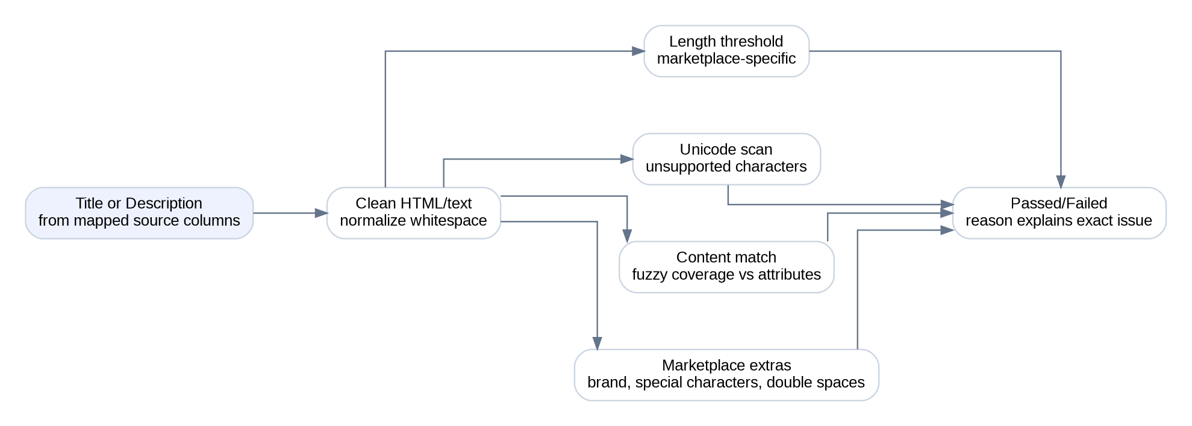
Title and description check flow
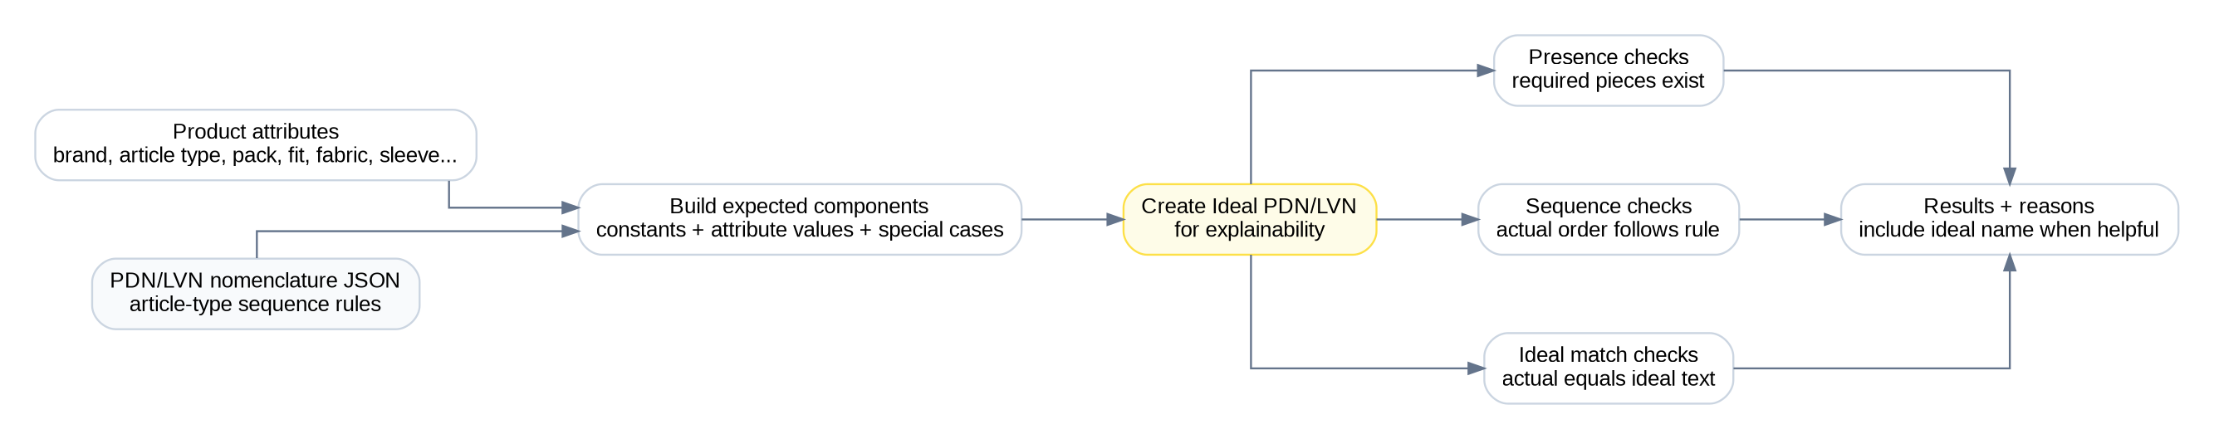
PDN/LVN nomenclature flow
Flow step | Input | Output
Normalize columns | Marketplace source title/description/article type/brand columns | CAST internal fields
Clean text | HTML, whitespace, escaped text | Plain text used for counts and matching
Run text checks | Clean text plus attributes | Pass/fail values and reasons
Resolve nomenclature | Article type rule plus attributes | Ideal PDN/LVN and comparison results

Size chart and compliance flows
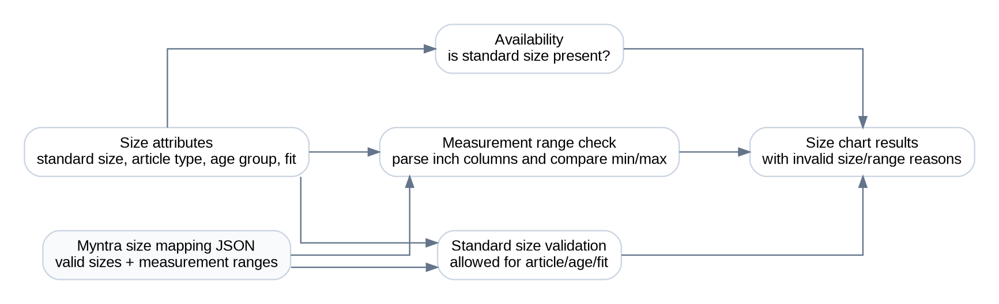
Size chart validation flow
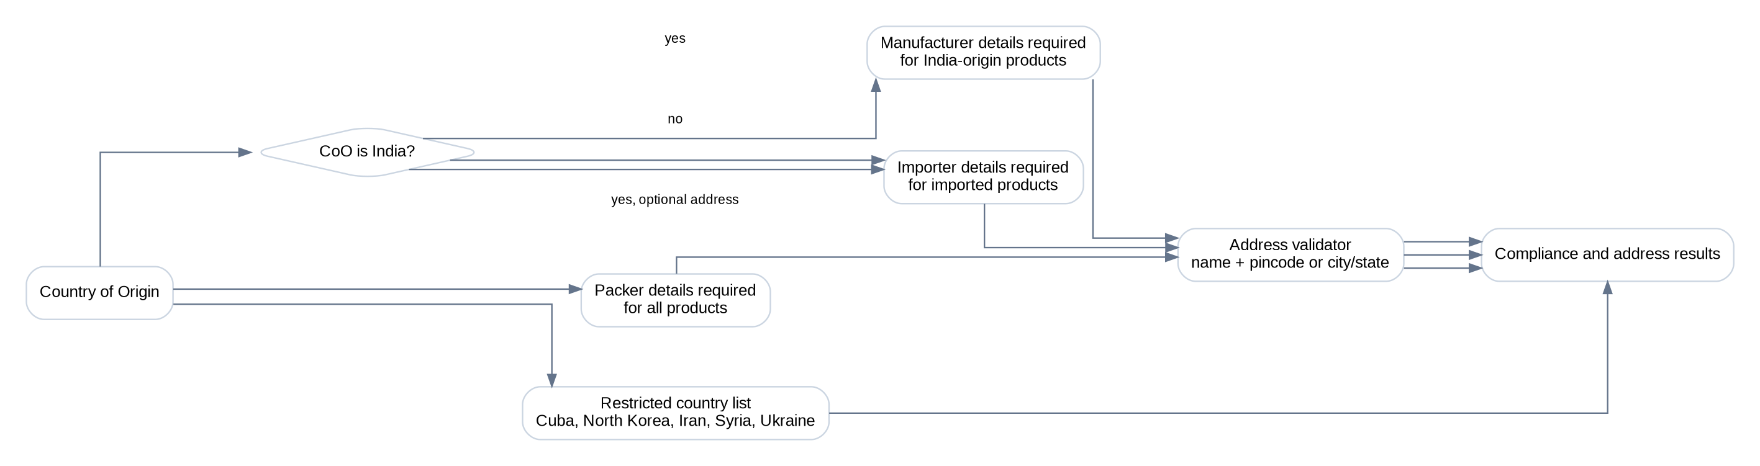
Legal and address validation flow
Flow | Input | Output
Size availability | Standard Size and one-size marker | Size chart availability result
Standard size validation | Article Type, Age Group, Fit, Standard Size, size mapping | Invalid or accepted size result
Measurement range validation | Inch measurement columns and size mapping ranges | Out-of-range measurement result
Compliance details | Country of Origin and legal fields | Mandatory details result
Address validation | Manufacturer, importer, packer address text | Name/location validity result

Image and vision flow
Image and vision pipeline
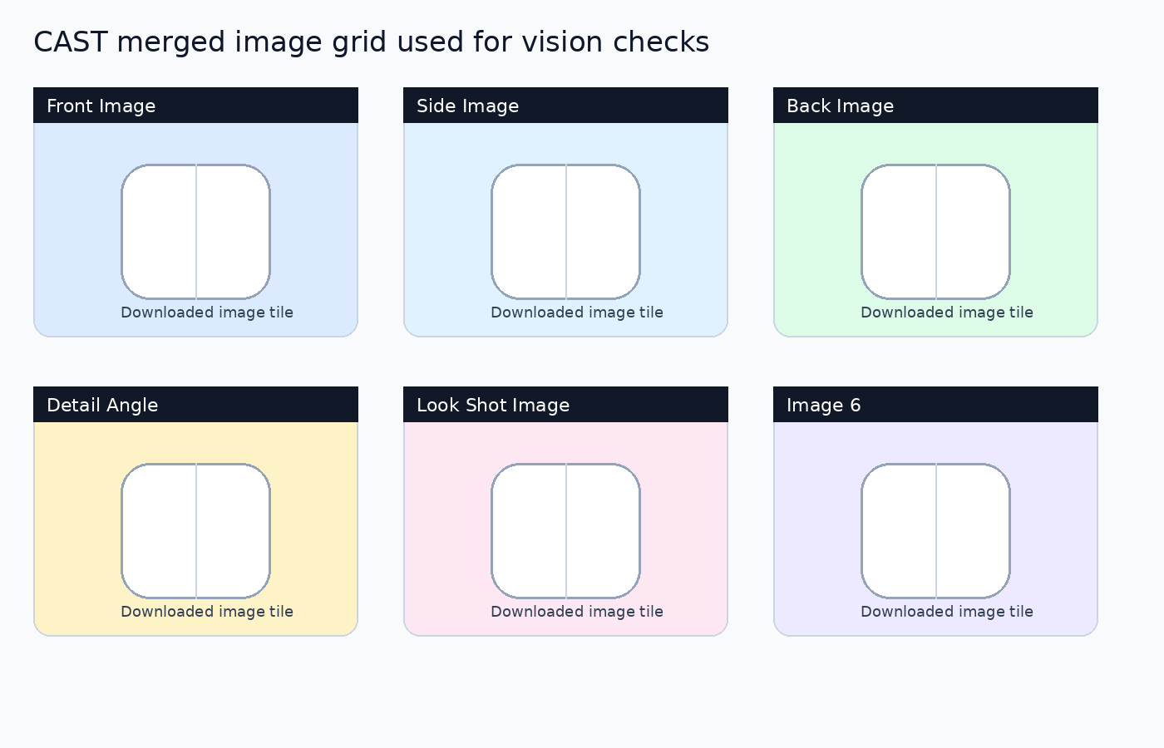
Rendered image-grid example
Stage | What CAST does | Why it matters
Download | Fetches configured image URLs with retry and browser-like headers | Reduces false failures from server protections
Merge | Builds one labeled grid containing all available image slots | Lets the model understand which slot it is judging
Prompt | Combines marketplace instructions, attributes, and expected JSON keys | Keeps response structured
Validate | Retries malformed or incomplete JSON responses | Avoids worker crashes from imperfect model output
Cache | Stores image analysis per SKU | Reuses one model response for many image flags

Output and webhook flow
Webhook output flow
Output piece | Meaning
Check result column | Visible Passed/Failed value for one check
Check Reason column | Human-readable explanation for the result
Failure Rate | Percentage of failed checks among checks that ran
Failure Summary | Short list of failed checks
Failure Report | Longer failure details for debugging or display

Excel and helper flows
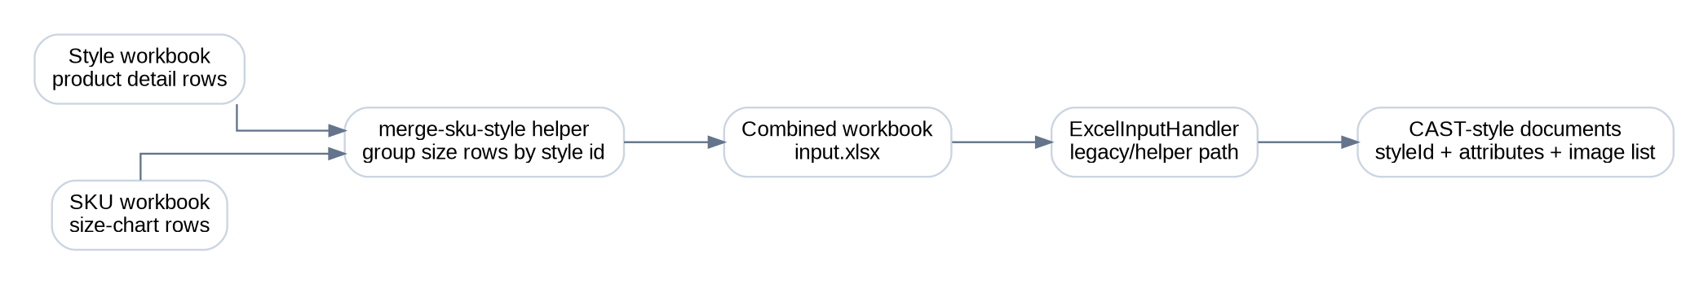
Style/SKU workbook merge flow
Flow | Input | Processing | Output
Excel input helper | Workbook sheets except masterdata | Maps rows, tags specifications, combines image URLs | CAST-style documents
Excel output helper | Analysis results | Writes or updates workbook rows and color-codes results | Output workbook
Merge helper | Style workbook and SKU workbook | Groups size data by style id | Combined input workbook

Deployment and operations
Production-like local runtime
Pipeline stage | What happens | Required variables
Build | Docker image is built from the repository-root Dockerfile | Docker service in CI
Tag | Image is tagged with commit id and ECR repository | AWS account, region, ECR repository
Push | Image is pushed to ECR | AWS credentials and ECR access
Update Lambda | Lambda function code is updated to the pushed image URI | Lambda function name and IAM permissions

The deploy readme mentions a deploy-specific Dockerfile, but the repository contains the Dockerfile at the repository root. Use the root Dockerfile unless the deployment layout is changed.

Troubleshooting and implementation notes
- Local server import error: install boto3.
- Mongo order mode returns no work: confirm database connection, database name, and valid order id.
- Spell checks fail to start: install Java 11 and enable spell checks only when needed.
- Vision checks time out: test image URLs from the runtime network and verify the selected vision provider settings.
- Webhook receives no response: confirm workers are invoked and the webhook URL is reachable from the runtime network.
- Some legal rules are configured but not implemented in the current legal analyzer.
- Additional material/fabric and restricted-keyword checks should be reviewed against the current worker call shape.
- Vision fallback can mark missing model keys as Passed after retries; monitor logs for missing or malformed model responses.

Glossary
Term | Meaning
PDN | Product Display Name, usually the main marketplace title.
LVN | List View Name, a shorter marketplace listing name.
CoO | Country of Origin.
Worker payload | A single-SKU payload dispatched by the dispatcher or sent directly in worker mode.
Output columns | Flat result fields sent back to the webhook, including reasons and failure summary.
Vision flag | A check answered by the vision model after CAST sends the labeled image grid.

