Write a program where one player is going against a computer player in a dice game. The dice is a six sided die. First to 50 points wins. Ask players if they would like to continue the game as they go.

**Nouns**: players, dice

**Verbs**: Ask

**Defining Diagram**:

Input:

rollDice

PlayerOne

Processing:

Ask to continue game

Rolldice

Output:

Display output

**Flow Chart**

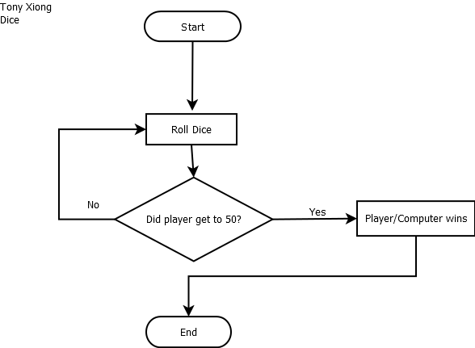

**Pseudocode**

BeatTheComputerDiceGame

Initialize answer to “”

Initialize dice1 to Math.floor((Math.random() * 6) + 1)

Initialize dice2 to Math.floor((Math.random() * 6) + 1)

Initialize diceSum to dice1 + dice2

Initialize doubles to “”;

Initialize computerPoints to zero

Initialize computerScore to zero

Initialize playerPoints to zero

Initialize playerOneScore to zero

Prompt answer with (“Press enter to roll dice or 2 to quit")

IF dice1 is equal to dice2 THEN

doubles = true;

output is “Die 1: " + dice1

output1 is "Die 2: " + dice2

output2 is “Dice Total: " + diceSum

WHILE playerPoints is less than 50 AND computerPoints is less than 50 AND continueGame() is not equal to 2 THEN

doubles equal false

IF doubles AND playerOneScore is greater than computerScore THEN

playerPoints plus equals playerOneScore time two

ELSE IF doubles AND playerOneScore less than computerScore THEN

computerPoints plus equals computerScore times two

ELSE IF playerOneScore is greater than computerScore THEN

playerPoints plus equals playerOneScore

ELSE IF computerScore is greater than playerOneScore THEN

computerPoints plus equals computerScore

END IF

Output playerPoints with "Your Points: " + playerPoints

Output computerPoints with "Computer Points: " + computerPoints

Test plans

variables: playerOneScore computerScore answer

Test Plan 1:

Inputs: 42 53 Enter

Expected Results: Computer wins

Actual Results: prompts ends

Test Plan 2:

Inputs: 55, 19, Enter

Expected Results: PlayerOne Wins

Actual Results: Prompt ends with playerOne Winning

Test Plan 3:

Inputs: 20, 20, 2

Expected Results: Game was ended by player

Actual Results: prompt Answer was ended by player

Test Plan 4:

Inputs: 0, 0, 2

Expected Results: game was ended by player

Actual Results: Prompt answer was ended by player

Test Plan 5:

Inputs: A, B, Enter

Expected Results: Please press enter or 2