Homework 4 Report

1. EM Algorithm

Randomization strategy: first run k-means several iterations to get the initialization parameters (Bishop – Pattern Recognition And Machine Learning, p. 438). I use Weka’s k-means for initialization, and used 3 different initializations iterations, 1, 2, and the following is the clustering centers and variances after initialization:

Notice that when we set iteration number to 2, the results is close to the final results after using EM, so I did not use iteration number greater than 2 for initialization.

The following gives the log likelihood after running different number of iteration of EM algorithms under 2 initialization settings (1 and 2), and setting variance to 1 or not:

From the results, we see that if we set the variance to 1, the EM algorithm will converge much faster, it shows that if we know some distribution information about the data, we can get a much faster convergence.

2. Boosting & Bagging

Three data set chooses: Heart Disease Data Set (Dataset 1), Pima Indians Diabetes Data Set (Dataset 2), Ionosphere Data Set (Dataset 3), all of them are from UCI Repository, and you can find the converted .arff file in the embkk/dataset directory.
For Heart Disease Data Set, if the missing rates if >50%, the the attribute is committed, the other missing value are being modified as the average value giving the class. The following is the experiment results (Iteration number: 30, 100, 150, I marked the best performance of a row as red):

Question 1:
Which algorithm+dataset combination is improved by bagging
J48+dataset1, J48+dataset2, Decision Stump+dataset1, Decision Stump+dataset2, Decision Stump+dataset3

Question 2:
Which algorithm+dataset combination is improved by boosting
J48+dataset1, J48+dataset2, Decision Stump+dataset1, Decision Stump+datatset2, Decision Stump+dataset3

Question 3:
Can you explain these results in terms of the bias and variance of the learning algorithms applied to these domains? Are some of the learning algorithms unbiased for some of the domains? Which ones?
Bagging can reduce bias, boosting can reduce both bias and variance. From the experiment results, we can see that the performance of Logistic Regression is not improved by bagging and boosting.

3. K-means

Compression Ratios for Penguins.jpg (length of color vector: 786432):
K=2 : 3.125%
K=5 : 9.376%
K=10 : 12.50%
K=15 : 12.50%
K=20 : 15.63%

Compression Ratios for Penguins.jpg (length of color vector: 786432):
K=2 : 3.125%
K=5 : 9.376%
K=10 : 12.50%
K=15 : 12.50%
K=20 : 15.63%

Using Penguins.jpg as example, show these images, K=2, 5, 10, 15, 20:


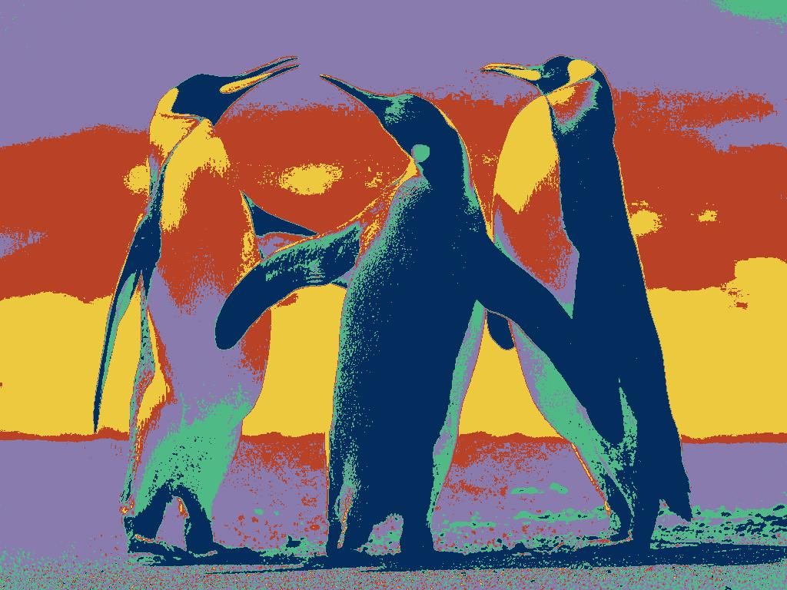

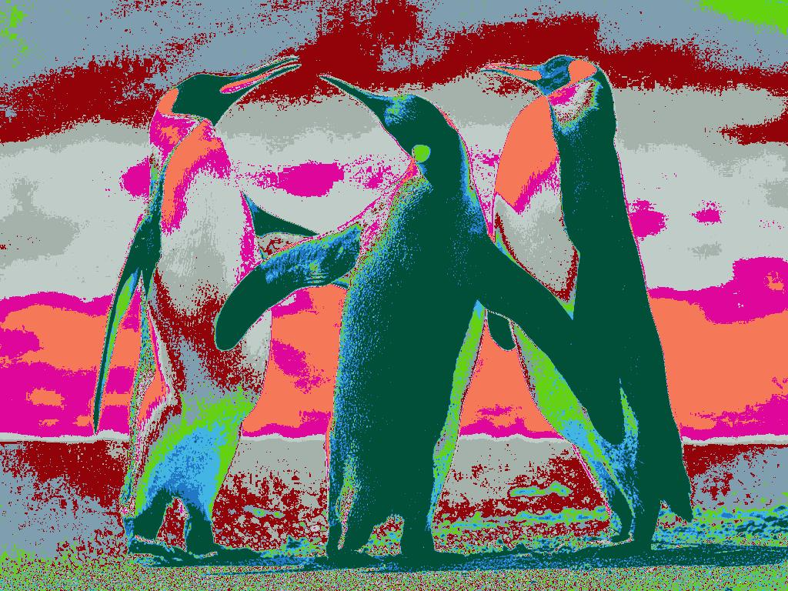

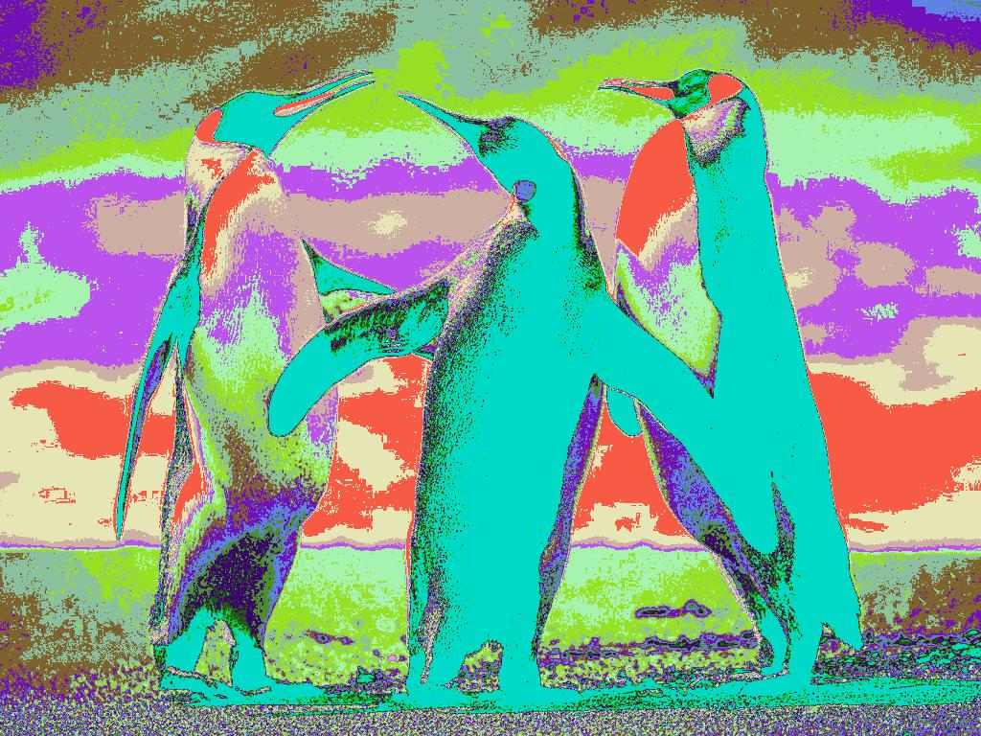



We can see K=10 is the best. K’s best value depends on the color distribution of the images, and should be chosen by experiment and artificially, for images with small number of color clusters, K should be small, while for images with large number of color clusters, K should be large to keep a good quality of the compressed images.

