SDG8
C7
2025-12-10

Introduction : Target 1
Target 1 : Sustain per capita economic growth in accordance with national circumstances and, in particular, at least 7 per cent gross domestic product growth per annum in the least developed countries.

Data Loading and Preparation
Here we will load: continents-according-to-our-world-in-data.csv, gdp-per-capita-worldbank.csv, Also, create a dataframe of all the 44 UN designated LDCs, Dec 2024 Compute GDP per Capita growth and compile all the information into one database. Also compute an average growth for all the African LDCs.
library(dplyr)
library(tidyverse)
library(ggplot2)
library(readr)
continents_according_to_our_world_in_data <- read.csv("continents-according-to-our-world-in-data.csv",
stringsAsFactors = F) %>% select(-Year)%>%rename(country = Entity)
ldcs <- data.frame("Angola", "Benin", "Burkina Faso", "Burundi", "Central African Republic", "Chad", "Comoros", "Democratic Republic of Congo", "Djibouti", "Eritrea", "Ethiopia", "Gambia", "Guinea", "Guinea-Bissau", "Lesotho", "Liberia", "Madagascar", "Malawi", "Mali", "Mauritania", "Mozambique", "Niger", "Rwanda", "Senegal", "Sierra Leone", "Somalia", "South Sudan", "Sudan", "Togo", "Uganda", "Tanzania", "Zambia", "Afghanistan", "Bangladesh", "Cambodia", "Laos", "Myanmar", "Nepal", "East Timor", "Yemen", "Haiti", "Kiribati", "Solomon Islands", "Tuvalu")%>%
gather()%>% select(-1)%>% rename( `country` = `value`) %>% mutate (ldc = TRUE)
ldc_continents <- left_join(continents_according_to_our_world_in_data, ldcs)
gdp_per_capita_worldbank <- read.csv ("gdp-per-capita-worldbank.csv",
stringsAsFactors = F)%>%
rename(`GDP per Capita` = `GDP.per.capita..PPP..constant.2017.international...`)%>%
arrange(Entity, Year) %>%
group_by(Entity) %>%
mutate(
gdp_prev = lag(`GDP per Capita`),
`GDP per Capita growth` = (`GDP per Capita` - gdp_prev) * 100/ gdp_prev) %>%
ungroup()%>%
select (-gdp_prev)%>%
rename(country = Entity)%>%
left_join(ldc_continents)
africa_grouped <- gdp_per_capita_worldbank%>%
filter(Continent == "Africa")%>%
drop_na()%>%
group_by(Year) %>%
summarise(mean_growth = mean(`GDP per Capita growth`, na.rm = TRUE))

Target 1 Analysis — GDP per Capita Growth
Compute yearly growth % for each continent.
gdp_growth_plot <- gdp_per_capita_worldbank %>%
group_by(Continent, Year) %>%
summarise(avg_growth = mean(`GDP per Capita growth`, na.rm = TRUE))%>%
drop_na()%>%
ggplot(aes(x = `Year`, y = `avg_growth`, colour = Continent)) +
geom_line(aes(group = Continent), linewidth = 1)+
xlab("Year") +
theme(axis.text.y = element_text)+
ylab("GDP per Capita growth rate (%) ") +
scale_colour_manual(values = c("lightblue", "violet", "lightpink", "turquoise", "lightgreen", "orange"))+
ggtitle("Average annual GDP per Capita Growth per continent")+
theme_minimal()
print(gdp_growth_plot)
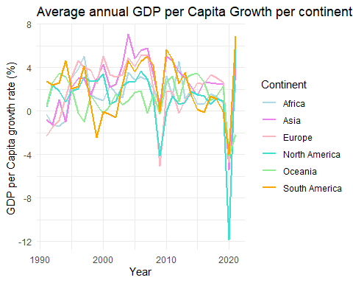

GDP Per Capita Levels by Continent Line Plot

Purpose:
Plot GDP per capita levels by continent (SDG 8.1 context)

Inputs:
data/gdp-per-capita-worldbank.csv, data/continents-according-to-our-world-in-data.csv

Outputs:
figures/gdp_levels_continent.png (continent averages + country traces)

Data Loading and Preparation
library(tidyverse)
# File paths (relative to project root)
gdp_path <- "../data/gdp-per-capita-worldbank.csv"
continents_path <- "../data/continents-according-to-our-world-in-data.csv"
# Ensure figures directory exists
dir.create("figures", showWarnings = FALSE)
# Load and clean GDP per capita data
gdp_clean <- readr::read_csv(gdp_path, show_col_types = FALSE) %>%
rename(
country = Entity,
code = Code,
year = Year,
gdp_pc = `GDP per capita, PPP (constant 2017 international $)`
) %>%
mutate(
year = as.numeric(year),
gdp_pc = as.numeric(gdp_pc)
) %>%
select(country, code, year, gdp_pc) %>%
drop_na(country)
# Load continent lookup and keep one continent per country
continents_clean <- readr::read_csv(continents_path, show_col_types = FALSE) %>%
rename(
country = Entity,
code = Code,
year = Year,
continent = Continent
) %>%
mutate(
country = str_trim(country),
continent = str_trim(continent)
) %>%
select(country, code, continent) %>%
distinct(country, .keep_all = TRUE) %>%
drop_na(continent)
# Merge GDP with continent info
gdp_all <- gdp_clean %>%
left_join(continents_clean %>% select(country, continent), by = "country") %>%
rename(gdp_per_capita = gdp_pc) %>%
filter(!is.na(continent))

GDP Per Capita Levels by Continent
# Generate the plot (country traces in grey, continent means colored)
gdp_levels_plot <- gdp_all %>%
# Plot individual country lines (thin, grey, transparent)
ggplot(aes(x = year, y = gdp_per_capita)) +
geom_line(aes(group = country), color = "grey", alpha = 0.2, linewidth = 0.3) +
# Add continent mean lines (thicker, colored)
geom_line(
aes(x = year, y = gdp_per_capita, color = continent, group = continent),
data = gdp_all %>%
group_by(continent, year) %>%
summarise(gdp_per_capita = mean(gdp_per_capita, na.rm = TRUE), .groups = "drop"),
linewidth = 1.2
) +
labs(
title = "GDP Per Capita Levels by Continent",
x = "Year",
y = "GDP Per Capita (USD)",
color = "Continent"
) +
theme_minimal() +
theme(
plot.title = element_text(hjust = 0.5, face = "bold"),
legend.position = "bottom"
)
# Save the figure
ggsave(
"figures/gdp_levels_continent.png",
plot = gdp_levels_plot,
width = 12,
height = 7,
dpi = 300
)
message("Plot saved successfully to: figures/gdp_levels_continent.png")
print(gdp_levels_plot)
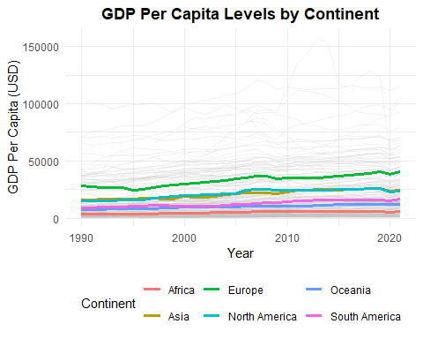

GDP Growth Rates by Country by Year Chloropleth

Purpose:
Create world maps of GDP per capita growth for SDG 8.1 (2015–2020) with 7% benchmark coloring.

Inputs:
data/gdp-per-capita-worldbank.csv data/continents-according-to-our-world-in-data.csv

Outputs:
PNG maps saved to analysis/figures/gdp_growth_map_.png
#Data Loading and Preparation
library(tidyverse)
library(sf)
library(rnaturalearth)
# File paths (relative to project root)
gdp_path <- "../data/gdp-per-capita-worldbank.csv"
continents_path <- "../data/continents-according-to-our-world-in-data.csv"
# Read and clean GDP data (long format already)
gdp_clean <- read_csv(gdp_path, show_col_types = FALSE) %>%
rename(
country = Entity,
code = Code,
year = Year,
gdp_pc = `GDP per capita, PPP (constant 2017 international $)`
) %>%
mutate(
year = as.numeric(year),
gdp_pc = as.numeric(gdp_pc)
) %>%
select(country, code, year, gdp_pc) %>%
drop_na(country)
# Read continent lookup and keep one continent per country
continents_clean <- read_csv(continents_path, show_col_types = FALSE) %>%
rename(
country = Entity,
code = Code,
year = Year,
continent = Continent
) %>%
mutate(
country = str_trim(country),
continent = str_trim(continent)
) %>%
select(country, code, continent) %>%
distinct(country, .keep_all = TRUE) %>%
drop_na(continent)
# Compute year-over-year GDP per capita growth per country
gdp_growth <- gdp_clean %>%
group_by(country) %>%
arrange(year, .by_group = TRUE) %>%
mutate(gdp_growth = 100 * (gdp_pc - lag(gdp_pc)) / lag(gdp_pc)) %>%
ungroup() %>%
left_join(continents_clean %>% select(country, continent), by = "country")
# Years to plot
years_to_plot <- 2015:2020
# Country geometries (ISO A3 codes align with gdp_clean$code)
world <- rnaturalearth::ne_countries(scale = "medium", returnclass = "sf") %>%
select(iso_a3, geometry)
# Prep growth data for join
growth_map_data <- gdp_growth %>%
filter(year %in% years_to_plot) %>%
select(code, country, continent, year, gdp_growth)

Plots
# Output directory for maps (relative to this script)
out_dir <- "figures"
dir.create(out_dir, showWarnings = FALSE)
plot_growth_map <- function(target_year) {
# Join growth data to shapes for the target year
df_year <- world %>%
left_join(
growth_map_data %>% filter(year == target_year),
by = c("iso_a3" = "code")
)
# Map with symmetric red/green scale around 0, squishing beyond +/-7%
p <- ggplot(df_year) +
geom_sf(aes(fill = gdp_growth), color = "grey80", size = 0.1) +
scale_fill_gradient2(
low = "darkred",
mid = "white",
high = "darkgreen",
midpoint = 0,
limits = c(-7, 7),
oob = scales::squish,
name = "GDP Growth (%)"
) +
labs(
title = paste0("GDP Growth Rates by Country (", target_year, ")"),
subtitle = "Dark red: growth <= -7% | Dark green: growth >= +7%",
caption = "Source: World Bank GDP per capita (PPP, constant 2017); year-over-year growth"
) +
theme_minimal() +
theme(
legend.position = "bottom",
plot.title = element_text(face = "bold")
)
out_file <- file.path(out_dir, paste0("gdp_growth_map_", target_year, ".png"))
ggsave(out_file, p, width = 12, height = 6, dpi = 300)
message("Saved: ", out_file)
print(p)
}
invisible(lapply(years_to_plot, plot_growth_map))
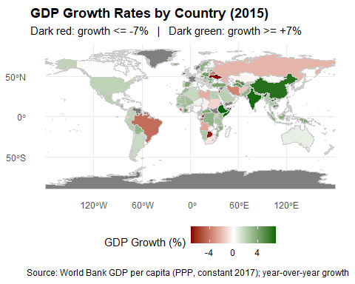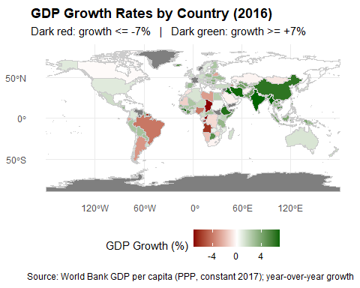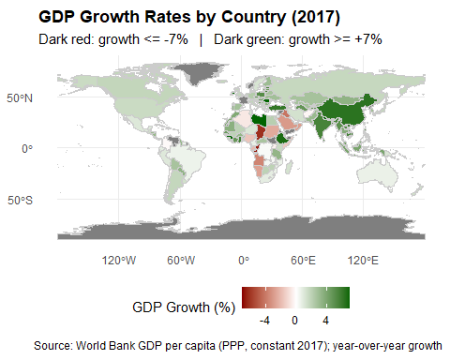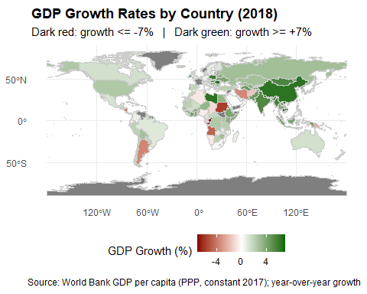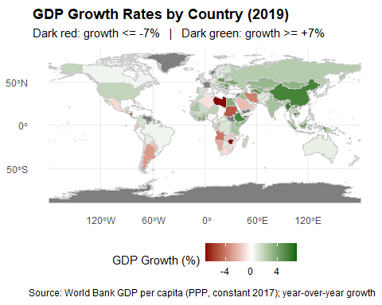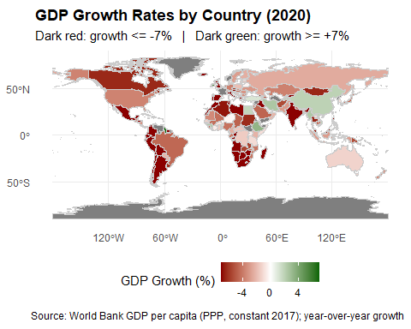

Target 1 Analysis — growth of LDCs per continent
Plot the graphs for the LDCs of each continent. There is an extra graph with the average growth rate for all the LDCs in Africa since there are 30 LDCs in Africa and the graph is quite messy. The red dashed line indicates the 7 percent growth target.
gdp_growth_only_ldc_asia_plot <- gdp_per_capita_worldbank %>%
filter(Continent == "Asia")%>%
filter(ldc == TRUE)%>%
ggplot(aes(x = `Year`, y = `GDP per Capita growth`, colour = country)) +
geom_line(aes(group = country), linewidth = 1)+
geom_hline(yintercept = 7, colour = "red", linewidth = 1, linetype = "dashed")+
xlab("Year") +
geom_text(aes(2022, 7, label = '7%'), vjust = -1, colour = "red")+
theme(axis.text.y = element_text)+
ylab("GDP growth rate (%) ") +
scale_colour_manual(values = c("lightblue", "violet", "lightpink", "turquoise", "lightgreen", "orange", "darkseagreen", "deeppink2"))+
ggtitle("Average annual GDP per Capita Growth for Asia's LDCs")+
theme_minimal()
print(gdp_growth_only_ldc_asia_plot)
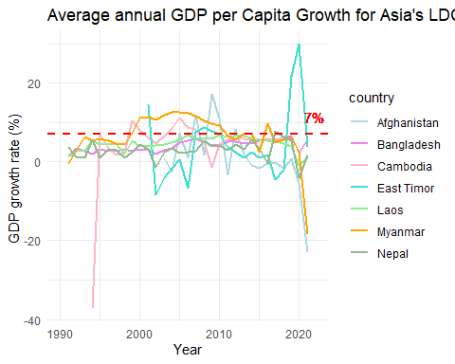
gdp_growth_only_ldc_africa_plot <- gdp_per_capita_worldbank %>%
filter(Continent == "Africa")%>%
filter(ldc == TRUE)%>%
ggplot(aes(x = `Year`, y = `GDP per Capita growth`, colour = country)) +
geom_line(aes(group = country))+
geom_hline(yintercept = 7, colour = "red", linewidth = 1, linetype = "dashed")+
xlab("Year") +
geom_text(aes(2022, 7, label = '7%'), vjust = -1, colour = "red")+
theme(axis.text.y = element_text)+
ylab("GDP growth rate (%) ") +
scale_colour_manual(values = c("lightblue", "violet", "lightpink", "turquoise", "lightgreen", "orange", "darkblue", "darkgreen", "darkred",
"darkkhaki", "grey", "beige", "magenta", "darkslateblue", "deeppink4", "chocolate4", "coral", "deepskyblue4", "darkorchid3",
"darkseagreen2", "darkseagreen4", "darkgoldenrod2", "cyan3", "cornflowerblue", "blueviolet", "azure3", "burlywood", "cadetblue", "deeppink2", "darkolivegreen3"))+
ggtitle("Average annual GDP per Capita Growth for Africa's LDCs")+
theme_minimal()
print(gdp_growth_only_ldc_africa_plot)
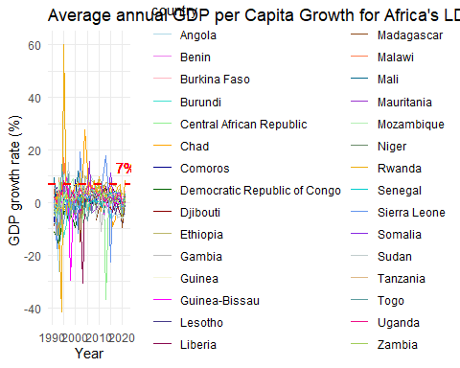
africa_grouped_plot <- africa_grouped %>%
ggplot(aes(x = `Year`, y = `mean_growth`)) +
geom_line(colour = "darkseagreen", linewidth = 1)+
geom_hline(yintercept = 7, colour = "red", linewidth = 1, linetype = "dashed")+
xlab("Year") +
geom_text(aes(2022, 7, label = '7%'), vjust = 1.5, colour = "red")+
theme(axis.text.y = element_text)+
ylab("GDP growth rate (%) ") +
ggtitle("Average annual GDP per Capita Growth for Africa's LDCs")+
theme_minimal()
print(africa_grouped_plot)
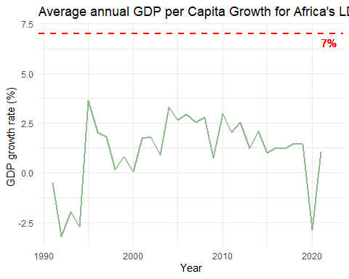
gdp_growth_only_ldc_northamerica_plot <- gdp_per_capita_worldbank %>%
filter(Continent == "North America")%>%
filter(ldc == TRUE)%>%
ggplot(aes(x = `Year`, y = `GDP per Capita growth`, colour = country)) +
geom_line(aes(group = country), linewidth = 1)+
geom_hline(yintercept = 7, colour = "red", linewidth = 1, linetype = "dashed")+
xlab("Year") +
geom_text(aes(2022, 7, label = '7%'), vjust = 1.5, colour = "red")+
theme(axis.text.y = element_text)+
ylab("GDP growth rate (%) ") +
scale_colour_manual(values = c("lightblue"))+
ggtitle("Average annual GDP per Capita Growth for North America's LDCs")+
theme_minimal()
print(gdp_growth_only_ldc_northamerica_plot)
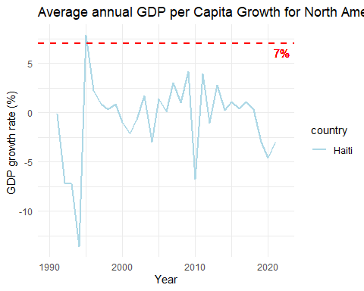
gdp_growth_only_ldc_oceania_plot <- gdp_per_capita_worldbank %>%
filter(Continent == "Oceania")%>%
filter(ldc == TRUE)%>%
ggplot(aes(x = `Year`, y = `GDP per Capita growth`, colour = country)) +
geom_line(aes(group = country), linewidth = 1)+
geom_hline(yintercept = 7, colour = "red", linewidth = 1, linetype = "dashed")+
geom_text(aes(2022, 7, label = '7%'), vjust = -1, colour = "red")+
xlab("Year") +
theme(axis.text.y = element_text)+
ylab("GDP growth rate (%) ") +
scale_colour_manual(values = c("lightblue", "violet", "lightpink"))+
ggtitle("Average annual GDP per Capita Growth for Oceania's LDCs")+
theme_minimal()
print(gdp_growth_only_ldc_oceania_plot)
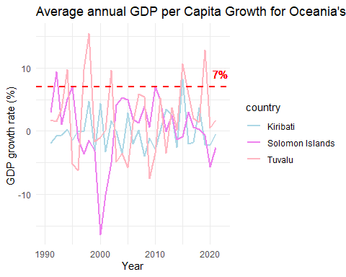

Introduction : Target 2
Target 2 : By 2020, substantially reduce the proportion of youth not in employment, education or training.

Data Loading and Preparation
library(readr)
library(dplyr)
library(ggplot2)
# Load raw continent classifications and youth NEET data
continents_raw <- read_csv("continents-according-to-our-world-in-data.csv")
youth_raw <- read_csv("youth-not-in-education-employment-training.csv")
# Keep one row per country code
continents_clean <- continents_raw %>%
select(Code, Continent) %>%
distinct(Code, .keep_all = TRUE)
# Clean NEET column name for easier use
youth_clean <- youth_raw %>%
rename(
`share_neet` = `Share of youth not in education, employment or training, total (% of youth population)`
)
# Merge NEET data with continent labels and restrict to 2000–2020, excluding Antarctica
youth_with_continents <- youth_clean %>%
left_join(continents_clean, by = "Code") %>%
filter(!is.na(Continent), Continent != "Antarctica") %>%
filter(Year >= 2000, Year <= 2020)
# Save cleaned dataset
write_csv(youth_with_continents, "youth_with_continents_cleaned_2000_2020.csv")
# Load NEET dataset
neet <- readr::read_csv("youth_with_continents_cleaned_2000_2020.csv")
names(neet)[4] <- "share_neet"
# Load HDI dataset
hdi <- readr::read_csv("human-development-index.csv")
hdi <- hdi %>%
filter(indicatorCode == "hdi") %>%
select(countryIsoCode, year, value)
# Rename for merge compatibility
hdi <- hdi %>%
rename(
Code = countryIsoCode,
Year = year,
HDI = value
)
# Merge by country code + year
merged <- neet %>%
left_join(hdi, by = c("Code", "Year"))
# Save merged dataset
write_csv(merged, "youth_continents_hdi_2000_2020.csv")
# Load merged dataset containing NEET rates, HDI values, and continent labels
df <- read_csv("youth_continents_hdi_2000_2020.csv")
df <- df %>%
# Create HDI tiers and broader HDI groups for comparing NEET outcomes
mutate(
HDI_tier = case_when(
HDI >= 0.800 ~ "Very High",
HDI >= 0.700 & HDI < 0.800 ~ "High",
HDI >= 0.550 & HDI < 0.700 ~ "Medium",
HDI < 0.550 ~ "Low",
TRUE ~ NA_character_
),
HDI_group2 = case_when(
HDI_tier %in% c("Very High", "High") ~ "High & Very High HDI",
HDI_tier %in% c("Medium", "Low") ~ "Medium & Low HDI",
TRUE ~ NA_character_
)
) %>%
filter(!is.na(HDI_group2)) # drop rows without HDI classification
continents <- read.csv("continents-according-to-our-world-in-data.csv",
stringsAsFactors = FALSE)
youth <- read.csv("youth-not-in-education-employment-training.csv", stringsAsFactors = FALSE)

Africa Youth NEET (%) by HDI group
# Compute annual average NEET for Africa by HDI group
africa <- df %>%
filter(Continent == "Africa") %>%
group_by(Year, HDI_group2) %>%
summarise(
mean_neet = mean(share_neet, na.rm = TRUE),
.groups = "drop"
)
# Plot NEET trends over time for African HDI groups
ggplot(africa, aes(x = Year, y = mean_neet, colour = HDI_group2)) +
geom_line(linewidth = 1) +
geom_point(size = 1.3) +
labs(
title = "Africa: Youth NEET (%) by HDI group",
subtitle = "High & Very High vs Medium & Low HDI",
x = "Year",
y = "% of youth NEET",
colour = "HDI group"
) +
theme_minimal()
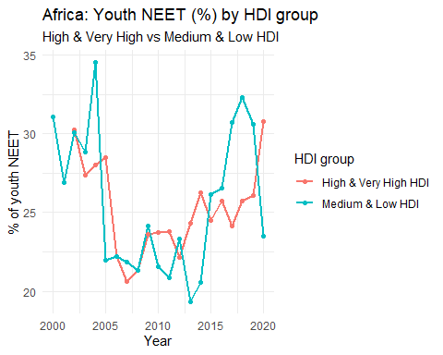

Asia Youth NEET (%) by HDI group
# Compute annual average NEET for Asia by HDI group
asia <- df %>%
filter(Continent == "Asia") %>%
group_by(Year, HDI_group2) %>%
summarise(
mean_neet = mean(share_neet, na.rm = TRUE),
.groups = "drop"
)
# Plot NEET trends over time for Asian HDI groups
ggplot(asia, aes(x = Year, y = mean_neet, colour = HDI_group2)) +
geom_line(linewidth = 1) +
geom_point(size = 1.3) +
labs(
title = "Asia: Youth NEET (%) by HDI group",
subtitle = "High & Very High vs Medium & Low HDI",
x = "Year",
y = "% of youth NEET",
colour = "HDI group"
) +
theme_minimal()
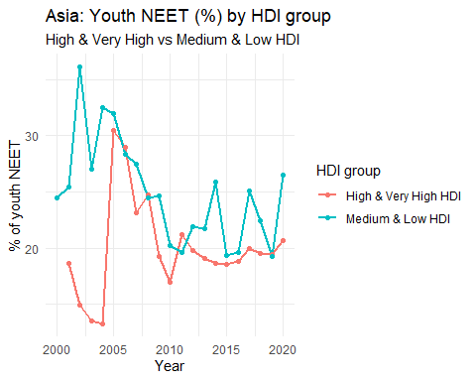

Europe Youth NEET (%) by HDI group
# Compute annual average NEET for Europe by HDI group
europe <- df %>%
filter(Continent == "Europe") %>%
group_by(Year, HDI_group2) %>%
summarise(
mean_neet = mean(share_neet, na.rm = TRUE),
.groups = "drop"
)
#Plot NEET trends over time for European HDI groups
ggplot(europe, aes(x = Year, y = mean_neet, colour = HDI_group2)) +
geom_line(linewidth = 1) +
geom_point(size = 1.3) +
labs(
title = "Europe: Youth NEET (%) by HDI group",
subtitle = "High & Very High vs Medium & Low HDI",
x = "Year",
y = "% of youth NEET",
colour = "HDI group"
) +
theme_minimal()
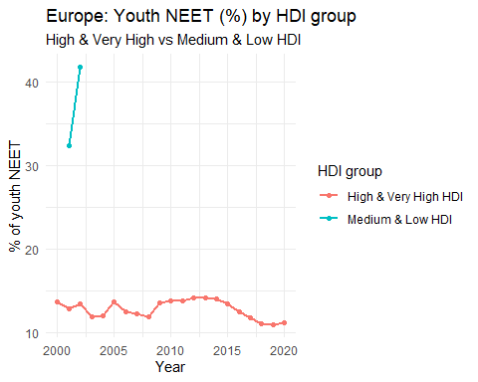

North America Youth NEET (%) by HDI group
# Compute annual average NEET for North America by HDI group
north_america <- df %>%
filter(Continent == "North America") %>%
group_by(Year, HDI_group2) %>%
summarise(
mean_neet = mean(share_neet, na.rm = TRUE),
.groups = "drop"
)
# Plot NEET trends over time for North American HDI groups
ggplot(north_america, aes(x = Year, y = mean_neet, colour = HDI_group2)) +
geom_line(linewidth = 1) +
geom_point(size = 1.3) +
labs(
title = "North America: Youth NEET (%) by HDI group",
subtitle = "High & Very High vs Medium & Low HDI",
x = "Year",
y = "% of youth NEET",
colour = "HDI group"
) +
theme_minimal()
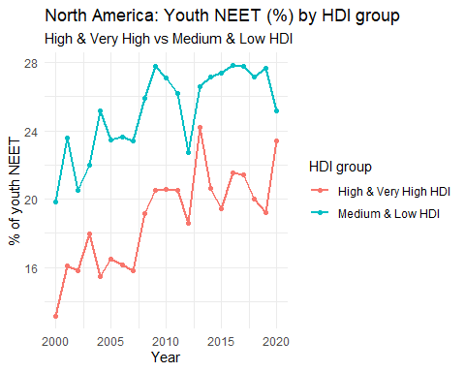

Oceania Youth NEET (%) by HDI group
#Compute annual average NEET for Oceania by HDI group
oceania <- df %>%
filter(Continent == "Oceania") %>%
group_by(Year, HDI_group2) %>%
summarise(
mean_neet = mean(share_neet, na.rm = TRUE),
.groups = "drop"
)
#Plot NEET trends over time for Oceanic HDI groups
ggplot(oceania, aes(x = Year, y = mean_neet, colour = HDI_group2)) +
geom_line(linewidth = 1) +
geom_point(size = 1.3) +
labs(
title = "Oceania: Youth NEET (%) by HDI group",
subtitle = "High & Very High vs Medium & Low HDI",
x = "Year",
y = "% of youth NEET",
colour = "HDI group"
) +
theme_minimal()
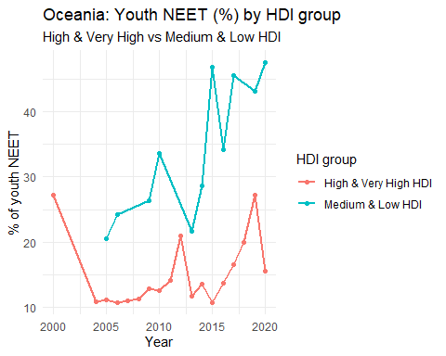

South America Youth NEET (%) by HDI group
# Compute annual average NEET for South America by HDI group
south_america <- df %>%
filter(Continent == "South America") %>%
group_by(Year, HDI_group2) %>%
summarise(
mean_neet = mean(share_neet, na.rm = TRUE),
.groups = "drop"
)
# Plot NEET trends over time for South American HDI groups
ggplot(south_america, aes(x = Year, y = mean_neet, colour = HDI_group2)) +
geom_line(linewidth = 1) +
geom_point(size = 1.3) +
labs(
title = "South America: Youth NEET (%) by HDI group",
subtitle = "High & Very High vs Medium & Low HDI",
x = "Year",
y = "% of youth NEET",
colour = "HDI group"
) +
theme_minimal()
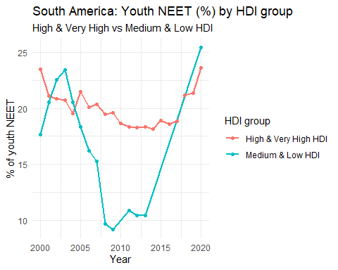

Africa Youth NEET (%)
africa <- df %>%
#subset Africa and compute yearly average NEET for the continent
filter(Continent == "Africa") %>%
group_by(Year) %>%
summarise(
mean_neet = mean(share_neet, na.rm = TRUE),
.groups = "drop"
)
# Plot Africa's average NEET trend over 2000–2020
ggplot(africa, aes(x = Year, y = mean_neet)) +
geom_line(linewidth = 1) +
geom_point(size = 1.3) +
labs(
title = "Africa: Youth NEET (%)",
x = "Year",
y = "% of youth NEET"
) +
theme_minimal()
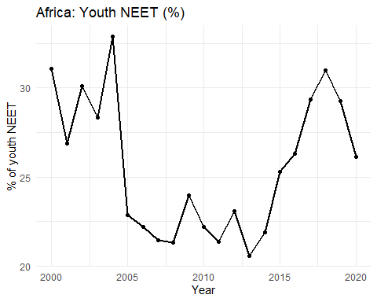

Asia Youth NEET (%)
asia <- df %>%
#subset Asia and compute yearly average NEET for the continent
filter(Continent == "Asia") %>%
group_by(Year) %>%
summarise(
mean_neet = mean(share_neet, na.rm = TRUE),
.groups = "drop"
)
# Plot Asia's average NEET trend over 2000–2020
ggplot(asia, aes(x = Year, y = mean_neet)) +
geom_line(linewidth = 1) +
geom_point(size = 1.3) +
labs(
title = "Asia: Youth NEET (%)",
x = "Year",
y = "% of youth NEET"
) +
theme_minimal()
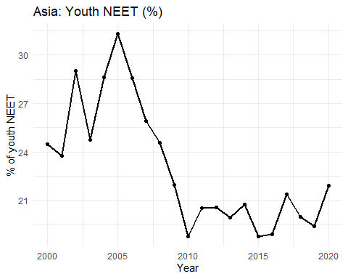

Oceania Youth NEET (%)
oceania <- df %>%
# subset Oceania and compute yearly average NEET for the continent
filter(Continent == "Oceania") %>%
group_by(Year) %>%
summarise(
mean_neet = mean(share_neet, na.rm = TRUE),
.groups = "drop"
)
# Plot Oceania's average NEET trend over 2000–2020
ggplot(oceania, aes(x = Year, y = mean_neet)) +
geom_line(linewidth = 1) +
geom_point(size = 1.3) +
labs(
title = "Oceania: Youth NEET (%)",
x = "Year",
y = "% of youth NEET"
) +
theme_minimal()
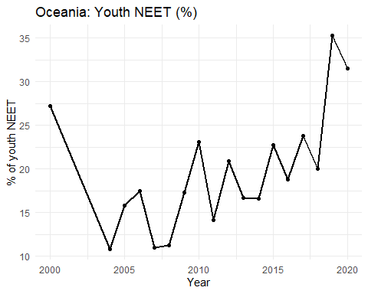

Europe Youth NEET (%)
europe <- df %>%
#subset Europe and compute yearly average NEET for the continent
filter(Continent == "Europe") %>%
group_by(Year) %>%
summarise(
mean_neet = mean(share_neet, na.rm = TRUE),
.groups = "drop"
)
# Plot Europe's average NEET trend over 2000–2020
ggplot(europe, aes(x = Year, y = mean_neet)) +
geom_line(linewidth = 1) +
geom_point(size = 1.3) +
labs(
title = "Europe: Youth NEET (%)",
x = "Year",
y = "% of youth NEET"
) +
theme_minimal()
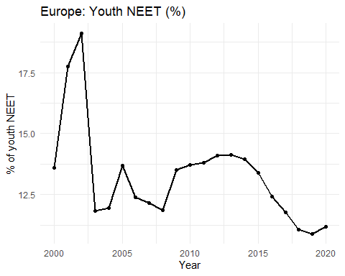

North America Youth NEET (%)
north_america <- df %>%
# subset North America and compute yearly average NEET for the continent
filter(Continent == "North America") %>%
group_by(Year) %>%
summarise(
mean_neet = mean(share_neet, na.rm = TRUE),
.groups = "drop"
)
# Plot North America's average NEET trend over 2000–2020
ggplot(north_america, aes(x = Year, y = mean_neet)) +
geom_line(linewidth = 1) +
geom_point(size = 1.3) +
labs(
title = "North America: Youth NEET (%)",
x = "Year",
y = "% of youth NEET"
) +
theme_minimal()
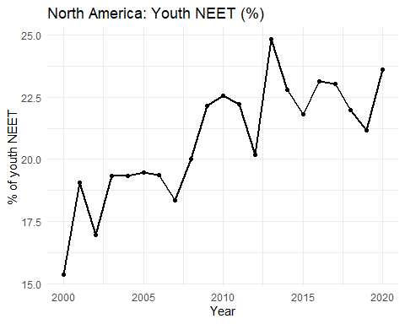

South America Youth NEET (%)
south_america <- df %>%
# subset South America and compute yearly average NEET for the continent
filter(Continent == "South America") %>%
group_by(Year) %>%
summarise(
mean_neet = mean(share_neet, na.rm = TRUE),
.groups = "drop"
)
# Plot South America's average NEET trend over 2000–2020
ggplot(south_america, aes(x = Year, y = mean_neet)) +
geom_line(linewidth = 1) +
geom_point(size = 1.3) +
labs(
title = "South America: Youth NEET (%)",
x = "Year",
y = "% of youth NEET"
) +
theme_minimal()
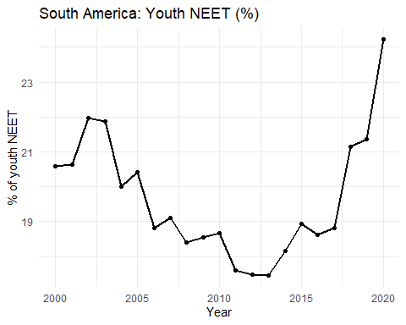

Youth NEET by Continent heatmap
# Selecting Relevant Columns
continents <- continents %>%
select("Entity", "Code", "Continent")
# Joining Youth Data With Continent Classification
all <- youth %>%
left_join(continents, by = "Entity")
# Removing Duplicate/Unnecessary Columns
all <- all %>%
select("Entity", "Code.x", "Year", "Continent",
"Share.of.youth.not.in.education..employment.or.training..total....of.youth.population.")
# Removing Missing Values
all <- all %>% na.omit()
# Filtering Years 2000–2020
all <- all %>%
filter(Year >= 2000 & Year <= 2020)
# Grouping by Continent and Year, Computing Averages
by_continent <- all %>%
group_by(Continent, Year) %>%
summarise(continent_avg = mean(
Share.of.youth.not.in.education..employment.or.training..total....of.youth.population.
))
# Heatmap Plot
by_continent %>%
ggplot(aes(x = Year, y = Continent, fill = continent_avg)) +
geom_tile() +
scale_fill_gradient(low = "green", high = "red") +
labs(
title = "Youth Not in Employment, Training or Education (NEET) by Continent, 2000–2020",
fill = "Average NEET Share (%)"
) +
theme(legend.position = "bottom")
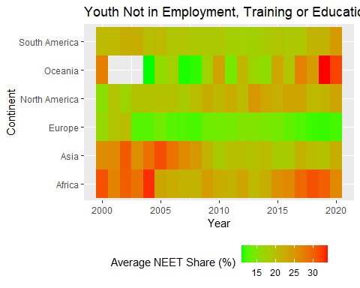

Youth Not in Education, Employment or Training by Year Chloropleth

Purpose:
Create world maps of youth NEET rates (2015–2020) for SDG 8.6

Inputs:
data/youth-not-in-education-employment-training.csv, data/continents-according-to-our-world-in-data.csv

Outputs:
PNG maps saved to analysis/figures/neet_map_.png

Data Loading and Preparation
library(tidyverse)
library(sf)
library(rnaturalearth)
# File paths (relative to project root)
neet_path <- "../data/youth-not-in-education-employment-training.csv"
continents_path <- "../data/continents-according-to-our-world-in-data.csv"
# Years to plot
years_to_plot <- 2015:2020
# Load and clean NEET data (long format already)
neet_clean <- readr::read_csv(neet_path, show_col_types = FALSE) %>%
rename(
country = Entity,
code = Code,
year = Year,
neet_rate = `Share of youth not in education, employment or training, total (% of youth population)`
) %>%
mutate(
year = as.numeric(year),
neet_rate = as.numeric(neet_rate)
) %>%
select(country, code, year, neet_rate) %>%
drop_na(country)
# Load continent lookup and keep one continent per country
continents_clean <- readr::read_csv(continents_path, show_col_types = FALSE) %>%
rename(
country = Entity,
code = Code,
year = Year,
continent = Continent
) %>%
mutate(
country = str_trim(country),
continent = str_trim(continent)
) %>%
select(country, continent) %>%
distinct(country, .keep_all = TRUE) %>%
drop_na(continent)
# Merge NEET data with continents
neet_map_data <- neet_clean %>%
left_join(continents_clean, by = "country") %>%
filter(year %in% years_to_plot)
# Country geometries
world <- rnaturalearth::ne_countries(scale = "medium", returnclass = "sf") %>%
select(iso_a3, geometry)
# Output directory
out_dir <- "figures"
dir.create(out_dir, showWarnings = FALSE)

Plots
plot_neet_map <- function(target_year) {
# Join NEET data to shapes for the target year
df_year <- world %>%
left_join(
neet_map_data %>% filter(year == target_year),
by = c("iso_a3" = "code")
)
# OWID-like beige-to-red palette
palette_colors <- c("#fef6e4", "#f9d9a9", "#f7a26d", "#e25b42", "#b2171e")
palette_values <- scales::rescale(c(0, 10, 25, 40, 60))
p <- ggplot(df_year) +
geom_sf(aes(fill = neet_rate), color = "grey80", size = 0.1) +
scale_fill_gradientn(
colours = palette_colors,
values = palette_values,
limits = c(0, 60),
oob = scales::squish,
na.value = "grey90",
name = "NEET (%)"
) +
labs(
title = paste0("Youth Not in Education, Employment or Training (", target_year, ")"),
subtitle = "Share of youth population",
caption = "Source: ILO / World Bank NEET data"
) +
theme_minimal() +
theme(
legend.position = "bottom",
plot.title = element_text(face = "bold")
)
out_file <- file.path(out_dir, paste0("neet_map_", target_year, ".png"))
ggsave(out_file, p, width = 12, height = 6, dpi = 300)
message("Saved: ", out_file)
print(p)
}
invisible(lapply(years_to_plot, plot_neet_map))
