**My Lent To Do List**

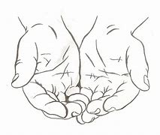

**Give to people in need**

 **PRAY** **the Rosary with your family,** **the Sign of The Cross**

**Apostle Creed, Our Father, Hail Mary, Glory Be Prayer, Grace Before**

**Meals, go to Mass on Sunday and go to special Lent services, visit the Adoration Chapel spend time with Jesus. TALK TO JESUS and MOTHER MARY.**

**DO GOOD**

**Obey your parents and guardians, DO NOT argue, answer back or give attitude. Respect your parents and guardians, LOVE YOUR PARENTS and GUARDIANS.**

**SHOW**

**Kindess, Love, Care, Help, Share, Smile, Comfort, show love to everyone, visit your family members, be last and BE THE LIGHT OF THE WORLD**

**SHOW the HEART and the WORDS of JESUS.**

**SACRIFICE**

**Watch less T.V.**

**Play less video games, or better NO video games**

**Give up your favorite candy, food or drink**

