

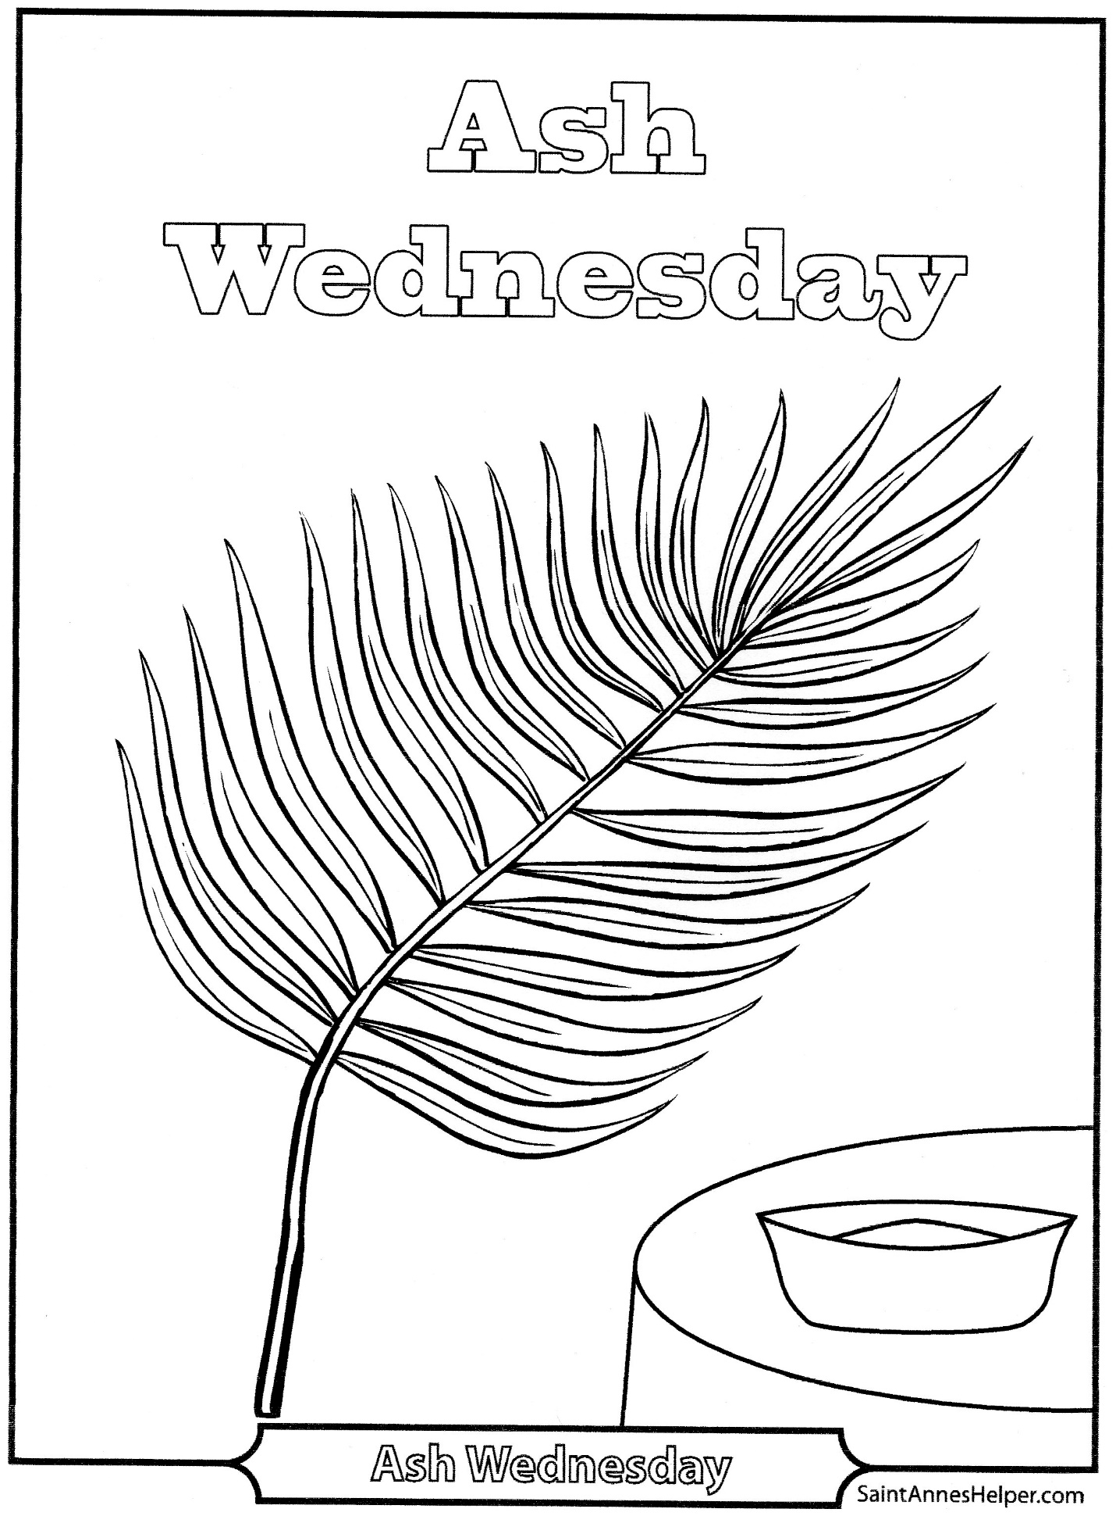
My Lent To Do List

Give to people in need

PRAY the Rosary with your family, the Sign of The Cross
Apostle Creed, Our Father, Hail Mary, Glory Be Prayer, Grace Before
Meals, go to Mass on Sunday and go to special Lent services, visit the Adoration Chapel spend time with Jesus. TALK TO JESUS and MOTHER MARY.
DO GOOD
Obey your parents and guardians, DO NOT argue, answer back or give attitude. Respect your parents and guardians, LOVE YOUR PARENTS and GUARDIANS.
SHOW
Kindess, Love, Care, Help, Share, Smile, Comfort, show love to everyone, visit your family members, be last and BE THE LIGHT OF THE WORLD
SHOW the HEART and the WORDS of JESUS.

SACRIFICE
Watch less T.V.
Play less video games, or better NO video games
Give up your favorite candy, food or drink

