System Architecture Document

Bath Secure – Smart Bathroom Fall Detection System

# Contents

Anandu V K, Abhiram Krishna July 18, 2025

1. Introduction 2
   1. Document Overview . . . . . . . . . . . . . . . . . . . . . . . . . . . . . . . 2
   2. Abbreviations and Glossary . . . . . . . . . . . . . . . . . . . . . . . . . . . 2
      1. Abbreviations . . . . . . . . . . . . . . . . . . . . . . . . . . . . . . . 2
      2. Glossary . . . . . . . . . . . . . . . . . . . . . . . . . . . . . . . . . . 2
   3. References . . . . . . . . . . . . . . . . . . . . . . . . . . . . . . . . . . . . . 2
      1. Project References . . . . . . . . . . . . . . . . . . . . . . . . . . . . 2
      2. Standard and Regulatory References . . . . . . . . . . . . . . . . . . 2
   4. Conventions . . . . . . . . . . . . . . . . . . . . . . . . . . . . . . . . . . . . 3
2. Architecture 3
   1. Architecture Overview . . . . . . . . . . . . . . . . . . . . . . . . . . . . . . 3
   2. Physical Architecture Overview . . . . . . . . . . . . . . . . . . . . . . . . . 3
      1. Network Diagram . . . . . . . . . . . . . . . . . . . . . . . . . . . . . 3
      2. Hardware Components . . . . . . . . . . . . . . . . . . . . . . . . . . 3
      3. Component Diagram . . . . . . . . . . . . . . . . . . . . . . . . . . . 4
   3. Logical Architecture Overview . . . . . . . . . . . . . . . . . . . . . . . . . . 4
      1. Software Component 1: Sensor Handler . . . . . . . . . . . . . . . . . 4
      2. Software Component 2: Fall Detection Logic . . . . . . . . . . . . . . 5
      3. Software Component 3: Alert Manager . . . . . . . . . . . . . . . . . 5
      4. Software Architecture Diagram . . . . . . . . . . . . . . . . . . . . . 5
   4. Modbus Interface Module . . . . . . . . . . . . . . . . . . . . . . . . . . . . . 5  
      2.4.1 Address Mapping for Peripheral in Modbus . . . . . . . . . . . . . . . . 5
   5. Software SOUP . . . . . . . . . . . . . . . . . . . . . . . . . . . . . . . . . . 5
3. Dynamic Behaviour of Architecture 5
   1. Workflow / Sequence 1 – Normal Entry . . . . . . . . . . . . . . . . . . . . . 5
   2. Workflow / Sequence 2 – Suspected Fall . . . . . . . . . . . . . . . . . . . . 5
4. Justification of Architecture 6
   1. System Architecture Capabilities . . . . . . . . . . . . . . . . . . . . . . . . 6
   2. Network Architecture Capabilities . . . . . . . . . . . . . . . . . . . . . . . . 6
   3. Risk Analysis Outputs . . . . . . . . . . . . . . . . . . . . . . . . . . . . . . 6
   4. Human Factors Engineering Outputs . . . . . . . . . . . . . . . . . . . . . . 6
   5. SOUP Integration . . . . . . . . . . . . . . . . . . . . . . . . . . . . . . . . . 6
5. Requirements Traceability 6

# Introduction

## Document Overview

This document describes the architecture of the **Bath Secure** system. It includes:

* A general description of the system
* The logical architecture of software and top-level components
* The physical architecture of hardware
* The justification of technical choices made
* The traceability between the architecture and system requirements

## Abbreviations and Glossary

## Abbreviations

|  |  |
| --- | --- |
| **Abbreviation** | **Meaning** |
| PIR | Passive Infrared Sensor |
| GSM | Global System for Mobile Communications |
| UART | Universal Asynchronous Receiver-Transmitter |
| SOUP | Software of Unknown Provenance |
| COTS | Components Off The Shelf |

## Glossary

* + - * **Fall Detection:** Identifying prolonged immobility or suspicious motion suggesting a fall.
      * **Manual Override:** Button press by user to cancel a false alert.

## References

## Project References

|  |  |  |
| --- | --- | --- |
| **#** | **Document Identifier** | **Title** |
| R1 | PRS-001 | Bath Secure Product Specification Requirement |

## Standard and Regulatory References

|  |  |  |
| --- | --- | --- |
| **#** | **Document Identifier** | **Title** |
| STD1 | IEC 62304 | Medical Device Software Lifecycle Standard |

## Conventions

UML diagrams and block diagrams are used. GPIO, UART, and power lines are labeled on component diagrams. Time sequences and alert flows are shown using structured lists.

# Architecture

## Architecture Overview

The Bath Secure system is a bathroom-based fall detection device that operates in home or hospital environments. It uses PIR motion sensors to detect movement, a microcontroller for processing, and a GSM module to notify caregivers. It provides:

* Motion-based fall detection using dual PIRs
* Local alert via buzzer
* Remote alert via GSM call or SMS
* Manual override by push button

## Physical Architecture Overview

## Network Diagram

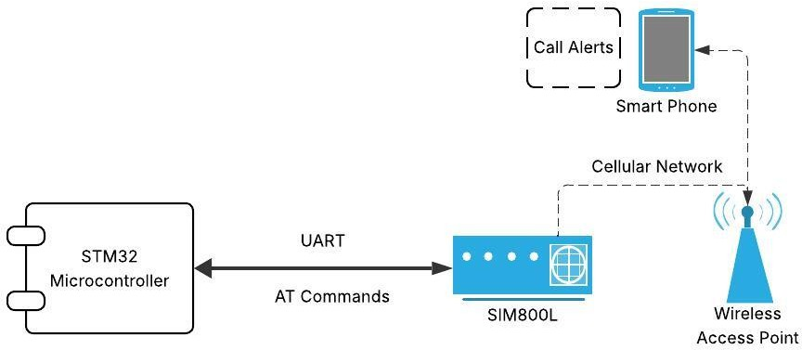

Figure 1: Network Diagram – Bath Secure System

## Hardware Components

|  |  |
| --- | --- |
| **Component** | **Description** |
| STM32F446ZE | Main processor, controls system logic and interfaces. |

|  |  |
| --- | --- |
| PIR Sensor 1 | Detects upper-body motion. |
| PIR Sensor 2 | Detects lower-body motion. |
| Push Button | Cancels false alerts via GPIO interrupt. |
| Buzzer | Inside bathroom; alerts user. |
| SIM800L GSM Mod-  ule | Sends SMS/call alert to predefined number. |
| PL2303 | Enables user interface and professional diagnosis. |
| Power Supply | Regulates voltage to 3.3V (MCU) and 4.2V (GSM). |

## Component Diagram

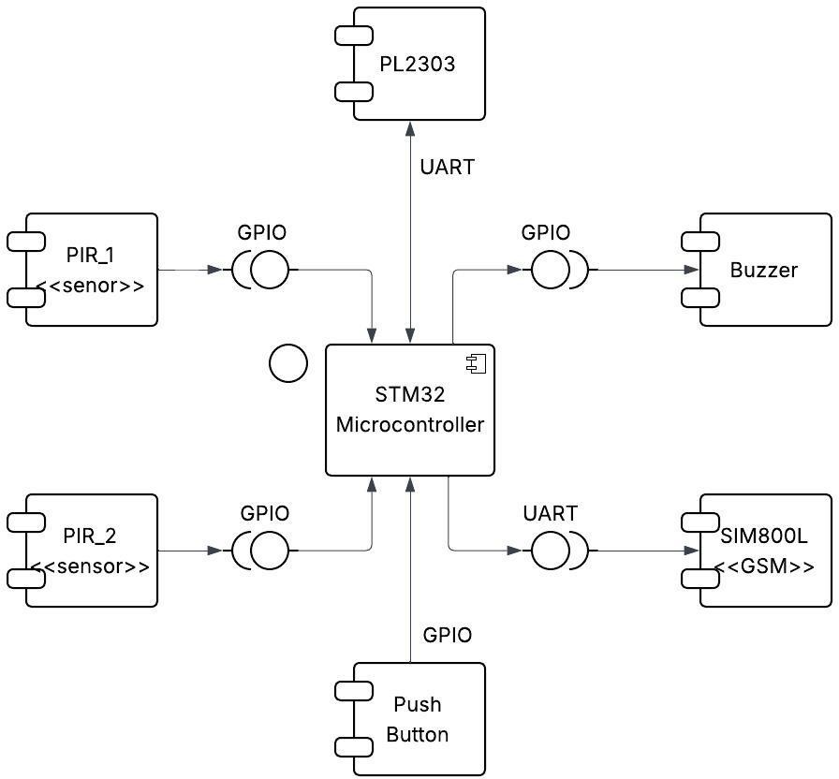

Figure 2: Component Diagram – Bath Secure

## Logical Architecture Overview

## Software Component 1: Sensor Handler

Reads values from PIR1 and PIR2 and updates flags.

## Software Component 2: Fall Detection Logic

If PIR1 is LOW and PIR2 is HIGH for 5 minutes → starts alert sequence.

## Software Component 3: Alert Manager

Handles buzzer activation, GSM alert, and button override.

## Software Architecture Diagram

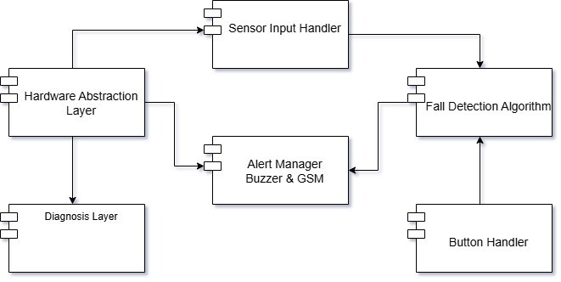

Figure 3: Software Architecture Diagram – Bath Secure Firmware Logic

## Modbus Interface Module

## Address Mapping for Peripherals in Modbus

## User Interface

|  |  |  |
| --- | --- | --- |
| Peripheral | Address | Multiplier |
| PIR_1 status | 40001 | 1 |
| PIR_2 status | 40002 | 1 |
| System status | 40003 | 1 |
| Last Emergency details | 40004 | 1 |

## Diagnosis Interface

|  |  |  |
| --- | --- | --- |
| Peripheral | Address | Multiplier |
| PIR_1 | 41001 | 1 |
| PIR_2 | 41002 | 1 |
| Buzzer | 41003 | 1 |
| Switch | 41004 | 1 |
| SIM800L | 41005 | 1 |

## Software SOUP No SOUP component used. All software written in Embedded C for STM32 using HAL.

# Dynamic Behaviour of Architecture

## Workflow / Sequence 1 – Normal Entry

* PIR1 = HIGH, PIR2 = HIGH → motion detected
* No alert; user is active

## Workflow / Sequence 2 – Suspected Fall

* PIR1 = LOW, PIR2 = HIGH persists for 5 minutes
* Buzzer activates for 2 minutes
* If button pressed → cancel
* Else → GSM module sends alert

# Justification of Architecture

## System Architecture Capabilities

* Fast fall detection and response
* Low power consumption
* Minimal hardware footprint
* Easy manual override

## Network Architecture Capabilities

* GSM ensures alert even without Wi-Fi
* UART for reliable SIM800L communication

## Risk Analysis Outputs

* Buzzer gives user chance to cancel alert
* Capacitor filtering prevents GSM noise reset

## Human Factors Engineering Outputs

* Only a buzzer and button – simple interface
* Waterproof enclosure

## SOUP Integration

Not applicable.

# Requirements Traceability

|  |  |  |
| --- | --- | --- |
| **Requirement** | **Component** | **Comment** |
| REQ-001: Fall detection | PIR1, PIR2, STM32 | Logic evaluates persistent lower-  body-only detection. |
| REQ-002: User alert | Buzzer | Notifies occupant of detected fall. |
| REQ-003: False alarm  cancel | Push Button | Allows user override before GSM  triggers. |
| REQ-004: Remote  alert | SIM800L | Sends call/SMS to caregiver. |