Machine Learning & Data Mining

T3 2019

COMP9417 – Homework-1

Chirag Panikkasseril Unni – z5241855
11/10/2019

1. Estimated θ parameters for TV feature for the below parameters is
θ₀ = −1, θ₁ = −0.5
α = 0.01
maximum iteration = 500

estimated Theta values for iteration:500:
θ₀ = 10.11455567, θ₁ = 8.26795499

2. A plot, which visualizes the change in cost function J θ at each iteration.

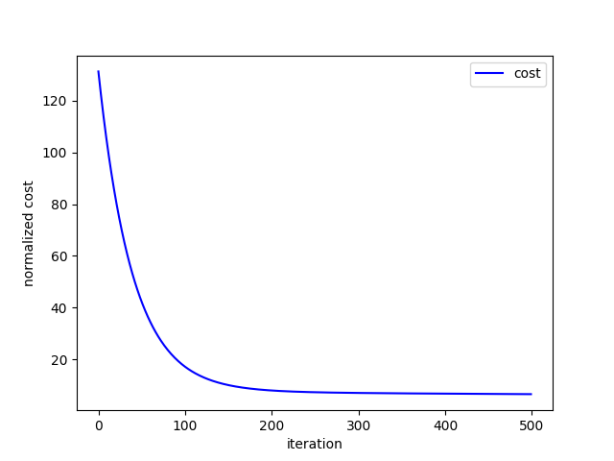
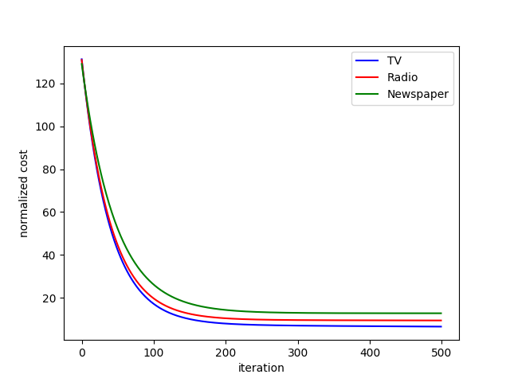
Cost curve for TV featureCombined Cost Curve for all features

3. RMSE for TV train data: 3.6408394507948225

4. RMSE for TV test data: 3.9092605131614144

5. RMSE for Radio test data: 4.200750008993373

6. RMSE for newspaper test data: 5.427934797044488

7. Using the RMSE data we can see that estimated model can be ranked as:

TV > Radio > newspaper

Python 3 code:
import pandas as pd
import numpy as np
import matplotlib.pyplot as plt
def func_rmse(X, Y, theta):
X1 = np.append(np.ones(shape=(X.shape[0], 1)), X, axis=1)
y_hat = np.dot(X1, theta.T)
m = X.shape[0] # no.of training data items
rmse = np.sqrt((1 / m) * np.square(Y - y_hat).sum())
return rmse
def gradient_descent(X, Y, theta, alpha, max_iter):
X1 = np.append(np.ones(shape=(X.shape[0], 1)), X, axis=1)
cost = np.ones(shape=(max_iter, 1))
theta_hist = np.ones(shape=(max_iter, 2))
m = X.shape[0] # no.of training data items
for i in range(max_iter):
theta_hist[i] = theta
h = np.dot(X1, theta.T)
cost[i] = (1 / (2 * m)) * (np.square(Y - h).sum())
theta = theta + ((alpha / m) * np.sum(((Y - h) * X1), axis=0))
return cost, theta_hist
def normalize(x, min, max):
new = ((x - min) / (max - min))
return new
df = pd.read_csv("Advertising.csv")
data = np.array(df)
# 1. Pre-‐processing:
minValues = np.amin(data, axis=0)[1:5]
maxValues = np.amax(data, axis=0)[1:5]
min_TV, min_Radio, min_News, min_Sales = minValues
max_TV, max_Radio, max_News, max_Sales = maxValues
# min-max normalization
for i in range(data.shape[0]):
data[i][1] = normalize(data[i][1], min_TV, max_TV)
data[i][2] = normalize(data[i][2], min_Radio, max_Radio)
data[i][3] = normalize(data[i][3], min_News, max_News)
# 2. Creating test and training set
train_data = np.copy(data[:-10])
test_data = np.copy(data[-10:])
# 3. Gradient descent
theta0 = -1
theta1 = -0.5
alpha = 0.01
max_iter = 500
theta = np.array([[theta0, theta1]])
# train TV x Sales
print(f'train TV x Sales')
X = train_data[:, [1]]
Y = train_data[:, [4]]
cost_TV, theta_hist = gradient_descent(X, Y, theta, alpha, max_iter)
print(f'min of J(0):{np.amin(cost_TV)}')
est_theta = theta_hist[-1:]
print(f'estimated Theta values for iteration:{max_iter}:{est_theta}')
# RMSE TV train data
rmse = func_rmse(X, Y, est_theta)
print(f'RMSE for TV train data:{rmse}')
print()
# A plot, which visualises the change in cost function J θ at each iteration.
plt.figure()
plt.plot(np.arange(max_iter), cost_TV, 'b', label='TV')
plt.xlabel('iteration')
plt.ylabel('normalized cost')
plt.legend()
plt.show()
# test TV x Sales
print(f'test TV x Sales')
X = test_data[:, [1]]
Y = test_data[:, [4]]
# RMSE TV test data
rmse = func_rmse(X, Y, est_theta)
print(f'RMSE for TV test data:{rmse}')
print()
#train Radio x Sales
print(f'train Radio x Sales')
X = train_data[:, [2]]
Y = train_data[:, [4]]
cost_Radio, theta_hist = gradient_descent(X, Y, theta, alpha, max_iter)
print(f'min of J(O):{np.amin(cost_Radio)}')
est_theta = theta_hist[-1:]
print(f'estimated Theta values for iteration:{max_iter}:{est_theta}')
# RMSE Radio train data
rmse = func_rmse(X, Y, est_theta)
print(f'RMSE for Radio train data:{rmse}')
print()
# test Radio x Sales
print(f'test Radio x Sales')
X = test_data[:, [2]]
Y = test_data[:, [4]]
rmse = func_rmse(X, Y, est_theta)
print(f'RMSE for Radio test data:{rmse}')
print()
#train newspaper x Sales
print(f'train newspaper x Sales')
X = train_data[:, [3]]
Y = train_data[:, [4]]
cost_news, theta_hist = gradient_descent(X, Y, theta, alpha, max_iter)
print(f'min of J(O):{np.amin(cost_news)}')
est_theta = theta_hist[-1:]
print(f'estimated Theta values for iteration:{max_iter}:{est_theta}')
# RMSE newspaper train data
rmse = func_rmse(X, Y, est_theta)
print(f'RMSE for newspaper train data:{rmse}')
print()
# test newspaper x Sales
print(f'test newspaper x Sales')
X = test_data[:, [3]]
Y = test_data[:, [4]]
rmse = func_rmse(X, Y, est_theta)
print(f'RMSE for newspaper test data:{rmse}')
print()
# A plot, which visualises the change in cost function J θ at each iteration.
plt.figure()
plt.plot(np.arange(max_iter), cost_TV, 'b', label='TV')
plt.plot(np.arange(max_iter), cost_Radio, 'r', label='Radio')
plt.plot(np.arange(max_iter), cost_news, 'g', label='Newspaper')
plt.xlabel('iteration')
plt.ylabel('normalized cost')
plt.legend()
plt.show()
Console Output:

/usr/bin/python3.7 /home/chirag/PycharmProjects/9417homework1/h.py
train TV x Sales
min of J(0):6.627855953231973
estimated Theta values for iteration:500:[[10.11455567 8.26795499]]
RMSE for TV train data:3.6408394507948225

test TV x Sales
RMSE for TV test data:3.9092605131614144

train Radio x Sales
min of J(O):9.493644157608461
estimated Theta values for iteration:500:[[10.82283051 7.01105184]]
RMSE for Radio train data:4.357440569327013

test Radio x Sales
RMSE for Radio test data:4.200750008993373

train newspaper x Sales
min of J(O):12.846999312254798
estimated Theta values for iteration:500:[[12.96616311 3.83655296]]
RMSE for newspaper train data:5.068924799650277

test newspaper x Sales
RMSE for newspaper test data:5.427934797044488

Process finished with exit code 0

